Test 1

1. What is required before generating the encryption keys for SSH on a router or switch? Setting the hostname an domain name
2. You want to change the size of the command history buffer. Which of the following commands will set permanently to 100? Terminal history size 100
3. Which command can be used to quickly reveal the status of all interfaces? **show ip interface brief**
4. **If both ends of an Ethernet connection is configured for half duplex, where would late collisions be observed?** on both ends of the connection
5. What is the function provided by the network layer? 1. providing end devices with a unique network identifier. 2. Directing data packets to destination hosts on other networks
6. The router executes diagnostics from ROM on several hardware components, including the CPU, RAM, and NVRAM. This is the main task of: POST
7. You have just received 14 Catalyst switches for your network. You would like to install these switches into your production network to provide separate collision domains for each of the connected devices. What configuration is required to provide this functionality? No configuration is required.
8. You want to turn on local authentication so that a user must supply a username and password when managing the switch. You have created the username and password combinations on the switch. Which command will direct SSH and Telnet to use this authentication model? Switch(config-line)#login local
9. In order to test end-to-end connectivity, you would use this command ping
10. The default gateway is only used when the host wants to send a packet to a device on another network
11. You call your manager to tell him you cannot access router in another city over the Internet. He provides you with the information to access the switch through a telephone connection. Select appropriate access method: AUX
12. Choose the correct commands to configure IP address on a switch:

* S1(config)#interface vlan 1
* S1(config-if)#ip address 192.168.1.254 255.255.255.0
* S1(config-if)#no shutdown

1. What is a loopback interface on a Cisco router? It is a logical interface internal to the router
2. You type Switch#sh r and receive a % ambiguous command error. Why did you receive this message? There is more than one show command that starts with the letter r.
3. Which command displays interface information and packet flow count for all interfaces on the device? **show interfaces**
4. **Which command or commands will set a password and require login for a line?**

* **Router(config-line)#password Password20!**
* **Router(config-line)#login**

1. You need to set up a password that will prevent unauthorized users from telnetting into your router. What series of commands would you use?

* Acme1(config)#line vty 0
* Acme1(config-line)#password acme
* Acme1(config-line)#login

1. Following default settings, what is the next step in the router boot sequence after the IOS loads from flash? Locate and load the startup-config file from NVRAM.
2. You are configuring your router, and your boss happens to look over your shoulder as you type a **show running-config command**. She sees one of the lines that says **password 7 14361F009A056E7D** and asks what this means. What do you tell her? It is the result of a service password-encryption command.
3. Which commands display the contents of the IPv4 or IPv6 routing table stored in RAM? (Choose two). **show ip route** and **show ipv6 route**
4. **Which command will configure the enable password for a router or switch? Router(config)# enable secret Password20!**
5. **What type of route is indicated by the code L in an IPv4 routing table on a Cisco router? The Ipv4 address of the interface on the router**
6. **You need to set the login password for Telnet. Which command will you type first? Switch(config)#line vty 0 5**
7. **Which definition is referred to “Collisions” error type? Number of messages retransmitted because of an Ethernet collision.**
8. **Why would a technician enter the command copy running-config startup-config? To save an active configuration to NVRAM**
9. **The reported “Output errors” from the show interfaces command include the following(Choose two): Late collisions, Collisions**
10. Within a production network, what is the purpose of configuring a switch with a default gateway address? The default gateway address is used to forward packets originating from the switch to remote networks.
11. You type Router#sh ru and receive an % ambiguous command error. Why did you receive this message? There is more than one show command that starts with the letters
12. The reported **“Input errors” from the show interfaces command include the following(Choose three): Runt Frames, CRC errors, Glants**
13. Show the router boot process order: 1. Post, 2. Boot load, 3. Ios, 4. Conf file
14. Which command will prevent all unencrypted passwords from displaying in plain text in a configuration file? Switch(config)#service password-encryption
15. Which command will delete the contents of NVRAM on a switch? Erase startup-config
16. A technician configures a switch with these commands:

Switch#config t

Switch(config)#hostname SW-Floor-1

SW-Floor-1(config)#

What is the technician configuring? Name of the device

1. A technician configures a switch with these commands:

SwitchA(config)#interface vlan 1

SwitchA(config-if)#ip address 192.168.1.1 255.255.255.0

SwitchA(config-if)#no shutdown

What is the technician configuring? Switch virtual interface(SVI)

1. The device prompt for this mode is “Switch(config)#”: Global configuration mode
2. Identify router component by its description: a way to remotely access the cli across a network interface: telnet/ssh
3. A local port which uses USB or low-speed, serial connections to manage network devices. Console port
4. You want to prevent unauthorized users from plugging their laptops into the router. What type of password will help prevent this issue? Console
5. Which definition is refered to “Runts” error type? Packets that are discarded because they are smaller than the minimum packet size for the medium.
6. The Cisco IOS returns a help message to indicate that there were not enough characters entered for the command interpreter to recognize the command. Define the help message type. Incomplete command
7. Which command will configure the router or switch to allow SSH as a protocol for management …….. of Telnet? Which command will configure the router or switch to allow SSH as a protocol for management with a fallback of Telnet? Switch(config-line)#transport ssh telnet
8. As a network administrator, you telnet to a switch and receive the error Password required, but none set.[Connection to 192.168.1.1 closed by foreign host]. What is the problem? The line login password is not set.
9. Identify router component by its description: connects computers, switches, and router for internal networking. LAN interfaces
10. Which portion of the network layer address does a router use to forward packets? network portion
11. Why would a technician enter the command copy running-config startup-config? To save an active configuration to NVRAM
12. You type Switch#sh r and receive a % ambiguous command error. Why did you receive this message? There is more than one show command that starts with the letter r.
13. Choose the correct prompt for the Privileged EXEC mode: Switch#
14. What is the function provided by the network layer? Directing data packets to destination hosts on other networks
15. The device prompt for this mode is “Switch(config-if)#”. Answer:Interface configuration mode
16. What must be configured on a Cisco device to enable Telnet functionality? A management IP address
17. Why would a technician enter the command copy startup-config running-config? To copy an existing configuration into RAM
18. During the boot process where will the router boot loader program look for the ios image by default? Flash
19. In which mode you can issue “enable secret password” command? Switch(config)#
20. What is the value of administrative distance for the local host route? 110
21. Identify router component by its description: connects routers to external networks, usually over a large distance. Answer: WAN interface
22. In which of the following modes in Cisco’s IOS can you issue show commands? (choose two). User, Privileged
23. Identify router components by its description: a port to manage routers using telephone lines and modems. AUX port
24. In which memory type running-configuration file is located? RAM
25. A technician is configuring a new Cisco 2960 switch. What is the effect of issuing the BranchSw(config-if)# duplex full command? It allows data to flow in both directions at the same time on the interface
26. Choose the correct command to configure a banner message: S1(config)#banner motd @Warning!@
27. The Cisco IOS returns a help message indicating that required keywords or arguments were left off the end of the command. Define the help message type: Incomplete command
28. A technician configures a switch with these commands:

SwitchA(config)#line vty 0 15

SwitchA(config-if)#password cisco123

SwitchA(config-if)#login What is the technician configuring?

Limits device access over Telnet

1. This is typically stored in flash memory and is copied into RAM for execution by the CPU. the IOS image
2. The Cisco IOS returns a help message to indicate where the command interpreter can not decipher the command. Define the help message type. Invalid input detected at ‘^’ marker.
3. The Cisco IOS returns a help message to indicate that there were not enough characters entered for the command interpreter to recognize the command. Define the help message type: Ambiguous command.
4. The ip address of the host device and the router interface address must be: in the same network
5. Which global configuration mode command sets the BOOT environment variable? Boot system
6. Passwords can be used to restrict access to the Cisco IOS. Select the mode or interface that can be protected with a password: VTY interface
7. What is the purpose of the startup configuration file on a Cisco router?to contain the commands that are used to initially configure a router on startup
8. A technician is configuring a new Cisco 2960 switch. What is the effect of issuing the BranchSw(config-if)# mdix auto command? It automatically adjusts the port to allow device connections to use either a straight-through or a crossover cable.
9. Which command will configure a local user for SSH access? Router(config)#username user1 password Password20!
10. Which device acts as a gateway to allow hosts to send traffic to remote ip networks? Local router

2 Test

1. What the VLAN tag control information field consists of? Type field, a Priority field, a Canonical Format Identifier field, and VLAN ID field
2. Which option of the switchport mode command puts the interface into permanent nontrunking mode and negotiates convert the link into a nontrunk link: Access
3. Where is the vlan.dat file stored on a switch? In flash memory
4. Which configuration command helps to stop DTP negotiation? switchport nonegotiate
5. Which type of VLAN is assigned to 802.1Q trunk ports to carry untagged traffic? native
6. If an organization is changing to include Cisco IP phones in its network, what design feature must be considered to ensure voice quality? A separate VLAN is needed for voice traffic.
7. On a cisco switch, where is extended VLAN information stored? Running configuration file
8. Which distinct type of VLAN is used by an administrator to access and configure a switch? Management VLAN
9. In which memory location are the VLAN configurations of normal range VLANs stored on a Cisco switch by default? Flash memory
10. In which memory location are the VLAN configurations of normal range VLANs stored on a Catalyst switch? Flash memory
11. Refer to the exhibit Topology. PC2 sends an ARP broadcast frame. Which PCs will receive the ARP broadcast frame? PC3, PC4, PC6
12. A Cisco switch currently allows traffic tagged with VLANs 10 and 20 across trunk port Fa0/5. What is the effect of issuing a switchport trunk allowed vlan 30 command on Fa0/5? It allows only VLAN 30 on Fa0/5
13. Which option of the switchport mode command puts the interface trunking mode and negotiate the neighboring link into a trunk link. Trunk
14. What is the purpose of setting the native VLAN separate from data VLANs? A separate VLAN should be used to carry uncommon untagged frames to avoid bandwidth contention on data VLANs.
15. What are three primary benefits of using VLANs? (Choose three) security, cost reduction, improved IT staff efficiency
16. An administrator is investigating a failure on a trunk link between a Cisco switch and a switch from another vendor. After a few show commands, the administrator notices that the the switches are not negotiating a trunk. What is a probable cause for this issue? Switches from other vendors do not support DTP.
17. Name the characteristics of normal range vlans (choose three):

* They are identified by a VLAN ID between 1 and 1005.
* IDs 1002 through 1005 are reserved for legacy network technologies (i.e., Token Ring and Fiber Distributed Data Interface).
* IDs 1 and 1002 to 1005 are automatically created and cannot be removed.

1. Refer to the exhibit Topology. PC3 sends an ARP broadcast frame. Which PCs will receive the ARP broadcast frame? PC5
2. Which two DTP modes will form a trunk with an interface that is configured as dynamic auto? (Choose two.) trunk, dynamic desirable
3. Refer to the exhibit Topology. PC1 sends an ARP broadcast frame. Which PC will receive the ARP broadcast frame? PC4
4. Which option of the switchport mode command makes the interface actively attempt to convert the link into a trunk link: dynamic desirable
5. A network administrator is determining the best placement of VLAN trunk links. Which two types of point-to-point connections utilize VLAN trunking? (Choose two.) between two switches that utilize multiple VLANs, between a switch and a server that has an 802.1Q NIC
6. What is true of Voice VLAN? (Choose three) Transmission priority over other types of network traffic, Ability to be routed around congested areas on the network, Delay of less than 150 ms across the network
7. What is the purpose of the vlan.dat file on a switch? It holds the VLAN database.
8. Which option of the switchport mode command makes the interface able to convert the link: dynamic auto
9. What will happen to a port that is related with VLAN 10 when the administrator deletes VLAN 10 from the device? The port goes back to the default VLAN
10. For what reason would a network administrator use the show interfaces trunk command on a switch? to view the native VLAN
11. When a Cisco switch receives untagged frames on a 802.1Q trunk port, which VLAN ID is the traffic switched to native VLAN ID
12. What is the default switchport mode for Cisco Catalyst switches? dynamic auto
13. In which location are the normal range VLANs stored on a Cisco switch by default? Flash memory
14. Name the characteristics of Extended Range VLANs (Choose three):

* They support fewer VLAN features than normal range VLANs.
* Requires VTP transparent mode configuration to support extended range VLANs.
* Configurations are saved, by default, in the running configuration.

1. Which is true of VLAN 1? (Choose three)

* The native VLAN is VLAN 1 by default
* The management VLAN is VLAN 1 by default
* All ports are assigned to VLAN 1 by default

Test 3

1. Which type of inter-VLAN communication design requires the configuration of multiple subinterfaces? Router-on-a-stick

### 2. What is a disadvantage of using router-on-a-stick inter-VLAN routing? does not scale well beyond 50 VLANs

3. When configuring a router as part of a router-on-a-stick inter-VLAN routing topology, where should the IP address be assigned? To the subinterface

4. What the first inter-vlan routing solution was based on? On using multiple Ethernet interfaces

5. Which command helps to verify switch trunk port issues type? Show interfaces trunk

6. A small college uses VLAN 10 for the classroom network and VLAN 20 for the office network. What is needed to enable communication between these two VLANs while using legacy inter-VLAN routing? A router with at least two LAN interfaces should be used

7. What command is used to configure the SVI? **Interface vlan** vlan-id

8. According to the topology which statement best describes this type of inter-VLAN routing solution(SB)

Topology describes a legacy inter-VLAN solution

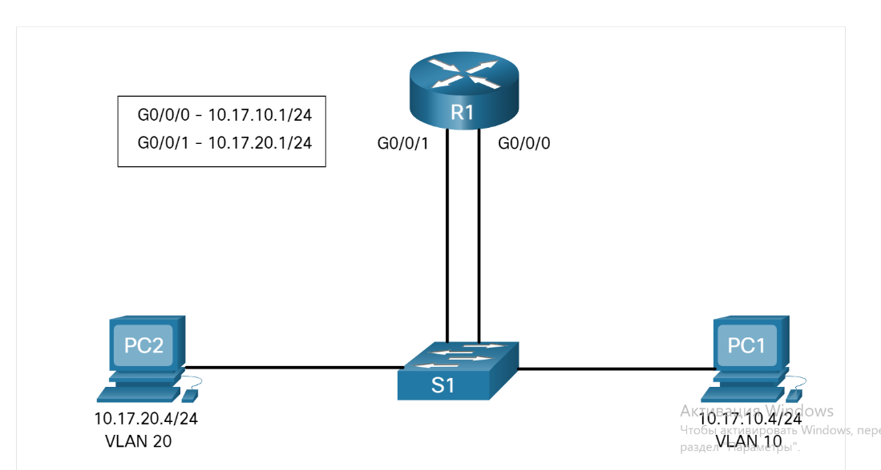

9. How to fix switch access port issues? Assign correct VLAN to access port. Host is incorrectly configured in the wrong subnet.

10. Which scalable method must be implemented in order to provide inter-VLAN routing on a switched network with more than 1000 VLANs?

Routing traffic internally to a Layer 3 switch device

11. According to the topology which statement best describes this type of inter-vlan routing solution? Topology describes a Router-on-a-stick inter-VLAN solution

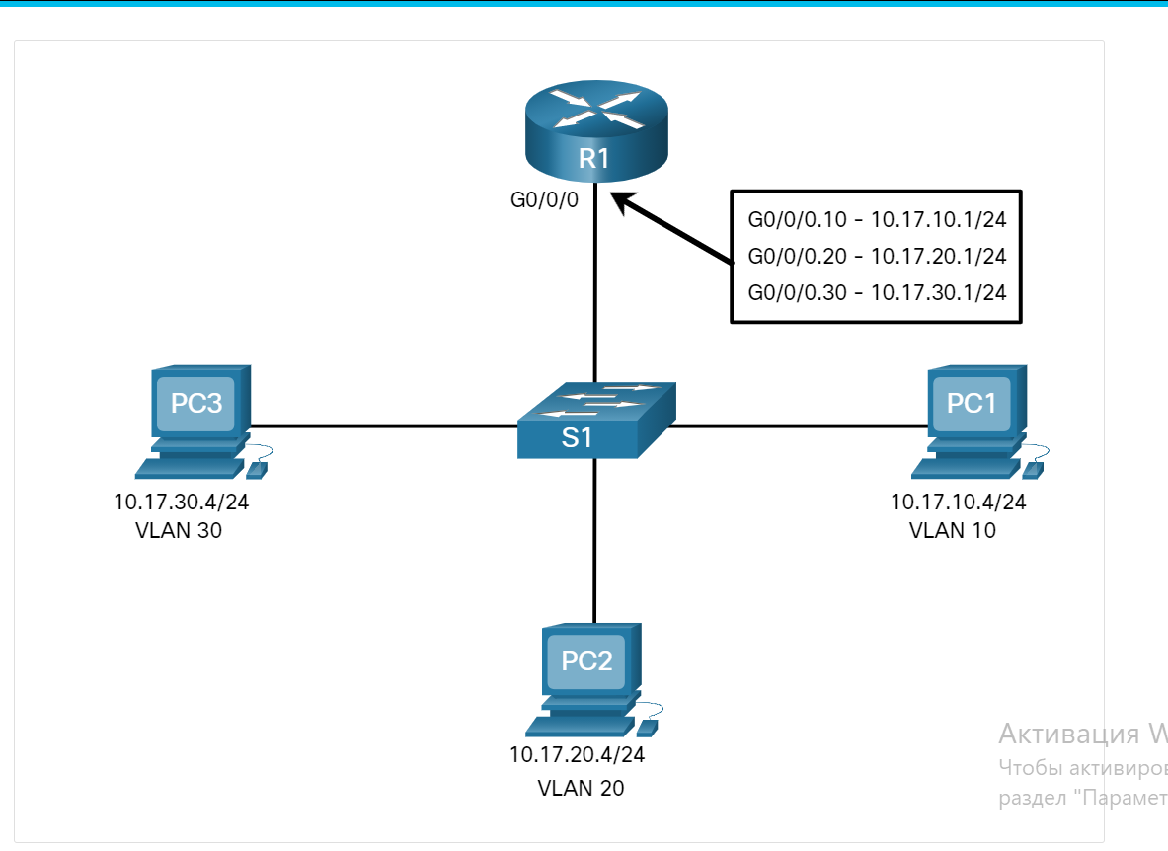

12. Which command helps to verify Missing VLANs issue type? **show interfaces switchport**

13. How many Ethernet physical interfaces are required to configure network traffic routing between multiple VLANs using the “Router-on-a-Stick” method? One

14. How to fix Missing VLANs issue? Ensure host port is assigned to the correct VLAN

15. List the sequence of steps to configure s1 with vlans and trunking. Create and name the VLANs: Create the management interface: Configure access ports: Configure trunking ports.

# 16. Which type of inter-VLAN communication design requires the configuration of multiple subinterfaces? Router-on-a-sick

17. What a the three routing options between Vlans? Legacy Inter-VLAN routing. Router-on-a-Stick. Layer 3 switch using switched virtual interfaces (SVIs)

18. what the first inter-vlan routing solution was based on? On using multiple Ethernet interfaces

19.According to the topology which statement best describes this type of inter-VLAN routing solution (S cenario A)

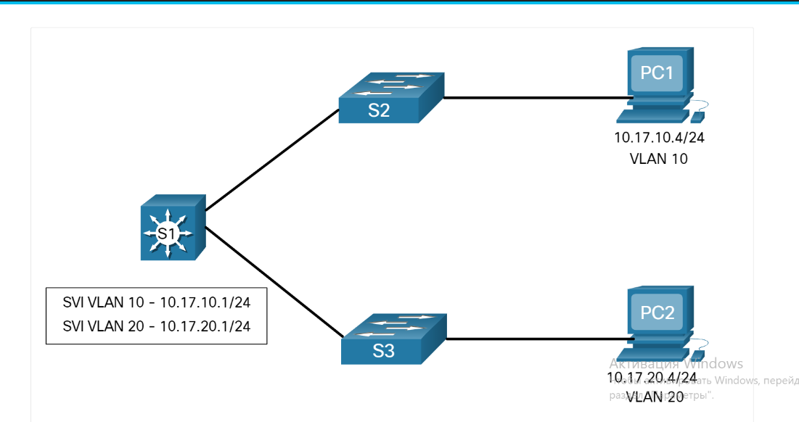

Topology describes a Layer 3 inter-VLAN solution

* 20. How to fix Router Configuration Issues? Router subinterface IPv4 address is incorrectly configured.

Midterm test

1Which one of these IPv6 addresses is a link –local address?

FE80::FB:1D54:839F:F595

2. What is the purpose of frame buffers on a switch? They hold traffic, thus alleviating network congestion.

3. For what reason would a network administrator use the show interface trunk command on a switch? To view the native vlan

4. A technician is configuring a new Cisco 2960 switch. What is the effect of issuing the BranchSw(con

It automatically adjusts the port to allow device connections to use either a straight-through or a crossover cable.

5.IPv6 address consists of ______ bits(enter the number)

128

6. Why should Telnet be replaced with SSH? SSH is encrypted

7. During the boot process, where will the router bootstrap program look for the IOS image by default? flash

8. In which memory type the IOS image is located?

Flash

9. How many collision domains are shown in the diagram above? (type a number in the answer field) Answer: 12 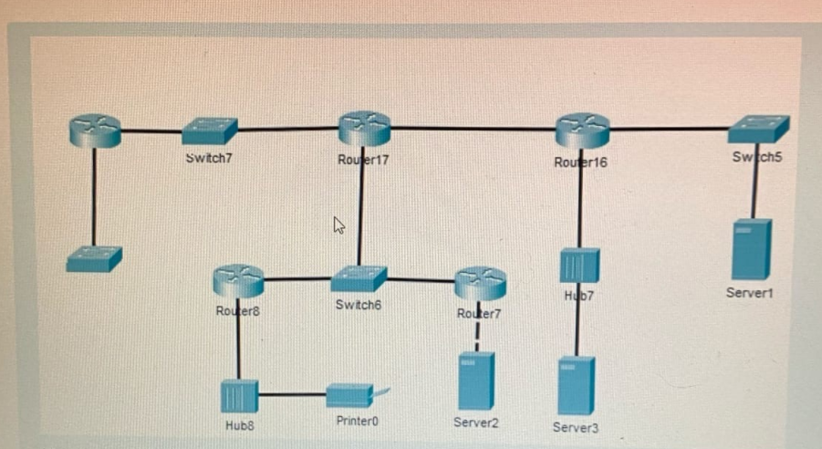

10.Which command helps to verify Switch Trunk Port Issues type?

Show interface trunk

11. What is the main difference between stateless and stateful address configuration? In Stateful DHCPv6 server maintains IPv6 state information

12. How many broadcast domains are shown in the diagram above assuming only the default VLN is configured on the switches? One

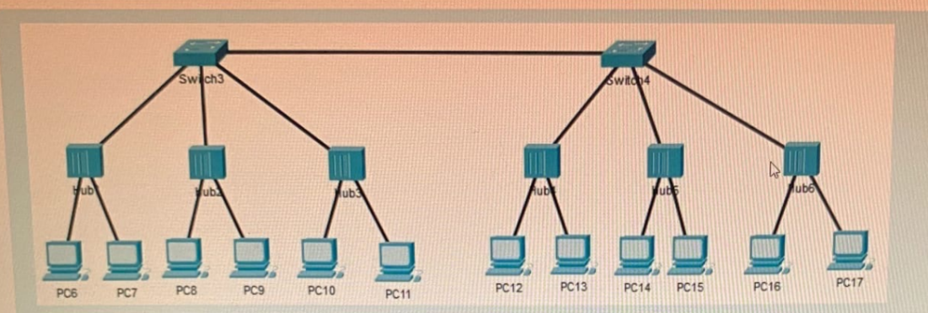

13. Why would a technician enter the command copy running-config startup-config? To save an active configuration to NVRAM

14. What is one way to correct a spanning tree failure?

Manually remove redundant links in the switched network.

15.Which command helps to verify Switch Trunk Port Issues type? Show interfaces trunk

16. Which distinct type of VLAN is used by an administrator to access and configure a switch? Management VLAN

17. How many broadcast domains are shown in the diagram above? Answer: 6

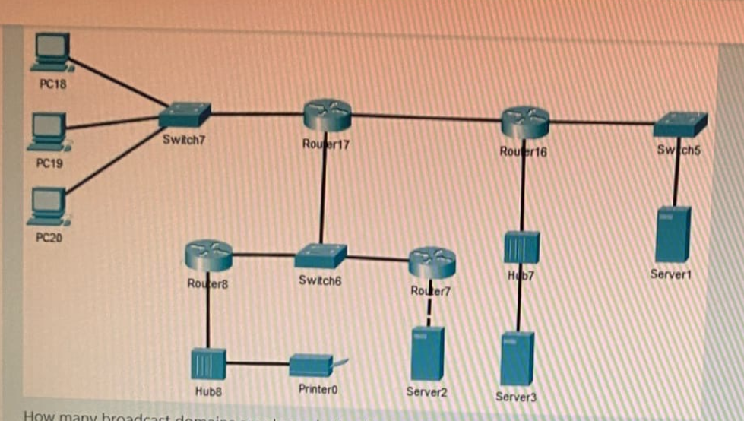

18. In which memory location are the VLAN configurations of normal range VLANs stored on Catalyst switch? flash

19. Interface types cannot be mixed. For example, Fast Ethernet and Gigabit Ethernet cannot be mixed within a single EtherChannel. True

20. STP is a Layer 3 loop prevention protocol for IP network? False

21. What happens during the DHCP Discover step in the four-step DHCPv4 process? DHCP server proposes an IPv4 configuration to the client

22. How to view the EtherChannel Summary Infromation? show etherchannel summary

23. What is the third step in four-step DHCPv4 process to obtain a lease? DHCP Request

24. What address will be first to be assigned to the client with this configuration?

R1(config)# ip dhcp excluded-address 192.168.10.1 192.168.10.9 R1(config)# ip dhcp excluded-address 192.168.10.254 R1(config)# ip dhcp pool LAN-POOL-1 R1(dhcp-config)# network 192.168.10.0 255.255.255.0 R1(dhcp-config)# default-router 192.168.10.1 R1(dhcp-config)# dns-server 192.168.11.5 R1(dhcp-config)# domain-name example.com R1(dhcp-config)# end

192.168.10.10

25. The reported “Input errors” from the **show interfaces** command include the following(choose three):

Runt Frames, Giants, CRC errors.

26. Create the port channel interface with __________________ (what command?) command in interafce range configuration mode. S1(config-if-range)# **channel-group 1 mode active**

27. A technician configures a switch with these commands:

Switch(config)#enable secret class

Switch(config)#line condole 0

Switch(config-line)#password cisco

Switch(config-line)#login

Which of the passwords is prompted?

Warning! Authorized access only!

Password:

Switch>enable

Password:

class

28. Which type of address does a switch use to build the MAC address table? Source MAC address

29. When PVST is running over a switched network, which port state can participate in BPDU frame forwarding based on BPDUs received , but does not forward data frames? Listening

30. What type of the message is used for DHCP Discover? Broadcast

31. What is the main disadvantage of Layer 3 switches? They are more expensive

1. Which configuration command helps to stop DTP negotiation? Switchport nonegotiate
2. Which command displays information about the auto-MDIX setting for a specific interface? Show controllers
3. What is the second step in four-step DHCPv4 process to obtain a lease? DHCP Offer

36. A switch port in the _______ state does not participate in spanning tree and does not forward frames. The disabled state is set when the switch port is administratively disabled.

Disabled

37.Choose the command that displays the general status of the port channel interface. show interfaces port-channel

38. Which address type is automatically created by default on a host interface when no RAs are received? Link-Local Address

39. What are three primary benefits of using VLANs? Security, Improved IT staff efficiency, cost reduction

40. How many collision domains are there in the diagram above? 5

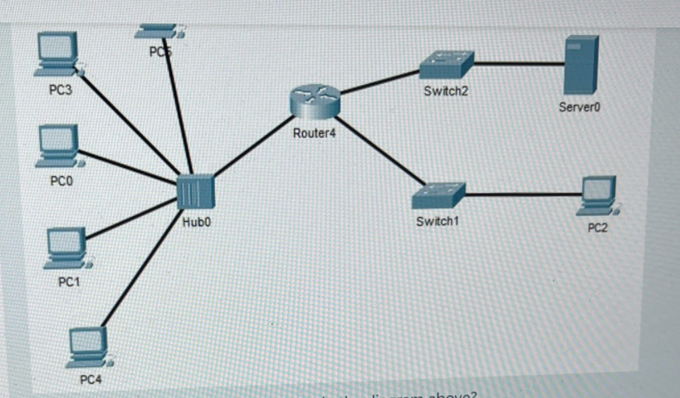

41. Which two DHCPv4 messages are sent by the server in the lease obtaining process? (Choose two.) DHCPACK, DHCPOFFER

42.Locate the Cisco IOS and load it into RAM. This is the main task of:

The boot loader program

43. The default gateway is only used when the host wants to send a packet to a device on another network.

44. What will a Cisco LAN switch do if it receives an incoming frame and the destination MAC address is not listed in the MAC address table? Forward the frame out all ports except the port where the frame is received.

45. How many broadcast domains are there in the diagram above? Answer: 2

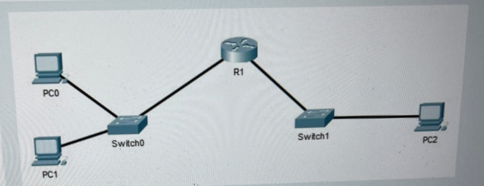

46. Choose the STP versions. PVST+ RSTP

47. An administrator is troubleshooting a switch and wants to verify if it is a root bridge. What command can be used to do this?

Show spanning-tree

48. You need to set up a password that will prevent unauthorized users from telnetting into your router. What series of commands would you use? Acme1(config)#line vty 0

Acme1(config-line)#password acme

Acme1(config-line)#login

49. SLAAC stands for: Stateless Address Autoconfiguration

50. The Cisco IOS returs a help message to indicate that there were not enough characters entered for the command interpreter to recognize the command? Define the help message type. Ambiguous command

51. True or False? Fault-tolerance is benefits of etherchannel technology. True

52.Which type of address does a switch use to build the Mac address table?

source MAC address

53. Which information does a switch use to keep the MAC address table information current?

The source MAC address and the incoming port

54. You configured the password for Telnet access, but when you perform a show running-configuration, the password shows in clear text. Which command should be run? Router(config)#service password-encryption

55. Which option of the **switchport mode** command puts the interface into permanent trunking mode and negotiates to convert the neighboring link into a trunk link. Trunk

56. What type of icmpv6 messages is being sent for duplicate address detection process?

Neighbor Solicitation (NS)

57. Which function is provided to users by the context-sensitive help feature of the Cisco IOS CLI? Displaying a list of all available commands within the current mode

58. Which definition is referred to collisions error type?

Number of messages retransmitted because of an Ethernet collision.

59. Within a production network, what is the purpose of configuring a switch with a default gateway address? The default gateway address is used to forward packets originating from the switch to remote networks.

60. Fault-tolerance is benefit of EtherChannel technology. True

61.When a Cisco switch receives untagged frames on a 802.1Q trunk port, which vlan id is the traffic switched by default?

Native vlan id

62. What does the term “port density” represent for an Ethernet switch? The number of available ports

63. A PC is to access a web server on another network. Which inter-VLAN method will provide the highest bandwidth at Layer 3 and also provide a default gateway for the PC? multilayer switch with routing enabled

64. Which IPv6 address type is automatically created by default on a host interface when no RAs are received? Link-Local address

65.Choose the following guidelines and restrictions are useful for configuring EtherChannel:

EtherChannel support - All Ethernet interfaces must support EtherChannel with no requirement that interfaces be physically contiguous.

VLAN match - All interfaces in the EtherChannel bundle must be assigned to the same VLAN or be configured as a trunk (shown in the figure).

66.

# 67. What is the Purpose of DHCP? To assign IPv4 configuration dynamically

68.What is the purpose of the following command? Router(config )#ip dhcp excluded-address 192.168.1.1 192.168.1.99

To prevent addresses from 192.168.1.1 to 192.168.1.99 from being assigned

Test after midka

1) Choose the answers for question marks.

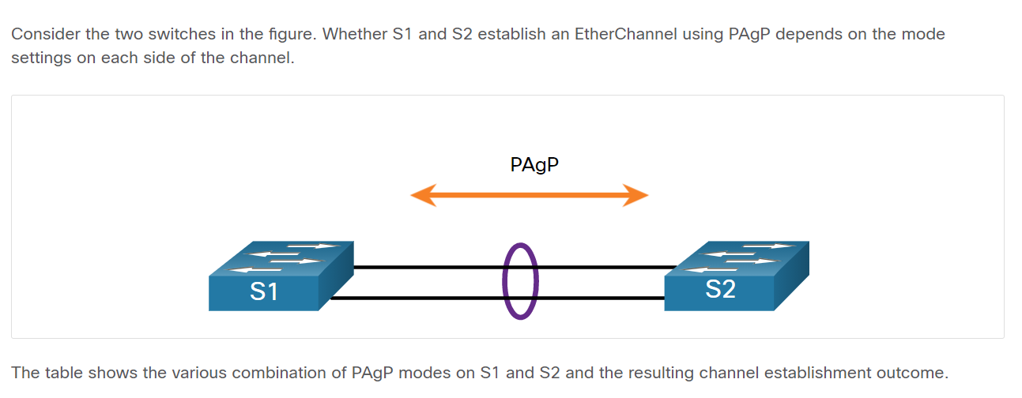

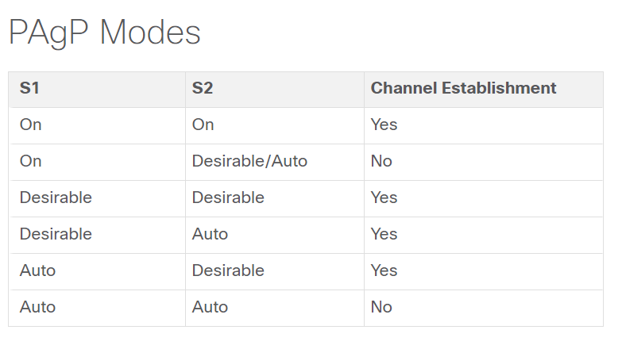

2) How to view the EtherChannel Summary Information? **show etherchannel summary**

3) What will happen if a network administrator puts a port that I spart of an EtherChannel bundle into a different VLAN than the other ports in that bundle? The EtherChannel will fail

4) When a range of ports is being configured for EtherChannel, which mode will configure LACP on a port only if the port receives LACP packets from another device? passive

5)What parameter can be different on ports within an EtherChannel? DTP negotiation settings

6) Which statement is true about EtherChannel? A trunked port can be part of an EtherChannel bundle

7) True or False? PAgP and LACP are both Cisco-proprietary link aggregation protocols. False

8) Will EtherChannel form if one side of the mode (for PAgP) is configured to be an auto mode and the other side is also set to auto mode? The negotiation never starts and the EtherChannel does not form

9)True or False? Fault-tolerance is benefit of EtherChannel technology. True

10) True or False? EtherChannel provides redundancy because the overall link is seen as one logical connection. Additionally, the loss of one physical link within the channel does not create a change in the topology. True

11) Choose the correct command that shows the following configuration

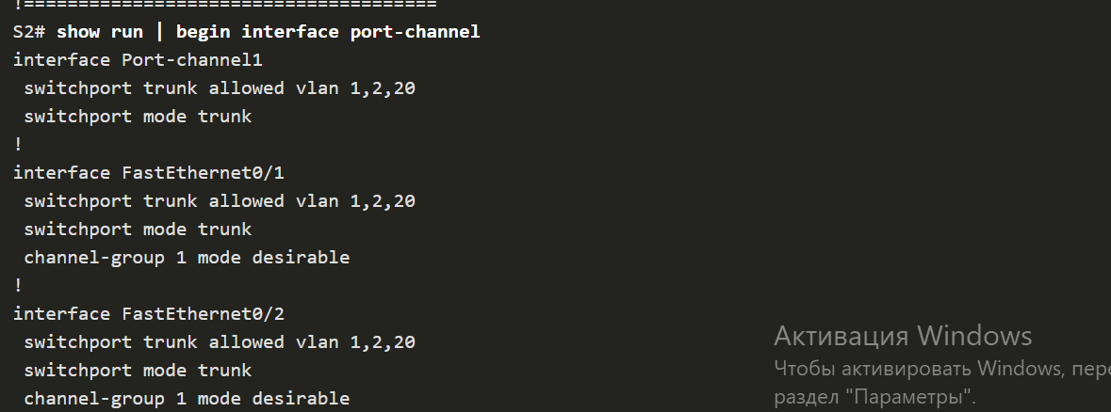

**Show run | begin interface port-channel**

12) Choose common EtherChannel issues

* Assigned ports in the EtherChannel are not part of the same VLAN, or not configured as trunks. Ports with different native VLANs cannot form an EtherChannel.
* Trunking was configured on some of the ports that make up the EtherChannel, but not all of them. It is not recommended that you configure trunking mode on individual ports that make up the EtherChannel. When configuring a trunk on an EtherChannel, verify the trunking mode on the EtherChannel.
* If the allowed range of VLANs is not the same, the ports do not form an EtherChannel even when PAgP is set to the **auto** or **desirable** mode.

13) True or False? PAgP and LACP are used for link aggregation (EtherChannel). DTP is used for automating the creation of trunk links. When an EtherChannel trunks configured, typically EtherChannel (PAgP or LACP) is configured first and then DTP. True

14) Will EtherChannel be formed between S1 and S2? NO 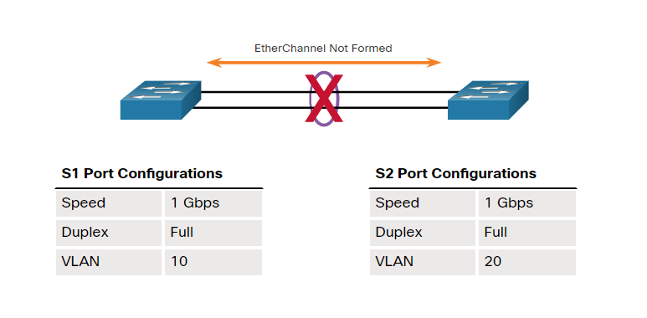

15)Which PAgP interface mode will initiate negotiation with ither interfaces? Desirable

16) Interface types cannot be mixed. For example, Fast Ethernet and Gigabit Ethernet cannot be mixed within a single EtherChannel. True

17) Choose the command that displays the general status of the port channel interface. S1# **show interfaces port-channel**

18) Create the port channel interface with ___________________ (what command?) command in interface range configuration mode. S1(config-if-range)# **channel-group 1 mode active**

19) This PAgP mode places an interface in an active negotiating state in which the interface initiates negotiations with other interfaces by sending PAgP packets. PAgP desirable

Test 10 module

1)What type of device routes traffic to the external networks?

Default-gateway

2)During which HSRP state does an interface waits to hear from the active router? Learn

3)Which FHRP implementation is a Cisco-proprietary protocol that supports IPv4 without load sharing? HSRP

4) Which is a characteristic of the HSRP active state? The router won the election.

5) Which is a characteristic of the HSRP listen state? The router knows the virtual IP address

6)Which of the following options are FHRPs? HSRP GLBP VRRP

7)

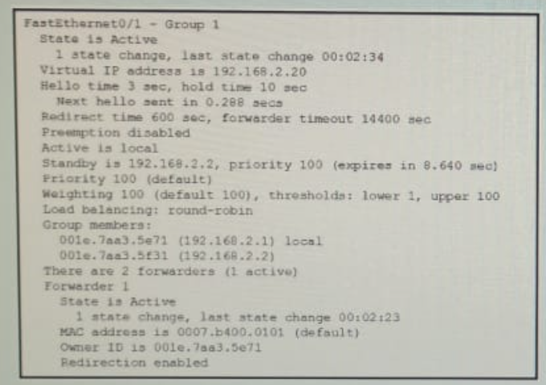

Refer to the exhibit. A network engineer is troubleshooting host connectivity on a LAN that uses a first hop redundancy protocol. Which IPv4 gateway address should be configured on the host? 192.168.2.20

8)

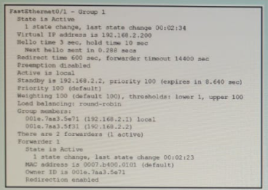

Refer to the exhibit. A network engineer is troubleshooting host connectivity on a LAN that uses a first hop redundancy protocol. Which IPv4 gateway address should be configured on the host? 192.168.2.200

9)What protocol can be configured on gateway routers R1 and R2 that will allow traffic from the internal LAN to be forwarded across to the two gateways without load balancing to the Internet? HSRP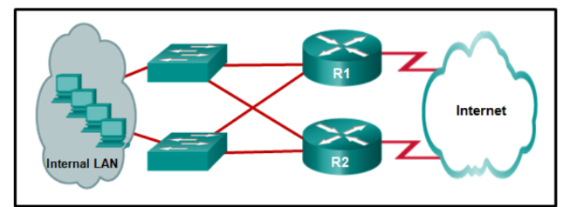

10)What is the range of the HSRP priority? 0 to 255

11) Refer to the exhibit. A network engineer is troubleshooting host connectivity on a LAN that uses a first hop redundancy protocol. Which IPv4 gateway address should be configured on the host? 192.168.2.168

12)

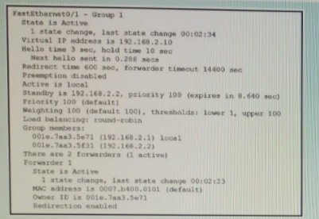

Refer to the exhibit. A network engineer is troubleshooting host connectivity on a LAN that uses a first hop redundancy protocol. Which IPv4 gateway address should be configured on the host? 192.168.2.10

13) What device is assigned the role of alternate default gateway? Standby router

14)Which IPv4 address should be used as the default gateway for the workstations when FHRP is implemented? IPv4 address of the virtual router

15) Which of the following devices can act as the default gateway? layer 3 switch, router

Omardiki

2) Which FHRP implementation is a Cisco-proprietary that supports IPv4 without load sharing? HSRP

3) What is the range of the HSRP priority? 0 to 255

4) How many default gateways can each host receive in a switched network? 1

6)Which FHRP implementation is a nonproprietary and support IPv4 and IPv6 election protocols which has one master router per? VRRPv3

8) Which FHRP implementation is a Cisco-proprietary protocol that supports IPv6 without load balancing? HSRP for IPv6

9) During which HSRP state does an interface sends periodic hello messages and actively participates in the election? Speak

11)What device presents the illusion of a single router to hosts on a LAN segment but actually represents a set of routers working together? Virtual router

12) Which FHRPs are non-proprietary? VRRPv3 and VRRPv2

13) Which command must be enabled to force a new HSRP election process? Standby preempt

Nazeka

13)What does FHRPs provide to the clients? Alternate default-gateway

14) Which FHRPs are non-proprietary? VRRPv2 VRRPv3

15) Which of the following options are FHRPs? HSRP, GLBP, VRRP

LAB 8

1) What is the best way to prevent a VLAN hopping attack? Disable trunk negotiation for trunk ports and statically set nontrunk ports as access ports

2) Which two commands can be used to enable PortFast on a switch? (Choose two.) S1(config-if)# spanning-tree **portfast**. S1(config)# spanning-tree **portfast** default.

3) Which authentication method stores usernames and passwords in the router and is ideal for small networks? Local AAA

4)What does DHCP starvation attack cause? Clients receive IP addresses assignments from a rogue DHCP server.

5) What is a recommended best practice when dealing with the native VLAN? Assign it to an unused VLAN

6) Which of the following mitigation techniques prevents ARP spoofing and ARP poisoning attacks? DAI

7) An attacker changes the MAC address of his device to the MAC address of the default gateway. What type of attack is this? Address spoofing

8) What definition describes Phishing attacks? This attack is the practice of sending emails that appear to be from trusted sources with the goal of gaining personal information or influencing users to do something

9)Which devices are specifically designed for network security? (Choose three) Vpn-enabled router NGFW NAC

10) Authentication is a component of AAA which is responsible for … controlling who is permitted to access the network?

11)What definition describes Data Breach attack? This is an attack in which an organization’s data servers or hosts are compromised to steal confidential information

12) An attacker sends a BPDU message with priority 0. What type of attacks is this? STP attack

13) Where are dynamically learned MAC addresses stored when sticky learning is enabled with the “switchport port-security mac-address sticky” command? RAM

14) What port security violation mode is enabled by default? shutdown

15) After entering command **switchport port-security** on interface configuration mode the following message appears:

**Command rejected: FastEthernet0/1 is a dynamic port.**

What command must be entered to solve this problem? Switchport mode access

16) What is one of the most effective methods to mitigate MAC address table overflow attacks? port security

17) Which OSI Layer is considered to be the weakest link in a network? Layer 2

18)What layer 2 attack is mitigated by disabling Dynamic Trunking Protocol? DHCP spoofing

19) On what switch ports should PortFast be enabled to enhance STP stability? all end-user ports

20)What are two types of switch ports are used on Cisco switches as part of the defense against DHCP spoofing attacks? untrusted port, trusted DHCP port

21) The following configuration commands are entered on an Interface

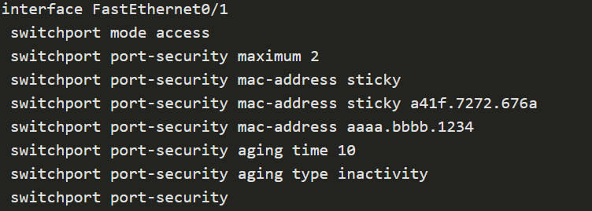

A device with MAC address **A42E.5292.123F** connected to this interface sends a broadcast frame to the network. What will happen when the frame arrives to the Fa0/1 interface? The frame will be discarded, and Syslog message will be sent

22) Which protocols in AAA are responsible for authentication users against a central database of usernames and password? RADIUS, TACACS+

23) An attacker configures a host with the 802.1Q protocol and forms a trunk with the connected switch. What type of attack is this? VLAN hopping

24) At what layer of OSI model is the MAC-address presented? Layer 2

25) What is the main function of switch Port security? to limit the number of permitted MAC addesses on a port

Lab 9 def

1. What IPv4 address is not routed on the Internet? 10.10.10.1
2. Which one of these shared key authentication techniques is considered the most secured standard? WPA2
3. How to start setting up a new interface during configuring the VLAN interface on the WLC? From creating a new interface
4. Match each wireless technology to its most corresponding description. **Bluetooth**-An IEEE 802.15 standard that uses a device-pairing process to communicate over distances up to 100m. It can be found in smart home devices, audio connections, automobiles, and other devices that require a short distance connection. **Satellite Broadband** - Provides network access to remote sites through the use of a directional antenna in a form of a dish. It is usually more expensive and requires a clear line of sight. Typically, it is used by rural homeowners and businesses where cable and DSL are not available. **WiMAX** - an alternative to broadband wired internet connections. It is an **IEEE 802.16** standard that provides high-speed wireless broadband access of up to50 km. **Cellular broadband-** multi-access network carrying both data and voice communications . Current standards are 4G and 5G.
5. What does the stage of identifying the problem mean troubleshooting WLAN issues? Establish a Theory of Probable Causes
6. What method WLANs use to determine how and when to send data on the network? CSMA/CA
7. What you need to check in case of a problem with connecting to the WLAN network of the wireless client in case the computer is working correctly?(Choose three.) Reload drivers as appropriate for the client. Verify that the PC has received an IP address via DHCP. Connect the device to the wired LAN and ping a known IP address.
8. What is the difference between autonomous APs that operate in a home environment and controller-based APs that operate in a corporate environment? Controlled-based APs can be automatically configured and managed by a WLAN controller
9. What is the default for newly created WLANs on the WLC? WPA2 with Advanced Encryption System (AES)
10. Which WLC tab would a network administrator typically use to see a summary view of the most heavily used WLANs including the number of clients using a particular WLAN? Monitor
11. Users on an IEEE 802.11n network are complaining of slow speeds. The network administrator checks the AP and verifies it is operating properly. What can be done to improve the wireless performance in the network? Split the wireless traffic between the 802.11n 2.4 GHz band and the 5 GHz band.
12. Which feature of 802.11n wireless access points allows them to transmit data at faster speeds than previous versions of 802.11 Wi-Fi standards did? MIMO
13. On which page of configuring a WLC you can see the number of rogue access points and clients? The Network Summary page
14. What is the difference between Autonomous APs and Controller –based APs? Autonomous APs are standalone devices configured using a GUI, while Controller-based APs are usually configured using WLC
15. In the context of mobile devices, what does the term tethering involve? connecting a mobile device to another mobile device or computer to share a network connection
16. Which characteristic describes a wireless client operating in active mode? must know the SSID to connect to an AP
17. Match standard names to its corresponding descriptions according to the Institute of Electrical and Electronics Engineers (IEEE) standards. **Wireless Personal-Area Networks (WPAN)** - Uses low powered transmitters for a short-range network, usually 6 to 9 meters. Based on the 802.15 standard and a 2.4-GHz radio frequency. **Wireless LANs (WLAN)** - Uses transmitters to cover a medium-sized network, usually up to 100 meters. Suitable for use in a SOHO and even a campus environment. Based on the 802.11 standard and a 2.4-GHz or 5-GHz radio frequency. **Wireless MANs (WMAN)** - Uses transmitters to provide wireless service over a larger geographic area. Suitable for providing wireless access to a metropolitan city or specific district. Use specific licensed frequencies. **Wireless Wide-Area Networks (WWANs)** - Uses transmitters to provide coverage over an extensive geographic area. Suitable for national and global communications. Use specific licensed frequencies.
18. Match the descriptions of each wireless networks threat to its name. **Interception of data** - Wireless data should be encrypted to prevent it from being read by eavesdroppers. **Wireless intruders** - Unauthorized users attempting to access network resources can be deterred through effective authentication techniques. **Denial of Service (DoS) Attacks** - Access to WLAN services can be compromised either accidentally or maliciously. Various solutions exist depending on the source of the DoS attack. **Rogue APs -** Unauthorized access points installed by a well-intentioned user or for malicious purposes can be detected using management software.
19. Which of the following components are integrated in a wireless home router? (Choose three.) Access point Switch Router
20. What is the term for an AP that openly advertises its service periodically? Passive
21. When a wireless network in a small office is being set up, which type of IP addressing is typically used on the networked devices? private
22. What functionality is required on routers to provide remote workers with VoIP and videoconferencing capabilities? Qos
23. Match each standards organization to its description. **The International Telecommunication Union (ITU)** regulates the allocation of the radio frequency spectrum and satellite orbits. **The IEEE** specifies how a radio frequency is modulated to carry information. It maintains the standards for local and metropolitan area networks (MAN) with the IEEE 802 LAN/MAN family of standards. **The Wi-Fi Alliance** - an association of vendors whose objective is to improve the interoperability of products that are based on the 802.11 standard by certifying vendors for conformance to industry norms and adherence to standards.
24. What type of attack implies that the hacker is positioned in between two legitimate entities in order to read or modify the data that passes between the two parties? MITM
25. A laptop cannot connect to a wireless access point. Which two troubleshooting steps should be taken first? (Choose two.) Ensure that the wireless NIC is enabled. Ensure that the wireless SSID is chosen.
26. A wireless router is displaying the IP address of 192.168.0.1. What could this mean? The wireless router still has the factory default IP address.
27. What is the term for an AP that does not send a beacon, but waits for clients to send probes? Active.
28. How is called the network name in the WLAN defaults setting? SSID
29. AP stands for … Access point
30. Which wireless topology mode is used by two devices to connect in a peer-to-peer network? Ad Hoc
31. In setting up a small office network, the network administrator decides to assign private IP addresses dynamically to workstations and mobile devices. Which feature must be enabled on the company router in order for office devices to access the internet? NAT
32. Why would a technician configure a passphrase for a WLAN on a wireless router? To configure wireless client authentication
33. A customer installs a wireless access point at home in the closet next to the kitchen. The customer mentions that the wireless communication performance seems degraded when the cordless phone or the microwave oven is in use. What is the possible reason for this degradation? the wireless signal is the same radio frequency range as the household devices are in.
34. what is the SNMP protocol used for in networks with the WLC? To monitor the network
35. How to increase the bandwidth of dual band router? Split and traffic

DHCPv4 Server and Client

Dynamic Host Configuration Protocol v4 (DHCPv4) assigns IPv4 addresses and other network configuration information dynamically. Because desktop clients typically make up the bulk of network nodes, DHCPv4 is an extremely useful and timesaving tool for network administrators.

A dedicated DHCPv4 server is scalable and relatively easy to manage. However, in a small branch or SOHO location, a Cisco router can be configured to provide DHCPv4 services without the need for a dedicated server. Cisco IOS software supports an optional, full-featured DHCPv4 server.

The DHCPv4 server dynamically assigns, or leases, an IPv4 address from a pool of addresses for a limited period of time chosen by the server, or until the client no longer needs the address.

Clients lease the information from the server for an administratively defined period. Administrators configure DHCPv4 servers to set the leases to time out at different intervals. The lease is typically anywhere from 24 hours to a week or more. When the lease expires, the client must ask for another address, although the client is typically reassigned the same address.

DHCPv4 server connected to a switch connected to a DHCPv4 client; in step one the DHCPv4 client sends a message; in step two the DHCPv6 server responds with a message

12

DHCPv4 ServerDHCPv4 Client

1. The DHCPv4 lease process begins with the client sending a message requesting the services of a DHCP server.
2. If there is a DHCPv4 server that receives the message, it will respond with an IPv4 address and possible other network configuration information.

7.1.2

DHCPv4 Operation

DHCPv4 works in a client/server mode. When a client communicates with a DHCPv4 server, the server assigns or leases an IPv4 address to that client. The client connects to the network with that leased IPv4 address until the lease expires. The client must contact the DHCP server periodically to extend the lease. This lease mechanism ensures that clients that move or power off do not keep addresses that they no longer need. When a lease expires, the DHCP server returns the address to the pool where it can be reallocated as necessary.

7.1.3

Steps to Obtain a Lease

When the client boots (or otherwise wants to join a network), it begins a four-step process to obtain a lease:

1. DHCP Discover (DHCPDISCOVER)
2. DHCP Offer (DHCPOFFER)
3. DHCP Request (DHCPREQUEST)
4. DHCP Acknowledgment (DHCPACK)

**Step 1. DHCP Discover (DHCPDISCOVER)**

The client starts the process using a broadcast DHCPDISCOVER message with its own MAC address to discover available DHCPv4 servers. Because the client has no valid IPv4 information at bootup, it uses Layer 2 and Layer 3 broadcast addresses to communicate with the server. The purpose of the DHCPDISCOVER message is to find DHCPv4 servers on the network.

**Step 2. DHCP Offer (DHCPOFFER)**

When the DHCPv4 server receives a DHCPDISCOVER message, it reserves an available IPv4 address to lease to the client. The server also creates an ARP entry consisting of the MAC address of the requesting client and the leased IPv4 address of the client. The DHCPv4 server sends the binding DHCPOFFER message to the requesting client.

**Step 3. DHCP Request (DHCPREQUEST)**

When the client receives the DHCPOFFER from the server, it sends back a DHCPREQUEST message. This message is used for both lease origination and lease renewal. When used for lease origination, the DHCPREQUEST serves as a binding acceptance notice to the selected server for the parameters it has offered and an implicit decline to any other servers that may have provided the client a binding offer.

Many enterprise networks use multiple DHCPv4 servers. The DHCPREQUEST message is sent in the form of a broadcast to inform this DHCPv4 server and any other DHCPv4 servers about the accepted offer.

**Step 4. DHCP Acknowledgment (DHCPACK)**

On receiving the DHCPREQUEST message, the server may verify the lease information with an ICMP ping to that address to ensure it is not being used already, it will create a new ARP entry for the client lease, and reply with a DHCPACK message. The DHCPACK message is a duplicate of the DHCPOFFER, except for a change in the message type field. When the client receives the DHCPACK message, it logs the configuration information and may perform an ARP lookup for the assigned address. If there is no reply to the ARP, the client knows that the IPv4 address is valid and starts using it as its own.

Steps to Renew a Lease

Prior to lease expiration, the client begins a two-step process to renew the lease with the DHCPv4 server, as shown in the figure:

**1. DHCP Request (DHCPREQUEST)**

Before the lease expires, the client sends a DHCPREQUEST message directly to the DHCPv4 server that originally offered the IPv4 address. If a DHCPACK is not received within a specified amount of time, the client broadcasts another DHCPREQUEST so that one of the other DHCPv4 servers can extend the lease.

**2. DHCP Acknowledgment (DHCPACK)**

On receiving the DHCPREQUEST message, the server verifies the lease information by returning a DHCPACK.

**Note**: These messages (primarily the DHCPOFFER and DHCPACK) can be sent as unicast or broadcast according to IETF RFC 2131.

The diagram shows the two-step process and exchange of messages between a DHCPv4 client and a DHCPv4 server when the client wants to renew a lease. In step one, the client sends a DCHPREQUEST unicast message to the server saying, in essence, I would like to renew my lease. In step 2, the server responds with a DHCPACK unicast message saying, in essence, your request in acknowledged.

7.1.5

Check Your Understanding - DHCPv4 Concepts

Начало формы

Check your understanding of DHCPv4 concepts by choosing the BEST answer to the following questions.

1. Which message is sent by a DHCPv4 client to initiate the lease obtaining process? **DHCPDISCOVER**
2. Which two DHCPv4 messages are sent by the server in the lease obtaining process? (Choose two.)

* **DCHPOFFER**
* **DHCPACK**

1. Which two DHCPv4 messages are used in the lease renewal process? (Choose two.)

* **DHCPREQUEST**
* **DHCPACK**

Cisco IOS DHCPv4 Server

Now you have a basic understanding of how DHCPv4 works and how it can make your job a bit easier. If you do not have a separate DHCPv4 server, this topic will show you how to configure a Cisco IOS router to act as one. A Cisco router running Cisco IOS software can be configured to act as a DHCPv4 server. The Cisco IOS DHCPv4 server assigns and manages IPv4 addresses from specified address pools within the router to DHCPv4 clients.

The network topology shows a router, functioning as a DHCPv4 server, connecting two LANs together. On the left is network 192.168.10.0/24 consisting of host PC1 connected to switch S1 connected to router R1 at G0/0/0 with an address of .1. On the right is network 192.168.11.0/24 consisting of host PC2 and a DNS server at address 192.168.11.6/24 connected to switch S2 which is connected to R1 at G0/0/1 with an address of .1.

PC2S1PC1S2R1G0/0/0.1192.168.11.0/24192.168.10.0/24G0/0/1.1

DNS Server 192.168.11.5/24**DHCPv4 Server**

7.2.2

Steps to Configure a Cisco IOS DHCPv4 Server

Use the following steps to configure a Cisco IOS DHCPv4 server:

**Step 1**. Exclude IPv4 addresses.  
**Step 2**. Define a DHCPv4 pool name.  
**Step 3**. Configure the DHCPv4 pool.

**Step 1. Exclude IPv4 Addresses**

The router functioning as the DHCPv4 server assigns all IPv4 addresses in a DHCPv4 address pool unless it is configured to exclude specific addresses. Typically, some IPv4 addresses in a pool are assigned to network devices that require static address assignments. Therefore, these IPv4 addresses should not be assigned to other devices. The command syntax to exclude IPv4 addresses is the following:

Router(config)# **ip dhcp excluded-address** *low-address* [*high-address*]

A single address or a range of addresses can be excluded by specifying the *low-address* and *high-address* of the range. Excluded addresses should be those addresses that are assigned to routers, servers, printers, and other devices that have been, or will be, manually configured. You can also enter the command multiple times.

**Step 2. Define a DHCPv4 Pool Name**

Configuring a DHCPv4 server involves defining a pool of addresses to assign.

As shown in the example, the **ip dhcp pool** *pool-name* command creates a pool with the specified name and puts the router in DHCPv4 configuration mode, which is identified by the prompt Router(dhcp-config)#.

The command syntax to define the pool is the following:

Router(config)# **ip dhcp pool** *pool-name*  
Router(dhcp-config)#

**Step 3. Configure the DHCPv4 Pool**

The table lists the tasks to complete the DHCPv4 pool configuration.

The address pool and default gateway router must be configured. Use the **network** statement to define the range of available addresses. Use the **default-router** command to define the default gateway router. Typically, the gateway is the LAN interface of the router closest to the client devices. One gateway is required, but you can list up to eight addresses if there are multiple gateways.

Other DHCPv4 pool commands are optional. For example, the IPv4 address of the DNS server that is available to a DHCPv4 client is configured using the **dns-server** command. The **domain-name** command is used to define the domain name. The duration of the DHCPv4 lease can be changed using the **lease** command. The default lease value is one day. The **netbios-name-server** command is used to define the NetBIOS WINS server.

| TaskIOS CommandDefine the address pool.network network-number [mask | /prefix-length]Define the default router or gateway.default-router address [address2….address8]Define a DNS server.dns-server address [address2…address8]Define the domain name.domain-name domainDefine the duration of the DHCP lease.lease {days[hours[minutes]] | infinite} Define the NetBIOS WINS server.netbios-name-server address [address2…address8] | |
| --- | --- |
| **Task** | **IOS Command** |
| Define the address pool. | **network** *network-number* [*mask* | / *prefix-length*] |
| Define the default router or gateway. | **default-router** address [ *address2….address8*] |
| Define a DNS server. | **dns-server** *address* [ *address2…address8*] |
| Define the domain name. | **domain-name** *domain* |
| Define the duration of the DHCP lease. | **lease** {*days* [*hours* [ *minutes*]] | **infinite**} |
| Define the NetBIOS WINS server. | **netbios-name-server** *address* [ *address2…address8*] |

**Note**: Microsoft recommends not deploying WINS, instead configure DNS for Windows name resolution and decommission WINS.

7.2.3

Configuration Example

The topology for the example configuration is shown in the figure.

The network topology shows a router, functioning as a DHCPv4 server, connecting two LANs together. On the left is network 192.168.10.0/24 consisting of host PC1 connected to switch S1 connected to router R1 at G0/0/0 with an address of .1. On the right is network 192.168.11.0/24 consisting of host PC2 and a DNS server at address 192.168.11.5/24 connected to switch S2 which is connected to R1 at G0/0/1 with an address of .1.

PC2S1PC1S2R1G0/0/0.1192.168.11.0/24192.168.10.0/24G0/0/1.1192.168.11.5/24

DNS Server**DHCPv4 Server**

The example shows the configuration to make R1 a DHCPv4 server for the 192.168.10.0/24 LAN.

R1(config)# **ip dhcp excluded-address 192.168.10.1 192.168.10.9**

R1(config)# **ip dhcp excluded-address 192.168.10.254**

R1(config)# **ip dhcp pool LAN-POOL-1**

R1(dhcp-config)# **network 192.168.10.0 255.255.255.0**

R1(dhcp-config)# **default-router 192.168.10.1**

R1(dhcp-config)# **dns-server 192.168.11.5**

R1(dhcp-config)# **domain-name example.com**

R1(dhcp-config)# **end**

R1#

7.2.4

DHCPv4 Verification Commands

Use the commands in the table to verify that the Cisco IOS DHCPv4 server is operational.

| CommandDescriptionshow running-config | section dhcpDisplays the DHCPv4 commands configured on the router.show ip dhcp bindingDisplays a list of all IPv4 address to MAC address bindings provided by the DHCPv4 service.show ip dhcp server statisticsDisplays count information regarding the number of DHCPv4 messages that have been sent and received. | |
| --- | --- |
| **Command** | **Description** |
| **show running-config | section dhcp** | Displays the DHCPv4 commands configured on the router. |
| **show ip dhcp binding** | Displays a list of all IPv4 address to MAC address bindings provided by the DHCPv4 service. |
| **show ip dhcp server statistics** | Displays count information regarding the number of DHCPv4 messages that have been sent and received. |

7.2.5

Verify DHCPv4 is Operational

The topology shown in the figure is used in the example output. In this example, R1 has been configured to provide DHCPv4 services. PC1 has not been powered up and, therefore, does not have an IP address.

The network topology shows a router, functioning as a DHCPv4 server, connecting two LANs together. On the left is network 192.168.10.0/24 consisting of host PC1 connected to switch S1 which is connected to router R1 at G0/0/0 with an address of .1. On the right is network 192.168.11.0/24 consisting of host PC2 and a DNS server at address 192.168.11.5/24 connected to switch S2 which is connected to R1 at G0/0/1 with an address of .1.

PC2S1PC1S2R1G0/0/0.1192.168.11.0/24192.168.10.0/24G0/0/1.1192.168.11.5/24

DNS Server**DHCPv4 Server**

The output for the following commands assumes PC1 has received its IPv4 addressing information from the DHCPv4 server. You may need to enter ipconfig /renew on a Windows PC to force it to send out a DHCPDISCOVER message.Click each button to see the command output verifying that DHCPv4 is operational.

**Verify the DHCPv4 Configuration**

As shown in the example, the **show running-config | section dhcp** command output displays the DHCPv4 commands configured on R1. The **| section** parameter displays only the commands associated with DHCPv4 configuration.

R1# **show running-config | section dhcp**

ip dhcp excluded-address 192.168.10.1 192.168.10.9

ip dhcp excluded-address 192.168.10.254

ip dhcp pool LAN-POOL-1

network 192.168.10.0 255.255.255.0

default-router 192.168.10.1

dns-server 192.168.11.5

domain-name example.com

**Verify DHCPv4 Bindings**

As shown in the example, the operation of DHCPv4 can be verified using the **show ip dhcp binding** command. This command displays a list of all IPv4 address to MAC address bindings that have been provided by the DHCPv4 service.

R1# **show ip dhcp binding**

Bindings from all pools not associated with VRF:

IP address Client-ID/ Lease expiration Type State Interface

Hardware address/

User name

192.168.10.10 0100.5056.b3ed.d8 Sep 15 2019 8:42 AM Automatic Active GigabitEthernet0/0/0

**Verify DHCPv4 Statistics**

The output of the **show ip dhcp server statistics** is used to verify that messages are being received or sent by the router. This command displays count information regarding the number of DHCPv4 messages that have been sent and received.

R1# **show ip dhcp server statistics**

Memory usage 19465

Address pools 1

Database agents 0

Automatic bindings 2

Manual bindings 0

Expired bindings 0

Malformed messages 0

Secure arp entries 0

Renew messages 0

Workspace timeouts 0

Static routes 0

Relay bindings 0

Relay bindings active 0

Relay bindings terminated 0

Relay bindings selecting 0

Message Received

BOOTREQUEST 0

DHCPDISCOVER 4

DHCPREQUEST 2

DHCPDECLINE 0

DHCPRELEASE 0

DHCPINFORM 0

**Verify DHCPv4 Client Received IPv4 Addressing**

The **ipconfig /all** command, when issued on PC1, displays the TCP/IP parameters, as shown in the example. Because PC1 was connected to the network segment 192.168.10.0/24, it automatically received a DNS suffix, IPv4 address, subnet mask, default gateway, and DNS server address from that pool. No DHCP-specific router interface configuration is required. If a PC is connected to a network segment that has a DHCPv4 pool available, the PC can obtain an IPv4 address from the appropriate pool automatically.

C:\Users\Student> **ipconfig /all**

Windows IP Configuration

Host Name . . . . . . . . . . . . : ciscolab

Primary Dns Suffix . . . . . . . :

Node Type . . . . . . . . . . . . : Hybrid

IP Routing Enabled. . . . . . . . : No

WINS Proxy Enabled. . . . . . . . : No

Ethernet adapter Ethernet0:

Connection-specific DNS Suffix . : example.com

Description . . . . . . . . . . . : Realtek PCIe GBE Family Controller

Physical Address. . . . . . . . . : 00-05-9A-3C-7A-00

DHCP Enabled. . . . . . . . . . . : Yes

Autoconfiguration Enabled . . . . : Yes

IPv4 Address. . . . . . . . . . . : 192.168.10.10

Subnet Mask . . . . . . . . . . . : 255.255.255.0

Lease Obtained . . . . . . . . . : Saturday, September 14, 2019 8:42:22AM

Lease Expires . . . . . . . . . : Sunday, September 15, 2019 8:42:22AM

Default Gateway . . . . . . . . . : 192.168.10.1

DHCP Server . . . . . . . .. . . : 192.168.10.1

DNS Servers . . . . . . . .. . . : 192.168.11.5

Disable the Cisco IOS DHCPv4 Server

The DHCPv4 service is enabled by default. To disable the service, use the **no service dhcp** global configuration mode command. Use the **service dhcp** global configuration mode command to re-enable the DHCPv4 server process, as shown in the example. Enabling the service has no effect if the parameters are not configured.

**Note**: Clearing the DHCP bindings or stopping and restarting the DHCP service may result in duplicate IP addresses being temporarily assigned on the network.

R1(config)# **no service dhcp**

R1(config)# **service dhcp**

R1(config)#

7.2.8

DHCPv4 Relay

In a complex hierarchical network, enterprise servers are usually located centrally. These servers may provide DHCP, DNS, TFTP, and FTP services for the network. Network clients are not typically on the same subnet as those servers. In order to locate the servers and receive services, clients often use broadcast messages.

In the figure, PC1 is attempting to acquire an IPv4 address from a DHCPv4 server using a broadcast message. In this scenario, R1 is not configured as a DHCPv4 server and does not forward the broadcast. Because the DHCPv4 server is located on a different network, PC1 cannot receive an IP address using DHCP. R1 must be configured to relay DHCPv4 messages to the DHCPv4 server.

The network topology shows a router connecting two LANs together. On the left is network 192.168.10.0/24 consisting of host PC1 connected to switch S1 which is connected to router R1 at G0/0/0 with an address of .1. Text underneath PC1 reads; looking for a DHCPv4 server. Text underneath the router reads; I cannot forward broadcasts between networks. On the right is network 192.168.11.0/24 consisting of host PC2, a DNS server at address 192.168.11.5/24, and a DHCPv4 server at address 192.168.11.6/24 all connected to switch S2 which is connected to R1 at G0/0/1 with an address of .1.

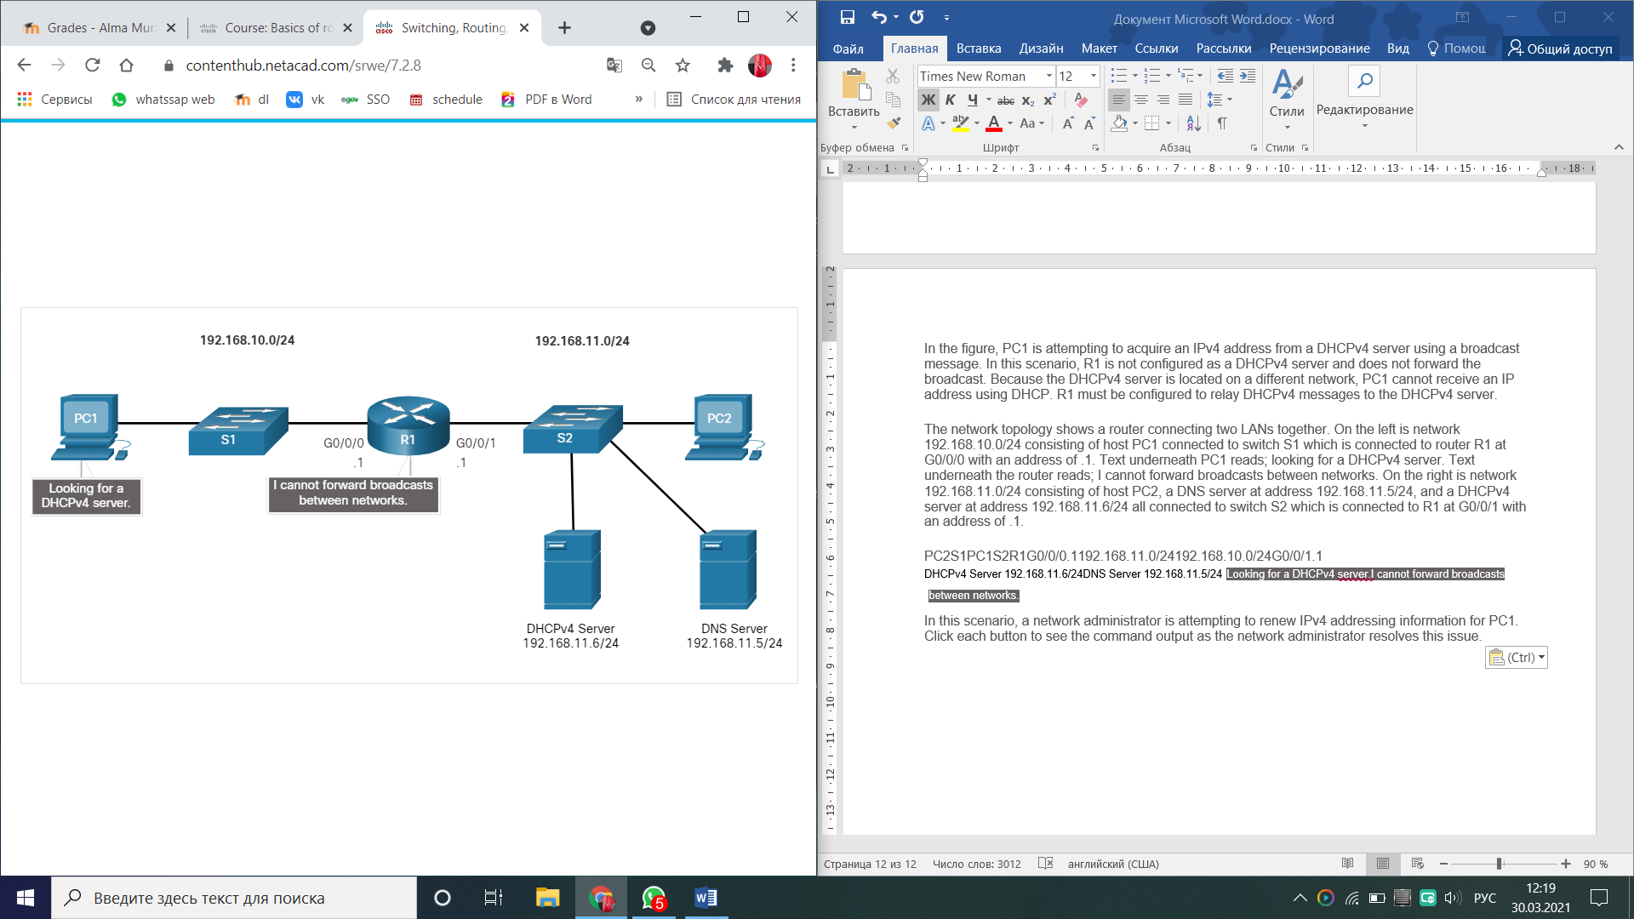

In this scenario, a network administrator is attempting to renew IPv4 addressing information for PC1. Click each button to see the command output as the network administrator resolves this issue.

**ipconfig /release**

PC1 is a Windows computer. The network administrator releases all current IPv4 addressing information using the **ipconfig /release** command. Notice that the IPv4 address is released and no address is shown.

C:\Users\Student> **ipconfig /release**

Windows IP Configuration

Ethernet adapter Ethernet0:

Connection-specific DNS Suffix . :

Default Gateway . . . . . . . . . :

**ipconfig /renew**

Next, the network administrator attempts to renew the IPv4 addressing information with the **ipconfig /renew** command. This command causes PC1 to broadcast a DHCPDISCOVER message. The output shows that PC1 is unable to locate the DHCPv4 server. Because routers do not forward broadcasts, the request is not successful.

The network administrator could add DHCPv4 servers on R1 for all subnets. However, this would create additional cost and administrative overhead.

C:\Users\Student> **ipconfig /renew**

Windows IP Configuration

An error occurred while renewing interface Ethernet0 : unable to connect to your DHCP server. Request has timed out.

**ip helper-address**

A better solution is to configure R1 with the **ip helper-address** address interface configuration command. This will cause R1 to relay DHCPv4 broadcasts to the DHCPv4 server. As shown in the example, the interface on R1 receiving the broadcast from PC1 is configured to relay DHCPv4 address to the DHCPv4 server at 192.168.11.6.

R1(config)# **interface g0/0/0**

R1(config-if)# **ip helper-address 192.168.11.6**

R1(config-if)# **end**

R1#

**show ip interface**

When R1 has been configured as a DHCPv4 relay agent, it accepts broadcast requests for the DHCPv4 service and then forwards those requests as a unicast to the IPv4 address 192.168.11.6. The network administrator can use the **show ip interface** command to verify the configuration.

R1# **show ip interface g0/0/0**

GigabitEthernet0/0/0 is up, line protocol is up

Internet address is 192.168.10.1/24

Broadcast address is 255.255.255.255

Address determined by setup command

MTU is 1500 bytes

Helper address is 192.168.11.6

(output omitted)

**ipconfig /all**

As shown in the output, PC1 is now able to acquire an IPv4 address from the DHCPv4 server as verified with the **ipconfig /all** command.

C:\Users\Student> **ipconfig /all**

Windows IP Configuration

Ethernet adapter Ethernet0:

Connection-specific DNS Suffix . : example.com

IPv4 Address. . . . . . . . . . . : 192.168.10.10

Subnet Mask . . . . . . . . . . . : 255.255.255.0

Default Gateway . . . . . . . . . : 192.168.10.1

## Other Service Broadcasts Relayed

DHCPv4 is not the only service that the router can be configured to relay. By default, the **ip helper-address** command forwards the following eight UDP services:

* Port 37: Time
* Port 49: TACACS
* Port 53: DNS
* Port 67: DHCP/BOOTP server
* Port 68: DHCP/BOOTP client
* Port 69: TFTP
* Port 137: NetBIOS name service
* Port 138: NetBIOS datagram service
* Cisco Router as a DHCPv4 Client
* There are scenarios where you might have access to a DHCP server through your ISP. In these instances, you can configure a Cisco IOS router as a DHCPv4 client. This topic walks you through that process.
* Sometimes, Cisco routers in a small office or home office (SOHO) and branch sites have to be configured as DHCPv4 clients in a similar manner to client computers. The method used depends on the ISP. However, in its simplest configuration, the Ethernet interface is used to connect to a cable or DSL modem.
* To configure an Ethernet interface as a DHCP client, use the **ip address dhcp** interface configuration mode command.
* In the figure, assume that an ISP has been configured to provide select customers with IP addresses from the 209.165.201.0/27 network range after the G0/0/1 interface is configured with the **ip address dhcp** command.
* a router configured as a DHCPv4 client is connected via G0/0/1 to a cable or DSL modem which is then connected to the cloud which is then connected to an ISP router functioning as a DHCPv4 server
* G0/0/1SOHOISP
* **DHCPv4 ClientCable or DSL  
  ModemDHCPv4 Server**
* 7.3.2
* Configuration Example
* To configure an Ethernet interface as a DHCP client, use the **ip address dhcp** interface configuration mode command, as shown in the example. This configuration assumes that the ISP has been configured to provide select customers with IPv4 addressing information.
* SOHO(config)# **interface G0/0/1**
* SOHO(config-if)# **ip address dhcp**
* SOHO(config-if)# **no shutdown**
* Sep 12 10:01:25.773: %DHCP-6-ADDRESS_ASSIGN: Interface GigabitEthernet0/0/1 assigned DHCP address 209.165.201.12, mask 255.255.255.224, hostname SOHO
* The **show ip interface g0/0/1** command confirms that the interface is up and that the address was allocated by a DHCPv4 server.
* SOHO# **show ip interface g0/0/1**
* GigabitEthernet0/0/1 is up, line protocol is up
* Internet address is 209.165.201.12/27
* Broadcast address is 255.255.255.255
* Address determined by DHCP
* (output omitted)
* 7.3.3
* Home Router as a DHCPv4 Client
* Home routers are typically already set to receive IPv4 addressing information automatically from the ISP. This is so that customers can easily set up the router and connect to the internet.
* For example, the figure shows the default WAN setup page for a Packet Tracer wireless router. Notice that the internet connection type is set to **Automatic Configuration - DHCP**. This selection is used when the router is connected to a DSL or cable modem and acts as a DHCPv4 client, requesting an IPv4 address from the ISP.
* Various manufacturers of home routers will have a similar setup.
* 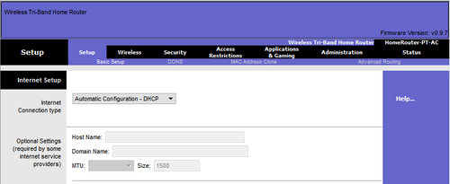

**DHCPv4 Concepts**

The DHCPv4 server dynamically assigns, or leases, an IPv4 address to a client from a pool of addresses for a limited period of time chosen by the server, or until the client no longer needs the address. The DHCPv4 lease process begins with the client sending message requesting the services of a DHCP server. If there is a DHCPv4 server that receives the message it will respond with an IPv4 address and possible other network configuration information. The client must contact the DHCP server periodically to extend the lease. This lease mechanism ensures that clients that move or power off do not keep addresses that they no longer need. When the client boots (or otherwise wants to join a network), it begins a four-step process to obtain a lease: DHCPDISCOVER, then DHCPOFFER, then DHCPREQUEST, and finally DHCPACK. Prior to lease expiration, the client begins a two-step process to renew the lease with the DHCPv4 server: DHCPREQUEST then DHCPACK.

**Configure a Cisco IOS DHCPv4 Server**

A Cisco router running Cisco IOS software can be configured to act as a DHCPv4 server. Use the following steps to configure a Cisco IOS DHCPv4 server: exclude IPv4 addresses, define a DHCPv4 pool name, and configure the DHCPv4 pool. Verify your configuration using the **show running-config | section dhcp**, **show ip dhcp binding**, and **show ip dhcp server statistics** commands. The DHCPv4 service is enabled, by default. To disable the service, use the **no service dhcp** global configuration mode command. In a complex hierarchical network, enterprise servers are usually located centrally. These servers may provide DHCP, DNS, TFTP, and FTP services for the network. Network clients are not typically on the same subnet as those servers. In order to locate the servers and receive services, clients often use broadcast messages. A PC is attempting to acquire an IPv4 address from a DHCPv4 server using a broadcast message. If the router is not configured as a DHCPv4 server, it will not forward the broadcast. If the DHCPv4 server is located on a different network, the PC cannot receive an IP address using DHCP. The router must be configured to relay DHCPv4 messages to the DHCPv4 server. The network administrator releases all current IPv4 addressing information using the **ipconfig /release** command. Next, the network administrator attempts to renew the IPv4 addressing information with the **ipconfig /renew** command. A better solution is to configure R1 with the **ip helper-address** *address interface* configuration command. The network administrator can use the **show ip interface** command to verify the configuration. The PC is now able to acquire an IPv4 address from the DHCPv4 server as verified with the **ipconfig /all** command. By default, the **ip helper-address** command forwards the following eight UDP services:

* Port 37: Time
* Port 49: TACACS
* Port 53: DNS
* Port 67: DHCP/BOOTP server
* Port 68: DHCP/BOOTP client
* Port 69: TFTP
* Port 137: NetBIOS name service
* Port 138: NetBIOS datagram service

**Configure a DHCPv4 Client**

The Ethernet interface is used to connect to a cable or DSL modem. To configure an Ethernet interface as a DHCP client, use the **ip address dhcp interface** configuration mode command. Home routers are typically already set to receive IPv4 addressing information automatically from the ISP. The internet connection type is set to Automatic Configuration - DHCP. This selection is used when the router is connected to a DSL or cable modem and acts as a DHCPv4 client, requesting an IPv4 address from the ISP.

## Module Quiz - DHCPv4

Начало формы

1. A DHCP-enabled client PC has just booted. During which two steps will the client PC use broadcast messages when communicating with a DHCP server? (Choose two.)

* **DHCPDISCOVER**
* **DHCPREQUEST**

1. An administrator issues the commands:

Router(config)# **interface g0/1**  
Router(config-if)# **ip address dhcp**

What is the administrator trying to achieve? **configuring the router to obtain IP parameters from a DHCPv4 server**

1. When a client is requesting an initial address lease from a DHCP server, why is the DHCPREQUEST message sent as a broadcast? **The client may have received offers from multiple servers, and the broadcast serves to implicitly decline those other offers.**
2. Which DHCP IPv4 message contains the following information?

Destination address: 255.255.255.255  
Client IPv4 address: 0.0.0.0  
Default gateway address: 0.0.0.0  
Subnet mask: 0.0.0.0

**DHCPDISCOVER**

1. What kind of message is sent by a DHCPv4 client requesting an IP address? **DHCPDISCOVER**
2. As a DHCPv4 client lease is about to expire, what is the message that the client sends the DHCP server? **DHCPREQUEST**
3. What is the destination IP address when an IPv4 host sends a DHCPDISCOVER message? **255.255.255.255**
4. If more than one DHCP server is available on the local network, in which order will DHCP messages be sent between a host and a DHCP server? **discover, offer, request, acknowledgment**
5. What is the most likely scenario in which the WAN interface of a router would be configured as a DHCP client to be assigned a dynamic IP address from an ISP? **It is a SOHO or home broadband router.**
6. Which is a DHCPv4 address allocation method that assigns IPv4 addresses for a limited lease period? **dynamic allocation**
7. What is the reason why the DHCPREQUEST message is sent as a broadcast during the DHCPv4 process? **to notify other DHCP servers on the subnet that the IP address was leased**
8. How is a DHCPDISCOVER transmitted on a network to reach a DHCP server**? A DHCPDISCOVER message is sent with the broadcast IP address as the destination address**
9. Which destination IPv4 address does a DHCPv4 client use to send the initial DHCP Discover packet when the client is looking for a DHCP server? **255.255.255.255**
10. Under which two circumstances would a router usually be configured as a DHCPv4 client? (Choose two.)

* **The router is intended to be used as a SOHO gateway.**
* **This is an ISP requirement.**

1. Which address does a DHCPv4 server target when sending a DHCPOFFER message to a client that makes an address request? **client hardware address**
2. What happens during the DHCP Offer step in the four-step DHCPv4 process? **DHCP server proposes an IPv4 configuration to the client**
3. What type of the message is used for DHCP Discover? **Broadcast**
4. What happens during the DHCP Discover step in the four-step DHCPv4 process? **A client initiates the DHCP server search process**
5. What happens during the DHCP Acknowledgment step in the four-step DHCPv4 process? **DHCP server confirms the IPv4 assignment by the client**
6. What happens during the DHCP Request step in the four-step DHCPv4 process? **DHCP client accepts the proposed by the server IPv4 configuration**
7. In which mode does DHCPv4 operate? **Client-server**
8. What is the purpose of DHCPv4? **To assign IPv4 configuration dynamically**
9. What is the second step in four-step DHCPv4 process to obtain a lease? **DHCP Offer**
10. What address will be first to be assigned to the client with this configuration? R1(config)# ip excluded-address 192. 168. 10.1 192. 168. 10.9 R1(config) #ip dhcp excluded-address 192. 168. 10.254 R1(config)# ip dhcp pool LAN-POOL-1 R1(dhcp-config)# network 192. 168. 10.0 255. 255. 255. 0 R1(dhcp-config)= default-router 192. 168. 10.1 R1(dhcp-config)# dns server 192. 168. 11.5 R1(dhcp-config)# domain-name example.com R1(dhcp-config)# end **192.168.10.10**
11. What is the third step in four-step DHCPv4 process to obtain a lease? **DHCP REQUEST**
12. What is the purpose of DHCPv4 Relay?
13. DHCP stands for: **Dynamic Host Configuration Protocol**
14. What is the purpose of the following command? Router(config)* ip dhcp excluded-address 192. 168. 1.1 192. 168. 1.99 **from… to**

Which address type is automatically created by default on a host interface when no RAs are received? link-local address

Which method best describes stateless DHCP? SLAAC with stateless DHCPv6 Server

Which two ICMPv6 messages are used in the SLAAC process? (Choose two.) Router Solicitation (RS) , Router Advertisements (RA)

Which command must be configured on a router to enable it to join the IPv6 all-routers multicast address ff02::2? **ipv6 unicast-routing**

What are the flag settings when a host should use the SLAAC only option? A=1, M=0, O=0

Which ICMPv6 message is sent by a host in an attempt to locate an online IPv6enabled router to obtain IPv6 addressing information? Router Solicitation (RS)

What method is used by a host to verify an IPv6 address is unique on the local network before assigning that address to an interface? DAD

What UDP port do DHCPv6 clients use to send DHCPv6 messages? 547

What DHCPv6 message does a host send to look for a DHCPv6 server? SOLICIT

What DHCPv6 message does a host send to the DHCPv6 server if it is using stateful DHCPv6? REQUEST

What flag settings combination is used for stateless DHCP? A=1, M=0, O=1

What M flag setting indicates that stateful DHCPv6 is used? M=1

Which three DHCPv6 roles can a router perform? (Choose all that apply.) DHCPv6 client , DHCPv6 relay agent , DHCPv6 server

Which command is not configured in stateless DHCPv6? **address prefix** ipv6-address/prefix

An IPv6-enabled router is to acquire its IPv6 GUA from another IPv6 router using SLAAC. Which interface configuration command should be configured on the client router? **ipv6 address autoconfig**

A router is to provide DHCPv6 server services. Which command should be configured on the client facing interface? **ipv6 dhcp server** POOL-NAME

An IPv6-enabled router is to acquire its IPv6 GUA from a DHCPv6 server. Which interface configuration command should be configured on client router? **ipv6 address dhcp**

Which DHCPv6 verification command would display the link-local and GUA assigned address for each active client? **show ipv6 dhcp binding**

Which command is configured on the client LAN interface of the DHCPv6 relay agent? **ipv6 dhcp relay destination**

How does an IPv6 client ensure that it has a unique address after it configures its IPv6 address using the SLAAC allocation method? It sends an ICMPv6 Neighbor Solicitation message with the IPv6 address as the target IPv6 address.

Which method would an IPv6-enabled host using SLAAC employ to learn the address of the default gateway? router advertisements that are received from the link router

What two methods can be used to generate an interface ID by an IPv6 host that is using SLAAC? (Choose two.) random generation , EUI-64

A client is using SLAAC to obtain an IPv6 address for its interface. After an address has been generated and applied to the interface, what must the client do before it can begin to use this IPv6 address? It must send an ICMPv6 Neighbor Solicitation message to ensure that the address is not already in use on the network.

Which command should be configured on a router interface to set the router as a stateful DHCPv6 client? **ipv6 address dhcp**

What message informs IPv6 enabled interfaces to use stateful DHCPv6 for obtaining an IPv6 address? the ICMPv6 Router Advertisement

Which destination IP address is used when an IPv6 host sends a DHCPv6 SOLICIT message to locate a DHCPv6 server? FF02::1:2

In which alternative to DHCPv6 does a router dynamically provide IPv6 configuration information to hosts? SLAAC

A company implements the stateless DHCPv6 method for configuring IPv6 addresses on employee workstations. After a workstation receives messages from multiple DHCPv6 servers to indicate their availability for DHCPv6 service, which message does it send to a server for configuration information? DHCPv6 INFORMATION-REQUEST

What process is used in ICMPv6 for a host to verify that an IPv6 address is unique before configuring it on an interface? DAD

What are two characteristics of the SLAAC method for IPv6 address configuration? (Choose two.) IPv6 addressing is dynamically assigned to clients through the use of ICMPv6.

After booting, a client receives an ICMPv6 RA message with the M flag set to 0 and the O flag set to 1. What does this indicate? The client should automatically configure an IPv6 address and then contact a DHCPv6 server for more information.

A network administrator is entering the command **ipv6 unicast-routing** to start configuring DHCPv6 operation on a router. Which statement describes the function of this command?

It is required for sending ICMPv6 RA messages.

What type of device routes traffic destined to network segments beyond the source network segment for which the sending node may not have explicit routing information? default gateway

What device presents the illusion of a single router to hosts on a LAN segment but actually represents a set of routers working together? virtual router

What device is part of a virtual router group assigned the role of alternate default gateway? standby router

What device that is part of a virtual router group assigned to the role of default gateway? forwarding router

Which FHRPs are Cisco-proprietary? (Choose two.)

HSRP , HSRP for IPv6

What is the purpose of HSRP? It provides a continuous network connection when a router fails.

Which nonproprietary protocol provides router redundancy for a group of routers which support IPv4 LANs? VRRPv2

A network administrator is analyzing first-hop router redundancy protocols. What is a characteristic of VRRPv3? It supports IPv6 and IPv4 addressing.

What is a potential disadvantage when implementing HSRP as compared to GLBP? HSRP does not provide load balancing with multiple active routers.

A network engineer is configuring a LAN with a redundant first hop to make better use of the available network resources. Which protocol should the engineer implement? GLBP

When first hop redundancy protocols are used, which two items will be shared by a set of routers that are presenting the illusion of being a single router? (Choose two.) MAC address , IP address

In FHRP terminology, what represents a set of routers that present the illusion of a single router to hosts? virtual router

A user needs to add redundancy to the routers in a company. What are the three options the user can use? (Choose three.) HSRP , VRRP , GLBP

Which two protocols provide gateway redundancy at Layer 3? (Choose two.) HSRP , VRRP

A network administrator is overseeing the implementation of first hop redundancy protocols. Which two protocols are Cisco proprietary? (Choose two.) GLBP , HSRP

Which statement describes a characteristic of GLBP? It provides automatic rerouting if any router in the group fails.

.

A network administrator is analyzing the features that are supported by different first-hop router redundancy protocols. Which statement is a feature that is associated with GLBP? GLBP allows load balancing between routers.

What is the default HSRP priority? 100

True or False? If a router with a higher HSRP priority joins the network, it will take over the active router roll from an existing active router which has a lower priority. False

During which HSRP state does an interface begin sending periodic hello messages? Speak

Which is a characteristic of the HSRP learn state? the router has not determined the virtual IP address

Which attack encrypts the data on hosts in an attempt to extract a monetary payment from the victim? Ransomware

Which devices are specifically designed for network security? (Choose three) VPN-enabled router , NGFW , NAC

Which device monitors SMTP traffic to block threats and encrypt outgoing messages to prevent data loss? ESA

Which device monitors HTTP traffic to block access to risky sites and encrypt outgoing messages? WSA

Which AAA component is responsible for collecting and reporting usage data for auditing and billing purposes? Accounting

Which AAA component is responsible for controlling who is permitted to access the network? Authentication

Which AAA component is responsible for determining what the user can access? Authorization

In an 802.1X implementation, which device is responsible for relaying responses? Authenticator

Which of the following mitigation techniques are used to protect Layer 3 through Layer 7 of the OSI Model? (Choose three.) VPN , Firewalls , IPS devices

Which of the following mitigation techniques prevents many types of attacks including MAC address table overflow and DHCP starvation attacks? Port security

Which of the following mitigation techniques prevents MAC and IP address spoofing? IPSG

Which of the following mitigation techniques prevents ARP spoofing and ARP poisoning attacks? DAI

Which of the following mitigation techniques prevents DHCP starvation and DHCP spoofing attacks? DHCP snooping

What is the behavior of a switch as a result of a successful MAC address table attack? The switch will forward all received frames to all other ports within the VLAN.

What would be the primary reason a threat actor would launch a MAC address overflow attack? So that the threat actor can see frames that are destined for other devices.

What mitigation technique must be implemented to prevent MAC address overflow attacks? Port security

A threat actor changes the MAC address of the threat actor's device to the MAC address of the default gateway. What type of attack is this? Address spoofing

A threat actor sends a BPDU message with priority 0. What type of attack is this? STP attack

A threat actor leases all the available IP addresses on a subnet. What type of attack is this?

DHCP starvation

A threat actor sends a message that causes all other devices to believe the MAC address of the threat actor's device is the default gateway. What type of attack is this? ARP spoofing

A threat actor configures a host with the 802.1Q protocol and forms a trunk with the connected switch. What type of attack is this? VLAN spoofing

A threat actor discovers the IOS version and IP addresses of the local switch. What type of attack is this? CDP reconnaissance

What two protocols are supported on Cisco devices for AAA communications? (Choose two.) RADIUS , TACACS+

Which service is enabled on a Cisco router by default that can reveal significant information about the router and potentially make it more vulnerable to attack? CDP

When security is a concern, which OSI Layer is considered to be the weakest link in a network system?​ Layer 2

Which Layer 2 attack will result in a switch flooding incoming frames to all ports? MAC address overflow

Why is authentication with AAA preferred over a local database method? It provides a fallback authentication method if the administrator forgets the username or password.

In a server-based AAA implementation, which protocol will allow the router to successfully communicate with the AAA server?  RADIUS

Which Cisco solution helps prevent MAC and IP address spoofing attacks? IP Source Guard

What is the purpose of AAA accounting?   to collect and report application usage

Which Layer 2 attack will result in legitimate users not getting valid IP addresses? DHCP starvation

Which three Cisco products focus on endpoint security solutions? (Choose three.) Email Security Appliance , Web Security Appliance , NAC Appliance

True or False? In the 802.1X standard, the client attempting to access the network is referred to as the supplicant. True

What is involved in an IP address spoofing attack? A legitimate network IP address is hijacked by a rogue node.

What three services are provided by the AAA framework? (Choose three.) accounting , authentication , authorization

Because of implemented security controls, a user can only access a server with FTP. Which AAA component accomplishes this? authorization

What mitigation plan is best for thwarting a DoS attack that is creating a MAC address table overflow? Enable port security.

What will I learn to do in this module?

**Module Title**: SLAAC and DHCPv6

**Module Objective**: Configure dynamic address allocation in IPv6 networks.

| Table caption | |
| --- | --- |
| **Topic Title** | **Topic Objective** |
| **IPv6 Global Unicast Address Assignment** | Explain how an IPv6 host can acquire its IPv6 configuration. |
| **SLAAC** | Explain the operation of SLAAC. |
| **DHCPv6** | Explain the operation of DHCPv6. |
| **Configure DHCPv6 Server** | Configure a stateful and stateless DHCPv6 server. |

## IPv6 Host Configuration

First things first. To use either stateless address autoconfiguration (SLAAC) or DHCPv6, you should review global unicast addresses (GUAs) and link-local addresses (LLAs). This topic covers both.

On a router, an IPv6 global unicast address (GUA) is manually configured using the **ipv6 address** ipv6-address**/**prefix-length interface configuration command.

A Windows host can also be manually configured with an IPv6 GUA address configuration, as shown in the figure.

shows the Internet Protocol Version 6 properties window and static IPv6 address and DNS server settings

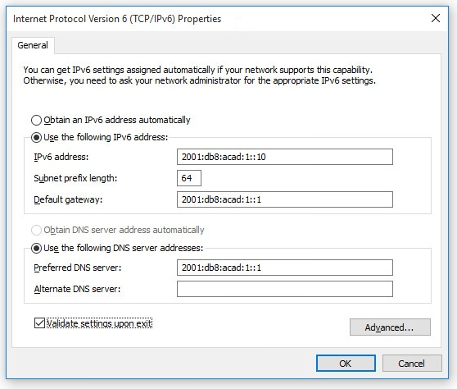

Manually entering an IPv6 GUA can be time consuming and somewhat error prone. Therefore, most Windows host are enabled to dynamically acquire an IPv6 GUA configuration, as shown in the figure.

shows the Internet Protocol Version 6 properties window and automatic DHCP IPv6 address and DNS server settings

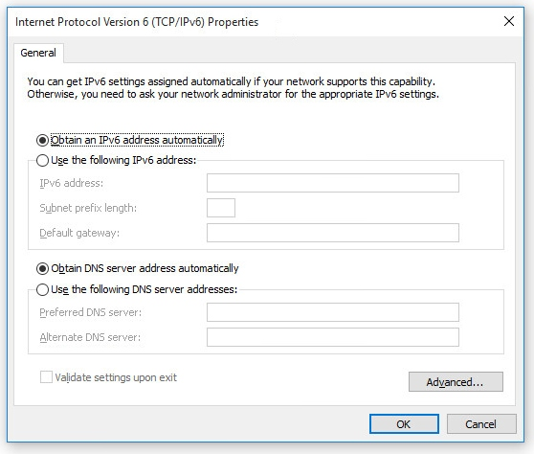

8.1.2

## IPv6 Host Link-Local Address

When automatic IPv6 addressing is selected, the host will attempt to automatically obtain and configure IPv6 address information on the interface. The host will use one of three methods defined by the Internet Control Message Protocol version 6 (ICMPv6) Router Advertisement (RA) message received on the interface. An IPv6 router that is on the same link as the host sends out RA messages that suggest to the hosts how to obtain their IPv6 addressing information. The IPv6 link-local address is automatically created by the host when it boots and the Ethernet interface is active. The example **ipconfig** output shows an automatically generated link-local address (LLA) on an interface.

In the figure, notice that the interface does not have an IPv6 GUA. The reason is because, in this example, the network segment does not have a router to provide network configuration instructions for the host or the host has not been configured with at static IPv6 address.

**Note:** Host operating systems will at times show a link-local address appended with a "%" and a number. This is known as a Zone ID or Scope ID. It is used by the OS to associate the LLA with a specific interface.

C:\PC1> **ipconfig**

Windows IP Configuration

Ethernet adapter Ethernet0:

Connection-specific DNS Suffix . :

IPv6 Address. . . . . . . . . . . :

Link-local IPv6 Address . . . . . : fe80::fb:1d54:839f:f595%21

IPv4 Address. . . . . . . . . . . : 169.254.202.140

Subnet Mask . . . . . . . . . . . : 255.255.0.0

Default Gateway . . . . . . . . . :

C:\PC1>

8.1.3

## IPv6 GUA Assignment

IPv6 was designed to simplify how a host can acquire its IPv6 configuration. By default, an IPv6-enabled router advertises its IPv6 information. This allows a host to dynamically create or acquire its IPv6 configuration.

The IPv6 GUA can be assigned dynamically using stateless and stateful services, as shown in the figure.

All stateless and stateful methods in this module use ICMPv6 RA messages to suggest to the host how to create or acquire its IPv6 configuration. Although host operating systems follow the suggestion of the RA, the actual decision is ultimately up to the host.

an inverted tree diagram starts with Dynamic GUA Assignment, splits into two: stateless and stateful. Stateless splits into SLAAC and SLAAC with DHCPv6 server and stateful leades to a DHCPv6 stateful server

**Dynamic GUA AssignmentStateless**

* No device is tracking the assignment of IPv6 addresses.

**Stateful**

* A DHCPv6 server is managing the assignment of IPv6 addresses.

**SLAAC Only**

* Router sends Router Advertisement (RA) messages providing all IPv6 addressing information (i.e., network prefix, prefix-length, and default gateway information).
* Hosts use the RA information exclusively for all their addressing including creating their own GUA.

**SLAAC with DHCP server**  
**(Stateless DHCPv6)**

* Router RA messages provide IPv6 configuration information to hosts and inform them to contact a stateless DHCPv6 server for additional configuration information.
* Hosts use the RA information to create their own unique GUA and get additional information from a DHCPv6 server.

**DHCPv6 Server**  
**(Stateful DHCPv6)**

* Router RA messages inform hosts to contact a stateful DHCPv6 server or DHCPv6-enabled router for all IPv6 configuration information, except the default gateway address.
* Hosts contact a DHCPv6 server to acquire all of their IPv6 addressing information.
* Host obtains default gateway information from router RA messages.

8.1.4

## Three RA Message Flags

The decision of how a client will obtain an IPv6 GUA depends on the settings within the RA message.

An ICMPv6 RA message includes three flags to identify the dynamic options available to a host, as follows:

* **A flag** - This is the Address Autoconfiguration flag. Use Stateless Address Autoconfiguration (SLAAC) to create an IPv6 GUA.
* **O flag** - This is the Other Configuration flag. Other information is available from a stateless DHCPv6 server.
* **M flag** - This is the Managed Address Configuration flag. Use a stateful DHCPv6 server to obtain an IPv6 GUA.

Using different combinations of the A, O and M flags, RA messages inform the host about the dynamic options available.

The figure illustrates these three methods.

diagram shows R1 sending an RA message in response to an RS from PC1. The RA option fields can specify three different options: SLAAC only, stateless SLAAC with DHCPv6 server, and stateful DHCPv6 server only

R1PC1G0/0/1

Client**RS**"Only use this RA."**RA Options**"I need an RA from R1."SLAAC Only (Default)"Use this RA and a DHCPv6 server."Stateless DHCP: SLAAC and DHCPv6"Use a DHCPv6 server."Stateful DHCPv6: DHCPv6 Only**A flag=1O flag=0M flag=0A flag=1O flag=1M flag=0A flag=0M flag=1**

8.1.5

SLAAC Overview

Not every network has or needs access to a DHCPv6 server. But every device in an IPv6 network needs a GUA. The SLAAC method enables hosts to create their own unique IPv6 global unicast address without the services of a DHCPv6 server.

SLAAC is a stateless service. This means there is no server that maintains network address information to know which IPv6 addresses are being used and which ones are available.

SLAAC uses ICMPv6 RA messages to provide addressing and other configuration information that would normally be provided by a DHCP server. A host configures its IPv6 address based on the information that is sent in the RA. RA messages are sent by an IPv6 router every 200 seconds.

A host can also send a Router Solicitation (RS) message requesting that an IPv6-enabled router send the host an RA.

SLAAC can be deployed as SLAAC only, or SLAAC with DHCPv6.

8.2.2

Enabling SLAAC

Refer to the following topology to see how SLAAC is enabled to provide stateless dynamic GUA allocation.

shows a topology with a router connected to a switch connected to a host PC

PC1R1G0/0/1fe80::12001:db8:acad:1::1/642001:db8:acad:1::/64

Assume R1 GigabitEthernet 0/0/1 has been configured with the indicated IPv6 GUA and link-local addresses. Click each button for an explanation of how R1 is enabled for SLAAC.

Verify IPv6 Addresses

Enable IPv6 Routing

Verify SLAAC is Enabled

The output of the **show ipv6 interface** command displays the current settings on the G0/0/1 interface.

As highlighted, R1 has been assigned the following IPv6 addresses:

* **Link-local IPv6 address** - fe80::1
* **GUA and subnet** - 2001:db8:acad:1::1 and 2001:db8:acad:1::/64
* **IPv6 all-nodes group** - ff02::1

R1# **show ipv6 interface G0/0/1**

GigabitEthernet0/0/1 is up, line protocol is up

IPv6 is enabled, link-local address is FE80::1

No Virtual link-local address(es):

Description: Link to LAN

Global unicast address(es):

2001:DB8:ACAD:1::1, subnet is 2001:DB8:ACAD:1::/64

Joined group address(es):

FF02::1

FF02::1:FF00:1

(output omitted)

R1#

Although the router interface has an IPv6 configuration, it is still not yet enabled to send RAs containing address configuration information to hosts using SLAAC.

To enable the sending of RA messages, a router must join the IPv6 all-routers group using the **ipv6 unicast-routing** global config command, as show in the output.

R1(config)# **ipv6 unicast-routing**

R1(config)# **exit**

R1#

The IPv6 all-routers group responds to the IPv6 multicast address ff02::2. You can use the **show ipv6 interface** command to verify if a router is enabled as shown, in the output.

An IPv6-enabled Cisco router sends RA messages to the IPv6 all-nodes multicast address ff02::1 every 200 seconds.

R1# **show ipv6 interface G0/0/1 | section Joined**

Joined group address(es):

FF02::1

FF02::2

FF02::1:FF00:1

R1#

8.2.3

SLAAC Only Method

The SLAAC only method is enabled by default when the **ipv6 unicast-routing** command is configured. All enabled Ethernet interfaces with an IPv6 GUA configured will start sending RA messages with the A flag set to 1, and the O and M flags set to 0, as shown in the figure.

The **A = 1** flag suggests to the client that it create its own IPv6 GUA using the prefix advertised in the RA. The client can create its own Interface ID using either Extended Unique Identifier method (EUI-64) or have it randomly generated.

The **O =0** and **M=0** flags instruct the client to use the information in the RA message exclusively. The RA includes the prefix, prefix-length, DNS server, MTU, and default gateway information. There is no further information available from a DHCPv6 server.

diagram shows that with SLAAC only the router has the A flag set to 1 in the RA

R1PC1G0/0/1fe80::12001:db8:acad:1::1/642001:db8:acad:1::/64

RA Message

| **Flag** | **value** |
| --- | --- |
| A | 1 |
| O | 0 |
| M | 0 |

In the example, PC1 is enabled to obtain its IPv6 addressing information automatically. Because of the settings of the A, O and M flags, PC1 performs SLAAC only, using the information contained in the RA message sent by R1.

The default gateway address is the source IPv6 address of the RA message, which is the LLA for R1. The default gateway can only be obtained automatically from the RA message. A DHCPv6 server does not provide this information.

C:\PC1> **ipconfig**

Windows IP Configuration

Ethernet adapter Ethernet0:

Connection-specific DNS Suffix . :

IPv6 Address. . . . . . . . . . . : 2001:db8:acad:1:1de9:c69:73ee:ca8c

Link-local IPv6 Address . . . . . : fe80::fb:1d54:839f:f595%21

IPv4 Address. . . . . . . . . . . : 169.254.202.140

Subnet Mask . . . . . . . . . . . : 255.255.0.0

Default Gateway . . . . . . . . . : fe80::1%6

C:\PC1>

8.2.4

ICMPv6 RS Messages

A router sends RA messages every 200 seconds. However, it will also send an RA message if it receives an RS message from a host.

When a client is configured to obtain its addressing information automatically, it sends an RS message to the IPv6 all-routers multicast address of ff02::2.

The figure illustrates how a host initiates the SLAAC method.

show the PC sending an RS message to the all routers multicast address and getting an RA in response

12PC1R1G0/0/1fe80::12001:db8:acad:1::1/642001:db8:acad:1::/64

RA MessageRS Message

1. PC1 has just booted and has not yet received an RA message. Therefore, it sends an RS message to the IPv6 all-routers multicast address of ff02::2 requesting an RA.
2. R1 is part of the IPv6 all-routers group and received the RS message. It generates an RA containing the local network prefix and prefix length (e.g., 2001:db8:acad:1::/64). It then sends the RA message to the IPv6 all-nodes multicast address of ff02::1. PC1 uses this information to create a unique IPv6 GUA.

8.2.5

Host Process to Generate Interface ID

Using SLAAC, a host typically acquires its 64-bit IPv6 subnet information from the router RA. However, it must generate the remainder 64-bit interface identifier (ID) using one of two methods:

* **Randomly generated** - The 64-bit interface ID is randomly generated by the client operating system. This is the method now used by Windows 10 hosts.
* **EUI-64** - The host creates an interface ID using its 48-bit MAC address. The host inserts the hex value of fffe in the middle of the address, and flips the seventh bit of the interface ID. This changes the value of the second hexadecimal digit of the interface ID. Some operating systems default to the randomly generated interface ID instead of the EUI-64 method, due to privacy concerns. This is because the Ethernet MAC address of the host is used by EUI-64 to create the interface ID.

**Note**: Windows, Linux, and Mac OS allow for the user to modify the generation of the interface ID to be either randomly generated or to use EUI-64.

For instance, in the following **ipconfig** output, the Windows 10 PC1 host used the IPv6 subnet information contained in the R1 RA and randomly generated a 64-bit interface ID as highlighted in the output.

C:\PC1> **ipconfig**

Windows IP Configuration

Ethernet adapter Ethernet0:

Connection-specific DNS Suffix . :

IPv6 Address. . . . . . . . . . . : 2001:db8:acad:1:1de9:c69:73ee:ca8c

Link-local IPv6 Address . . . . . : fe80::fb:1d54:839f:f595%21

IPv4 Address. . . . . . . . . . . : 169.254.202.140

Subnet Mask . . . . . . . . . . . : 255.255.0.0

Default Gateway . . . . . . . . . : fe80::1%6

C:\PC1>

8.2.6

Duplicate Address Detection

The process enables the host to create an IPv6 address. However, there is no guarantee that the address is unique on the network.

SLAAC is a stateless process; therefore, a host has the option to verify that a newly created IPv6 address is unique before it can be used. The Duplicate Address Detection (DAD) process is used by a host to ensure that the IPv6 GUA is unique.

DAD is implemented using ICMPv6. To perform DAD, the host sends an ICMPv6 Neighbor Solicitation (NS) message with a specially constructed multicast address, called a solicited-node multicast address. This address duplicates the last 24 bits of IPv6 address of the host.

If no other devices respond with a NA message, then the address is virtually guaranteed to be unique and can be used by the host. If an NA is received by the host, then the address is not unique, and the operating system has to determine a new interface ID to use.

The Internet Engineering Task Force (IETF) recommends that DAD is used on all IPv6 unicast addresses regardless of whether it is created using SLAAC only, obtained using stateful DHCPv6, or manually configured. DAD is not mandatory because a 64-bit interface ID provides 18 quintillion possibilities and the chance that there is a duplication is remote. However, most operating systems perform DAD on all IPv6 unicast addresses, regardless of how the address is configured.

DHCPv6 Operation Steps

This topic explains stateless and stateful DHCPv6. Stateless DHCPv6 uses parts of SLAAC to ensure that all the necessary information is supplied to the host. Stateful DHCPv6 does not require SLAAC.

Although DHCPv6 is similar to DHCPv4 in what it provides, the two protocols are independent of each other.

**Note**: DHCPv6 is defined in RFC 3315.

The host begins the DHCPv6 client/server communications after stateless DHCPv6 or stateful DHCPv6 is indicated in the RA.

Server to client DHCPv6 messages use UDP destination port 546 while client to server DHCPv6 messages use UDP destination port 547.

The steps for DHCPv6 operations are as follows:

1. The host sends an RS message.
2. The router responds with an RA message.
3. The host sends a DHCPv6 SOLICIT message.
4. The DHCPv6 server responds with an ADVERTISE message.
5. The host responds to the DHCPv6 server.
6. The DHCPv6 server sends a REPLY message.

Click each button for an explanation and illustration of these DHCPv6 operation steps.

**Step 1. Host sends an RS message.**

PC1 sends an RS message to all IPv6-enabled routers.

R1PC1G0/0/11

**SLAAC Operations**Router SolicitationDHCPv6 Server

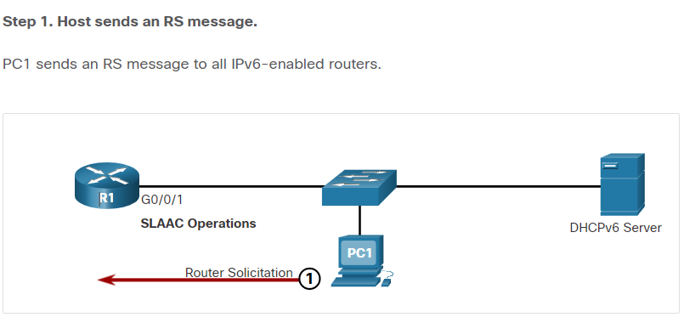

**Step 2. Router responds with an RA message.**

R1 receives the RS and responds with an RA indicating that the client is to initiate communication with a DHCPv6 server.

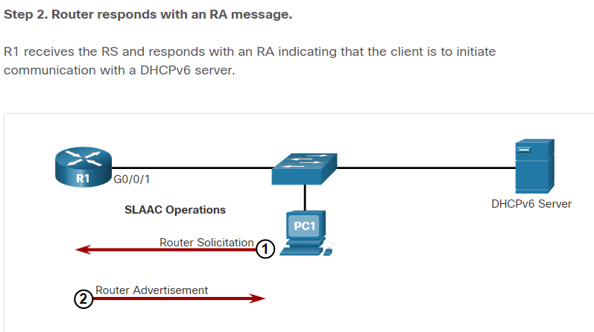

**Step 3. Host sends a DHCPv6 SOLICIT message.**

The client, now a DHCPv6 client, needs to locate a DHCPv6 server and sends a DHCPv6 SOLICIT message to the reserved IPv6 multicast all-DHCPv6-servers address of ff02::1:2. This multicast address has link-local scope, which means routers do not forward the messages to other networks.

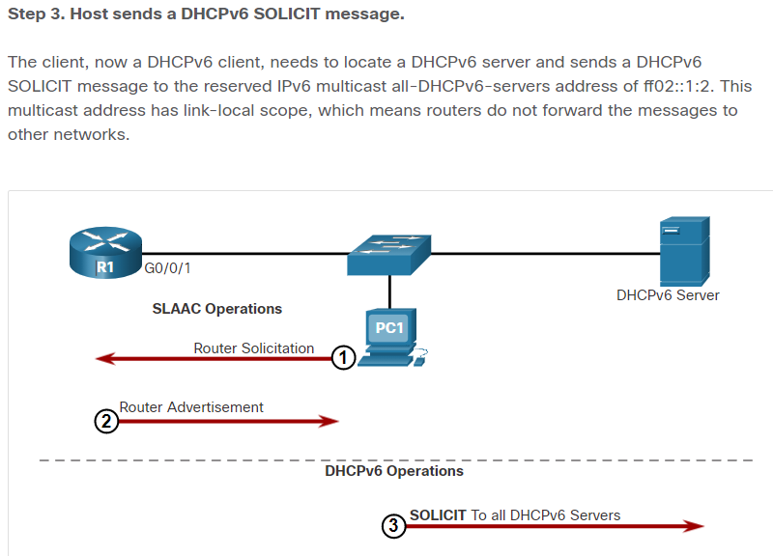**Step 4. DHCPv6 server responds with an ADVERTISE message.**

One or more DHCPv6 servers respond with a DHCPv6 ADVERTISE unicast message. The ADVERTISE message informs the DHCPv6 client that the server is available for DHCPv6 service.

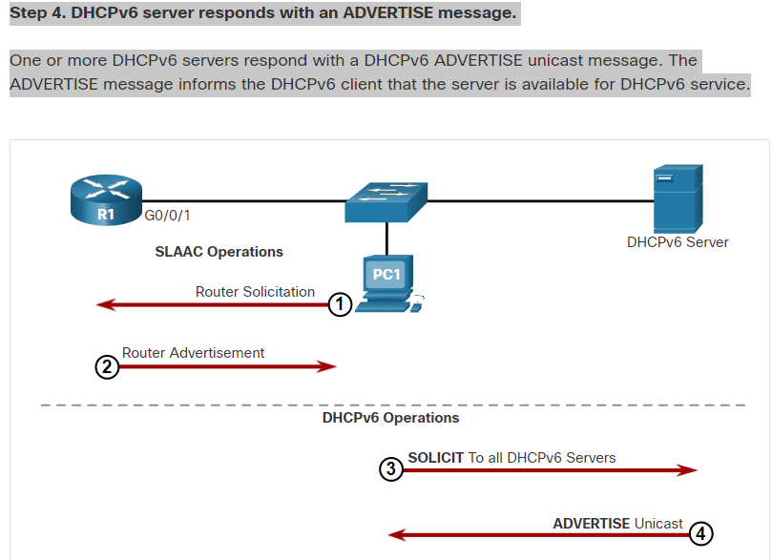**Step 5. Host responds to DHCPv6 server.**

The PC1 response depends on whether it is using stateful or stateless DHCPv6:

* **Stateless DHCPv6 client** - The client creates an IPv6 address using the prefix in the RA message and a self-generated Interface ID. The client then sends a DHCPv6 INFORMATION-REQUEST message to the DHCPv6 server requesting additional configuration parameters (e.g., DNS server address).
* **Stateful DHCPv6 client** - The client sends a DHCPv6 REQUEST message to the DHCPv6 server to obtain all necessary IPv6 configuration parameters.

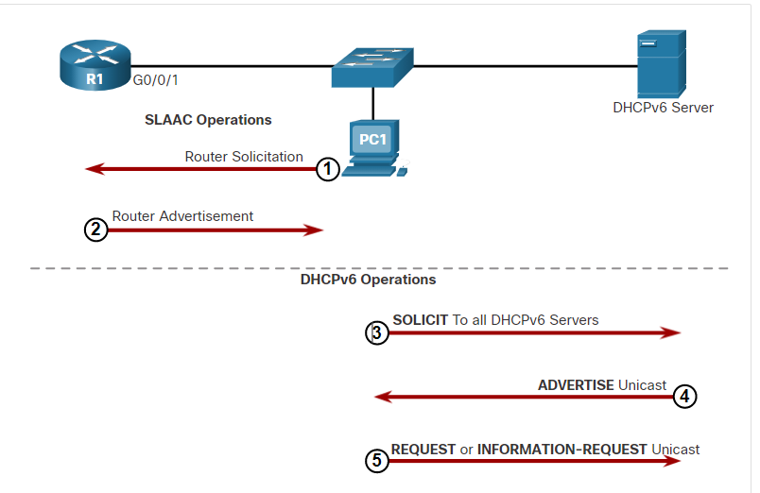**Step 6. DHCPv6 sends a REPLY message.**

The server sends a DHCPv6 REPLY unicast message to the client. The content of the message varies depending on if it is replying to a REQUEST or INFORMATION-REQUEST message.

**Note**: The client will use the source IPv6 Link-local address of the RA as its default gateway address. A DHCPv6 server does not provide this information.

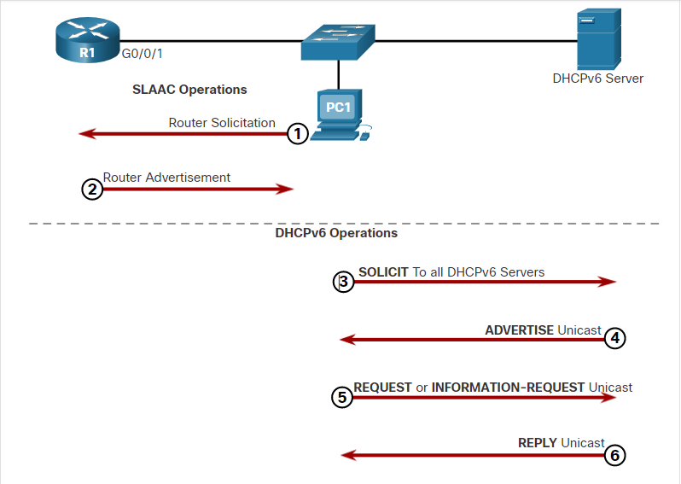

8.3.2

Stateless DHCPv6 Operation

The stateless DHCPv6 server is only providing information that is identical for all devices on the network such as the IPv6 address of a DNS server.

This process is known as stateless DHCPv6 because the server is not maintaining any client state information (i.e., a list of available and allocated IPv6 addresses). The stateless DHCPv6 server is only providing configuration parameters for clients, not IPv6 addresses.

The figure illustrates stateless DHCPv6 operation.

shows a diagram in which the PC gets its stateless DHCPv6 server information from router R1

2001:db8:acad:1::1/64fe80::1G0/0/112R1PC1

|  |  |
| --- | --- |
| **Flag** | **Value** |
| A | 1 |
| O | 1 |
| M | 0 |

**Stateless DHCPv6 ServerRA Message**

1. PC1 receives a stateless DHCP RA message. The RA message contains the network prefix and prefix length. The M flag for stateful DHCP is set to the default value 0. The A=1 flag tells the client to use SLAAC. The O=1 flag informs the client that additional configuration information is available from a stateless DHCPv6 server.
2. The client sends a DHCPv6 SOLICIT message looking for a stateless DHCPv6 server to obtain additional information (e.g., DNS server addresses).

8.3.3

Enable Stateless DHCPv6 on an Interface

Stateless DHCPv6 is enabled on a router interface using the **ipv6 nd other-config-flag** interface configuration command. This sets the O flag to 1.

The highlighted output confirms the RA will tell receiving hosts to use stateless autoconfigure (A flag = 1) and contact a DHCPv6 server to obtain another configuration information (O flag = 1).

**Note:** You can use the **no ipv6 nd other-config-flag** to reset the interface to the default SLAAC only option (O flag = 0).

R1(config-if)# **ipv6 nd other-config-flag**

R1(config-if)# **end**

R1#

R1# **show ipv6 interface g0/0/1 | begin ND**

ND DAD is enabled, number of DAD attempts: 1

ND reachable time is 30000 milliseconds (using 30000)

ND advertised reachable time is 0 (unspecified)

ND advertised retransmit interval is 0 (unspecified)

ND router advertisements are sent every 200 seconds

ND router advertisements live for 1800 seconds

ND advertised default router preference is Medium

Hosts use stateless autoconfig for addresses.

Hosts use DHCP to obtain other configuration.

R1#

8.3.4

Stateful DHCPv6 Operation

This option is most similar to DHCPv4. In this case, the RA message tells the client to obtain all addressing information from a stateful DHCPv6 server, except the default gateway address which is the source IPv6 link-local address of the RA.

This is known as stateful DHCPv6 because the DHCPv6 server maintains IPv6 state information. This is similar to a DHCPv4 server allocating addresses for IPv4.

The figure illustrates stateful DHCPv6 operation.

shows a diagram with a stateful DHCPv6 server, connected to a switch, connected to a client PC and a DHCPv6 client router

2001:db8:acad:1::1/64fe80::1G0/0/112R1PC1

|  |  |
| --- | --- |
| **Flag** | **Value** |
| A | 0 |
| O | 0 |
| M | 1 |

**Stateful DHCPv6 ServerRA Message**

1. PC1 receives a DHCPv6 RA message with the O flag set to 0 and the M flag set to 1, indicating to PC1 that it will receive all its IPv6 addressing information from a stateful DHCPv6 server.
2. PC1 sends a DHCPv6 SOLICIT message looking for a stateful DHCPv6 server.

**Note**: If A=1 and M=1, some operating systems such as Windows will create an IPv6 address using SLAAC and obtain a different address from the stateful DHCPv6 server. In most cases it is recommended to manually set the A flag to 0.

8.3.5

Enable Stateful DHCPv6 on an Interface

Stateful DHCPv6 is enabled on a router interface using the **ipv6 nd managed-config-flag** interface configuration command. This sets the M flag to 1. The **ipv6 nd prefix default no-autoconfig** interface command disables SLAAC by setting the A flag to 0.

The highlighted output in the example confirms that the RA will tell the host to obtain all IPv6 configuration information from a DHCPv6 server (M flag = 1).

R1(config)# **int g0/0/1**

R1(config-if)# **ipv6 nd managed-config-flag**

R1(config-if)# **ipv6 nd prefix default no-autoconfig**

R1(config-if)# **end**

R1#

R1# **show ipv6 interface g0/0/1 | begin ND**

ND DAD is enabled, number of DAD attempts: 1

ND reachable time is 30000 milliseconds (using 30000)

ND advertised reachable time is 0 (unspecified)

ND advertised retransmit interval is 0 (unspecified)

ND router advertisements are sent every 200 seconds

ND router advertisements live for 1800 seconds

ND advertised default router preference is Medium

Hosts use DHCP to obtain routable addresses.

R1#

DHCPv6 Router Roles

Cisco IOS routers are powerful devices. In smaller networks, you do not have to have separate devices to have a DHCPv6 server, client, or relay agent. A Cisco IOS router can be configured to provide DHCPv6 server services.

Specifically, it can be configured to be one of the following:

* **DHCPv6 Server** - Router provides stateless or stateful DHCPv6 services.
* **DHCPv6 Client** - Router interface acquires an IPv6 IP configuration from a DHCPv6 server.
* **DHCPv6 Relay Agent** - Router provides DHCPv6 forwarding services when the client and the server are located on different networks.

8.4.2

Configure a Stateless DHCPv6 Server

The stateless DHCPv6 server option requires that the router advertise the IPv6 network addressing information in RA messages. However, the client must contact a DHCPv6 server for more information.

Refer to the sample topology to learn how to configure the stateless DHCPv6 server method.

shows a diagram in which a client router gets its stateless DHCPv6 server information from router R1

G0/0/1G0/0/1fe80::12001:db8:acad:1::1/64R1R3PC1

**Stateless DHCPv6 ServerClient**

In this example, R1 will provide SLAAC services for the host IPv6 configuration and DHCPv6 services.

There are five steps to configure and verify a router as a stateless DHCPv6 server:

**Step 1**. Enable IPv6 routing.  
**Step 2**. Define a DHCPv6 pool name.  
**Step 3**. Configure the DHCPv6 pool.  
**Step 4**. Bind the DHCPv6 pool to an interface.  
**Step 5**. Verify that the hosts have received IPv6 addressing information.

Click each button for an example of these steps.

Step 1

Step 2

Step 3

Step 4

Step 5

**Step 1. Enable IPv6 routing.**

The **ipv6 unicast-routing** command is required to enable IPv6 routing. Although it is not necessary for the router to be a stateless DHCPv6 server, it is required for the router to source ICMPv6 RA messages.

R1(config)# **ipv6 unicast-routing**

R1(config)#

8.4.3

Configure a Stateless DHCPv6 Client

A router can also be a DHCPv6 client and get an IPv6 configuration from a DHCPv6 server, such as a router functioning as a DHCPv6 server. In the figure, R1 is a stateless DHCPv6 server.

G0/0/1G0/0/1fe80::12001:db8:acad:1::1/64R1R3PC1

**Stateless DHCPv6 ServerClient**

There are five steps to configure and verify a router as a stateless DHCPv6 server.

**Step 1**. Enable IPv6 routing.  
**Step 2**. Configure the client router to create an LLA.  
**Step 3**. Configure the client router to use SLAAC.  
**Step 4**. Verify that the client router is assigned a GUA.  
**Step 5**. Verify that the client router received other necessary DHCPv6 information.

Click each button for an example of these steps.

Step 1

Step 2

Step 3

Step 4

Step 5

**Step 1. Enable IPv6 routing.**

The DHCPv6 client router needs to have **ipv6 unicast-routing** enabled.

R3(config)# **ipv6 unicast-routing**

R3(config)#

8.4.4

Configure a Stateful DHCPv6 Server

The stateful DHCP server option requires that the IPv6 enabled router tells the host to contact a DHCPv6 server to obtain all necessary IPv6 network addressing information.

In the figure, R1 will provide stateful DHCPv6 services to all hosts on the local network. Configuring a stateful DHCPv6 server is similar to configuring a stateless server. The most significant difference is that a stateful DHCPv6 server also includes IPv6 addressing information similar to a DHCPv4 server.

R1R3PC1G0/0/1fe80::12001:db8:acad:1::1/64G0/0/1

**Stateful DHCPv6 ServerDHCPv6 Client**

There are five steps to configure and verify a router as a stateless DHCPv6 server:

**Step 1**. Enable IPv6 routing.  
**Step 2**. Define a DHCPv6 pool name.  
**Step 3**. Configure the DHCPv6 pool.  
**Step 4**. Bind the DHCPv6 pool to an interface.  
**Step 5**. Verify that the hosts have received IPv6 addressing information.

Click each button for an example of these steps.

Step 1

Step 2

Step 3

Step 4

Step 5

**Step 1. Enable IPv6 routing.**

The **ipv6 unicast-routing** command is required to enable IPv6 routing.

R1(config)# **ipv6 unicast-routing**

R1(config)#

8.4.5

Configure a Stateful DHCPv6 Client

A router can also be a DHCPv6 client. The client router needs to have **ipv6 unicast-routing** enabled and an IPv6 link-local address to send and receive IPv6 messages.

Refer to the sample topology to learn how to configure the stateful DHCPv6 client.

PC1R32001:db8:acad:1::1/64fe80::1G0/0/1G0/0/1R1

**Stateful DHCPv6 ServerDHCPv6  
Client**

There are five steps to configure and verify a router as a stateless DHCPv6 server.

**Step 1**. Enable IPv6 routing.  
**Step 2**. Configure the client router to create an LLA.  
**Step 3**. Configure the client router to use DHCPv6.  
**Step 4**. Verify that the client router is assigned a GUA.  
**Step 5**. Verify that the client router received other necessary DHCPv6 information.

Click each button for an example of these steps.

Step 1

Step 2

Step 3

Step 4

Step 5

**Step 1. Enable IPv6 routing.**

The DHCPv6 client router needs to have **ipv6 unicast-routing** enabled.

R3(config)# **ipv6 unicast-routing**

R3(config)#

**Step 2. Define a DHCPv6 pool name.**

Create the DHCPv6 pool using the **ipv6 dhcp pool** *POOL-NAME* global config command. This enters DHCPv6 pool sub-configuration mode as identified by the **Router(config-dhcpv6)#** prompt.

**Note:** The pool name does not have to be uppercase. However, using an uppercase name makes it easier to see in a configuration.

R1(config)# **ipv6 dhcp pool IPV6-STATELESS**

R1(config-dhcpv6)#

**Step 3. Configure the DHCPv6 pool.**

R1 will be configured to provide additional DHCP information including DNS server address and domain name, as shown in the command output.

R1(config-dhcpv6)# **dns-server 2001:db8:acad:1::254**

R1(config-dhcpv6)# **domain-name example.com**

R1(config-dhcpv6)# **exit**

R1(config)#

**Step 4. Bind the DHCPv6 pool to an interface.**

The DHCPv6 pool has to be bound to the interface using the **ipv6 dhcp server** *POOL-NAME* interface config command as shown in the output.

The router responds to stateless DHCPv6 requests on this interface with the information contained in the pool. The O flag needs to be manually changed from 0 to 1 using the interface command **ipv6 nd other-config-flag**. RA messages sent on this interface indicate that additional information is available from a stateless DHCPv6 server. The A flag is 1 by default, telling clients to use SLAAC to create their own GUA.

R1(config)# **interface GigabitEthernet0/0/1**

R1(config-if)# **description Link to LAN**

R1(config-if)# **ipv6 address fe80::1 link-local**

R1(config-if)# **ipv6 address 2001:db8:acad:1::1/64**

R1(config-if)# **ipv6 nd other-config-flag**

R1(config-if)# **ipv6 dhcp server IPV6-STATELESS**

R1(config-if)# **no shut**

R1(config-if)# **end**

R1#

**Step 5. Verify hosts received IPv6 addressing information.**

To verify stateless DHCP on a Windows host, use the **ipconfig /all** command. The example output displays the settings on PC1.

Notice in the output that PC1 created its IPv6 GUA using the 2001:db8:acad:1::/64 prefix. Also notice that the default gateway is the IPv6 link-local address of R1. This confirms that PC1 derived its IPv6 configuration from the RA of R1.

The highlighted output confirms that PC1 has learned the domain name and DNS server address information from the stateless DHCPv6 server.

C:\PC1> **ipconfig /all**

Windows IP Configuration

Ethernet adapter Ethernet0:

Connection-specific DNS Suffix . : example.com

Description . . . . . . . . . . . : Intel(R) 82574L Gigabit Network Connection

Physical Address. . . . . . . . . : 00-05-9A-3C-7A-00

DHCP Enabled. . . . . . . . . . . : Yes

Autoconfiguration Enabled . . . . : Yes

IPv6 Address. . . . . . . . . . . : 2001:db8:acad:1:1de9:c69:73ee:ca8c (Preferred)

Link-local IPv6 Address . . . . . : fe80::fb:1d54:839f:f595%21(Preferred)

IPv4 Address. . . . . . . . . . . : 169.254.102.23 (Preferred)

Subnet Mask . . . . . . . . . . . : 255.255.0.0

Default Gateway . . . . . . . . . : fe80::1%6

DHCPv6 IAID . . . . . . . . . . . : 318768538

DHCPv6 Client DUID. . . . . . . . : 00-01-00-01-21-F3-76-75-54-E1-AD-DE-DA-9A

DNS Servers . . . . . . . . . . . : 2001:db8:acad:1::254

NetBIOS over Tcpip. . . . . . . . : Enabled

C:\PC1>

8.4.6

DHCPv6 Server Verification Commands

Use the **show ipv6 dhcp pool** and **show ipv6 dhcp binding** commands to verify DHCPv6 operation on a router.

Click each button for example output.

show ipv6 dhcp pool

show ipv6 dhcp binding

The **show ipv6 dhcp pool** command verifies the name of the DHCPv6 pool and its parameters. The command also identifies the number of active clients. In this example, the IPV6-STATEFUL pool currently has 2 clients, which reflects PC1 and R3 receiving their IPv6 global unicast address from this server.

When a router is providing stateful DHCPv6 services, it also maintains a database of assigned IPv6 addresses.

R1# **show ipv6 dhcp pool**

DHCPv6 pool: IPV6-STATEFUL

Address allocation prefix: 2001:DB8:ACAD:1::/64 valid 172800 preferred 86400 (2 in use, 0 conflicts)

DNS server: 2001:4860:4860::8888

Domain name: example.com

Active clients: 2

R1#

8.4.7

Configure a DHCPv6 Relay Agent

If the DHCPv6 server is located on a different network than the client, then the IPv6 router can be configured as a DHCPv6 relay agent. The configuration of a DHCPv6 relay agent is similar to the configuration of an IPv4 router as a DHCPv4 relay.

In the figure, R3 is configured as a stateful DHCPv6 server. PC1 is on the 2001:db8:acad:2::/64 network and requires the services of a stateful DHCPv6 server to acquire its IPv6 configuration. R1 needs to be configured as the DHCPv6 Relay Agent.

PC1R1R32001:db8:acad:2::/642001:db8:acad:1::/64:1fe80::1:1fe80::1:2fe80::3G0/0/1G0/0/0G0/0/0

**DHCPv6  
ClientDHCPv6  
Relay AgentStateful DHCPv6  
Server**

The command syntax to configure a router as a DHCPv6 relay agent is as follows:

Router(config-if)# **ipv6 dhcp relay destination** *ipv6-address* [*interface-type interface-number*]

This command is configured on the interface facing the DHCPv6 clients and specifies the DHCPv6 server address and egress interface to reach the server, as shown in the output. The egress interface is only required when the next-hop address is an LLA.

R1(config)# **interface gigabitethernet 0/0/1**

R1(config-if)# **ipv6 dhcp relay destination 2001:db8:acad:1::2 G0/0/0**

R1(config-if)# **exit**

R1(config)#

8.4.8

Verify the DHCPv6 Relay Agent

Verify that the DHCPv6 relay agent is operational with the **show ipv6 dhcp interface** and **show ipv6 dhcp binding** commands. Verify Windows hosts received IPv6 addressing information with the **ipconfig /all** command.

Click each button for example output.

show ipv6 dhcp interface

show ipv6 dhcp binding

ipconfig /all

The DHCPv6 relay agent can be verified using the **show ipv6 dhcp interface** command. This will verify that the G0/0/1 interface is in relay mode.

R1# **show ipv6 dhcp interface**

GigabitEthernet0/0/1 is in relay mode

Relay destinations:

2001:DB8:ACAD:1::2

2001:DB8:ACAD:1::2 via GigabitEthernet0/0/0

R1#

Lab - Configure DHCPv6

In this lab, you will complete the following objectives:

* Part 1: Build the Network and Configure Basic Device Settings
* Part 2: Verify SLAAC address assignment from R1
* Part 3: Configure and verify a Stateless DHCPv6 Server on R1
* Part 4: Configure and verify a Stateful DHCPv6 Server on R1
* Part 5: Configure and verify a DHCPv6 Relay on R2

 Configure DHCPv6

8.5.2

What did I learn in this module?

**IPv6 GUA Assignment**

On a router, an IPv6 global unicast addresses (GUA) is manually configured using the **ipv6 address** *ipv6-address/prefix-length* interface configuration command. When automatic IPv6 addressing is selected, the host will attempt to automatically obtain and configure IPv6 address information on the interface. The IPv6 link-local address is automatically created by the host when it boots and the Ethernet interface is active. By default, an IPv6-enabled router advertises its IPv6 information enabling a host to dynamically create or acquire its IPv6 configuration. The IPv6 GUA can be assigned dynamically using stateless and stateful services. The decision of how a client will obtain an IPv6 GUA depends on the settings within the RA message. An ICMPv6 RA message includes three flags to identify the dynamic options available to a host:

* **A flag** – This is the Address Autoconfiguration flag. Use SLAAC to create an IPv6 GUA.
* **O flag** – This is the Other Configuration flag. Get Other information from a stateless DHCPv6 server.
* **M flag** – This is the Managed Address Configuration flag. Use a stateful DHCPv6 server to obtain an IPv6 GUA.

**SLAAC**

The SLAAC method enables hosts to create their own unique IPv6 global unicast address without the services of a DHCPv6 server. SLAAC, which is stateless, uses ICMPv6 RA messages to provide addressing and other configuration information that would normally be provided by a DHCP server. SLAAC can be deployed as SLAAC only, or SLAAC with DHCPv6. To enable the sending of RA messages, a router must join the IPv6 all-routers group using the **ipv6 unicast-routing** global config command. Use the **show ipv6 interface** command to verify if a router is enabled. The SLAAC only method is enabled by default when the ipv6 unicast-routing command is configured. All enabled Ethernet interfaces with an IPv6 GUA configured will start sending RA messages with the A flag set to 1, and the O and M flags set to 0. The A = 1 flag suggests to the client to create its own IPv6 GUA using the prefix advertised in the RA. The O =0 and M=0 flags instructs the client to use the information in the RA message exclusively. A router sends RA messages every 200 seconds. However, it will also send an RA message if it receives an RS message from a host. Using SLAAC, a host typically acquires its 64-bit IPv6 subnet information from the router RA. However, it must generate the remainder 64-bit interface identifier (ID) using one of two methods: randomly generated, or EUI-64. The DAD process is used by a host to ensure that the IPv6 GUA is unique. DAD is implemented using ICMPv6. To perform DAD, the host sends an ICMPv6 NS message with a specially constructed multicast address, called a solicited-node multicast address. This address duplicates the last 24 bits of IPv6 address of the host.

**DHCPv6**

The host begins the DHCPv6 client/server communications after stateless DHCPv6 or stateful DHCPv6 is indicated in the RA. Server to client DHCPv6 messages use UDP destination port 546, while client to server DHCPv6 messages use UDP destination port 547. The stateless DHCPv6 option informs the client to use the information in the RA message for addressing, but additional configuration parameters are available from a DHCPv6 server. This is called stateless DHCPv6 because the server is not maintaining any client state information. Stateless DHCPv6 is enabled on a router interface using the **ipv6 nd other-config-flag** interface configuration command. This sets the O flag to 1. In stateful DHCPv6, the RA message tells the client to obtain all addressing information from a stateful DHCPv6 server, except the default gateway address which is the source IPv6 link-local address of the RA. It is called stateful because the DHCPv6 server maintains IPv6 state information. Stateful DHCPv6 is enabled on a router interface using the **ipv6 nd managed-config-flag** interface configuration command. This sets the M flag to 1.

**Configure DHCPv6 Server**

A Cisco IOS router can be configured to provide DHCPv6 server services as one of the following three types: DHCPv6 server, DHCPv6 client, or DHCPv6 relay agent. The stateless DHCPv6 server option requires that the router advertise the IPv6 network addressing information in RA messages. A router can also be a DHCPv6 client and get an IPv6 configuration from a DHCPv6 server. The stateful DHCP server option requires that the IPv6-enabled router tells the host to contact a DHCPv6 server to acquire all required IPv6 network addressing information. For a client router to be a DHCPv6 router, it needs to **have ipv6 unicast-routing** enabled and an IPv6 link-local address to send and receive IPv6 messages. Use the **show ipv6 dhcp pool** and **show ipv6 dhcp binding** commands to verify DHCPv6 operation on a router. If the DHCPv6 server is located on a different network than the client, then the IPv6 router can be configured as a DHCPv6 relay agent using the **ipv6 dhcp relay destination** *ipv6-address [interface-type interface-number]* command. This command is configured on the interface facing the DHCPv6 clients and specifies the DHCPv6 server address and egress interface to reach the server. The egress interface is only required when the next-hop address is an LLA. Verify the DHCPv6 relay agent is operational with the **show ipv6 dhcp interface** and **show ipv6 dhcp binding** commands.

Default Gateway Limitations

If a router or router interface (that serves as a default gateway) fails, the hosts configured with that default gateway are isolated from outside networks. A mechanism is needed to provide alternate default gateways in switched networks where two or more routers are connected to the same VLANs. That mechanism is provided by first hop redundancy protocols (FHRPs).

In a switched network, each client receives only one default gateway. There is no way to use a secondary gateway, even if a second path exists to carry packets off the local segment.

In the figure, R1 is responsible for routing packets from PC1. If R1 becomes unavailable, the routing protocols can dynamically converge. R2 now routes packets from outside networks that would have gone through R1. However, traffic from the inside network associated with R1, including traffic from workstations, servers, and printers configured with R1 as their default gateway, are still sent to R1 and dropped.

**Note**: For the purposes of the discussion on router redundancy, there is no functional difference between a Layer 3 switch and a router at the distribution layer. In practice, it is common for a Layer 3 switch to act as the default gateway for each VLAN in a switched network. This discussion focuses on the functionality of routing, regardless of the physical device used.

The physcial network topology shows two switches, router, a PC, and a server. The PC, PC1, is sending a packet through the network. The graphic shows the packet being dropped at the interface of R1.

R1R2PC1

10.1.10.3/24  
0014.a866.289810.1.10.2/24  
0014.a855.1788Server  
10.9.1.50/24

PC1 is unable to reach the default gateway.

End devices are typically configured with a single IPv4 address for a default gateway. This address does not change when the network topology changes. If that default gateway IPv4 address cannot be reached, the local device is unable to send packets off the local network segment, effectively disconnecting it from other networks. Even if a redundant router exists that could serve as a default gateway for that segment, there is no dynamic method by which these devices can determine the address of a new default gateway.

**Note**: IPv6 devices receive their default gateway address dynamically from the ICMPv6 Router Advertisement. However, IPv6 devices benefit with a faster failover to the new default gateway when using FHRP.

9.1.2

Router Redundancy

One way to prevent a single point of failure at the default gateway is to implement a virtual router. To implement this type of router redundancy, multiple routers are configured to work together to present the illusion of a single router to the hosts on the LAN, as shown in the figure. By sharing an IP address and a MAC address, two or more routers can act as a single virtual router.

The physcial network topology shows four PCs, three routers and an Internet or ISP backbone cloud. The four PCs and the three routers are connected to a LAN. The three routers also each have a link going up to the Ineternet or IPS backbone. There is a forwarding router with IP address 192.0.2.1/24. There is a virtual router with IP address 192.0.2.100/24. There is a standby router with IP address 192.0.2.2/24. An arrow representing a packet sent from PC2 goes to the virtual router at IP address 192.0.2.100 then to the forwarding router with IP address 192.0.2.1 and then to the Internet or ISP backbone.

PC1PC3PC4PC2192.0.2.2/24192.0.2.1/24192.0.2.3/24

Forwarding  
RouterStandby  
RouterVirtual  
RouterInternet or ISP backboneLAN

The IPv4 address of the virtual router is configured as the default gateway for the workstations on a specific IPv4 segment. When frames are sent from host devices to the default gateway, the hosts use ARP to resolve the MAC address that is associated with the IPv4 address of the default gateway. The ARP resolution returns the MAC address of the virtual router. Frames that are sent to the MAC address of the virtual router can then be physically processed by the currently active router within the virtual router group. A protocol is used to identify two or more routers as the devices that are responsible for processing frames that are sent to the MAC or IP address of a single virtual router. Host devices send traffic to the address of the virtual router. The physical router that forwards this traffic is transparent to the host devices.

A redundancy protocol provides the mechanism for determining which router should take the active role in forwarding traffic. It also determines when the forwarding role must be taken over by a standby router. The transition from one forwarding router to another is transparent to the end devices.

The ability of a network to dynamically recover from the failure of a device acting as a default gateway is known as first-hop redundancy.

9.1.3

Steps for Router Failover

When the active router fails, the redundancy protocol transitions the standby router to the new active router role, as shown in the figure. These are the steps that take place when the active router fails:

1. The standby router stops seeing Hello messages from the forwarding router.
2. The standby router assumes the role of the forwarding router.
3. Because the new forwarding router assumes both the IPv4 and MAC addresses of the virtual router, the host devices see no disruption in service.

The physcial network topology shows four PCs, three routers and an Internet or ISP backbone cloud. The four PCs and the three routers are connected to a LAN. The three routers also each have a link going up to the Ineternet or IPS backbone. There is a forwarding router with IP address 192.0.2.1/24. There is a virtual router with IP address 192.0.2.100/24. There is a standby router with IP address 192.0.2.2/24. There is an X through the LAN link to the router with IP address 192.0.2.1 that was previously a forwarding router. An arrow representing a packet sent from PC2 goes to the virtual router at IP address 192.0.2.100 then to the new forwarding router with IP address 192.0.2.2 and then to the Internet or ISP backbone.

PC1PC3PC4PC2192.0.2.1/24192.0.2.100/24192.0.2.2/24

Virtual RouterNew Forwarding  
RouterInternet or ISP backboneLANLink or device failure: Standby router becomes the forwarding router.

9.1.4

FHRP Options

The FHRP used in a production environment largely depends on the equipment and needs of the network. The table lists all the options available for FHRPs.

|  |  |
| --- | --- |
| **FHRP Options** | **Description** |
| Hot Standby Router Protocol (HSRP) | HRSP is a Cisco-proprietary FHRP that is designed to allow for transparent failover of a first-hop IPv4 device. HSRP provides high network availability by providing first-hop routing redundancy for IPv4 hosts on networks configured with an IPv4 default gateway address. HSRP is used in a group of routers for selecting an active device and a standby device. In a group of device interfaces, the active device is the device that is used for routing packets; the standby device is the device that takes over when the active device fails, or when pre-set conditions are met. The function of the HSRP standby router is to monitor the operational status of the HSRP group and to quickly assume packet-forwarding responsibility if the active router fails. |
| HSRP for IPv6 | This is a Cisco-proprietary FHRP that provides the same functionality of HSRP, but in an IPv6 environment. An HSRP IPv6 group has a virtual MAC address derived from the HSRP group number and a virtual IPv6 link-local address derived from the HSRP virtual MAC address. Periodic router advertisements (RAs) are sent for the HSRP virtual IPv6 link-local address when the HSRP group is active. When the group becomes inactive, these RAs stop after a final RA is sent. |
| Virtual Router Redundancy Protocol version 2 (VRRPv2) | This is a non-proprietary election protocol that dynamically assigns responsibility for one or more virtual routers to the VRRP routers on an IPv4 LAN. This allows several routers on a multiaccess link to use the same virtual IPv4 address. A VRRP router is configured to run the VRRP protocol in conjunction with one or more other routers attached to a LAN. In a VRRP configuration, one router is elected as the virtual router master, with the other routers acting as backups, in case the virtual router master fails. |
| VRRPv3 | This provides the capability to support IPv4 and IPv6 addresses. VRRPv3 works in multi-vendor environments and is more scalable than VRRPv2. |
| Gateway Load Balancing Protocol (GLBP) | This is a Cisco-proprietary FHRP that protects data traffic from a failed router or circuit, like HSRP and VRRP, while also allowing load balancing (also called load sharing) between a group of redundant routers. |
| GLBP for IPv6 | This is a Cisco-proprietary FHRP that provides the same functionality of GLBP, but in an IPv6 environment. GLBP for IPv6 provides automatic router backup for IPv6 hosts configured with a single default gateway on a LAN. Multiple first-hop routers on the LAN combine to offer a single virtual first-hop IPv6 router while sharing the IPv6 packet forwarding load. |
| ICMP Router Discovery Protocol (IRDP) | Specified in RFC 1256, IRDP is a legacy FHRP solution. IRDP allows IPv4 hosts to locate routers that provide IPv4 connectivity to other (nonlocal) IP networks. |

HSRP Overview

Cisco provides HSRP and HSRP for IPv6 as a way to avoid losing outside network access if your default router fails.

HSRP is a Cisco-proprietary FHRP that is designed to allow for transparent failover of a first-hop IP device.

HSRP ensures high network availability by providing first-hop routing redundancy for IP hosts on networks configured with an IP default gateway address. HSRP is used in a group of routers for selecting an active device and a standby device. In a group of device interfaces, the active device is the device that is used for routing packets; the standby device is the device that takes over when the active device fails, or when pre-set conditions are met. The function of the HSRP standby router is to monitor the operational status of the HSRP group and to quickly assume packet-forwarding responsibility if the active router fails.

9.2.2

HSRP Priority and Preemption

The role of the active and standby routers is determined during the HSRP election process. By default, the router with the numerically highest IPv4 address is elected as the active router. However, it is always better to control how your network will operate under normal conditions rather than leaving it to chance.

**HSRP Priority**

HSRP priority can be used to determine the active router. The router with the highest HSRP priority will become the active router. By default, the HSRP priority is 100. If the priorities are equal, the router with the numerically highest IPv4 address is elected as the active router.

To configure a router to be the active router, use the **standby priority** interface command. The range of the HSRP priority is 0 to 255.

**HSRP Preemption**

By default, after a router becomes the active router, it will remain the active router even if another router comes online with a higher HSRP priority.

To force a new HSRP election process to take place when a higher priority router comes online, preemption must be enabled using the **standby preempt** interface command. Preemption is the ability of an HSRP router to trigger the re-election process. With preemption enabled, a router that comes online with a higher HSRP priority will assume the role of the active router.

Preemption only allows a router to become the active router if it has a higher priority. A router enabled for preemption, with equal priority but a higher IPv4 address will not preempt an active router. Refer to the topology in the figure.

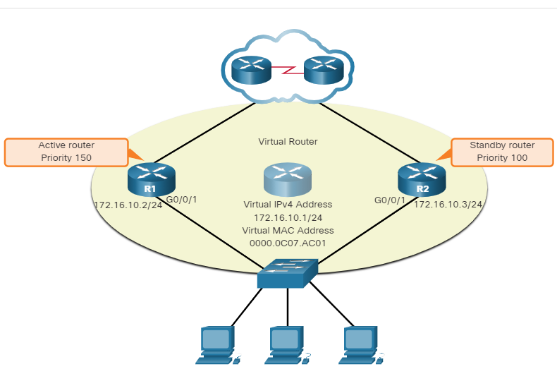R1 has been configured with the HSRP priority of 150 while R2 has the default HSRP priority of 100. Preemption has been enabled on R1. With a higher priority, R1 is the active router and R2 is the standby router. Due to a power failure affecting only R1, the active router is no longer available and the standby router, R2, assumes the role of the active router. After power is restored, R1 comes back online. Because R1 has a higher priority and preemption is enabled, it will force a new election process. R1 will re-assume the role of the active router and R2 will fall back to the role of the standby router.

**Note**: With preemption disabled, the router that boots up first will become the active router if there are no other routers online during the election process.

9.2.3

HSRP States and Timers

A router can either be the active HSRP router responsible for forwarding traffic for the segment, or it can be a passive HSRP router on standby, ready to assume the active role if the active router fails. When an interface is configured with HSRP or is first activated with an existing HSRP configuration, the router sends and receives HSRP hello packets to begin the process of determining which state it will assume in the HSRP group.

The table summarizes the HSRP states.

| Table caption | |
| --- | --- |
| **HSRP State** | **Description** |
| Initial | This state is entered through a configuration change or when an interface first becomes available. |
| Learn | The router has not determined the virtual IP address and has not yet seen a hello message from the active  router.In this state, the router waits to hear from the active router. |
| Listen | The router knows the virtual IP address, but the router is neither the active router nor the standby router.  It listens for hello messages from those routers. |
| Speak | The router sends periodic hello messages and actively participates in the election of the active and/or  standby router. |
| Standby | The router is a candidate to become the next active router and sends periodic hello messages. |
| Active | The router won the election. |

The active and standby HSRP routers send hello packets to the HSRP group multicast address every 3 seconds by default. The standby router will become active if it does not receive a hello message from the active router after 10 seconds. You can lower these timer settings to speed up the failover or preemption. However, to avoid increased CPU usage and unnecessary standby state changes, do not set the hello timer below 1 second or the hold timer below 4 seconds.

## What did I learn in this module?

**First Hop Redundancy Protocols**

If a router or router interface that serves as a default gateway fails, the hosts configured with that default gateway are isolated from outside networks. FHRP provides alternate default gateways in switched networks where two or more routers are connected to the same VLANs. One way to prevent a single point of failure at the default gateway, is to implement a virtual router. With a virtual router, multiple routers are configured to work together to present the illusion of a single router to the hosts on the LAN. When the active router fails, the redundancy protocol transitions the standby router to the new active router role. These are the steps that take place when the active router fails:

1. The standby router stops seeing Hello messages from the forwarding router.
2. The standby router assumes the role of the forwarding router.
3. Because the new forwarding router assumes both the IPv4 and MAC addresses of the virtual router, the host devices see no disruption in service.

The FHRP used in a production environment largely depends on the equipment and needs of the network. These are the options available for FHRPs:

* HSRP and HSRP for IPv6
* VRRPv2 and VRRPv3
* GLBP and GLBP for IPv6
* IRDP

**HSRP**

HSRP is a Cisco-proprietary FHRP designed to allow for transparent failover of a first-hop IP device. HSRP is used in a group of routers for selecting an active device and a standby device. In a group of device interfaces, the active device is the device that is used for routing packets; the standby device is the device that takes over when the active device fails, or when pre-set conditions are met. The function of the HSRP standby router is to monitor the operational status of the HSRP group and to quickly assume packet-forwarding responsibility if the active router fails. The router with the highest HSRP priority will become the active router. Preemption is the ability of an HSRP router to trigger the re-election process. With preemption enabled, a router that comes online with a higher HSRP priority will assume the role of the active router. HSRP states include initial, learn, listen, speak, and standby.

## Network Attacks Today

The news media commonly covers attacks on enterprise networks. Simply search the internet for “latest network attacks” to find up-to-date information on current attacks. Most likely, these attacks will involve one or more of the following:

* **Distributed Denial of Service (DDoS)** – This is a coordinated attack from many devices, called zombies, with the intention of degrading or halting public access to an organization’s website and resources.
* **Data Breach** – This is an attack in which an organization’s data servers or hosts are compromised to steal confidential information.
* **Malware** – This is an attack in which an organization’s hosts are infected with malicious software that cause a variety of problems. For example, ransomware such as WannaCry, shown in the figure, encrypts the data on a host and locks access to it until a ransom is paid.

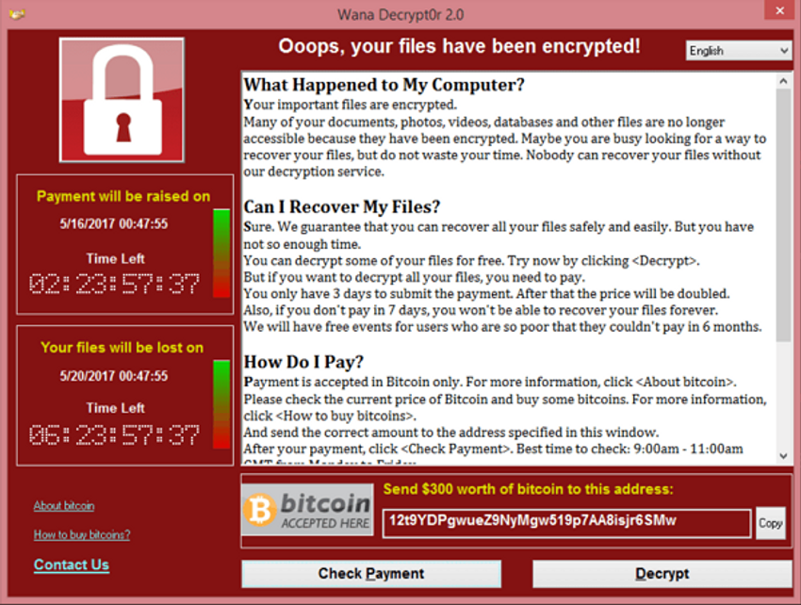

10.1.2

## Network Security Devices

Various network security devices are required to protect the network perimeter from outside access. These devices could include a virtual private network (VPN) enabled router, a next-generation firewall (NGFW), and a network access control (NAC) device.

A VPN-enabled router provides a secure connection to remote users across a public network and into the enterprise network. VPN services can be integrated into the firewall.

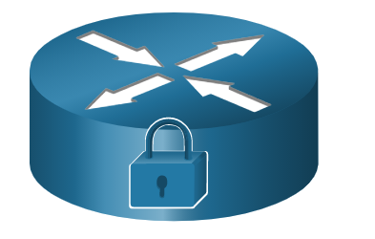

An NGFW provides stateful packet inspection, application visibility and control, a next-generation intrusion prevention system (NGIPS), advanced malware protection (AMP), and URL filtering.



A NAC device includes authentication, authorization, and accounting (AAA) services. In larger enterprises, these services might be incorporated into an appliance that can manage access policies across a wide variety of users and device types. The Cisco Identity Services Engine (ISE) is an example of a NAC device.



## Endpoint Protection

LAN devices such as switches, wireless LAN controllers (WLCs), and other access point (AP) devices interconnect endpoints. Most of these devices are susceptible to the LAN-related attacks that are covered in this module.

But many attacks can also originate from inside the network. If an internal host is infiltrated, it can become a starting point for a threat actor to gain access to critical system devices, such as servers and sensitive data.

Endpoints are hosts which commonly consist of laptops, desktops, servers, and IP phones, as well as employee-owned devices that are typically referred to as bring your own devices (BYODs). Endpoints are particularly susceptible to malware-related attacks that originate through email or web browsing. These endpoints have typically used traditional host-based security features, such as antivirus/antimalware, host-based firewalls, and host-based intrusion prevention systems (HIPSs). However, today endpoints are best protected by a combination of NAC, host-based AMP software, an email security appliance (ESA), and a web security appliance (WSA). Advanced Malware Protection (AMP) products include endpoint solutions such as Cisco AMP for Endpoints.

The figure is a simple topology representing all the network security devices and endpoint solutions discussed in this module.

The figure is a network topology showing network security devices and endpoint solutions. At the upper left is the Internet cloud. Attached to the Internet cloud is a remote user with VPN client. Connected to the cloud on the internal network is a VPN-enabled router which is connected to an NGFW. The NGFW is connected to a multilayer switch which has two connections to another multilayer switch. Connected to the first switch is a NAC AAA/ISE device. Connected to the second switch isn ESA/WSA device. The two multilayer switches are both connected to a secured LAN switch and a WLC. Several wired and wireless endpoints secured with AMP are also shown including a desktop, laptop, IP phone, and smartphone.

InternetRemote User with VPN ClientNAC  
AAA/ISEESA/WSAVPN-Enabled  
RouterNGFWWLCWired and Wireless  
Endpoints Secured with AMP

10.1.4

## Cisco Email Security Appliance

Content security appliances include fine-grained control over email and web browsing for an organization’s users.

According to the Cisco’s Talos Intelligence Group, in June 2019, 85% of all email sent was spam. Phishing attacks are a particularly virulent form of spam. Recall that a phishing attack entices the user to click a link or open an attachment. Spear phishing targets high-profile employees or executives that may have elevated login credentials. This is particularly crucial in today’s environment where, according to the SANS Institute, 95% of all attacks on enterprise networks are the result of a successful spear phishing attack.

The Cisco ESA is a device that is designed to monitor Simple Mail Transfer Protocol (SMTP). The Cisco ESA is constantly updated by real-time feeds from the Cisco Talos, which detects and correlates threats and solutions by using a worldwide database monitoring system. This threat intelligence data is pulled by the Cisco ESA every three to five minutes. These are some of the functions of the Cisco ESA:

* Block known threats.
* Remediate against stealth malware that evaded initial detection.
* Discard emails with bad links (as shown in the figure).
* Block access to newly infected sites.
* Encrypt content in outgoing email to prevent data loss.

In the figure, the Cisco ESA discards the email with bad links.

a threat actor sends a phishing email from the cloud intended for a company executive; the firewall forwards it to the ESA which discards it

123

ESACompany  
Executive

1. Threat actor sends a phishing attack to an important host on the network.
2. The firewall forwards all email to the ESA.
3. The ESA analyzes the email, logs it, and if it is malware discards it.

10.1.5

## Cisco Web Security Appliance

The Cisco Web Security Appliance (WSA) is a mitigation technology for web-based threats. It helps organizations address the challenges of securing and controlling web traffic. The Cisco WSA combines advanced malware protection, application visibility and control, acceptable use policy controls, and reporting.

Cisco WSA provides complete control over how users access the internet. Certain features and applications, such as chat, messaging, video and audio, can be allowed, restricted with time and bandwidth limits, or blocked, according to the organization’s requirements. The WSA can perform blacklisting of URLs, URL-filtering, malware scanning, URL categorization, Web application filtering, and encryption and decryption of web traffic.

In the figure, an internal corporate employee uses a smartphone to attempt to connect to a known blacklisted site.

an internal user attempts to connect to a blacklisted website; the firewall forwards it to the WSA which discards it

312

WSAInternethttp://example.com/bad

1. A user attempts to connect to a website.
2. The firewall forwards the website request to the WSA.
3. The WSA evaluates the URL and determines it is a known blacklisted site. The WSA discards the packet and sends an access denied message to the user.

## Authentication with a Local Password

In the previous topic, you learned that a NAC device provides AAA services. In this topic, you will learn more about AAA and the ways to control access.

Many types of authentication can be performed on networking devices, and each method offers varying levels of security. The simplest method of remote access authentication is to configure a login and password combination on console, vty lines, and aux ports, as shown in the vty lines in the following example. This method is the easiest to implement, but it is also the weakest and least secure. This method provides no accountability and the password is sent in plaintext. Anyone with the password can gain entry to the device.

R1(config)# **line vty 0 4**

R1(config-line)# **password ci5c0**

R1(config-line)# **login**

SSH is a more secure form of remote access:

* It requires a username and a password, both of which are encrypted during transmission.
* The username and password can be authenticated by the local database method.
* It provides more accountability because the username is recorded when a user logs in.

The following example illustrates SSH and local database methods of remote access.

R1(config)# **ip domain-name example.com**

R1(config)# **crypto key generate rsa general-keys modulus 2048**

R1(config)# **username Admin secret Str0ng3rPa55w0rd**

R1(config)# **ssh version 2**

R1(config)# **line vty 0 4**

R1(config-line)# **transport input ssh**

R1(config-line)# **login local**

The local database method has some limitations:

* User accounts must be configured locally on each device. In a large enterprise environment with multiple routers and switches to manage, it can take time to implement and change local databases on each device.
* The local database configuration provides no fallback authentication method. For example, what if the administrator forgets the username and password for that device? With no backup method available for authentication, password recovery becomes the only option.

A better solution is to have all devices refer to the same database of usernames and passwords from a central server.

10.2.2

## AAA Components

AAA stands for Authentication, Authorization, and Accounting. The AAA concept is similar to using a credit card, as shown in the figure. The credit card identifies who can use it, how much that user can spend, and keeps an account of what items or services the user purchased.

AAA provides the primary framework to set up access control on a network device. AAA is a way to control who is permitted to access a network (authenticate), what they can do while they are there (authorize), and to audit what actions they performed while accessing the network (accounting).

Authentication-Authorization-and-Accounting--transcript--UUID

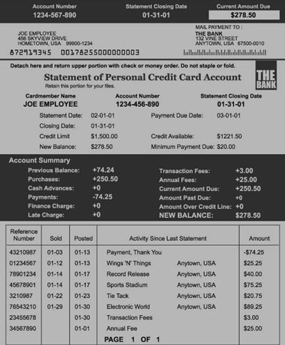

**Authentication**  
  
Who are you?**Authorization**  
  
How much can you spend?**Accounting**  
  
What did you spend it on?

10.2.3

## Authentication

Local and server-based are two common methods of implementing AAA authentication.

**Local AAA Authentication**

Local AAA stores usernames and passwords locally in a network device such as the Cisco router. Users authenticate against the local database, as shown in figure. Local AAA is ideal for small networks.

a remote client connects to a AAA router, is prompted for a username and password, the router checks its local database before allowing access into the corporate network

123

Remote ClientAAA RouterCorporate Network

1. The client establishes a connection with the router.
2. The AAA router prompts the user for a username and password.
3. The router authenticates the username and password using the local database and the user is provided access to the network based on information in the local database.

**Server-Based AAA Authentication**

With the server-based method, the router accesses a central AAA server, as shown in figure. The AAA server contains the usernames and passwords for all users. The router uses either the Remote Authentication Dial-In User Service (RADIUS) or Terminal Access Controller Access Control System (TACACS+) protocols to communicate with the AAA server. When there are multiple routers and switches, server-based AAA is more appropriate.

a remote client connects to a AAA router, is prompted for a username and password, the router authenticates the credentials using a AAA server, and the user is provided access to the network

1234

Remote ClientAAA RouterAAA Server

1. The client establishes a connection with the router.
2. The AAA router prompts the user for a username and password.
3. The router authenticates the username and password using a AAA server.
4. The user is provided access to the network based on information in the remote AAA server.

10.2.4

## Authorization

AAA authorization is automatic and does not require users to perform additional steps after authentication. Authorization governs what users can and cannot do on the network after they are authenticated.

Authorization uses a set of attributes that describes the user’s access to the network. These attributes are used by the AAA server to determine privileges and restrictions for that user, as shown in the figure.

123

Remote ClientAAA Server

1. When a user has been authenticated, a session is established between the router and the AAA server.
2. The router requests authorization from the AAA server for the client's requested service.
3. The AAA server returns a PASS/FAIL response for authorization.

10.2.5

## Accounting

AAA accounting collects and reports usage data. This data can be used for such purposes as auditing or billing. The collected data might include the start and stop connection times, executed commands, number of packets, and number of bytes.

A primary use of accounting is to combine it with AAA authentication. The AAA server keeps a detailed log of exactly what the authenticated user does on the device, as shown in the figure. This includes all EXEC and configuration commands issued by the user. The log contains numerous data fields, including the username, the date and time, and the actual command that was entered by the user. This information is useful when troubleshooting devices. It also provides evidence for when individuals perform malicious acts.

12

Remote ClientAAA Server

1. When a user has been authenticated, the AAA accounting process generates a start message to begin the accounting process.
2. When the user finishes, a stop message is recorded and the accounting process ends.

10.2.6

## 802.1X

The IEEE 802.1X standard is a port-based access control and authentication protocol. This protocol restricts unauthorized workstations from connecting to a LAN through publicly accessible switch ports. The authentication server authenticates each workstation that is connected to a switch port before making available any services offered by the switch or the LAN.

With 802.1X port-based authentication, the devices in the network have specific roles, as shown in the figure.

The diagram shows the devices involved in 802.1x port-based authentication. On the left is the supplicant, in this case a desktop, which requires access and responds to requests from a switch. The supplicant is connected to the authenticator, in this case a switch, which controls physical access to the network based on client authentication status. The authenticator is connected to the authentication server which performs client authentication.

**Supplicant**Requires access and responds to requests from switch**Authenticator**Controls physical access to the network based on client authentication status**Authentication**Performs client authentication

* **Client (Supplicant)** - This is a device running 802.1X-compliant client software, which is available for wired or wireless devices.
* **Switch (Authenticator)** –The switch acts as an intermediary between the client and the authentication server. It requests identifying information from the client, verifies that information with the authentication server, and relays a response to the client. Another device that could act as authenticator is a wireless access point.
* **Authentication server** –The server validates the identity of the client and notifies the switch or wireless access point that the client is or is not authorized to access the LAN and switch services.

## Layer 2 Vulnerabilities

The previous two topics discussed securing endpoints. In this topic, you will continue to learn about ways to secure the LAN by focusing on the frames found in the data link layer (Layer 2) and the switch.

Recall that the OSI reference model is divided into seven layers which work independently of each other. The figure shows the function of each layer and the core elements that can be exploited.

Network administrators routinely implement security solutions to protect the elements in Layer 3 up through Layer 7. They use VPNs, firewalls, and IPS devices to protect these elements. However, if Layer 2 is compromised, then all the layers above it are also affected. For example, if a threat actor with access to the internal network captured Layer 2 frames, then all the security implemented on the layers above would be useless. The threat actor could cause a lot of damage on the Layer 2 LAN networking infrastructure.

The diagram shows the number, name, and other information related to the OSI layers from top to bottom: 7 - application, 6- presentation, 5 - session, 4 - transport, 3 - Network, 2 - data link, and 1 - physical. It shows an initial compromise of Ethernet frames at layer 2 with an arrow indicating all the layers above have also been compromised.

**HTTP, HTTPS, POP3, IMAP, SSL, SSH,...Protocols/PortsIP AddressesEthernet FramesPhysical LinksInitial 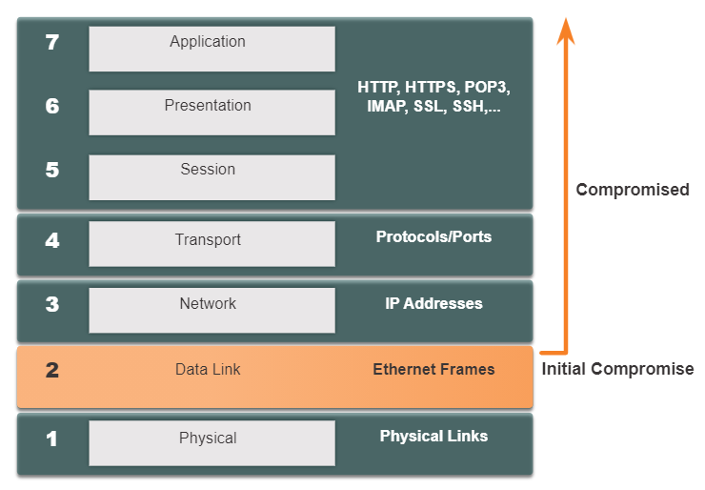Switch Attack Categories**

Security is only as strong as the weakest link in the system, and Layer 2 is considered to be that weak link. This is because LANs were traditionally under the administrative control of a single organization. We inherently trusted all persons and devices connected to our LAN. Today, with BYOD and more sophisticated attacks, our LANs have become more vulnerable to penetration. Therefore, in addition to protecting Layer 3 to Layer 7, network security professionals must also mitigate attacks to the Layer 2 LAN infrastructure.

The first step in mitigating attacks on the Layer 2 infrastructure is to understand the underlying operation of Layer 2 and the threats posed by the Layer 2 infrastructure.

Attacks against the Layer 2 LAN infrastructure are described in the table and are discussed in more detail later in this module.

### **Layer 2 Attacks**

| Table caption | |
| --- | --- |
| **Category** | **Examples** |
| **MAC Table Attacks** | Includes MAC address flooding attacks. |
| **VLAN Attacks** | Includes VLAN hopping and VLAN double-tagging attacks.  It also includes attacks between devices on a common VLAN. |
| **DHCP Attacks** | Includes DHCP starvation and DHCP spoofing attacks. |
| **ARP Attacks** | Includes ARP spoofing and ARP poisoning attacks. |
| **Address Spoofing Attacks** | Includes MAC address and IP address spoofing attacks. |
| **STP Attacks** | Includes Spanning Tree Protocol manipulation attacks. |

10.3.3

## Switch Attack Mitigation Techniques

The table provides an overview of Cisco solutions to help mitigate Layer 2 attacks.

### **Layer 2 Attack Mitigation**

| Table caption | |
| --- | --- |
| **Solution** | **Description** |
| **Port Security** | Prevents many types of attacks including MAC address flooding attacks and DHCP starvation attacks. |
| **DHCP Snooping** | Prevents DHCP starvation and DHCP spoofing attacks. |
| **Dynamic ARP Inspection (DAI)** | Prevents ARP spoofing and ARP poisoning attacks. |
| **IP Source Guard (IPSG)** | Prevents MAC and IP address spoofing attacks. |

These Layer 2 solutions will not be effective if the management protocols are not secured. For example, the management protocols Syslog, Simple Network Management Protocol (SNMP), Trivial File Transfer Protocol (TFTP), telnet, File Transfer Protocol (FTP) and most other common protocols are insecure; therefore, the following strategies are recommended:

* Always use secure variants of these protocols such as SSH, Secure Copy Protocol (SCP), Secure FTP (SFTP), and Secure Socket Layer/Transport Layer Security (SSL/TLS).
* Consider using out-of-band management network to manage devices.
* Use a dedicated management VLAN where nothing but management traffic resides.
* Use ACLs to filter unwanted access.

## Switch Operation Review

In this topic, the focus is still on switches, specifically their MAC address tables and how these tables are vulnerable to attacks.

Recall that to make forwarding decisions, a Layer 2 LAN switch builds a table based on the source MAC addresses in received frames. Shown in the figure, this is called a MAC address table. MAC address tables are stored in memory and are used to more efficiently forward frames.

S1# **show mac address-table dynamic**

Mac Address Table

-------------------------------------------

Vlan Mac Address Type Ports

---- ----------- -------- -----

1 0001.9717.22e0 DYNAMIC Fa0/4

1 000a.f38e.74b3 DYNAMIC Fa0/1

1 0090.0c23.ceca DYNAMIC Fa0/3

1 00d0.ba07.8499 DYNAMIC Fa0/2

S1#

10.4.2

## MAC Address Table Flooding

All MAC tables have a fixed size and consequently, a switch can run out of resources in which to store MAC addresses. MAC address flooding attacks take advantage of this limitation by bombarding the switch with fake source MAC addresses until the switch MAC address table is full.

When this occurs, the switch treats the frame as an unknown unicast and begins to flood all incoming traffic out all ports on the same VLAN without referencing the MAC table. This condition now allows a threat actor to capture all of the frames sent from one host to another on the local LAN or local VLAN.

**Note**: Traffic is flooded only within the local LAN or VLAN. The threat actor can only capture traffic within the local LAN or VLAN to which the threat actor is connected.

The figure shows how a threat actor can easily use the network attack tool **macof** to overflow a MAC address table.

The figure shows a threat actor with a computer connected to a switch with a cloud next to it labeled V LAN 10. An arrow from the threat actor to the switch is labeled 1. The switch is labeled 2. an arrow from the switch to the treat actor is labeled 3. The threat actor is labeled 4

1234

Threat ActorVLAN 10

1. The threat actor is connected to VLAN 10 and uses **macof** to rapidly generate many random source and destination MAC and IP addresses.
2. Over a short period of time, the switch’s MAC table fills up.
3. When the MAC table is full, the switch begins to flood all frames that it receives. As long as **macof** continues to run, the MAC table remains full and the switch continues to flood all incoming frames out every port associated with VLAN 10.
4. The threat actor then uses packet sniffing software to capture frames from any and all devices connected to VLAN 10.

If the threat actor stops **macof** from running or is discovered and stopped, the switch eventually ages out the older MAC address entries from the table and begins to act like a switch again.

10.4.3

## MAC Address Table Attack Mitigation

What makes tools such as **macof** so dangerous is that an attacker can create a MAC table overflow attack very quickly. For instance, a Catalyst 6500 switch can store 132,000 MAC addresses in its MAC address table. A tool such as **macof** can flood a switch with up to 8,000 bogus frames per second; creating a MAC address table overflow attack in a matter of a few seconds. The example shows a sample output of the **macof** command on a Linux host.

# **macof -i eth1**

36:a1:48:63:81:70 15:26:8d:4d:28:f8 0.0.0.0.26413 > 0.0.0.0.49492: S 1094191437:1094191437(0) win 512

16:e8:8:0:4d:9c da:4d:bc:7c:ef:be 0.0.0.0.61376 > 0.0.0.0.47523: S 446486755:446486755(0) win 512

18:2a:de:56:38:71 33:af:9b:5:a6:97 0.0.0.0.20086 > 0.0.0.0.6728: S 105051945:105051945(0) win 512

e7:5c:97:42:ec:1 83:73:1a:32:20:93 0.0.0.0.45282 > 0.0.0.0.24898: S 1838062028:1838062028(0) win 512

62:69:d3:1c:79:ef 80:13:35:4:cb:d0 0.0.0.0.11587 > 0.0.0.0.7723: S 1792413296:1792413296(0) win 512

c5:a:b7:3e:3c:7a 3a:ee:c0:23:4a:fe 0.0.0.0.19784 > 0.0.0.0.57433: S 1018924173:1018924173(0) win 512

88:43:ee:51:c7:68 b4:8d:ec:3e:14:bb 0.0.0.0.283 > 0.0.0.0.11466: S 727776406:727776406(0) win 512

b8:7a:7a:2d:2c:ae c2:fa:2d:7d:e7:bf 0.0.0.0.32650 > 0.0.0.0.11324: S 605528173:605528173(0) win 512

e0:d8:1e:74:1:e 57:98:b6:5a:fa:de 0.0.0.0.36346 > 0.0.0.0.55700: S 2128143986:2128143986(0) win 512

Another reason why these attack tools are dangerous is because they not only affect the local switch, they can also affect other connected Layer 2 switches. When the MAC address table of a switch is full, it starts flooding out all ports including those connected to other Layer 2 switches.

To mitigate MAC address table overflow attacks, network administrators must implement port security. Port security will only allow a specified number of source MAC addresses to be learned on the port. Port security is further discussed in another module.

VLAN Hopping Attacks

A VLAN hopping attack enables traffic from one VLAN to be seen by another VLAN without the aid of a router. In a basic VLAN hopping attack, the threat actor configures a host to act like a switch to take advantage of the automatic trunking port feature enabled by default on most switch ports.

The threat actor configures the host to spoof 802.1Q signaling and Cisco-proprietary Dynamic Trunking Protocol (DTP) signaling to trunk with the connecting switch. If successful, the switch establishes a trunk link with the host, as shown in the figure. Now the threat actor can access all the VLANs on the switch. The threat actor can send and receive traffic on any VLAN, effectively hopping between VLANs.

An attacker is connected to a switch which is connected to another switch via an 802.1Q trunk. The second switch has a connection to Server 1 on V LAN 10 and a connection to Server 2 at V LAN 20. The attacker established an unauthorized 802.1Q trunk link to the switch to gain access to the server V LAN. an arrow points from the attacker to the switch and is labeled unauthorized trunk.

802.1QTrunk802.1QVLAN 20Server1VLAN 10Server 2Attacker gains access to the server VLANUnauthorized Trunk

10.5.3

VLAN Double-Tagging Attack

A threat actor in specific situations could embed a hidden 802.1Q tag inside the frame that already has an 802.1Q tag. This tag allows the frame to go to a VLAN that the original 802.1Q tag did not specify.

The threat actor sends a double-tagged 802.1Q frame to the switch. The outer header has the VLAN tag of the threat actor, which is the same as the native VLAN of the trunk port. For the purposes of this example, assume that this is VLAN 10. The inner tag is the victim VLAN, in this example, VLAN 20.

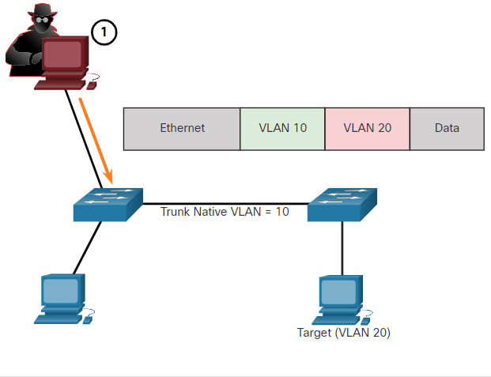

The frame arrives on the first switch, which looks at the first 4-byte 802.1Q tag. The switch sees that the frame is destined for VLAN 10, which is the native VLAN. The switch forwards the packet out all VLAN 10 ports after stripping the VLAN 10 tag. The frame is not retagged because it is part of the native VLAN. At this point, the VLAN 20 tag is still intact and has not been inspected by the first switch.

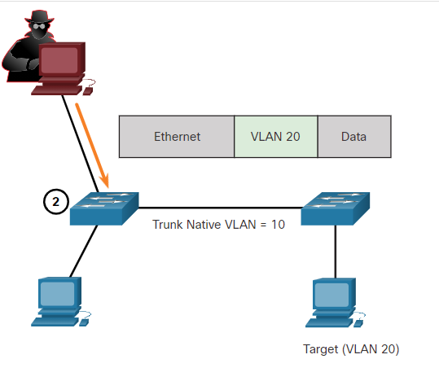

The frame arrives at the second switch which has no knowledge that it was supposed to be for VLAN 10. Native VLAN traffic is not tagged by the sending switch as specified in the 802.1Q specification. The second switch looks only at the inner 802.1Q tag that the threat actor inserted and sees that the frame is destined for VLAN 20, the target VLAN. The second switch sends the frame on to the target or floods it, depending on whether there is an existing MAC address table entry for the target.

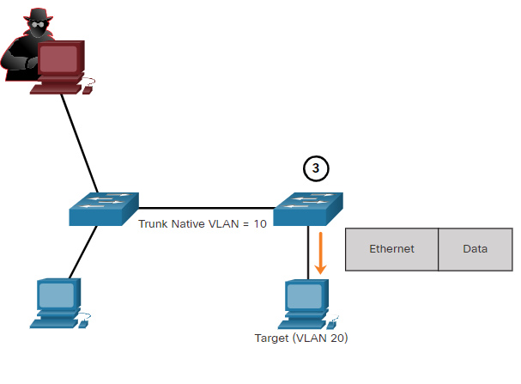

A VLAN double-tagging attack is unidirectional and works only when the attacker is connected to a port residing in the same VLAN as the native VLAN of the trunk port. The idea is that double tagging allows the attacker to send data to hosts or servers on a VLAN that otherwise would be blocked by some type of access control configuration. Presumably the return traffic will also be permitted, thus giving the attacker the ability to communicate with devices on the normally blocked VLAN.

**VLAN Attack Mitigation**

VLAN hopping and VLAN double-tagging attacks can be prevented by implementing the following trunk security guidelines, as discussed in a previous module:

* Disable trunking on all access ports.
* Disable auto trunking on trunk links so that trunks must be manually enabled.
* Be sure that the native VLAN is only used for trunk links.

10.5.4

## DHCP Messages

DHCP servers dynamically provide IP configuration information including IP address, subnet mask, default gateway, DNS servers, and more to clients. A review of the sequence of the DHCP message exchange between client and server is shown in the figure.

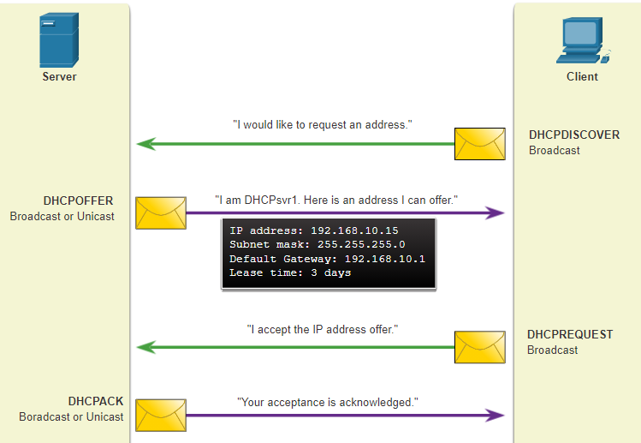

## DHCP Attacks

Two types of DHCP attacks are DHCP starvation and DHCP spoofing. Both attacks are mitigated by implementing DHCP snooping.

**DHCP Starvation Attack**

The goal of the DHCP Starvation attack is to create a DoS for connecting clients. DHCP starvation attacks require an attack tool such as Gobbler.

Gobbler has the ability to look at the entire scope of leasable IP addresses and tries to lease them all. Specifically, it creates DHCP discovery messages with bogus MAC addresses.

**DHCP Spoofing Attack**

A DHCP spoofing attack occurs when a rogue DHCP server is connected to the network and provides false IP configuration parameters to legitimate clients. A rogue server can provide a variety of misleading information:

* **Wrong default gateway** - The rogue server provides an invalid gateway or the IP address of its host to create a man-in-the-middle attack. This may go entirely undetected as the intruder intercepts the data flow through the network.
* **Wrong DNS server** - The rogue server provides an incorrect DNS server address pointing the user to a nefarious website.
* **Wrong IP address** - The rogue server provides an invalid IP address effectively creating a DoS attack on the DHCP client.
* **Threat Actor Connects Rogue DHCP Server**
* A threat actor successfully connects a rogue DHCP server to a switch port on the same subnet and VLANs as the target clients. The goal of the rogue server is to provide clients with false IP configuration information.

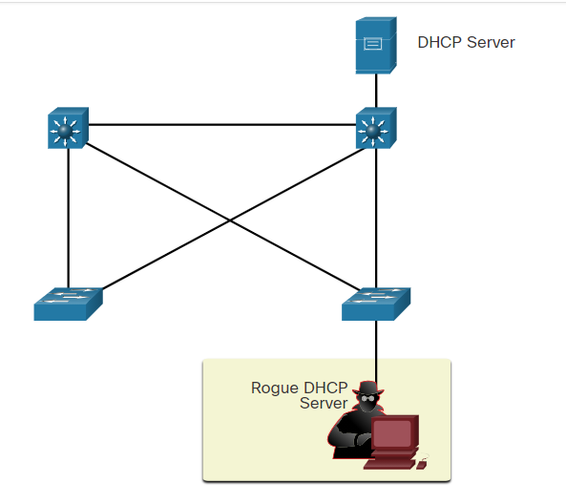

**Client Broadcasts DHCP Discovery Messages**

A legitimate client connects to the network and requires IP configuration parameters. Therefore, the client broadcasts a DHCP Discovery request looking for a response from a DHCP server. Both servers will receive the message and respond.

**Legitimate and Rogue DHCP Reply**

The legitimate DHCP server responds with valid IP configuration parameters. However, the rogue server also responds with a DHCP offer containing IP configuration parameters defined by the threat actor. The client will reply to the first offer received.

**Client Accepts Rogue DHCP Offer**

The rogue offer was received first, and therefore, the client broadcasts a DHCP request accepting the IP parameters defined by the threat actor. The legitimate and rogue server will receive the request.

**Rogue Server Acknowledges**

The rogue server unicasts a reply to the client to acknowledge its request. The legitimate server will cease communicating with the client.

## ARP Attacks

Recall that hosts broadcast ARP Requests to determine the MAC address of a host with a particular IPv4 address. This is typically done to discover the MAC address of the default gateway. All hosts on the subnet receive and process the ARP Request. The host with the matching IPv4 address in the ARP Request sends an ARP Reply.

According to the ARP RFC, a client is allowed to send an unsolicited ARP Request called a “gratuitous ARP.” When a host sends a gratuitous ARP, other hosts on the subnet store the MAC address and IPv4 address contained in the gratuitous ARP in their ARP tables.

The problem is that an attacker can send a gratuitous ARP message containing a spoofed MAC address to a switch, and the switch would update its MAC table accordingly. Therefore, any host can claim to be the owner of any IP and MAC address combination they choose. In a typical attack, a threat actor can send unsolicited ARP Replies to other hosts on the subnet with the MAC Address of the threat actor and the IPv4 address of the default gateway.

There are many tools available on the internet to create ARP man-in-the-middle attacks including dsniff, Cain & Abel, ettercap, Yersinia, and others. IPv6 uses ICMPv6 Neighbor Discovery Protocol for Layer 2 address resolution. IPv6 includes strategies to mitigate Neighbor Advertisement spoofing, similar to the way IPv6 prevents a spoofed ARP Reply.

ARP spoofing and ARP poisoning are mitigated by implementing DAI.

Step1 **Normal State with Converged MAC Tables**

Each device has an accurate MAC table with the correct IPv4 and MAC addresses for the other devices on the LAN.

Step 2 **ARP Spoofing Attack**

The threat actor sends two spoofed gratuitous ARP Replies in an attempt to replace R1 as the default gateway:

1. The first one informs all devices on the LAN that the threat actor’s MAC address (CC:CC:CC) maps to R1’s IPv4 address, 10.0.0.1.
2. The second one informs all devices on the LAN that the threat actor’s MAC address (CC:CC:CC) maps to PC1’s IPv4 address, 10.0.0.11.

Step 3 **ARP Poisoning Attack with Man-in-the-Middle Attack**

R1 and PC1 remove the correct entry for each other’s MAC address and replace it with PC2’s MAC address. The threat actor has now poisoned the ARP caches of all devices on the subnet. ARP poisoning leads to various man-in-the-middle attacks, posing a serious security threat to the network.

Address Spoofing Attack

IP addresses and MAC addresses can be spoofed for a variety of reasons. IP address spoofing is when a threat actor hijacks a valid IP address of another device on the subnet, or uses a random IP address. IP address spoofing is difficult to mitigate, especially when it is used inside a subnet in which the IP belongs.

MAC address spoofing attacks occur when the threat actors alter the MAC address of their host to match another known MAC address of a target host. The attacking host then sends a frame throughout the network with the newly-configured MAC address. When the switch receives the frame, it examines the source MAC address. The switch overwrites the current MAC table entry and assigns the MAC address to the new port, as shown in the figure. It then inadvertently forwards frames destined for the target host to the attacking host.

A threat agent on PC2 is connected to a switch at port Fa0/2. Connected to the switch at port Fa0/1 is PC1 with MAC BB:BB:BB. The threat agent is sending a message to the switch that says, my MAC is BB:BB:BB. The switch MAC address table now shows no MAC address mapped to port Fa0/1 but MAC BB:BB:BB mapped to port Fa0/1

PC2PC1Fa0/2Fa0/1

**MAC Address Table**

|  |  |
| --- | --- |
| **Port** | **MAC Address** |
| Fa0/1 |  |
| Fa0/2 | BB:BB:BB |

Note: MAC Addresses are shown as 24 bits for simplicity"My MAC is BB:BB:BB"MAC: BB:BB:BB

When the target host sends traffic, the switch will correct the error, realigning the MAC address to the original port. To stop the switch from returning the port assignment to its correct state, the threat actor can create a program or script that will constantly send frames to the switch so that the switch maintains the incorrect or spoofed information. There is no security mechanism at Layer 2 that allows a switch to verify the source of MAC addresses, which is what makes it so vulnerable to spoofing.

IP and MAC address spoofing can be mitigated by implementing IPSG.

10.5.9

STP Attack

Network attackers can manipulate the Spanning Tree Protocol (STP) to conduct an attack by spoofing the root bridge and changing the topology of a network. Attackers can make their hosts appear as root bridges; and therefore, capture all traffic for the immediate switched domain.

To conduct an STP manipulation attack, the attacking host broadcasts STP bridge protocol data units (BPDUs) containing configuration and topology changes that will force spanning-tree recalculations, as shown in the figure. The BPDUs sent by the attacking host announce a lower bridge priority in an attempt to be elected as the root bridge.

**Note**: These issues can occur when someone adds an Ethernet switch to the network without any malicious intent.

The diagram shows a threat agent and two switches connected together in a triangle, with the attacker at the bottom. Both ports between the attacker and the upper left switch are forwarding. Both ports on the connection between the switches are forwarding. On the link between the attacker and the upper right switch, the port on the attacker is blocking and the port on the switch is forwarding. The upper left switch is currently the root bridge with a priority of 8192. The attacker has sent S T P B P D Us to both switches with a priority of 0.

STP BDPU Priority = 0Root BridgeSTP BDPU Priority = 0ForwardBlockPriority = 8192

If successful, the attacking host becomes the root bridge, as shown in the figure, and can now capture a variety of frames that would otherwise not be accessible.

The diagram shows a threat agent and two switches connected together in a triangle, with the attacker at the bottom. The attacker has become the root bridge. Both ports between the attacker and the upper left switch are forwarding. Both ports on the link between the attacker and the upper right switch are also forwarding. On the connection between the upper switches, the switchport on the left is forwarding and the switchport on the right is blocking.

ForwardBlockRoot Bridge

This STP attack is mitigated by implementing BPDU Guard on all access ports. BPDU Guard is discussed in more detail later in the course.

10.5.10

CDP Reconnaissance

The Cisco Discovery Protocol (CDP) is a proprietary Layer 2 link discovery protocol. It is enabled on all Cisco devices by default. CDP can automatically discover other CDP-enabled devices and help auto-configure their connection. Network administrators also use CDP to help configure and troubleshoot network devices.

CDP information is sent out CDP-enabled ports in a periodic, unencrypted multicast. CDP information includes the IP address of the device, IOS software version, platform, capabilities, and the native VLAN. The device receiving the CDP message updates its CDP database.

CDP information is extremely useful in network troubleshooting. For example, CDP can be used to verify Layer 1 and 2 connectivity. If an administrator cannot ping a directly connected interface, but still receives CDP information, then the problem is most likely related to the Layer 3 configuration.

However, the information provided by CDP can also be used by a threat actor to discover network infrastructure vulnerabilities.

In the figure, a sample Wireshark capture displays the contents of a CDP packet. The attacker is able to identify the Cisco IOS software version used by the device. This allows the attacker to determine whether there were any security vulnerabilities specific to that particular version of IOS.

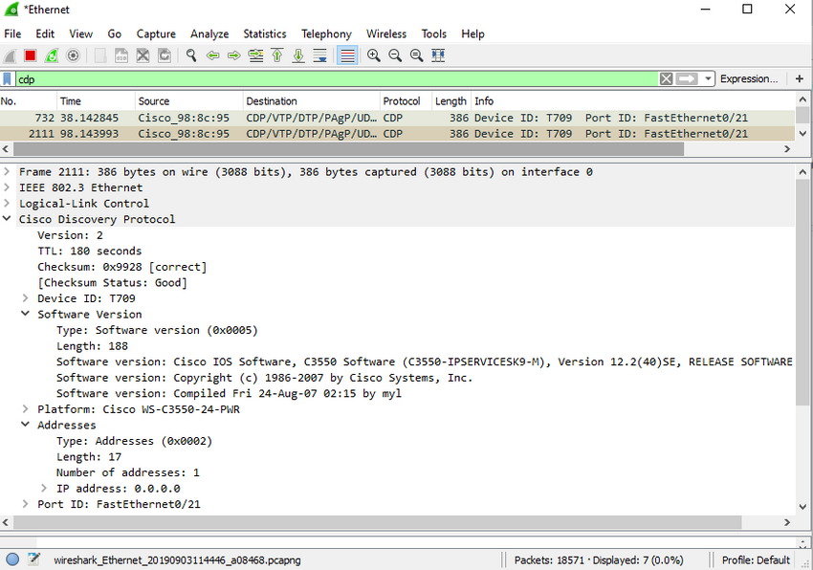

CDP broadcasts are sent unencrypted and unauthenticated. Therefore, an attacker could interfere with the network infrastructure by sending crafted CDP frames containing bogus device information to directly-connected Cisco devices.

To mitigate the exploitation of CDP, limit the use of CDP on devices or ports. For example, disable CDP on edge ports that connect to untrusted devices.

To disable CDP globally on a device, use the **no cdp run** global configuration mode command. To enable CDP globally, use the **cdp run** global configuration command.

To disable CDP on a port, use the **no cdp enable** interface configuration command. To enable CDP on a port, use the **cdp enable** interface configuration command.

**Note**: Link Layer Discovery Protocol (LLDP) is also vulnerable to reconnaissance attacks. Configure **no lldp run** to disable LLDP globally. To disable LLDP on the interface, configure **no lldp transmit** and **no lldp receive**.

## What did I learn in this module?

Endpoints are particularly susceptible to malware-related attacks that originate through email or web browsing, such as DDOS, date breaches, and malware. These endpoints have typically used traditional host-based security features, such as antivirus/antimalware, host-based firewalls, and host-based intrusion prevention systems (HIPSs). Endpoints are best protected by a combination of NAC, host-based AMP software, an email security appliance (ESA), and a web security appliance (WSA). Cisco WSA can perform blacklisting of URLs, URL-filtering, malware scanning, URL categorization, Web application filtering, and encryption and decryption of web traffic.

AAA controls who is permitted to access a network (authenticate), what they can do while they are there (authorize), and to audit what actions they performed while accessing the network (accounting). Authorization uses a set of attributes that describes the user’s access to the network. Accounting is combined with AAA authentication. The AAA server keeps a detailed log of exactly what the authenticated user does on the device. The IEEE 802.1X standard is a port-based access control and authentication protocol that restricts unauthorized workstations from connecting to a LAN through publicly accessible switch ports.

If Layer 2 is compromised, then all layers above it are also affected. The first step in mitigating attacks on the Layer 2 infrastructure is to understand the underlying operation of Layer 2 and the Layer 2 solutions: Port Security, DHCP Snooping, DAI, and IPSG. These won’t work unless management protocols are secured.

MAC address flooding attacks bombard the switch with fake source MAC addresses until the switch MAC address table is full. At this point, the switch treats the frame as an unknown unicast and begins to flood all incoming traffic out all ports on the same VLAN without referencing the MAC table. The threat actor can now capture all of the frames sent from one host to another on the local LAN or local VLAN. The threat actor uses **macof** to rapidly generate many random source and destination MAC and IP. To mitigate MAC table overflow attacks, network administrators must implement port security.

A VLAN hopping attack enables traffic from one VLAN to be seen by another VLAN without the aid of a router. The threat actor configures a host to act like a switch to take advantage of the automatic trunking port feature enabled by default on most switch ports.

A VLAN double-tagging attack is unidirectional and works only when the threat actor is connected to a port residing in the same VLAN as the native VLAN of the trunk port. Double tagging allows the threat actor to send data to hosts or servers on a VLAN that otherwise would be blocked by some type of access control configuration. Return traffic will also be permitted, letting the threat actor communicate with devices on the normally blocked VLAN.

VLAN hopping and VLAN double-tagging attacks can be prevented by implementing the following trunk security guidelines:

* Disable trunking on all access ports.
* Disable auto trunking on trunk links so that trunks must be manually enabled.
* Be sure that the native VLAN is only used for trunk links.

DHCP Attack: DHCP servers dynamically provide IP configuration information including IP address, subnet mask, default gateway, DNS servers, and more to clients. Two types of DHCP attacks are DHCP starvation and DHCP spoofing. Both attacks are mitigated by implementing DHCP snooping.

ARP Attack: A threat actor sends a gratuitous ARP message containing a spoofed MAC address to a switch, and the switch updates its MAC table accordingly. Now the threat actor sends unsolicited ARP Requests to other hosts on the subnet with the MAC Address of the threat actor and the IP address of the default gateway. ARP spoofing and ARP poisoning are mitigated by implementing DAI.

Address Spoofing Attack: IP address spoofing is when a threat actor hijacks a valid IP address of another device on the subnet or uses a random IP address. MAC address spoofing attacks occur when the threat actors alter the MAC address of their host to match another known MAC address of a target host. IP and MAC address spoofing can be mitigated by implementing IPSG.

STP Attack: Threat actors manipulate STP to conduct an attack by spoofing the root bridge and changing the topology of a network. Threat actors make their hosts appear as root bridges; therefore, capturing all traffic for the immediate switched domain. This STP attack is mitigated by implementing BPDU Guard on all access ports

CDP Reconnaissance: CDP information is sent out CDP-enabled ports in a periodic, unencrypted multicast. CDP information includes the IP address of the device, IOS software version, platform, capabilities, and the native VLAN. The device receiving the CDP message updates its CDP database. the information provided by CDP can also be used by a threat actor to discover network infrastructure vulnerabilities. To mitigate the exploitation of CDP, limit the use of CDP on devices or ports.

What is a recommended best practice when dealing with the native VLAN? Assign it to an unused VLAN.

On what switch ports should PortFast be enabled to enhance STP stability? all end-user ports

Which command would be best to use on an unused switch port if a company adheres to the best practices as recommended by Cisco? **Shutdown**

Which two features on a Cisco Catalyst switch can be used to mitigate DHCP starvation and DHCP spoofing attacks? (Choose two.) port security , DHCP snooping

What is the best way to prevent a VLAN hopping attack? Disable trunk negotiation for trunk ports and statically set nontrunk ports as access ports.

Which procedure is recommended to mitigate the chances of ARP spoofing? Enable DHCP snooping on selected VLANs.

What are two types of switch ports that are used on Cisco switches as part of the defense against DHCP spoofing attacks? (Choose two.) untrusted port , trusted DHCP port

Which two commands can be used to enable PortFast on a switch? (Choose two.) S1(config)# **spanning-tree portfast default** , S1(config-if)# **spanning-tree portfast**

An administrator who is troubleshooting connectivity issues on a switch notices that a switch port configured for port security is in the err-disabled state. After verifying the cause of the violation, how should the administrator re-enable the port without disrupting network operation? Issue the **shutdown** command followed by the **no shutdown** command on the interface.

A network administrator is configuring DHCP snooping on a switch. Which configuration command should be used first? **ip dhcp snooping**

A network administrator is configuring DAI on a switch with the command **ip arp inspection validate dst-mac**. What is the purpose of this configuration command? to check the destination MAC address in the Ethernet header against the target MAC address in the ARP body

Which security feature should be enabled in order to prevent an attacker from overflowing the MAC address table of a switch? port security

What Layer 2 attack is mitigated by disabling Dynamic Trunking Protocol? VLAN hopping

A network administrator is configuring DAI on a switch. Which command should be used on the uplink interface that connects to a router? **ip arp inspection trust**

Where are dynamically learned MAC addresses stored when sticky learning is enabled with the **switchport port-security mac-address sticky** command? RAM

Which of the following wireless networks typically uses lower powered transmitters for short ranges? WPAN

Which of the following wireless networks are specified in the IEEE 802.11 standards for the 2.4 GHz and 5 GHz radio frequencies? WLAN

Which of the following is an IEEE 802.15 WPAN standard that uses a device-pairing process to communicate? Bluetooth

Which 802.11 standards exclusively use the 5 GHz radio frequency? (Choose 2) 802.11a , 802.11ac

Which standards organization is responsible for allocating radio frequencies? ITU-RTrue or False: Laptops that do not have an integrated wireless NIC can only be attached to the network through a wired connection. False

Which of the following components are integrated in a wireless home router? (Choose three.)Access point , Switch , Router

True or False: When you need to expand the coverage of a small network, the best solution is to use a range extender. False

Which of the following is a standalone device, like a home router, where the entire WLAN configuration resides on the device? Autonomous AP

Which of the following antennas provide 360 degrees of coverage? Omnidirectional

Which wireless topology mode is used by two devices to connect in a peer-to-peer network? Ad hoc

True or False: An ESS is created when two or more BSSs need to be joined to support roaming clients. True

How many address fields are in the 802.11 wireless frame? 4

What is the term for an AP that openly advertises its service periodically? Passive

What is the term for an AP that does not send a beacon, but waits for clients to send probes? Active

What IP versions does CAPWAP support? IPv4 by default, but can configure IPv6

What UDP ports and IP protocols are used by CAPWAP for IPv4? (Choose three.) 17 , 5246 , 5247

What UDP ports and IP protocols are used by CAPWAP for IPv6? (Choose three.) 136 , 5246 , 5247

In the split MAC architecture for CAPWAP, which of the following are the responsibility of the AP? (Choose four.) Packet acknowledgments and retransmissions , Beacons and probe responses ,

MAC layer data encryption and decryption , Frame queueing and packet prioritization

In the split MAC architecture for CAPWAP, which of the following are the responsibility of the WLC? (Choose four.) Authentication , Association and re-association of roaming clients ,Termination of 802.11 traffic on a wired interface , Frame translation to other protocols

True or False: DTLS is enabled by default on the control and data CAPWAP tunnels. False

Which of the following statements are true about modes of operation for a FlexConnect AP?

In standalone mode, the WLC is unreachable and the AP switches local traffic and performs client authentication locally. ,

In connect mode, the WLC is reachable and performs all its CAPWAP functions.

Which of the following modulation techniques rapidly switches a signal among frequency channels? FHSS

Which of the following modulation techniques spreads a signal over a larger frequency band? DSSS

Which of the following modulation techniques is used in the new 802.11ax standard? OFDMA

How many channels are available for the 2.4 GHz band in Europe? 13

How many channels are available for the 5 GHz band? 24

Which of the following is most likely NOT the source of a wireless DoS attack? Rogue AP

True or False: A rogue AP is a misconfigured AP connected to the network and a possible source of DoS attacks. False

What type of attack is an “evil twin AP” attack? MITM

What are the best ways to secure WLANs? (Choose two.) Authentication , Encryption

Which of the following authentication methods does not use a password shared between the wireless client and the AP? Open

Which encryption method is used by the original 802.11 specification? RC4

Which of the following encryption methods uses CCMP to recognize if the encrypted and non-encrypted bits have been altered? AES

Which of the following authentication methods has the user enter a pre-shared password? (Choose two) WPA Personal , WPA2 Personal

In the context of mobile devices, what does the term tethering involve? connecting a mobile device to another mobile device or computer to share a network connection

Which feature of 802.11n wireless access points allows them to transmit data at faster speeds than previous versions of 802.11 Wi-Fi standards did? MIMO

Which method of wireless authentication is currently considered to be the strongest? WPA2

Which parameter is commonly used to identify a wireless network name when a home wireless AP is being configured? SSID

Which characteristic describes a wireless client operating in active mode? must know the SSID to connect to an AP

Which IEEE standard operates at wireless frequencies in both the 5 GHz and 2.4 GHz ranges?

802.11n

Which statement describes an autonomous access point? It is a standalone access point.

Which two roles are typically performed by a wireless router that is used in a home or small business? (Choose two.) Ethernet switch , access point

Which protocol and port numbers are used by both IPv4 and IPv6 CAPWAP tunnels? (Choose two.) 5246 and 5247 , UDP

If three 802.11b access points need to be deployed in close proximity, which three frequency channels should be used? (Choose three.) 6 , 11 , 1

Which type of telecommunication technology is used to provide Internet access to vessels at sea? satellite

Which wireless network topology is being configured by a technician who is installing a keyboard, a mouse, and headphones, each of which uses Bluetooth? ad hoc mode

Which type of wireless topology is created when two or more Basic Service Sets are interconnected by Ethernet? ESS

What Wi-Fi management frame is regularly broadcast by APs to announce their presence? beacon

Secure Unused Ports

Layer 2 devices are considered to be the weakest link in a company’s security infrastructure. Layer 2 attacks are some of the easiest for hackers to deploy but these threats can also be mitigated with some common Layer 2 solutions.

All switch ports (interfaces) should be secured before the switch is deployed for production use. How a port is secured depends on its function.

A simple method that many administrators use to help secure the network from unauthorized access is to disable all unused ports on a switch. For example, if a Catalyst 2960 switch has 24 ports and there are three Fast Ethernet connections in use, it is good practice to disable the 21 unused ports. Navigate to each unused port and issue the Cisco IOS **shutdown** command. If a port must be reactivated at a later time, it can be enabled with the **no shutdown** command.

To configure a range of ports, use the **interface range** command.

Switch(config)# **interface range** *type module/first-number – last-number*

For example, to shutdown ports for Fa0/8 through Fa0/24 on S1, you would enter the following command.

S1(config)# **interface range fa0/8 - 24**

S1(config-if-range)# **shutdown**

%LINK-5-CHANGED: Interface FastEthernet0/8, changed state to administratively down

(output omitted)

%LINK-5-CHANGED: Interface FastEthernet0/24, changed state to administratively down

S1(config-if-range)#

11.1.2

Mitigate MAC Address Table Attacks

The simplest and most effective method to prevent MAC address table overflow attacks is to enable port security.

Port security limits the number of valid MAC addresses allowed on a port. It allows an administrator to manually configure MAC addresses for a port or to permit the switch to dynamically learn a limited number of MAC addresses. When a port configured with port security receives a frame, the source MAC address of the frame is compared to the list of secure source MAC addresses that were manually configured or dynamically learned on the port.

By limiting the number of permitted MAC addresses on a port to one, port security can be used to control unauthorized access to the network, as shown in the figure.

The graphic shows a switch connected to three devices. Above the switch is a MAC address table with port 0/1 with allowed MAC AA:AA:AA, port 0/2 allowed MAC BB:BB:BB, and port 0/2 allowed MAC CC:CC:CC. The switch shows that port 0/1 that is connected to a P C with a MAC address of AA:AA:AA. This link has a green check. Then port 0/2 off of the switch is connected to a rogue laptop with the MAC address of BA:AD:01. The link has a red circle with a line through it. Port 0/3 off of the switch is also connected to a rogue laptop with the MAC address of BA:AD:02. This link also has a red circle with a line through it.

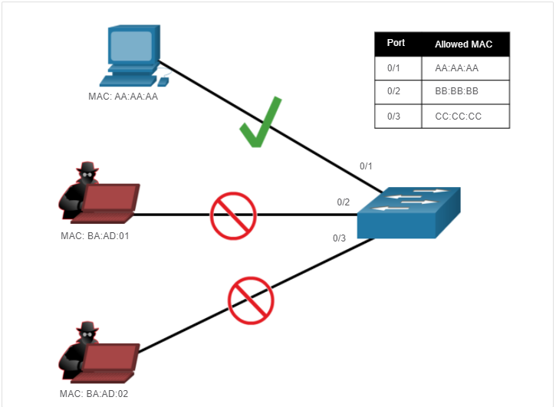

MAC: AA:AA:AAMAC: BA:AD:01MAC: BA:AD:020/10/20/3PortAllowed MAC0/10/20/3AA:AA:AABB:BB:BBCC:CC:CC

**Note**: MAC addresses are shown as 24 bits for simplicity.

11.1.3

Enable Port Security

Notice in the example, the **switchport port-security** command was rejected. This is because port security can only be configured on manually configured access ports or manually configured trunk ports. By default, Layer 2 switch ports are set to dynamic auto (trunking on). Therefore, in the example, the port is configured with the **switchport mode access** interface configuration command.

**Note**: Trunk port security is beyond the scope of this course.

S1(config)# **interface f0/1**

S1(config-if)# **switchport port-security**

Command rejected: FastEthernet0/1 is a dynamic port.

S1(config-if)# **switchport mode access**

S1(config-if)# **switchport port-security**

S1(config-if)# **end**

S1#

Use the **show port-security interface** command to display the current port security settings for FastEthernet 0/1, as shown in the example. Notice how port security is enabled, port status is Secure-down which means there are no devices attached and no violation has occurred, the violation mode is Shutdown, and how the maximum number of MAC addresses is 1. If a device is connected to the port, the switch port status would display Secure-up and the switch will automatically add the device’s MAC address as a secure MAC. In this example, no device is connected to the port.

S1# **show port-security interface f0/1**

Port Security : Enabled

Port Status : Secure-down

Violation Mode : Shutdown

Aging Time : 0 mins

Aging Type : Absolute

SecureStatic Address Aging : Disabled

Maximum MAC Addresses : 1

Total MAC Addresses : 0

Configured MAC Addresses : 0

Sticky MAC Addresses : 0

Last Source Address:Vlan : 0000.0000.0000:0

Security Violation Count : 0

S1#

**Note**: If an active port is configured with the **switchport port-security** command and more than one device is connected to that port, the port will transition to the error-disabled state. This condition is discussed later in this topic.

After port security is enabled, other port security specifics can be configured, as shown in the example.

S1(config-if)# **switchport port-security ?**

aging Port-security aging commands

mac-address Secure mac address

maximum Max secure addresses

violation Security violation mode <cr>

S1(config-if)# **switchport port-security**

11.1.4

Limit and Learn MAC Addresses

To set the maximum number of MAC addresses allowed on a port, use the following command:

Switch(config-if)# **switchport port-security maximum** *value*

The default port security value is 1. The maximum number of secure MAC addresses that can be configured depends the switch and the IOS. In this example, the maximum is 8192.

S1(config)# **interface f0/1**

S1(config-if)# **switchport port-security maximum ?**

<1-8192> Maximum addresses

S1(config-if)# **switchport port-security maximum**

The switch can be configured to learn about MAC addresses on a secure port in one of three ways:

**1. Manually Configured**

The administrator manually configures a static MAC address(es) by using the following command for each secure MAC address on the port:

Switch(config-if)# **switchport port-security mac-address** *mac-address*

**2. Dynamically Learned**

When the **switchport port-security** command is entered, the current source MAC for the device connected to the port is automatically secured but is not added to the startup configuration. If the switch is rebooted, the port will have to re-learn the device’s MAC address.

**3. Dynamically Learned – Sticky**

The administrator can enable the switch to dynamically learn the MAC address and “stick” them to the running configuration by using the following command:

Switch(config-if)# **switchport port-security mac-address sticky**

Saving the running configuration will commit the dynamically learned MAC address to NVRAM.

The following example demonstrates a complete port security configuration for FastEthernet 0/1 with a host connected to port Fa0/1. The administrator specifies a maximum of 2 MAC addresses, manually configures one secure MAC address, and then configures the port to dynamically learn additional secure MAC addresses up to the 2 secure MAC address maximum. Use the **show port-security interface** and the **show port-security address** command to verify the configuration.

*Mar 1 00:12:38.179: %LINK-3-UPDOWN: Interface FastEthernet0/1, changed state to up

*Mar 1 00:12:39.194: %LINEPROTO-5-UPDOWN: Line protocol on Interface FastEthernet0/1, changed state to up

S1#**conf t**

Enter configuration commands, one per line. End with CNTL/Z.

S1(config)#

S1(config)# **interface fa0/1**

S1(config-if)# **switchport mode access**

S1(config-if)# **switchport port-security**

S1(config-if)# **switchport port-security maximum 2**

S1(config-if)# **switchport port-security mac-address aaaa.bbbb.1234**

S1(config-if)# **switchport port-security mac-address sticky**

S1(config-if)# **end**

S1# **show port-security interface fa0/1**

Port Security : Enabled

Port Status : Secure-up

Violation Mode : Shutdown

Aging Time : 0 mins

Aging Type : Absolute

SecureStatic Address Aging : Disabled

Maximum MAC Addresses : 2

Total MAC Addresses : 2

Configured MAC Addresses : 1

Sticky MAC Addresses : 1

Last Source Address:Vlan : a41f.7272.676a:1

Security Violation Count : 0

S1# **show port-security address**

Secure Mac Address Table

-----------------------------------------------------------------------------

Vlan Mac Address Type Ports Remaining Age

(mins)

---- ----------- ---- ----- -------------

1 a41f.7272.676a SecureSticky Fa0/1 -

1 aaaa.bbbb.1234 SecureConfigured Fa0/1 -

-----------------------------------------------------------------------------

Total Addresses in System (excluding one mac per port) : 1

Max Addresses limit in System (excluding one mac per port) : 8192

S1#

The output of the **show port-security interface** command verifies that port security is enabled, there is a host connected to the port (i.e., Secure-up), a total of 2 MAC addresses will be allowed, and S1 has learned one MAC address statically and one MAC address dynamically (i.e., sticky).

The output of the **show port-security address** command lists the two learned MAC addresses.

11.1.5

Port Security Aging

Port security aging can be used to set the aging time for static and dynamic secure addresses on a port. Two types of aging are supported per port:

* **Absolute** - The secure addresses on the port are deleted after the specified aging time.
* **Inactivity** - The secure addresses on the port are deleted only if they are inactive for the specified aging time.

Use aging to remove secure MAC addresses on a secure port without manually deleting the existing secure MAC addresses. Aging time limits can also be increased to ensure past secure MAC addresses remain, even while new MAC addresses are added. Aging of statically configured secure addresses can be enabled or disabled on a per-port basis.

Use the **switchport port-security aging** command to enable or disable static aging for the secure port, or to set the aging time or type.

Switch(config-if)# **switchport port-security aging** { **static** | **time** *time* | **type** {**absolute** | **inactivity**}}

The parameters for the command are described in the table.

| Parameter Description staticEnable aging for statically configured secure addresses on this port.time time Specify the aging time for this port. The range is 0 to 1440 minutes. If the time is 0, aging is disabled for this port.type absoluteSet the absolute aging time. All the secure addresses on this port age out exactly after the time (in minutes) specified and are removed from the secure address list.type inactivitySet the inactivity aging type. The secure addresses on this port age out only if there is no data traffic from the secure source address for the specified time period. | |
| --- | --- |
| **Parameter** | **Description** |
| **static** | Enable aging for statically configured secure addresses on this port. |
| **time** *time* | Specify the aging time for this port. The range is 0 to 1440 minutes. If the time is 0, aging is disabled for this port. |
| **type absolute** | Set the absolute aging time. All the secure addresses on this port age out exactly after the time (in minutes) specified and are removed from the secure address list. |
| **type inactivity** | Set the inactivity aging type. The secure addresses on this port age out only if there is no data traffic from the secure source address for the specified time period. |

**Note**: MAC addresses are shown as 24 bits for simplicity.

The example shows an administrator configuring the aging type to 10 minutes of inactivity and by using the **show port-security interface** command to verify the configuration.

S1(config)# **interface fa0/1**

S1(config-if)# **switchport port-security aging time 10**

S1(config-if)# **switchport port-security aging type inactivity**

S1(config-if)# **end**

S1# **show port-security interface fa0/1**

Port Security : Enabled

Port Status : Secure-up

Violation Mode : Shutdown

Aging Time : 10 mins

Aging Type : Inactivity

SecureStatic Address Aging : Disabled

Maximum MAC Addresses : 2

Total MAC Addresses : 2

Configured MAC Addresses : 1

Sticky MAC Addresses : 1

Last Source Address:Vlan : a41f.7272.676a:1

Security Violation Count : 0

S1#

11.1.6

Port Security Violation Modes

If the MAC address of a device attached to the port differs from the list of secure addresses, then a port violation occurs. By default, the port enters the error-disabled state.

To set the port security violation mode, use the following command:

Switch(config-if)# **switchport port-security violation** { **protect** | **restrict** | **shutdown**}

The following tables show how a switch reacts based on the configured violation mode.

Security Violation Mode Descriptions

| ModeDescriptionshutdown(default)The port transitions to the error-disabled state immediately, turns off the port LED, and sends a syslog message. It increments the violation counter. When a secure port is in the error-disabled state, an administrator must re-enable it by entering the shutdown and no shutdown commands. restrictThe port drops packets with unknown source addresses until you remove a sufficient number of secure MAC addresses to drop below the maximum value or increase the maximum value. This mode causes the Security Violation counter to increment and generates a syslog message.protectThis is the least secure of the security violation modes. The port drops packets with unknown MAC source addresses until you remove a sufficient number of secure MAC addresses to drop below the maximum value or increase the maximum value. No syslog message is sent. | |
| --- | --- |
| **Mode** | **Description** |
| **shutdown**  (default) | The port transitions to the error-disabled state immediately, turns off the port LED, and sends a syslog message. It increments the violation counter. When a secure port is in the error-disabled state, an administrator must re-enable it by entering the **shutdown** and **no shutdown** commands. |
| **restrict** | The port drops packets with unknown source addresses until you remove a sufficient number of secure MAC addresses to drop below the maximum value or increase the maximum value. This mode causes the Security Violation counter to increment and generates a syslog message. |
| **protect** | This is the least secure of the security violation modes. The port drops packets with unknown MAC source addresses until you remove a sufficient number of secure MAC addresses to drop below the maximum value or increase the maximum value. No syslog message is sent. |

Security Violation Mode Comparison

| Violation Mode Discards Offending Traffic Sends Syslog MessageIncrease Violation CounterShuts Down PortProtect Yes No No NoRestrict YesYes Yes NoShutdown YesYes Yes Yes | | | | |
| --- | --- | --- | --- | --- |
| **Violation Mode** | **Discards Offending Traffic** | **Sends Syslog Message** | **Increase Violation Counter** | **Shuts Down Port** |
| Protect | Yes | No | No | No |
| Restrict | Yes | Yes | Yes | No |
| Shutdown | Yes | Yes | Yes | Yes |

The following example shows an administrator changing the security violation to “restrict”. The output of the **show port-security interface** command confirms that the change has been made.

S1(config)# **interface f0/1**

S1(config-if)# **switchport port-security violation restrict**

S1(config-if)# **end**

S1#

S1# **show port-security interface f0/1**

Port Security : Enabled

Port Status : Secure-up

Violation Mode : Restrict

Aging Time : 10 mins

Aging Type : Inactivity

SecureStatic Address Aging : Disabled

Maximum MAC Addresses : 2

Total MAC Addresses : 2

Configured MAC Addresses : 1

Sticky MAC Addresses : 1

Last Source Address:Vlan : a41f.7272.676a:1

Security Violation Count : 0

S1#

11.1.7

Ports in error-disabled State

What happens when the port security violation is shutdown and a port violation occurs? The port is physically shutdown and placed in the error-disabled state, and no traffic is sent or received on that port.

In the figure, the port security violation is changed back to the default shutdown setting. Then the host with MAC address a41f.7272.676a is disconnected and a new host is plugged into Fa0/1.

Notice how a series of port security related messages are generated on the console.

S1(config)# **int fa0/1**

S1(config-if)# **switchport port-security violation shutdown**

S1(config-if)# **end**

S1#

*Mar 1 00:24:15.599: %LINEPROTO-5-UPDOWN: Line protocol on Interface FastEthernet0/1, changed state to down

*Mar 1 00:24:16.606: %LINK-3-UPDOWN: Interface FastEthernet0/1, changed state to down

*Mar 1 00:24:19.114: %LINK-3-UPDOWN: Interface FastEthernet0/1, changed state to up

*Mar 1 00:24:20.121: %LINEPROTO-5-UPDOWN: Line protocol on Interface FastEthernet0/1, changed state to up

S1#

*Mar 1 00:24:32.829: %PM-4-ERR_DISABLE: psecure-violation error detected on Fa0/1, putting Fa0/1 in err-disable state

*Mar 1 00:24:32.838: %PORT_SECURITY-2-PSECURE_VIOLATION: Security violation occurred, caused by MAC address a41f.7273.018c on port FastEthernet0/1.

*Mar 1 00:24:33.836: %LINEPROTO-5-UPDOWN: Line protocol on Interface FastEthernet0/1, changed state to down

*Mar 1 00:24:34.843: %LINK-3-UPDOWN: Interface FastEthernet0/1, changed state to down

S1#

**Note**: The port protocol and link status are changed to down and the port LED is turned off.

In the example, the **show interface** command identifies the port status as **err-disabled**. The output of the **show port-security** interface command now shows the port status as Secure-shutdown instead of Secure-up. The Security Violation counter increments by 1.

S1# **show interface fa0/1 | include down**

FastEthernet0/18 is down, line protocol is down (err-disabled)

(output omitted)

S1# **show port-security interface fa0/1**

Port Security : Enabled

Port Status : Secure-shutdown

Violation Mode : Shutdown

Aging Time : 10 mins

Aging Type : Inactivity

SecureStatic Address Aging : Disabled

Maximum MAC Addresses : 2

Total MAC Addresses : 2

Configured MAC Addresses : 1

Sticky MAC Addresses : 1

Last Source Address:Vlan : a41f.7273.018c:1

Security Violation Count : 1

S1#

The administrator should determine what caused the security violation If an unauthorized device is connected to a secure port, the security threat is eliminated before re-enabling the port.

In the next example, the first host is reconnected to Fa0/1. To re-enable the port, first use the **shutdown** command, then, use the **no shutdown** command to make the port operational, as shown in the example.

S1(config)# **interface fa0/1**

S1(config-if)# **shutdown**

S1(config-if)#

*Mar 1 00:39:54.981: %LINK-5-CHANGED: Interface FastEthernet0/1, changed state to administratively down

S1(config-if)# **no shutdown**

S1(config-if)#

*Mar 1 00:40:04.275: %LINK-3-UPDOWN: Interface FastEthernet0/1, changed state to up

*Mar 1 00:40:05.282: %LINEPROTO-5-UPDOWN: Line protocol on Interface FastEthernet0/1, changed state to up

S1(config-if)#

11.1.8

Verify Port Security

After configuring port security on a switch, check each interface to verify that the port security is set correctly, and check to ensure that the static MAC addresses have been configured correctly.

**Port Security for All Interfaces**

To display port security settings for the switch, use the **show port-security** command. The example indicates that only one port is configured with the switchport port-security command.

S1# **show port-security**

Secure Port MaxSecureAddr CurrentAddr SecurityViolation Security Action

(Count) (Count) (Count)

---------------------------------------------------------------------------

Fa0/1 2 2 0 Shutdown

---------------------------------------------------------------------------

Total Addresses in System (excluding one mac per port) : 1

Max Addresses limit in System (excluding one mac per port) : 8192

S1#

**Port Security for a Specific Interface**

Use the **show port-security interface** command to view details for a specific interface, as shown previously and in this example.

S1# **show port-security interface fastethernet 0/1**

Port Security : Enabled

Port Status : Secure-up

Violation Mode : Shutdown

Aging Time : 10 mins

Aging Type : Inactivity

SecureStatic Address Aging : Disabled

Maximum MAC Addresses : 2

Total MAC Addresses : 2

Configured MAC Addresses : 1

Sticky MAC Addresses : 1

Last Source Address:Vlan : a41f.7273.018c:1

Security Violation Count : 0

S1#

**Verify Learned MAC Addresses**

To verify that MAC addresses are “sticking” to the configuration, use the **show run** command as shown in the example for FastEthernet 0/19.

S1# **show run interface fa0/1**

Building configuration...

Current configuration : 365 bytes

!

interface FastEthernet0/1

switchport mode access

switchport port-security maximum 2

switchport port-security mac-address sticky

switchport port-security mac-address sticky a41f.7272.676a

switchport port-security mac-address aaaa.bbbb.1234

switchport port-security aging time 10

switchport port-security aging type inactivity

switchport port-security

end

S1#

**Verify Secure MAC Addresses**

To display all secure MAC addresses that are manually configured or dynamically learned on all switch interfaces, use the **show port-security address** command as shown in the example.

S1# **show port-security address**

Secure Mac Address Table

-----------------------------------------------------------------------------

Vlan Mac Address Type Ports Remaining Age

(mins)

---- ----------- ---- ----- -------------

1 a41f.7272.676a SecureSticky Fa0/1 -

1 aaaa.bbbb.1234 SecureConfigured Fa0/1 -

-----------------------------------------------------------------------------

Total Addresses in System (excluding one mac per port) : 1

Max Addresses limit in System (excluding one mac per port) : 8192

S1#

Syntax Checker - Implement Port Security

Implement port security for a switch interface based on the specified requirements

You are currently logged into S1. Configure FastEthernet 0/5 for port security by using the following requirements:

* Use the interface name **fa0/5** to enter interface configuration mode.
* Enable the port for access mode.
* Enable port security.
* Set the maximum number of MAC address to 3.
* Statically configure the MAC address aaaa.bbbb.1234.
* Configure the port to dynamically learn additional MAC addresses and dynamically add them to the running configuration.
* Return to privileged EXEC mode.

S1(config)#interface fa0/5

S1(config-if)#switchport mode access

S1(config-if)#switchport port-security

S1(config-if)#switchport port-security maximum 3

S1(config-if)#switchport port-security mac-address aaaa.bbbb.1234

S1(config-if)#switchport port-security mac-address sticky

S1(config-if)#end

Enter the command to verify port security for all interfaces.

S1#show port-security

Secure Port MaxSecureAddr CurrentAddr SecurityViolation Security Action

(Count) (Count) (Count)

---------------------------------------------------------------------------

Fa0/5 3 2 0 Shutdown

---------------------------------------------------------------------------

Total Addresses in System (excluding one mac per port) : 0

Max Addresses limit in System (excluding one mac per port) : 8192

Enter the command to verify port security on FastEthernet 0/5. Use **fa0/5** for the interface name.

S1#show port-security interface fa0/5

Port Security : Enabled

Port Status : Secure-up

Violation Mode : Shutdown

Aging Time : 0 mins

Aging Type : Absolute

SecureStatic Address Aging : Disabled

Maximum MAC Addresses : 3

Total MAC Addresses : 2

Configured MAC Addresses : 1

Sticky MAC Addresses : 1

Last Source Address:Vlan : 0090.2135.6B8C:1

Security Violation Count : 0

Enter the command that will display all of the addresses to verify that the manually configured and dynamically learned MAC addresses are in the running configuration.

S1#show port-security address

Secure Mac Address Table

-----------------------------------------------------------------------------

Vlan Mac Address Type Ports Remaining Age

(mins)

---- ----------- ---- ----- -------------

1 0090.2135.6b8c SecureSticky Fa0/5 -

1 aaaa.bbbb.1234 SecureConfigured Fa0/5 -

-----------------------------------------------------------------------------

Total Addresses in System (excluding one mac per port) : 0

Max Addresses limit in System (excluding one mac per port) : 8192

You have successfully configured and verified port security for the interface.

Mitigate VLAN Attacks

11.2.1

VLAN Attacks Review

As a quick review**,** a VLAN hopping attack can be launched in one of three ways:

* Spoofing DTP messages from the attacking host to cause the switch to enter trunking mode. From here, the attacker can send traffic tagged with the target VLAN, and the switch then delivers the packets to the destination.
* Introducing a rogue switch and enabling trunking. The attacker can then access all the VLANs on the victim switch from the rogue switch.
* Another type of VLAN hopping attack is a double-tagging (or double-encapsulated) attack. This attack takes advantage of the way hardware on most switches operate.

11.2.2

Steps to Mitigate VLAN Hopping Attacks

Use the following steps to mitigate VLAN hopping attacks:

**Step 1**: Disable DTP (auto trunking) negotiations on non-trunking ports by using the **switchport mode access** interface configuration command.

**Step 2**: Disable unused ports and put them in an unused VLAN.

**Step 3**: Manually enable the trunk link on a trunking port by using the **switchport mode trunk** command.

**Step 4**: Disable DTP (auto trunking) negotiations on trunking ports by using the **switchport nonegotiate** command.

**Step 5**: Set the native VLAN to a VLAN other than VLAN 1 by using the **switchport trunk native vlan** *vlan_number* command.

For example, assume the following:

* FastEthernet ports 0/1 through fa0/16 are active access ports
* FastEthernet ports 0/17 through 0/20 are not currently in use
* FastEthernet ports 0/21 through 0/24 are trunk ports.

VLAN hopping can be mitigated by implementing the following configuration.

S1(config)# **interface range fa0/1 - 16**

S1(config-if-range)# **switchport mode access**

S1(config-if-range)# **exit**

S1(config)#

S1(config)# **interface range fa0/17 - 20**

S1(config-if-range)# **switchport mode access**

S1(config-if-range)# **switchport access vlan 1000**

S1(config-if-range)# **shutdown**

S1(config-if-range)# **exit**

S1(config)#

S1(config)# **interface range fa0/21 - 24**

S1(config-if-range)# **switchport mode trunk**

S1(config-if-range)# **switchport nonegotiate**

S1(config-if-range)# **switchport trunk native vlan 999**

S1(config-if-range)# **end**

S1#

* FastEthernet ports 0/1 to 0/16 are access ports and therefore trunking is disabled by explicitly making them access ports.
* FastEthernet ports 0/17 to 0/20 are unused ports and are disabled and assigned to an unused VLAN.
* FastEthernet ports 0/21 to 0/24 are trunk links and are manually enabled as trunks with DTP disabled. The native VLAN is also changed from the default VLAN 1 to an unused VLAN 999.

11.2.3

Syntax Checker - Mitigate VLAN Hopping Attacks

Mitigate VLAN hopping attacks on the switch based on the specified requirements.

You are currently logged into S1. The ports status of the ports are as follows:

* FastEthernet ports 0/1 through 0/4 are used for trunking with other switches.
* FastEthernet ports 0/5 through 0/10 are unused.
* FastEthernet ports 0/11 through 0/24 are active ports currently in use.

Use **range fa0/1 - 4** to enter interface configuration mode for the trunks.

S1(config)#interface range fa0/1 - 4

Configure the interfaces as nonnegotiating trunks assigned to default VLAN 99.

S1(config-if-range)#switchport mode trunk

S1(config-if-range)#switchport nonegotiate

S1(config-if-range)#switchport trunk native vlan 99

S1(config-if-range)# exit

Use **range fa0/5 - 10** to enter interface configuration mode for the unused ports.

S1(config)#interface range fa0/5 - 10

Configure the unused ports as access ports, assign them to VLAN 86, and shutdown the ports.

S1(config-if-range)#switchport mode access

S1(config-if-range)#switchport access vlan 86

% Access VLAN does not exist. Creating vlan 86

S1(config-if-range)#shutdown

*Mar 1 00:28:48.883: %LINK-5-CHANGED: Interface FastEthernet0/5, changed state to administratively down

*Mar 1 00:28:48.900: %LINK-5-CHANGED: Interface FastEthernet0/6, changed state to administratively down

*Mar 1 00:28:48.908: %LINK-5-CHANGED: Interface FastEthernet0/7, changed state to administratively down

*Mar 1 00:28:48.917: %LINK-5-CHANGED: Interface FastEthernet0/8, changed state to administratively down

*Mar 1 00:28:48.942: %LINK-5-CHANGED: Interface FastEthernet0/9, changed state to administratively down

*Mar 1 00:28:48.950: %LINK-5-CHANGED: Interface FastEthernet0/10, changed state to administratively down

*Mar 1 00:28:49.890: %LINEPROTO-5-UPDOWN: Line protocol on Interface FastEthernet0/5, changed state to down

*Mar 1 00:28:49.907: %LINEPROTO-5-UPDOWN: Line protocol on Interface FastEthernet0/6, changed state to down

S1(config-if-range)# exit

Use range **fa0/11 - 24** to enter interface configuration mode for the active ports and then configure them to prevent trunking.

S1(config)#interface range fa0/11 - 24

S1(config-if-range)#switchport mode access

S1(config-if-range)# end

S1#

You have successfully mitigated VLAN hopping attacks on this switch.

# Mitigate DHCP Attacks

11.3.1

## DHCP Attack Review

The goal of a DHCP starvation attack is to create a Denial of Service (DoS) for connecting clients. DHCP starvation attacks require an attack tool such as Gobbler. Recall that DHCP starvation attacks can be effectively mitigated by using port security because Gobbler uses a unique source MAC address for each DHCP request sent.

However, mitigating DHCP spoofing attacks requires more protection. Gobbler could be configured to use the actual interface MAC address as the source Ethernet address, but specify a different Ethernet address in the DHCP payload. This would render port security ineffective because the source MAC address would be legitimate.

DHCP spoofing attacks can be mitigated by using DHCP snooping on trusted ports.

11.3.2

## DHCP Snooping

DHCP snooping does not rely on source MAC addresses. Instead, DHCP snooping determines whether DHCP messages are from an administratively configured trusted or untrusted source. It then filters DHCP messages and rate-limits DHCP traffic from untrusted sources.

Devices under your administrative control, such as switches, routers, and servers, are trusted sources. Any device beyond the firewall or outside your network is an untrusted source. In addition, all access ports are generally treated as untrusted sources. The figure shows an example of trusted and untrusted ports.

The diagram shows a D H C P server at the upper right side of topology that is connected to a distribution switch below it. The distribution switch is connected to another distribution switch to the left of the diagram and access switch below it. The other distribution switch has an access switch connected below it. Both access switches have a connection to both distribution switches, but to each other. The access switch on the right has a P C below it and the other access switch has a P C with a rogue character under it. The diagram shows a purple square for trusted ports and a red circle for untrusted ports. There is are purple squares between the D H C P server and the distribution switch, as well as between each link between all of the switches. However, there is a red circle between the two P Cs and the access switches.

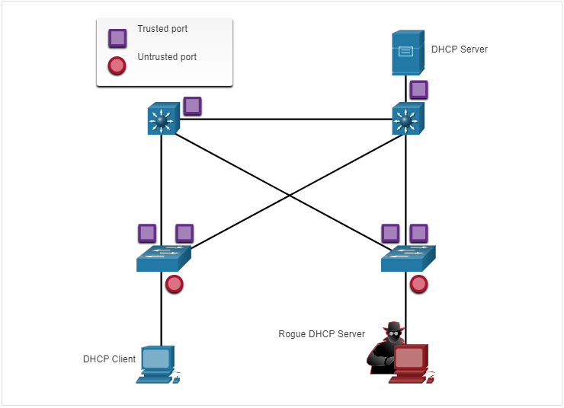

DHCP ClientDHCP ServerRogue DHCP ServerTrusted portUntrusted port

Notice that the rogue DHCP server would be on an untrusted port after enabling DHCP snooping. All interfaces are treated as untrusted by default. Trusted interfaces are typically trunk links and ports directly connected to a legitimate DHCP server. These interfaces must be explicitly configured as trusted.

A DHCP table is built that includes the source MAC address of a device on an untrusted port and the IP address assigned by the DHCP server to that device. The MAC address and IP address are bound together. Therefore, this table is called the DHCP snooping binding table.

11.3.3

## Steps to Implement DHCP Snooping

Use the following steps to enable DHCP snooping:

**Step 1**. Enable DHCP snooping by using the **ip dhcp snooping** global configuration command.

**Step 2**. On trusted ports, use the **ip dhcp snooping trust** interface configuration command.

**Step 3**. Limit the number of DHCP discovery messages that can be received per second on untrusted ports by using the **ip dhcp snooping limit rate** interface configuration command.

**Step 4**. Enable DHCP snooping by VLAN, or by a range of VLANs, by using the **ip dhcp snooping** vlan global configuration command.

11.3.4

## DHCP Snooping Configuration Example

The reference topology for this DHCP snooping example is shown in the figure. Notice that F0/5 is an untrusted port because it connects to a PC. F0/1 is a trusted port because it connects to the DHCP server.

The graphic has a legend with a Purple square Trusted Port and a red circle Untrusted Port below the topology diagram. Then the graphic shows a LAN network with a switch with trusted and untrusted ports. The switch has a P C connected to the left and a D H C P connected to it on the right. On the interface connecting to the P C is a red circle for an untrusted interface and on the interface connected to the D H C P Server is the purple square for a trusted port.

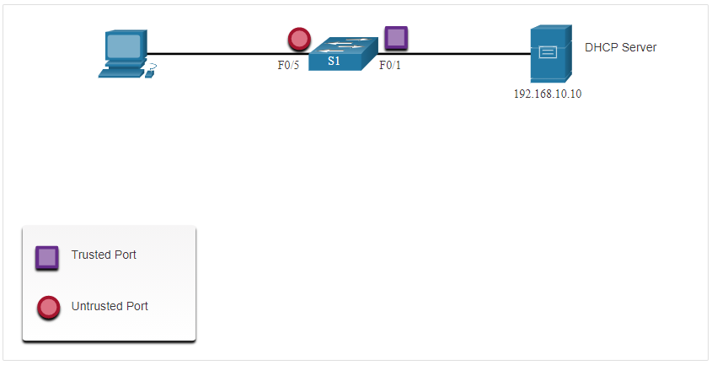

192.168.10.10F0/5S1F0/1

DHCP ServerTrusted PortUntrusted Port

The following is an example of how to configure DHCP snooping on S1. Notice how DHCP snooping is first enabled. Then the upstream interface to the DHCP server is explicitly trusted. Next, the range of FastEthernet ports from F0/5 to F0/24 are untrusted by default, so a rate limit is set to six packets per second. Finally, DHCP snooping is enabled on VLANS 5, 10, 50, 51, and 52.

S1(config)# **ip dhcp snooping**

S1(config)# **interface f0/1**

S1(config-if)# **ip dhcp snooping trust**

S1(config-if)# **exit**

S1(config)# **interface range f0/5 - 24**

S1(config-if-range)# **ip dhcp snooping limit rate 6**

S1(config-if-range)# **exit**

S1(config)# **ip dhcp snooping vlan 5,10,50-52**

S1(config)# **end**

S1#

Use the **show ip dhcp snooping** privileged EXEC command to verify DHCP snooping and **show ip dhcp snooping binding** to view the clients that have received DHCP information, as shown in the example.

**Note**: DHCP snooping is also required by Dynamic ARP Inspection (DAI), which is the next topic

S1# **show ip dhcp snooping**

Switch DHCP snooping is enabled

DHCP snooping is configured on following VLANs:

5,10,50-52

DHCP snooping is operational on following VLANs:

none

DHCP snooping is configured on the following L3 Interfaces:

Insertion of option 82 is enabled

circuit-id default format: vlan-mod-port

remote-id: 0cd9.96d2.3f80 (MAC)

Option 82 on untrusted port is not allowed

Verification of hwaddr field is enabled

Verification of giaddr field is enabled

DHCP snooping trust/rate is configured on the following Interfaces:

Interface Trusted Allow option Rate limit (pps)

----------------------- ------- ------------ ----------------

FastEthernet0/1 yes yes unlimited

Custom circuit-ids:

FastEthernet0/5 no no 6

Custom circuit-ids:

FastEthernet0/6 no no 6

Custom circuit-ids:

S1# **show ip dhcp snooping binding**

MacAddress IpAddress Lease(sec) Type VLAN Interface

------------------ --------------- ---------- ------------- ---- --------------------

00:03:47:B5:9F:AD 192.168.10.11 193185 dhcp-snooping 5 FastEthernet0/5

11.3.5

## Syntax Checker - Mitigate DHCP Attacks

Implement DHCP snooping for a switch based on the following topology and specified requirements.

The syntax checker has a topology that has a distribution switch connected to an access switch G0/1 interface. The access switch F0/1 interface connects to P C to the left and on the right side the switch G0/2 interface is connected to a server.

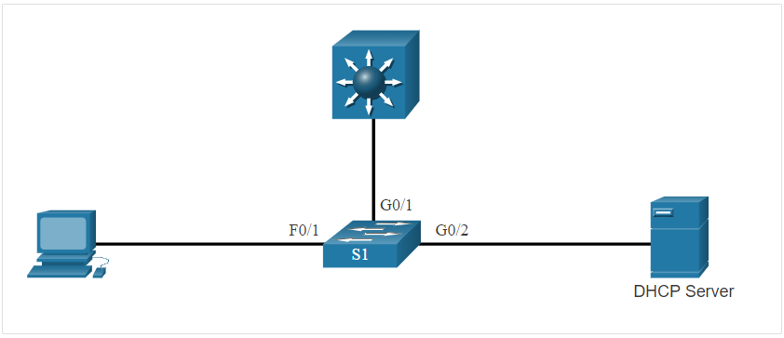

S1F0/1G0/1G0/2

DHCP Server

You are currently logged into S1. Enable DHCP snooping globally for the switch.

S1(config)#ip dhcp snooping

Enter interface configuration mode for **g0/1 - 2**, trust the interfaces, and return to global configuration mode.

S1(config)#interface range g0/1 - 2

S1(config-if-range)#ip dhcp snooping trust

S1(config-if-range)#exit

Enter interface configuration mode for **f0/1 - 24**, limit the DHCP messages to no more than 10 per second, and return to global configuration mode.

S1(config)#interface range f0/1 - 24

S1(config-if-range)#ip dhcp snooping limit rate 10

S1(config-if-range)#exit

Enable DHCP snooping for VLANs **10,20,30-49**.

S1(config)#ip dhcp snooping vlan 10,20,30-49

S1(config)# exit

Enter the command to verify DHCP snooping.

S1#show ip dhcp snooping

Switch DHCP snooping is enabled

DHCP snooping is configured on following VLANs:

10,20,30-49

DHCP snooping is operational on following VLANs:

none

DHCP snooping is configured on the following L3 Interfaces:

Insertion of option 82 is enabled

circuit-id default format: vlan-mod-port

remote-id: 0cd9.96d2.3f80 (MAC)

Option 82 on untrusted port is not allowed

Verification of hwaddr field is enabled

Verification of giaddr field is enabled

DHCP snooping trust/rate is configured on the following Interfaces:

Interface Trusted Allow option Rate limit (pps)

----------------------- ------- ------------ ----------------

GigabitEthernet0/1 yes yes unlimited

Custom circuit-ids:

GigabitEthernet0/2 yes yes unlimited

Custom circuit-ids:

FastEthernet0/1 no no 10

Custom circuit-ids:

Enter the command to verify the current DHCP bindings logged by DHCP snooping

S1#show ip dhcp snooping binding

MacAddress IpAddress Lease(sec) Type VLAN Interface

------------------ --------------- ---------- ------------- ---- --------------------

00:03:47:B5:9F:AD 10.0.0.10 193185 dhcp-snooping 5 FastEthernet0/1

S1#

You have successfully configured and verified DHCP snooping for the switch.

Mitigate ARP Attacks

11.4.1

Dynamic ARP Inspection

In a typical ARP attack, a threat actor can send unsolicited ARP requests to other hosts on the subnet with the MAC Address of the threat actor and the IP address of the default gateway. To prevent ARP spoofing and the resulting ARP poisoning, a switch must ensure that only valid ARP Requests and Replies are relayed.

Dynamic ARP inspection (DAI) requires DHCP snooping and helps prevent ARP attacks by:

* Not relaying invalid or gratuitous ARP Requests out to other ports in the same VLAN.
* Intercepting all ARP Requests and Replies on untrusted ports.
* Verifying each intercepted packet for a valid IP-to-MAC binding.
* Dropping and logging ARP Requests coming from invalid sources to prevent ARP poisoning.
* Error-disabling the interface if the configured DAI number of ARP packets is exceeded.

11.4.2

DAI Implementation Guidelines

To mitigate the chances of ARP spoofing and ARP poisoning, follow these DAI implementation guidelines:

* Enable DHCP snooping globally.
* Enable DHCP snooping on selected VLANs.
* Enable DAI on selected VLANs.
* Configure trusted interfaces for DHCP snooping and ARP inspection.

It is generally advisable to configure all access switch ports as untrusted and to configure all uplink ports that are connected to other switches as trusted.

The sample topology in the figure identifies trusted and untrusted ports.

The graphic shows a legend with a Purple square Trusted Port and a red circle Untrusted Port, above that is a LAN diagram showing Dynamic ARP Inspection Trust. The diagram illustrates a LAN network with trusted and untrusted ports. On one interface to the lower left is an attacker on one P C and to the upper left is a regular P C. Both devices are connected to the switch and both have a red circle on the switch port for an untrusted port. To the right of the switch is a router that is also connected to the switch. The router connection has a purple square on the switch that symbolizes a trusted connection for ARP.

PC-AS1R1F0/1F0/2F0/24

Untrusted PortTrusted PortVLAN 10

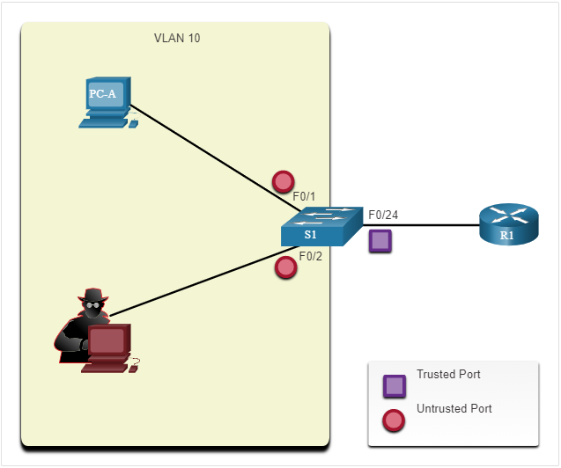

DAI Configuration Example

In the previous topology, S1 is connecting two users on VLAN 10. DAI will be configured to mitigate against ARP spoofing and ARP poisoning attacks.

As shown in the example, DHCP snooping is enabled because DAI requires the DHCP snooping binding table to operate. Next, DHCP snooping and ARP inspection are enabled for the PCs on VLAN10. The uplink port to the router is trusted, and therefore, is configured as trusted for DHCP snooping and ARP inspection.

S1(config)# **ip dhcp snooping**

S1(config)# **ip dhcp snooping vlan 10**

S1(config)# **ip arp inspection vlan 10**

S1(config)# **interface fa0/24**

S1(config-if)# **ip dhcp snooping trust**

S1(config-if)# **ip arp inspection trust**

DAI can also be configured to check for both destination or source MAC and IP addresses:

* **Destination MAC** - Checks the destination MAC address in the Ethernet header against the target MAC address in ARP body.
* **Source MAC** - Checks the source MAC address in the Ethernet header against the sender MAC address in the ARP body.
* **IP address** - Checks the ARP body for invalid and unexpected IP addresses including addresses 0.0.0.0, 255.255.255.255, and all IP multicast addresses.

The **ip arp inspection validate {[src-mac] [dst-mac] [ip]}** global configuration command is used to configure DAI to drop ARP packets when the IP addresses are invalid. It can be used when the MAC addresses in the body of the ARP packets do not match the addresses that are specified in the Ethernet header. Notice in the following example how only one command can be configured. Therefore, entering multiple **ip arp inspection validate** commands overwrites the previous command. To include more than one validation method, enter them on the same command line as shown and verified in the following output.

S1(config)# **ip arp inspection validate ?**

dst-mac Validate destination MAC address

ip Validate IP addresses

src-mac Validate source MAC address

S1(config)# **ip arp inspection validate src-mac**

S1(config)# **ip arp inspection validate dst-mac**

S1(config)# **ip arp inspection validate ip**

S1(config)# **do show run | include validate**

ip arp inspection validate ip

S1(config)# **ip arp inspection validate src-mac dst-mac ip**

S1(config)# **do show run | include validate**

ip arp inspection validate src-mac dst-mac ip

S1(config)#

11.4.4

Syntax Checker - Mitigate ARP Attacks

Implement DAI for a switch based on the following topology and specified requirements.

The syntax checker has a topology that has a distribution switch connected to an access switches G0/1 interface. The access switches F0/1 interface connects to P C to the left and on the right side the switch G0/2 interface is connected to a server.

S1F0/1G0/1G0/2

DHCP Server

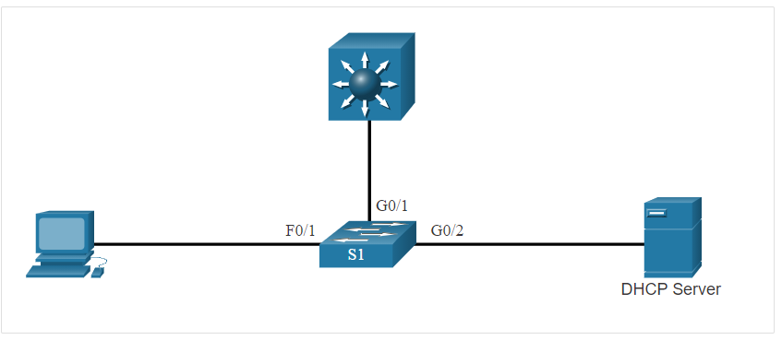

You are currently logged into S1. Enable DHCP snooping globally for the switch.

S1(config)#ip dhcp snooping

Enter interface configuration mode for **g0/1 - 2**, trust the interfaces for both DHCP snooping and DAI, and then return to global configuration mode.

S1(config)#interface range g0/1 - 2

S1(config-if-range)#ip dhcp snooping trust

S1(config-if-range)#ip arp inspection trust

S1(config-if-range)#exit

Enable DHCP snooping and DAI for VLANs **10,20,30-49**.

S1(config)#ip dhcp snooping vlan 10,20,30-49

S1(config)#ip arp inspection vlan 10,20,30-49

S1(config)#

You have successfully configured DAI for the switch.

Mitigate STP Attacks

11.5.1

PortFast and BPDU Guard

Recall that network attackers can manipulate the Spanning Tree Protocol (STP) to conduct an attack by spoofing the root bridge and changing the topology of a network. To mitigate Spanning Tree Protocol (STP) manipulation attacks, use PortFast and Bridge Protocol Data Unit (BPDU) Guard:

* **PortFast** - PortFast immediately brings an interface configured as an access port to the forwarding state from a blocking state, bypassing the listening and learning states. Apply to all end-user ports. PortFast should only be configured on ports attached to end devices.
* **BPDU Guard** - BPDU guard immediately error disables a port that receives a BPDU. Like PortFast, BPDU guard should only be configured on interfaces attached to end devices.

In the figure, the access ports for S1 should be configured with PortFast and BPDU Guard.

There are two distribution layer 3 switches at the top of the diagram that are connected by a trunk.  
Both layer 3 switches have a trunk link that are connected to the same access layer 2 switch below. This named S1 and is connected on int G0/1 and G0/2. Below S1 are several PCs and to the side of the switch it states Access Ports F0/1 - F0/24.

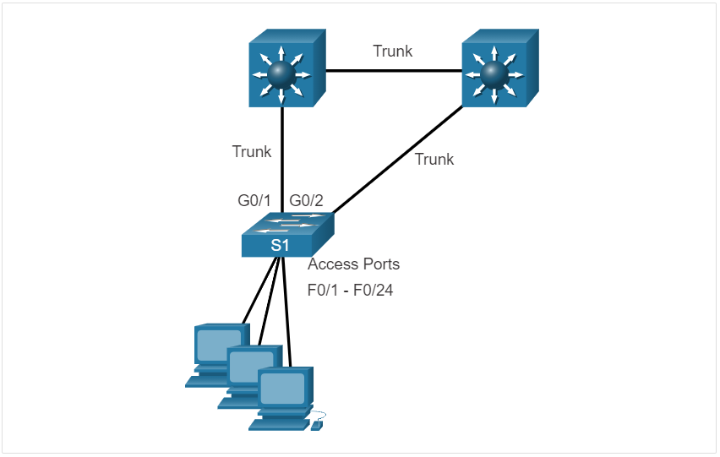

G0/1G0/2F0/1 - F0/24S1

TrunkTrunkTrunkAccess Ports

11.5.2

Configure PortFast

PortFast bypasses the STP listening and learning states to minimize the time that access ports must wait for STP to converge. If PortFast is enabled on a port connecting to another switch, there is a risk of creating a spanning-tree loop.

PortFast can be enabled on an interface by using the **spanning-tree portfast** interface configuration command. Alternatively, Portfast can be configured globally on all access ports by using the **spanning-tree portfast default** global configuration command.

To verify whether PortFast is enabled globally you can use either the **show running-config | begin span** command or the **show spanning-tree summary** command. To verify if PortFast is enabled an interface, use the **show running-config interface** *type/number* command, as shown in the following example. The **show** **spanning-tree interface** *type/number* **detail** command can also be used for verification.

Notice that when PortFast is enabled, warning messages are displayed.

S1(config)# **interface fa0/1**

S1(config-if)# **switchport mode access**

S1(config-if)# **spanning-tree portfast**

%Warning: portfast should only be enabled on ports connected to a single

host. Connecting hubs, concentrators, switches, bridges, etc... to this

interface when portfast is enabled, can cause temporary bridging loops.

Use with CAUTION

%Portfast has been configured on FastEthernet0/1 but will only

have effect when the interface is in a non-trunking mode.

S1(config-if)# **exit**

S1(config)# **spanning-tree portfast default**

%Warning: this command enables portfast by default on all interfaces. You

should now disable portfast explicitly on switched ports leading to hubs,

switches and bridges as they may create temporary bridging loops.

S1(config)# **exit**

S1# **show running-config | begin span**

spanning-tree mode pvst

spanning-tree portfast default

spanning-tree extend system-id

!

interface FastEthernet0/1

switchport mode access

spanning-tree portfast

!

interface FastEthernet0/2

!

interface FastEthernet0/3

!

interface FastEthernet0/4

!

interface FastEthernet0/5

!

(output omitted)

S1#

11.5.3

Configure BPDU Guard

Even though PortFast is enabled, the interface will still listen for BPDUs. Unexpected BPDUs might be accidental, or part of an unauthorized attempt to add a switch to the network.

If any BPDUs are received on a BPDU Guard enabled port, that port is put into error-disabled state. This means the port is shut down and must be manually re-enabled or automatically recovered through the **errdisable recovery cause bpduguard** global command.

BPDU Guard can be enabled on a port by using the **spanning-tree bpduguard enable** interface configuration command. Alternatively, Use the **spanning-tree portfast bpduguard default** global configuration command to globally enable BPDU guard on all PortFast-enabled ports.

To display information about the state of spanning tree, use the **show spanning-tree summary** command. In the example, PortFast default and BPDU Guard are both enabled as the default state for ports configured as access mode.

**Note**: Always enable BPDU Guard on all PortFast-enabled ports.

S1(config)# **interface fa0/1**

S1(config-if)# **spanning-tree bpduguard enable**

S1(config-if)# **exit**

S1(config)# **spanning-tree portfast bpduguard default**

S1(config)# **end**

S1# **show spanning-tree summary**

Switch is in pvst mode

Root bridge for: none

Extended system ID is enabled

Portfast Default is enabled

PortFast BPDU Guard Default is enabled

Portfast BPDU Filter Default is disabled

Loopguard Default is disabled

EtherChannel misconfig guard is enabled

UplinkFast is disabled

BackboneFast is disabled

Configured Pathcost method used is short

(output omitted)

S1#

11.5.4

Syntax Checker - Mitigate STP Attacks

Implement PortFast and BPDU Guard for a switch based on the following topology and specified requirements

The syntax checker has a topology where there are two distribution layer 3 switches at the top of the diagram that are connected by a trunk. Both layer 3 switches have a trunk link that are connected to the same access layer 2 switch below. This is named S 1 and is connected on G0/1 and G0/2. Below S 1 are several P Cs and to the side of the switch it states Access Ports F0/1 - F0/24.12.1.5.

G0/1G0/2F0/1 - F0/24S1

TrunkTrunkTrunkAccess Ports

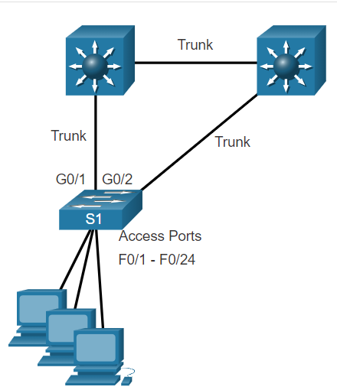

You are currently logged into S1. Complete the following steps to implement PortFast and BPDU Guard on all access ports:

* Enter interface configuration mode for **fa0/1 - 24**.
* Configure the ports for access mode.
* Return to global configuration mode.
* Enable PortFast by default for all access ports.
* Enable BPDU Guard by default for all access ports.

S1(config)#interface range fa0/1 - 24

S1(config-if-range)#switchport mode access

S1(config-if-range)#exit

S1(config)#spanning-tree portfast default

S1(config)#spanning-tree portfast bpduguard default

S1(config)# exit

Verify that PortFast and BPDU Guard is enabled by default by viewing STP summary information.

S1#show spanning-tree summary

Switch is in pvst mode

Root bridge for: none

Extended system ID is enabled

Portfast Default is enabled

PortFast BPDU Guard Default is enabled

Portfast BPDU Filter Default is disabled

Loopguard Default is disabled

EtherChannel misconfig guard is enabled

UplinkFast is disabled

BackboneFast is disabled

Configured Pathcost method used is short

(output omitted)

S1#

You have successfully configured and verified PortFast and BPDU Guard for the switch.

What did I learn in this module?

All switch ports (interfaces) should be secured before the switch is deployed for production use. The simplest and most effective method to prevent MAC address table overflow attacks is to enable port security. By default, Layer 2 switch ports are set to dynamic auto (trunking on). The switch can be configured to learn about MAC addresses on a secure port in one of three ways: manually configured, dynamically learned, and dynamically learned – sticky. Port security aging can be used to set the aging time for static and dynamic secure addresses on a port. Two types of aging are supported per port: absolute and inactivity. If the MAC address of a device attached to the port differs from the list of secure addresses, then a port violation occurs. By default, the port enters the error-disabled state. When a port is shutdown and placed in the error-disabled state, no traffic is sent or received on that port. To display port security settings for the switch, use the **show port-security** command.

To mitigate VLAN hopping attacks:

**Step 1.** Disable DTP negotiations on non-trunking ports.  
**Step 2.** Disable unused ports.  
**Step 3.** Manually enable the trunk link on a trunking port.  
**Step 4.** Disable DTP negotiations on trunking ports.  
**Step 5.** Set the native VLAN to a VLAN other than VLAN 1.

The goal of a DHCP starvation attack is to create a Denial of Service (DoS) for connecting clients. DHCP spoofing attacks can be mitigated by using DHCP snooping on trusted ports. DHCP snooping determines whether DHCP messages are from an administratively-configured trusted or untrusted source. It then filters DHCP messages and rate-limits DHCP traffic from untrusted sources. Use the following steps to enable DHCP snooping:

**Step 1.** Enable DHCP snooping.  
**Step 2.** On trusted ports, use the **ip dhcp snooping trust** interface configuration command.  
**Step 3.** Limit the number of DHCP discovery messages that can be received per second on untrusted ports.  
**Step 4.** Enable DHCP snooping by VLAN, or by a range of VLANs.

Dynamic ARP inspection (DAI) requires DHCP snooping and helps prevent ARP attacks by:

* Not relaying invalid or gratuitous ARP Replies out to other ports in the same VLAN.
* Intercepting all ARP Requests and Replies on untrusted ports.
* Verifying each intercepted packet for a valid IP-to-MAC binding.
* Dropping and logging ARP Replies coming from invalid to prevent ARP poisoning.
* Error-disabling the interface if the configured DAI number of ARP packets is exceeded.

To mitigate the chances of ARP spoofing and ARP poisoning, follow these DAI implementation guidelines:

* Enable DHCP snooping globally.
* Enable DHCP snooping on selected VLANs.
* Enable DAI on selected VLANs.
* Configure trusted interfaces for DHCP snooping and ARP inspection.

As a general guideline, configure all access switch ports as untrusted and all uplink ports that are connected to other switches as trusted.

DAI can also be configured to check for both destination or source MAC and IP addresses:

* **Destination MAC** - Checks the destination MAC address in the Ethernet header against the target MAC address in ARP body.
* **Source MAC** - Checks the source MAC address in the Ethernet header against the sender MAC address in the ARP body.
* **IP address** - Checks the ARP body for invalid and unexpected IP addresses including addresses 0.0.0.0, 255.255.255.255, and all IP multicast addresses.

To mitigate Spanning Tree Protocol (STP) manipulation attacks, use PortFast and Bridge Protocol Data Unit (BPDU) Guard:

* **PortFast** - PortFast immediately brings an interface configured as an access or trunk port to the forwarding state from a blocking state, bypassing the listening and learning states. Apply to all end-user ports. PortFast should only be configured on ports attached to end devices. PortFast bypasses the STP listening and learning states to minimize the time that access ports must wait for STP to converge. If PortFast is enabled on a port connecting to another switch, there is a risk of creating a spanning-tree loop.
* **BPDU Guard** - BPDU guard immediately error disables a port that receives a BPDU. Like PortFast, BPDU guard should only be configured on interfaces attached to end devices. BPDU Guard can be enabled on a port by using the **spanning-tree bpduguard enable** interface configuration command. Alternatively, Use the **spanning-tree portfast bpduguard default** global configuration command to globally enable BPDU guard on all PortFast-enabled ports.

12 модуль

Which of the following wireless networks typically uses lower powered transmitters for short ranges?WPAN

Which of the following wireless networks are specified in the IEEE 802.11 standards for the 2.4 GHz and 5 GHz radio frequencies? WLAN

Which of the following is an IEEE 802.15 WPAN standard that uses a device-pairing process to communicate? Bluetooth

Which 802.11 standards exclusively use the 5 GHz radio frequency? (Choose 2)802.11a 802.11ac

Which standards organization is responsible for allocating radio frequencies? ITU-R

True or False: Laptops that do not have an integrated wireless NIC can only be attached to the network through a wired connection. False

Which of the following components are integrated in a wireless home router? (Choose three.) Access point Switch Router

True or False: When you need to expand the coverage of a small network, the best solution is to use a range extender. False

Which of the following is a standalone device, like a home router, where the entire WLAN configuration resides on the device? Autonomous AP

Which of the following antennas provide 360 degrees of coverage? Omnidirectional

Which wireless topology mode is used by two devices to connect in a peer-to-peer network? Ad hoc

True or False: An ESS is created when two or more BSSs need to be joined to support roaming clients. True

How many address fields are in the 802.11 wireless frame? 4

What is the term for an AP that openly advertises its service periodically? Passive

What is the term for an AP that does not send a beacon, but waits for clients to send probes? Active

What IP versions does CAPWAP support? IPv4 by default, but can configure IPv6

What UDP ports and IP protocols are used by CAPWAP for IPv4? (Choose three.) 17 5246 5247

What UDP ports and IP protocols are used by CAPWAP for IPv6? (Choose three.) 136 5246 5247

In the split MAC architecture for CAPWAP, which of the following are the responsibility of the AP? (Choose four.) Packet acknowledgments and retransmissions

Beacons and probe responses

MAC layer data encryption and decryption

Frame queueing and packet prioritization

In the split MAC architecture for CAPWAP, which of the following are the responsibility of the WLC? (Choose four.) Authentication Association and re-association of roaming clients Termination of 802.11 traffic on a wired interface Frame translation to other protocols

True or False: DTLS is enabled by default on the control and data CAPWAP tunnels. False

Which of the following statements are true about modes of operation for a FlexConnect AP? (Choose two.) In standalone mode, the WLC is unreachable and the AP switches local traffic and performs client authentication locally. In connect mode, the WLC is reachable and performs all its CAPWAP functions.

Which of the following modulation techniques rapidly switches a signal among frequency channels?FHSS

Which of the following modulation techniques spreads a signal over a larger frequency band?DSSS

Which of the following modulation techniques is used in the new 802.11ax standard? OFDMA

How many channels are available for the 2.4 GHz band in Europe? 13

How many channels are available for the 5 GHz band? 24

Which of the following is most likely NOT the source of a wireless DoS attack? Rogue AP

True or False: A rogue AP is a misconfigured AP connected to the network and a possible source of DoS attacks. False

What type of attack is an “evil twin AP” attack? MITM

What are the best ways to secure WLANs? (Choose two.) Authentication Encryption

Which of the following authentication methods does not use a password shared between the wireless client and the AP? Open

Which encryption method is used by the original 802.11 specification? RC4

Which of the following encryption methods uses CCMP to recognize if the encrypted and non-encrypted bits have been altered? AES

Which of the following authentication methods has the user enter a pre-shared password? (Choose two) WPA Personal WPA2 Personal

In the context of mobile devices, what does the term tethering involve? connecting a mobile device to another mobile device or computer to share a network connection

Which feature of 802.11n wireless access points allows them to transmit data at faster speeds than previous versions of 802.11 Wi-Fi standards did? MIMO

Which method of wireless authentication is currently considered to be the strongest? WPA2

Which parameter is commonly used to identify a wireless network name when a home wireless AP is being configured? SSID

Which characteristic describes a wireless client operating in active mode? must know the SSID to connect to an AP

Which IEEE standard operates at wireless frequencies in both the 5 GHz and 2.4 GHz ranges? 802.11n

Which statement describes an autonomous access point? It is a standalone access point.

Which two roles are typically performed by a wireless router that is used in a home or small business? (Choose two.) access point Ethernet switch

Which protocol and port numbers are used by both IPv4 and IPv6 CAPWAP tunnels? (Choose two.) UDP 5246 and 5247

If three 802.11b access points need to be deployed in close proximity, which three frequency channels should be used? (Choose three.) 11 1 6

Which type of telecommunication technology is used to provide Internet access to vessels at sea? satellite

Which wireless network topology is being configured by a technician who is installing a keyboard, a mouse, and headphones, each of which uses Bluetooth? ad hoc mode

Which type of wireless topology is created when two or more Basic Service Sets are interconnected by Ethernet? ESS

What Wi-Fi management frame is regularly broadcast by APs to announce their presence? Beacon

13 модуль

A user is configuring a wireless access point and wants to prevent any neighbors from discovering the network. What action does the user need to take? Disable SSID broadcast.

When a wireless network in a small office is being set up, which type of IP addressing is typically used on the networked devices? Private

A user has just purchased a generic home router and would like to secure it. What should be done to help secure the wireless home router? Change the default administrator password.

Which protocol could be used by a company to monitor devices such as a wireless LAN controller (WLC)? SNMP

When configuring a Cisco 3500 series wireless LAN controller (WLC) for a WPA2 Enterprise WLAN, what has to be created on the WLC before creating the new WLAN? a VLAN for the wireless network

What is a DHCP scope as it relates to a WLAN configured on the WLC controller? a pool of IP addresses for WLAN clients

Why would a technician configure a passphrase for a WLAN on a wireless router? to configure wireless client authentication

A customer installs a wireless access point at home in the closet next to the kitchen.  The customer mentions that the wireless communication performance seems degraded when the cordless phone or the microwave oven is in use.  What is the possible reason for this degradation? The wireless signal is in the same radio frequency range as the household devices are in.

What functionality is required on routers to provide remote workers with VoIP and videoconferencing capabilities? QoS

A wireless router is displaying the IP address of 192.168.0.1. What could this mean? The wireless router still has the factory default IP address.

A laptop cannot connect to a wireless access point. Which two troubleshooting steps should be taken first? (Choose two.) Ensure that the wireless NIC is enabled. Ensure that the wireless SSID is chosen.

In setting up a small office network, the network administrator decides to assign private IP addresses dynamically to workstations and mobile devices. Which feature must be enabled on the company router in order for office devices to access the internet? NAT

What is a difference between autonomous APs that operate in a home environment and controller-based APs that operate in a corporate environment? Controller-based APs can be automatically configured and managed by a WLAN controller.

Which WLC tab would a network administrator typically use to see a summary view of the most heavily used WLANs including the number of clients using a particular WLAN? **Monitor**

Users on an IEEE 802.11n network are complaining of slow speeds. The network administrator checks the AP and verifies it is operating properly. What can be done to improve the wireless performance in the network? Split the wireless traffic between the 802.11n 2.4 GHz band and the 5 GHz band.

**Introduction to Wireless**

**Benefits of Wireless**

A Wireless LAN (WLAN) is a type of wireless network that is commonly used in homes, offices, and campus environments. Networks must support people who are on the move. People connect using computers, laptops, tablets, and smart phones. There are many different network infrastructures that provide network access, such as wired LANs, service provider networks, and cell phone networks. But it’s the WLAN that makes mobility possible within the home and business environments.

In businesses with a wireless infrastructure in place, there can be a cost savings any time equipment changes, or when relocating an employee within a building, reorganizing equipment or a lab, or moving to temporary locations or project sites. A wireless infrastructure can adapt to rapidly changing needs and technologies.

Types of Wireless Networks

Wireless networks are based on the Institute of Electrical and Electronics Engineers (IEEE) standards and can be classified broadly into four main types: WPAN, WLAN, WMAN, and WWAN.

Click each wireless network type for more information.

Wireless Personal-Area Networks (WPAN) - Uses low powered transmitters for a short-range network, usually 20 to 30 ft. (6 to 9 meters). Bluetooth and ZigBee based devices are commonly used in WPANs. WPANs are based on the 802.15 standard and a 2.4-GHz radio frequency.

Wireless LANs (WLAN) - Uses transmitters to cover a medium-sized network, usually up to 300 feet. WLANs are suitable for use in a home, office, and even a campus environment. WLANs are based on the 802.11 standard and a 2.4-GHz or 5-GHz radio frequency.

Wireless MANs (WMAN) - Uses transmitters to provide wireless service over a larger geographic area. WMANs are suitable for providing wireless access to a metropolitan city or specific district. WMANs use specific licensed frequencies.

Wireless Wide-Area Networks (WWANs) - Uses transmitters to provide coverage over an extensive geographic area. WWANs are suitable for national and global communications. WWANs also use specific licensed frequencies.

Wireless Technologies

Wireless technology uses the unlicensed radio spectrum to send and receive data. The unlicensed spectrum is accessible to anyone who has a wireless router and wireless technology in the device they are using.

Click each wireless technology for more information.

Bluetooth - An IEEE 802.15 WPAN standard that uses a device-pairing process to communicate over distances up to 300 ft. (100m). It can be found in smart home devices, audio connections, automobiles, and other devices that require a short distance connection. There are two types of Bluetooth radios:

Bluetooth Low Energy (BLE) - This supports multiple network technologies including mesh topology to large scale network devices.

Bluetooth Basic Rate/Enhanced Rate (BR/EDR) - This supports point to point topologies and is optimized for audio streaming.

WiMAX (Worldwide Interoperability for Microwave Access) - WiMAX is an alternative to broadband wired internet connections, competing with DSL and cable. However, it is typically used in areas that are not yet connected to a DSL or cable provider. It is an IEEE 802.16 WWAN standard that provides high-speed wireless broadband access of up to 30 miles (50 km). WiMAX operates in a similar way to Wi-Fi, but at higher speeds, over greater distances, and for a greater number of users. It uses a network of WiMAX towers that are similar to cell phone towers. WiMAX transmitters and cellular transmitters may share space on the same tower, as shown in the figure.

Cellular Broadband - Cellular 4G/5G are wireless mobile networks primarily used by cellular phones but can be used in automobiles, tablets, and laptops. Cellular networks are multi-access networks carrying both data and voice communications. A cell site is created by a cellular tower transmitting signals in a given area. Interconnecting cell sites form the cellular network. The two types of cellular networks are Global System for Mobile (GSM) and Code Division Multiple Access (CDMA). GSM is internationally recognized, while CDMA is primarily used in the US.

The 4th Generation mobile network (4G) is the current mobile network. 4G delivers speeds that are 10 times the previous 3G networks. The new 5G holds the promise of delivering 100 times faster speeds than 4G and connecting more devices to the network than ever before.

Satellite Broadband - Provides network access to remote sites through the use of a directional satellite dish that is aligned with a specific geostationary Earth orbit satellite. It is usually more expensive and requires a clear line of sight. Typically, it is used by rural homeowners and businesses where cable and DSL are not available.

**802.11 Standards**

The world of wireless communications is vast. However, for particular job-related skills, we want to focus on specific aspects of Wi Fi. The best place to start is with the IEEE 802.11 WLAN standards. These standards define how radio frequencies are used for wireless links. Most of the standards specify that wireless devices have one antenna to transmit and receive wireless signals on the specified radio frequency (2.4 GHz or 5 GHz). Some of the newer standards that transmit and receive at higher speeds require access points (APs) and wireless clients to have multiple antennas using the multiple-input and multiple-output (MIMO) technology. MIMO uses multiple antennas as both the transmitter and receiver to improve communication performance. Up to eight transmit and receive antennas can be used to increase throughput.

Various implementations of the IEEE 802.11 standard have been developed over the years. The table highlights these standards.

| Table caption | | |
| --- | --- | --- |
| **IEEE WLAN Standard** | **Radio Frequency** | **Description** |
| 802.11 | 2.4 GHz | * speeds of up to 2 Mbps |
| 802.11a | 5 GHz | * speeds of up to 54 Mbps * small coverage area * less effective at penetrating building structures * not interoperable with the 802.11b and 802.11g |
| 802.11b | 2.4 GHz | * speeds of up to 11 Mbps * longer range than 802.11a * better able to penetrate building structures |
| 802.11g | 2.4 GHz | * speeds of up to 54 Mbps * backward compatible with 802.11b with reduced bandwidth capacity |
| 802.11n | 2.4 GHz 5 GHz | * data rates range from 150 Mbps to 600 Mbps with a distance range of up to 70 m (230 feet) * APs and wireless clients require multiple antennas using MIMO technology * backward compatible with 802.11a/b/g devices with limiting data rates |
| 802.11ac | 5 GHz | * provides data rates ranging from 450 Mbps to 1.3 Gbps (1300 Mbps) using MIMO technology * Up to eight antennas can be supported * backwards compatible with 802.11a/n devices with limiting data rates |
| 802.11ax | 2.4 GHz 5 GHz | * latest standard released in 2019 * also known as Wi-Fi 6 or High-Efficiency Wireless (HEW) * provides improved power efficiency, higher data rates, increased capacity, and handles many connected devices * currently operates using 2.4 GHz and 5 GHz but will use 1 GHz and 7 GHz when those frequencies become available * Search the internet for Wi-Fi Generation 6 for more information   Radio Frequencies  All wireless devices operate in the radio waves range of the electromagnetic spectrum. WLAN networks operate in the 2.4 GHz frequency band and the 5 GHz band. Wireless LAN devices have transmitters and receivers tuned to specific frequencies of the radio waves range, as shown in the figure. Specifically, the following frequency bands are allocated to 802.11 wireless LANs:  2.4 GHz (UHF) - 802.11b/g/n/ax  5 GHz (SHF) - 802.11a/n/ac/ax  wireless devices, and other technologies, and where they operate on the electromagnetic spectrum  The Electromagnetic Spectrum |

**Wireless Standards Organizations**

Standards ensure interoperability between devices that are made by different manufacturers. Internationally, the three organizations influencing WLAN standards are the ITU-R, the IEEE, and the Wi-Fi Alliance.

Click each button for more information about the standards organization.

The Wi-Fi Alliance is a global, non-profit, industry trade association devoted to promoting the growth and acceptance of WLANs. It is an association of vendors whose objective is to improve the interoperability of products that are based on the 802.11 standard by certifying vendors for conformance to industry norms and adherence to standards.

The IEEE specifies how a radio frequency is modulated to carry information. It maintains the standards for local and metropolitan area networks (MAN) with the IEEE 802 LAN/MAN family of standards. The dominant standards in the IEEE 802 family are 802.3 Ethernet and 802.11 WLAN.

The International Telecommunication Union (ITU) regulates the allocation of the radio frequency spectrum and satellite orbits through the ITU-R. ITU-R stands for the ITU Radiocommunication Sector.

Which of the following wireless networks typically uses lower powered transmitters for short ranges?

Which of the following wireless networks are specified in the IEEE 802.11 standards for the 2.4 GHz and 5 GHz radio frequencies?

Which of the following is an IEEE 802.15 WPAN standard that uses a device-pairing process to communicate?

Which 802.11 standards exclusively use the 5 GHz radio frequency? (Choose 2)

Which standards organization is responsible for allocating radio frequencies?

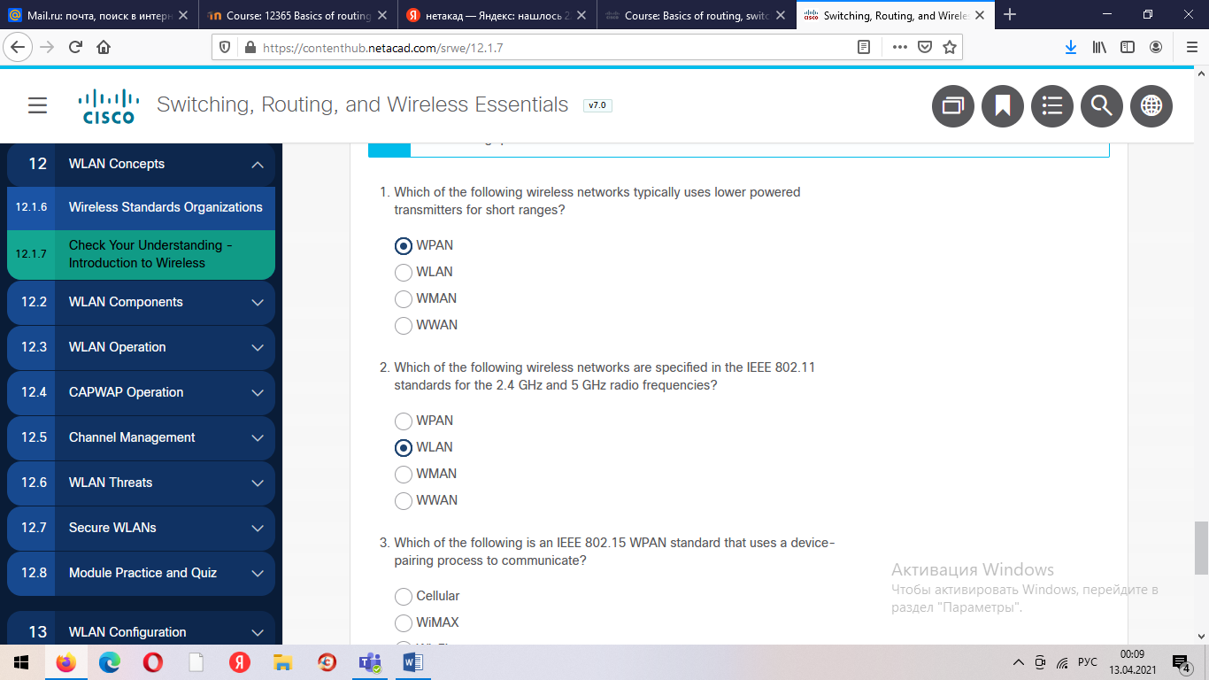

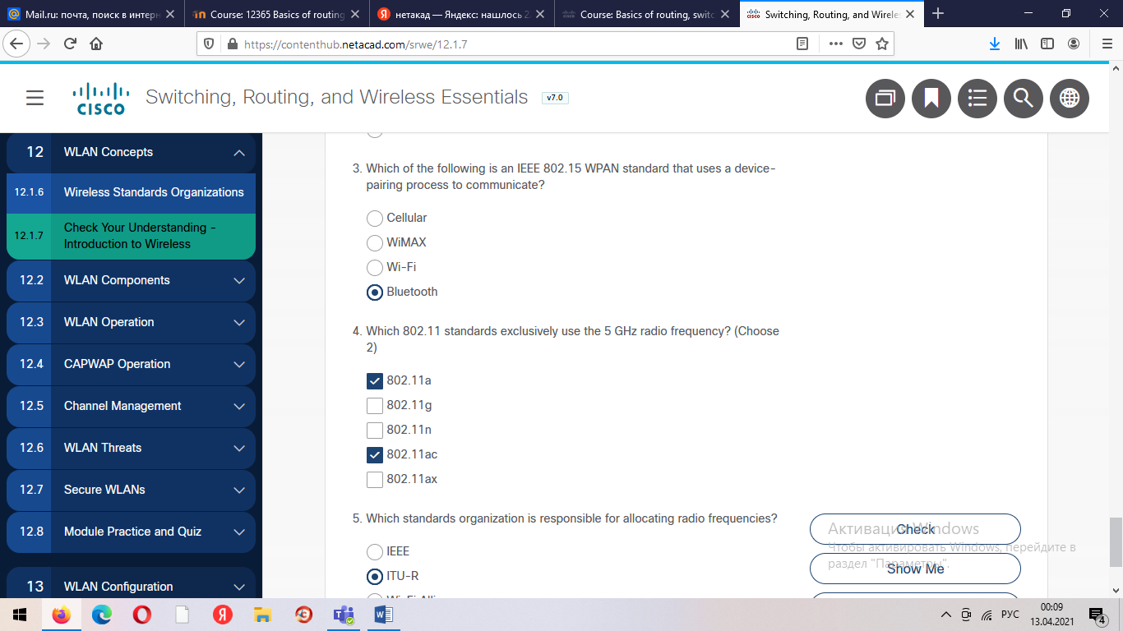

## Video - WLAN Components

In the previous topic you learned about the benefits of wireless, types of wireless networks, 802.11 standards, and radio frequencies. Here we will learn about WLAN components.

Click Play to view a video about WLAN components.

## Wireless NICs

Wireless deployments require a minimum of two devices that have a radio transmitter and a radio receiver tuned to the same radio frequencies:

* End devices with wireless NICs
* A network device, such as a wireless router or wireless AP

To communicate wirelessly, laptops, tablets, smart phones, and even the latest automobiles include integrated wireless NICs that incorporate a radio transmitter/receiver. However, if a device does not have an integrated wireless NIC, then a USB wireless adapter can be used, as shown in the figure.

**Note**: Many wireless devices you are familiar with do not have visible antennas. They are embedded inside smartphones, laptops, and wireless home routers.

**Wireless Home Router**

The type of infrastructure device that an end device associates and authenticates with varies based on the size and requirement of the WLAN.

For example, a home user typically interconnects wireless devices using a small, wireless router, as shown in the figure. The wireless router serves as an:

* **Access point** - This provides 802.11a/b/g/n/ac wireless access.
* **Switch** - This provides a four-port, full-duplex, 10/100/1000 Ethernet switch to interconnect wired devices.
* **Router** - This provides a default gateway for connecting to other network infrastructures, such as the internet.
* A wireless router is commonly implemented as a small business or residential wireless access device. The wireless router advertises its wireless services by sending beacons containing its shared service set identifier (SSID). Devices wirelessly discover the SSID and attempt to associate and authenticate with it to access the local network and internet.
* Most wireless routers also provide advanced features, such as high-speed access, support for video streaming, IPv6 addressing, quality of service (QoS), configuration utilities, and USB ports to connect printers or portable drives.
* Additionally, home users who want to extend their network services can implement Wi-Fi range extenders. A device can connect wirelessly to the extender, which boosts its communications to be repeated to the wireless router.

## Wireless Access Points

While range extenders are easy to set up and configure, the best solution would be to install another wireless access point to provide dedicated wireless access to the user devices. Wireless clients use their wireless NIC to discover nearby APs advertising their SSID. Clients then attempt to associate and authenticate with an AP. After being authenticated, wireless users have access to network resources. The Cisco Meraki Go APs are shown in the figure.

## AP Categories

APs can be categorized as either autonomous APs or controller-based APs.

Click each button for a topology and explanation of each type.

**Autonomous APs**

These are standalone devices configured using a command line interface or a GUI, as shown in the figure. Autonomous APs are useful in situations where only a couple of APs are required in the organization. A home router is an example of an autonomous AP because the entire AP configuration resides on the device. If the wireless demands increase, more APs would be required. Each AP would operate independent of other APs and each AP would require manual configuration and management. This would become overwhelming if many APs were needed.

**Controller-based APs**

These devices require no initial configuration and are often called lightweight APs (LAPs). LAPs use the Lightweight Access Point Protocol (LWAPP) to communicate with a WLAN controller (WLC), as shown in the next figure. Controller-based APs are useful in situations where many APs are required in the network. As more APs are added, each AP is automatically configured and managed by the WLC.

Notice in the figure that the WLC has four ports connected to the switching infrastructure. These four ports are configured as a link aggregation group (LAG) to bundle them together. Much like how EtherChannel operates, LAG provides redundancy and load-balancing. All the ports on the switch that are connected to the WLC need to be trunking and configured with EtherChannel on. However, LAG does not operate exactly like EtherChannel. The WLC does not support Port Aggregation Protocol (PaGP) or Link Aggregation Control Protocol (LACP).

## Wireless Antennas

Most business class APs require external antennas to make them fully functioning units.

Click each antenna for more information.

Omnidirectional antennas such as the one shown in the figure provide 360-degree coverage and are ideal in houses, open office areas, conference rooms, and outside areas.

Directional antennas focus the radio signal in a given direction. This enhances the signal to and from the AP in the direction the antenna is pointing This provides a stronger signal strength in one direction and reduced signal strength in all other directions. Examples of directional Wi-Fi antennas include Yagi and parabolic dish antennas.

Multiple Input Multiple Output (MIMO) uses multiple antennas to increase available bandwidth for IEEE 802.11n/ac/ax wireless networks. Up to eight transmit and receive antennas can be used to increase throughput.

## 802.11 Wireless Topology Modes

Wireless LANs can accommodate various network topologies. The 802.11 standard identifies two main wireless topology modes: Ad hoc mode and Infrastructure mode. Tethering is also a mode sometimes used to provide quick wireless access.

Click each wireless topology mode for more information.

**Ad hoc mode -** This is when two devices connect wirelessly in a peer-to-peer (P2P) manner without using APs or wireless routers. Examples include wireless clients connecting directly to each other using Bluetooth or Wi-Fi Direct. The IEEE 802.11 standard refers to an ad hoc network as an independent basic service set (IBSS).

**Infrastructure mode -** This is when wireless clients interconnect via a wireless router or AP, such as in WLANs. APs connect to the network infrastructure using the wired distribution system, such as Ethernet.

**Tethering** - A variation of the ad hoc topology is when a smart phone or tablet with cellular data access is enabled to create a personal hotspot. This feature is sometimes referred to as tethering. A hotspot is usually a temporary quick solution that enables a smart phone to provide the wireless services of a Wi-Fi router. Other devices can associate and authenticate with the smart phone to use the internet connection.

## BSS and ESS

Infrastructure mode defines two topology building blocks: A Basic Service Set (BSS) and an Extended Service Set (ESS).

Click BSS and ESS for more information.

**Basic Service Set**

A BSS consists of a single AP interconnecting all associated wireless clients. Two BSSs are shown in the figure. The circles depict the coverage area for the BSS, which is called the Basic Service Area (BSA). If a wireless client moves out of its BSA, it can no longer directly communicate with other wireless clients within the BSA.

The Layer 2 MAC address of the AP is used to uniquely identify each BSS, which is called the Basic Service Set Identifier (BSSID). Therefore, the BSSID is the formal name of the BSS and is always associated with only one AP.

**Extended Service Set**

When a single BSS provides insufficient coverage, two or more BSSs can be joined through a common distribution system (DS) into an ESS. An ESS is the union of two or more BSSs interconnected by a wired DS. Each ESS is identified by a SSID and each BSS is identified by its BSSID.

Wireless clients in one BSA can now communicate with wireless clients in another BSA within the same ESS. Roaming mobile wireless clients may move from one BSA to another (within the same ESS) and seamlessly connect.

The rectangular area in the figure depicts the coverage area within which members of an ESS may communicate. This area is called the Extended Service Area (ESA).

## 802.11 Frame Structure

Recall that all Layer 2 frames consist of a header, payload, and Frame Check Sequence (FCS) section. The 802.11 frame format is similar to the Ethernet frame format, except that it contains more fields, as shown in the figure.

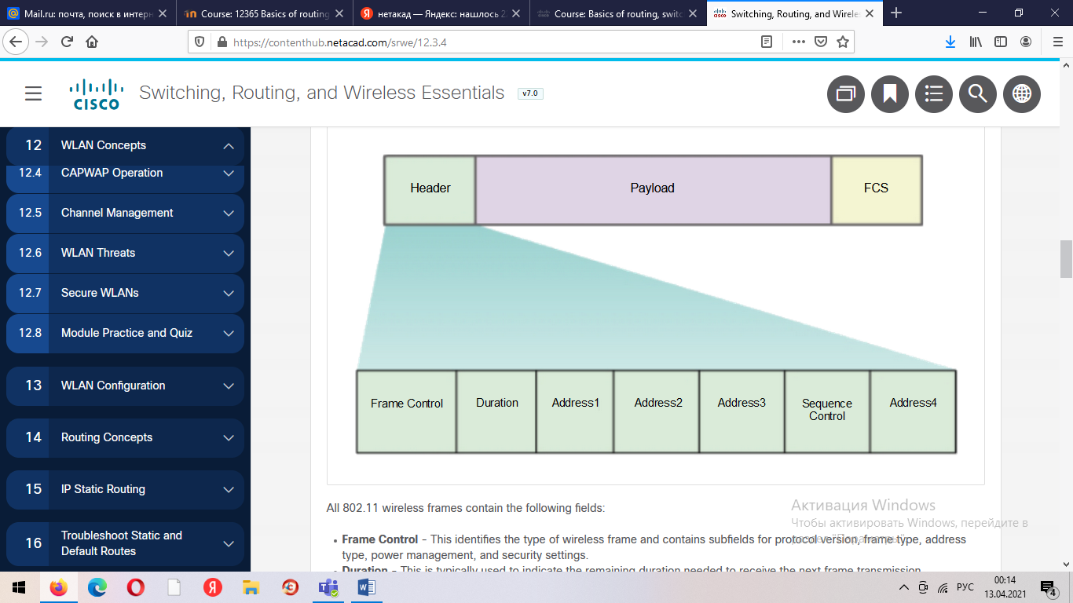

All 802.11 wireless frames contain the following fields:

* **Frame Control** - This identifies the type of wireless frame and contains subfields for protocol version, frame type, address type, power management, and security settings.
* **Duration** - This is typically used to indicate the remaining duration needed to receive the next frame transmission.

From a wireless device:

* **Address 1 Receiver Address** - MAC address of the AP.
* **Address 2 Transmitter Address** - MAC address of the sender.
* **Address 3 SA/DA/BSSID** - MAC address of the destination which could be a wireless device or wired device.

From the AP:

* **Address 1 Receiver Address** - MAC address of the sender.
* **Address 2 Transmitter Address** - MAC address of the AP.
* **Address 3 SA/DA/BSSID** - MAC address of the wireless destination.
* **Sequence Control** - This contains information to control sequencing and fragmented frames.
* **Address4** - This usually missing because it is used only in ad hoc mode.
* **Payload** - This contains the data for transmission.
* **FCS** - This is used for Layer 2 error control.

**CSMA/CA**

WLANs are half-duplex, shared media configurations. Half-duplex means that only one client can transmit or receive at any given moment. Shared media means that wireless clients can all transmit and receive on the same radio channel. This creates a problem because a wireless client cannot hear while it is sending, which makes it impossible to detect a collision.

To resolve this problem, WLANs use carrier sense multiple access with collision avoidance (CSMA/CA) as the method to determine how and when to send data on the network. A wireless client does the following:

1. Listens to the channel to see if it is idle, which means that is senses no other traffic is currently on the channel. The channel is also called the carrier.
2. Sends a request to send (RTS) message to the AP to request dedicated access to the network.
3. Receives a clear to send (CTS) message from the AP granting access to send.
4. If the wireless client does not receive a CTS message, it waits a random amount of time before restarting the process.
5. After it receives the CTS, it transmits the data.
6. All transmissions are acknowledged. If a wireless client does not receive an acknowledgment, it assumes a collision occurred and restarts the process.

12.3.6

**Wireless Client and AP Association**

For wireless devices to communicate over a network, they must first associate with an AP or wireless router. An important part of the 802.11 process is discovering a WLAN and subsequently connecting to it. Wireless devices complete the following three stage process, as shown in the figure:

* Discover a wireless AP
* Authenticate with AP
* Associate with AP

The figure shows the three-stage process used by a wireless client to associate with an AP. A laptop represents a wireless client that is communicating wirelessly with an AP. An arrow flowing from the client to the AP represents stage one in which the client discovers the AP. Below that, a double arrow between the devices represents the authentication stage. Below that, another double arrow between the devices represents the association stage.

Wireless ClientAPDiscover APAuthenticateAssociate

In order to have a successful association, a wireless client and an AP must agree on specific parameters. Parameters must then be configured on the AP and subsequently on the client to enable the negotiation of a successful association.

* **SSID** -The SSID name appears in the list of available wireless networks on a client. In larger organizations that use multiple VLANs to segment traffic, each SSID is mapped to one VLAN. Depending on the network configuration, several APs on a network can share a common SSID.
* **Password** - This is required from the wireless client to authenticate to the AP.
* **Network mode** - This refers to the 802.11a/b/g/n/ac/ad WLAN standards. APs and wireless routers can operate in a Mixed mode meaning that they can simultaneously support clients connecting via multiple standards.
* **Security mode** - This refers to the security parameter settings, such as WEP, WPA, or WPA2. Always enable the highest security level supported.
* **Channel settings** - This refers to the frequency bands used to transmit wireless data. Wireless routers and APs can scan the radio frequency channels and automatically select an appropriate channel setting. The channel can also be set manually if there is interference with another AP or wireless device.

12.3.7

**Passive and Active Discover Mode**

Wireless devices must discover and connect to an AP or wireless router. Wireless clients connect to the AP using a scanning (probing) process. This process can be passive or active.

Click each mode for more information.

In passive mode, the AP openly advertises its service by periodically sending broadcast beacon frames containing the SSID, supported standards, and security settings. The primary purpose of the beacon is to allow wireless clients to learn which networks and APs are available in a given area. This allows the wireless clients to choose which network and AP to use.

In active mode, wireless clients must know the name of the SSID. The wireless client initiates the process by broadcasting a probe request frame on multiple channels. The probe request includes the SSID name and standards supported. APs configured with the SSID will send a probe response that includes the SSID, supported standards, and security settings. Active mode may be required if an AP or wireless router is configured to not broadcast beacon frames.

A wireless client could also send a probe request without a SSID name to discover nearby WLAN networks. APs configured to broadcast beacon frames would respond to the wireless client with a probe response and provide the SSID name. APs with the broadcast SSID feature disabled do not respond.

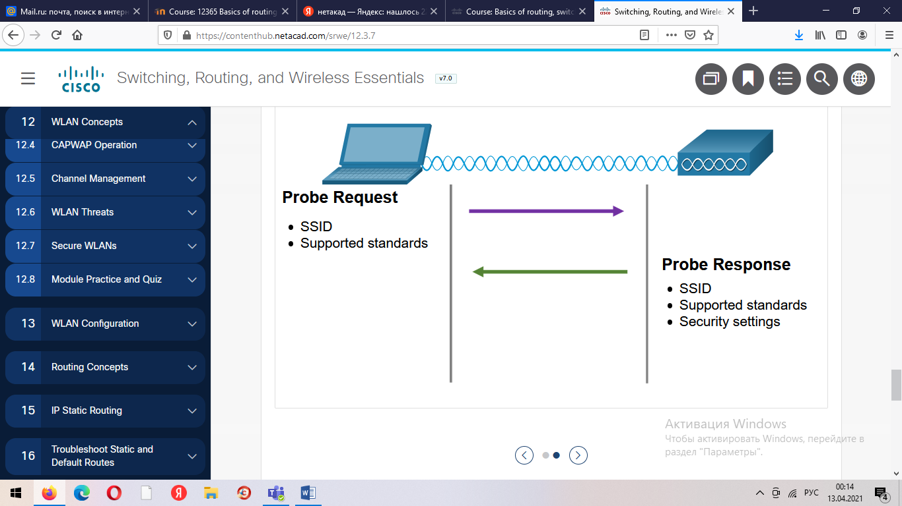

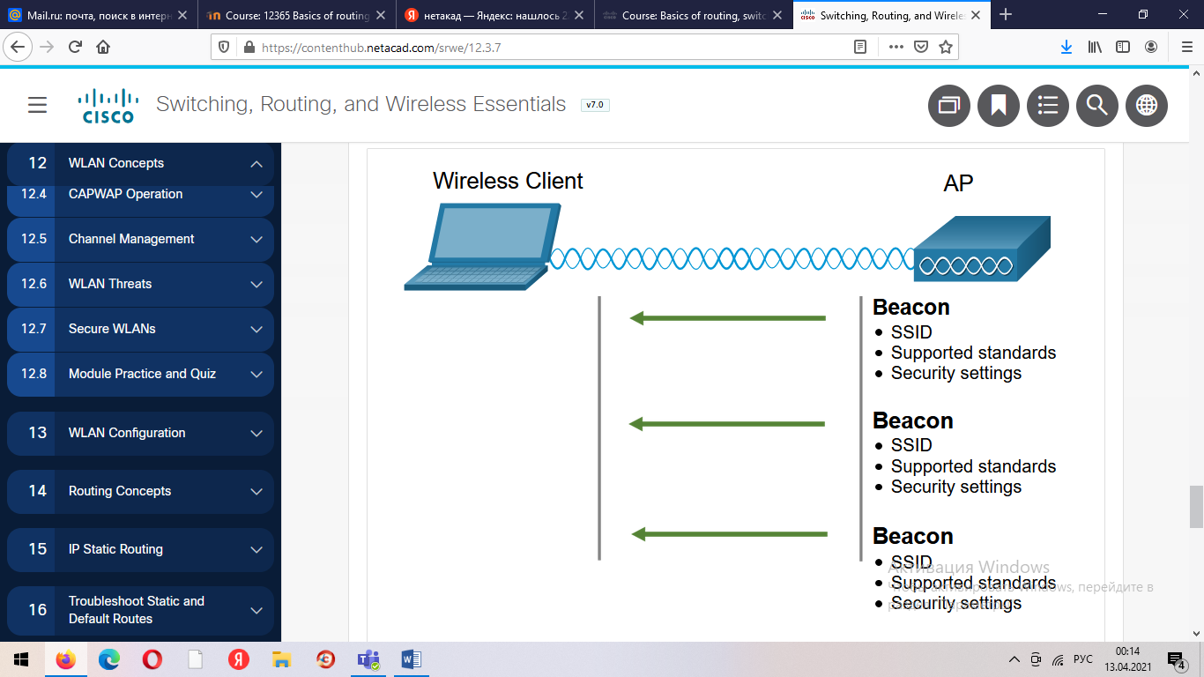

## Video - CAPWAP

In the previous topic you learned about WLAN operation. Now you will learn about Control and Provisioning of Wireless Access Points (CAPWAP).

Click Play to view a video about Control and Provisioning of Wireless Access Points (CAPWAP) protoc

**Introduction to CAPWAP**

CAPWAP is an IEEE standard protocol that enables a WLC to manage multiple APs and WLANs. CAPWAP is also responsible for the encapsulation and forwarding of WLAN client traffic between an AP and a WLC.

CAPWAP is based on LWAPP but adds additional security with Datagram Transport Layer Security (DTLS). CAPWAP establishes tunnels on User Datagram Protocol (UDP) ports. CAPWAP can operate either over IPv4 or IPv6, as shown in the figure, but uses IPv4 by default.

IPv4 and IPv6 both use UDP ports 5246 and 5247. Port 5246 is for CAPWAP control messages used by the WLC to manage the AP. Port 5247 is used by CAPWAP to encapsulate data packets traveling to and from wireless clients. However, CAPWAP tunnels use different IP protocols in the packet header. IPv4 uses IP protocol 17 and IPv6 uses IP protocol 136.

The figure shows a small IPv4 or IPv6 network in the cloud. A WLC connects to three APs using CAPWAP.

IPv4 or IPv6 NetworkAPAPWLCCAPWAPCAPWAPAPCAPWAP

12.4.3

**Split MAC Architecture**

A key component of CAPWAP is the concept of a split media access control (MAC). The CAPWAP split MAC concept does all of the functions normally performed by individual APs and distributes them between two functional components:

* AP MAC Functions
* WLC MAC Functions

The table shows some of the MAC functions performed by each.

| Table caption | |
| --- | --- |
| **AP MAC Functions** | **WLC MAC Functions** |
| Beacons and probe responses | Authentication |
| Packet acknowledgements and retransmissions | Association and re-association of roaming clients |
| Frame queueing and packet prioritization | Frame translation to other protocols |
| MAC layer data encryption and decryption | Termination of 802.11 traffic on a wired interface |

12.4.4

**DTLS Encryption**

DTLS is a protocol which provides security between the AP and the WLC. It allows them to communicate using encryption and prevents eavesdropping or tampering.

DTLS is enabled by default to secure the CAPWAP control channel but is disabled by default for the data channel, as shown in the figure. All CAPWAP management and control traffic exchanged between an AP and WLC is encrypted and secured by default to provide control plane privacy and prevent Man-In-the-Middle (MITM) attacks.

CAPWAP data encryption is optional and is enabled per AP. Data encryption requires a DTLS license to be installed on the WLC prior to being enabled on an AP. When enabled, all WLAN client traffic is encrypted at the AP before being forwarded to the WLC and vice versa.

The figure shows a WLC connected to an AP using CAPWAP encapsulation. The control channel encapsulation is enabled by default while the data encryption is optional and enabled on each AP.

CAPWAP EncapsulationCAPWAP ControlDTLS Encryption (disabled by default)CAPWAP DataDTLS Encryption (enabled by default)APWLC

12.4.5

**FlexConnect APs**

FlexConnect is a wireless solution for branch office and remote office deployments. It lets you configure and control access points in a branch office from the corporate office through a WAN link, without deploying a controller in each office.

There are two modes of operation for the FlexConnect AP.

* **Connected mode** - The WLC is reachable. In this mode the FlexConnect AP has CAPWAP connectivity with its WLC and can send traffic through the CAPWAP tunnel, as shown in the figure. The WLC performs all its CAPWAP functions.
* **Standalone mode** - The WLC is unreachable. The FlexConnect has lost or failed to establish CAPWAP connectivity with its WLC. In this mode, a FlexConnect AP can assume some of the WLC functions such as switching client data traffic locally and performing client authentication locally.

The figure shows a CAPWAP tunnel formed between a FlexConnect AP at a branch office and a WLC at a corporate office. The branch office equipment consists of a laptop with a wireless connection to a FlexConnect AP which is connected to a switch which is connected to a router. The router is then connected to another router in the corporate office to which the WLC is connected. The WLC provides access into the corporate network and the Internet.

InternetFlexConnect APCorporate NetworkCAPWAPBranch OfficeWLCCorporate Office

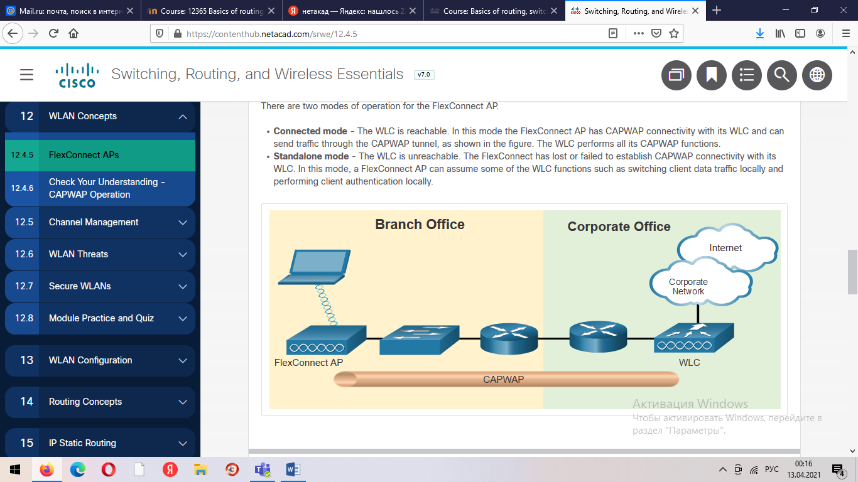

## Frequency Channel Saturation

Wireless LAN devices have transmitters and receivers tuned to specific frequencies of radio waves to communicate. A common practice is for frequencies to be allocated as ranges. Such ranges are then split into smaller ranges called channels.

If the demand for a specific channel is too high, that channel is likely to become oversaturated. The saturation of the wireless medium degrades the quality of the communication. Over the years, a number of techniques have been created to improve wireless communication and alleviate saturation. These techniques mitigate channel saturation by using the channels in a more efficient way.

Click each frequency channel saturation technique for more information.

**Direct-Sequence Spread Spectrum (DSSS)** - This is a modulation technique designed to spread a signal over a larger frequency band. Spread spectrum techniques were developed during war time to make it more difficult for enemies to intercept or jam a communication signal. It does this by spreading the signal over a wider frequency which effectively hides the discernable peak of the signal, as shown in the figure. A properly configured receiver can reverse the DSSS modulation and re-construct the original signal. DSSS is used by 802.11b devices to avoid interference from other devices using the same 2.4 GHz frequency.

PowerDSSS SignalOriginal SignalFrequency

**Frequency-Hopping Spread Spectrum (FHSS)** - This relies on spread spectrum methods to communicate. It transmits radio signals by rapidly switching a carrier signal among many frequency channels. With the FHSS, the sender and receiver must be synchronized to “know” which channel to jump to. This channel hopping process allows for a more efficient usage of the channels, decreasing channel congestion. FHSS was used by the original 802.11 standard. Walkie-talkies and 900 MHz cordless phones also use FHSS, and Bluetooth uses a variation of FHSS.

**Orthogonal Frequency-Division Multiplexing (OFDM)** - This is a subset of frequency division multiplexing in which a single channel uses multiple sub-channels on adjacent frequencies. Sub-channels in an OFDM system are precisely orthogonal to one another which allow the sub-channels to overlap without interfering. OFDM is used by a number of communication systems including 802.11a/g/n/ac. The new 802.11ax uses a variation of OFDM called Orthogonal frequency-division multiaccess (OFDMA).

## Channel Selection

A best practice for WLANs requiring multiple APs is to use non-overlapping channels. For example, the 802.11b/g/n standards operate in the 2.4 GHz to 2.5 GHz spectrum. The 2.4 GHz band is subdivided into multiple channels. Each channel is allotted 22 MHz bandwidth and is separated from the next channel by 5 MHz. The 802.11b standard identifies 11 channels for North America, as shown in the figure (13 in Europe and 14 in Japan).

**Note**: Search the internet for 2.4 GHz channels to learn more about the variations for different countries.

The figure shows 11 channels that are 22MHz wide and 5MHz between each. The spectrum is between 2.2GHz and 2.5GHz.

### 2.4 GHz Overlapping Channels in North America

Interference occurs when one signal overlaps a channel reserved for another signal, causing possible distortion. The best practice for 2.4 GHz WLANs that require multiple APs is to use non-overlapping channels, although most modern APs will do this automatically. If there are three adjacent APs, use channels 1, 6, and 11, as shown in the figure.

The figure shows three APs using channels 1, 6, and 11.

### 2.4 GHz Non-Overlapping Channels for 802.11b/g/n

Channel 1Channel 6Channel 11

For the 5 GHz standards 802.11a/n/ac, there are 24 channels. The 5 GHz band is divided into three sections. Each channel is separated from the next channel by 20 MHz. The figure shows all 24 Unlicensed National Information Infrastructure (U-NNI) 24 channels for the 5 GHz band. Although there is a slight overlap at the tails of each channel's frequency, the channels do not interfere with one another. 5 GHz wireless can provide faster data transmission for wireless clients in heavily populated wireless networks because of the large amount of non-overlapping wireless channels.

**Note**: Search the internet for 5 GHz channels to learn more about the variations for different countries.

The figure shows 8 channels that have 20MHz between each. The spectrum is between 5150 MHz and 5350 MHz.

### 5 GHz First Eight Non-Interfering Channels

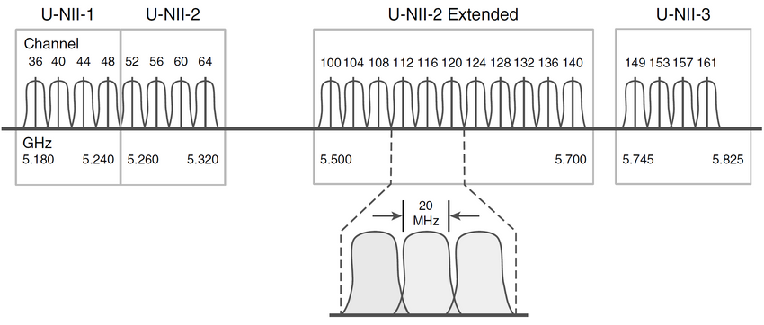

As with 2.4 GHz WLANs, choose non-interfering channels when configuring multiple 5 GHz APs that are adjacent to each other, as shown in the figure.

The figure shows three APs using channels 36, 48, and 60.

12.5.3

the figure shows a map of a venue with different areas, entrances, and exits. There are circles in different areas to limit the area of coverage.

### 5 GHz Non-Interfering Channels for 802.11a/n/ac

Channel 36Channel 40Channel 44

12.5.3

## Plan a WLAN Deployment

The number of users supported by a WLAN depends on the geographical layout of the facility, including the number of bodies and devices that can fit in a space, the data rates users expect, the use of non-overlapping channels by multiple APs in an ESS, and transmit power settings.

When planning the location of APs, the approximate circular coverage area is important (as shown in the figure), but there are some additional recommendations:

* If APs are to use existing wiring or if there are locations where APs cannot be placed, note these locations on the map.
* Note all potential sources of interference which can include microwave ovens, wireless video cameras, fluorescent lights, motion detectors, or any other device that uses the 2.4 GHz range.
* Position APs above obstructions.
* Position APs vertically near the ceiling in the center of each coverage area, if possible.
* Position APs in locations where users are expected to be. For example, conference rooms are typically a better location for APs than a hallway.
* If an IEEE 802.11 network has been configured for mixed mode, the wireless clients may experience slower than normal speeds in order to support the older wireless standards.

When estimating the expected coverage area of an AP, realize that this value varies depending on the WLAN standard or mix of standards that are deployed, the nature of the facility, and the transmit power that the AP is configured for. Always consult the specifications for the AP when planning for coverage areas.

**Video - WLAN Threats**

The previous topics covered the WLAN components and configuration. Here you will learn about WLAN threats.

Click Play to view a video about threats to WLANs.

12.6.2

**Wireless Security Overview**

A WLAN is open to anyone within range of an AP and the appropriate credentials to associate to it. With a wireless NIC and knowledge of cracking techniques, an attacker may not have to physically enter the workplace to gain access to a WLAN.

Attacks can be generated by outsiders, disgruntled employees, and even unintentionally by employees. Wireless networks are specifically susceptible to several threats, including:

* **Interception of data** - Wireless data should be encrypted to prevent it from being read by eavesdroppers.
* **Wireless intruders** - Unauthorized users attempting to access network resources can be deterred through effective authentication techniques.
* **Denial of Service (DoS) Attacks** - Access to WLAN services can be compromised either accidentally or maliciously. Various solutions exist depending on the source of the DoS attack.
* **Rogue APs** - Unauthorized APs installed by a well-intentioned user or for malicious purposes can be detected using management software.

12.6.3

**DoS Attacks**

Wireless DoS attacks can be the result of:

* **Improperly configured devices** - Configuration errors can disable the WLAN. For instance, an administrator could accidently alter a configuration and disable the network, or an intruder with administrator privileges could intentionally disable a WLAN.
* **A malicious user intentionally interfering with the wireless communication** - Their goal is to disable the wireless network completely or to the point where no legitimate device can access the medium.
* **Accidental interference** - WLANs are prone to interference from other wireless devices including microwave ovens, cordless phones, baby monitors, and more, as shown in the figure. The 2.4 GHz band is more prone to interference than the 5 GHz band.

signals radiating from a cordless phone and a microwave are interfering with signals on a wireless network

S3

WR



12.6.4

**Rogue Access Points**

A rogue AP is an AP or wireless router that has been connected to a corporate network without explicit authorization and against corporate policy. Anyone with access to the premises can install (maliciously or non-maliciously) an inexpensive wireless router that can potentially allow access to a secure network resource.

Once connected, the rogue AP can be used by an attacker to capture MAC addresses, capture data packets, gain access to network resources, or launch a man-in-the-middle attack.

A personal network hotspot could also be used as a rogue AP. For example, a user with secure network access enables their authorized Windows host to become a Wi-Fi AP. Doing so circumvents the security measures and other unauthorized devices can now access network resources as a shared device.

To prevent the installation of rogue APs, organizations must configure WLCs with rogue AP policies, as shown in the figure, and use monitoring software to actively monitor the radio spectrum for unauthorized APs.

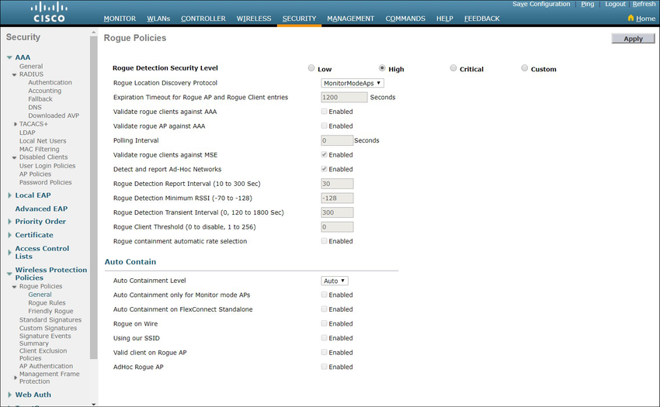

12.6.5

**Man-in-the-Middle Attack**

In a man-in-the-middle (MITM) attack, the hacker is positioned in between two legitimate entities in order to read or modify the data that passes between the two parties. There are many ways in which to create a MITM attack.

A popular wireless MITM attack is called the “evil twin AP” attack, where an attacker introduces a rogue AP and configures it with the same SSID as a legitimate AP, as shown in the figure. Locations offering free Wi-Fi, such as airports, cafes, and restaurants, are particularly popular spots for this type of attack due to the open authentication.

a threat actor at Bobs Latte has used their laptop to set up an evil twin using an SSID of Bob latte, open authentication, and channel 6

Bob's LatteSSID: Bob latte Authentication: Open Channel: 6UserInternet

Wireless clients attempting to connect to a WLAN would see two APs with the same SSID offering wireless access. Those near the rogue AP find the stronger signal and most likely associate with it. User traffic is now sent to the rogue AP, which in turn captures the data and forwards it to the legitimate AP, as shown in the figure. Return traffic from the legitimate AP is sent to the rogue AP, captured, and then forwarded to the unsuspecting user. The attacker can steal the user’s passwords, personal information, gain access to their device, and compromise the system.

a user at Bobs Latte is sending wireless traffic to a laptop set up by a threat actor as an evil twin which forwards the traffic to a router within the Internet cloud

Bob's LatteUserInternet

Defeating an attack like an MITM attack depends on the sophistication of the WLAN infrastructure and the vigilance in monitoring activity on the network. The process begins with identifying legitimate devices on the WLAN. To do this, users must be authenticated. After all of the legitimate devices are known, the network can be monitored for abnormal devices or traffic.

**Video - Secure WLANs**

The previous topic explained the WLAN threats. What can you do to secure the WLAN?

Click Play to view a video about techniques for securing WLANs.

12.7.2

**SSID Cloaking and MAC Address Filtering**

Wireless signals can travel through solid matter, such as ceilings, floors, walls, outside of the home, or office space. Without stringent security measures in place, installing a WLAN can be the equivalent of putting Ethernet ports everywhere, even outside.

To address the threats of keeping wireless intruders out and protecting data, two early security features were used and are still available on most routers and APs: SSID cloaking and MAC address filtering.

**SSID Cloaking**

APs and some wireless routers allow the SSID beacon frame to be disabled, as shown in the figure. Wireless clients must manually configure the SSID to connect to the network.

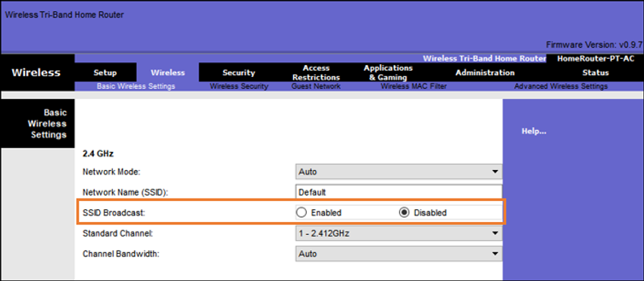

**MAC Addresses Filtering**

An administrator can manually permit or deny clients wireless access based on their physical MAC hardware address. In the figure, the router is configured to permit two MAC addresses. Devices with different MAC addresses will not be able to join the 2.4GHz WLAN.

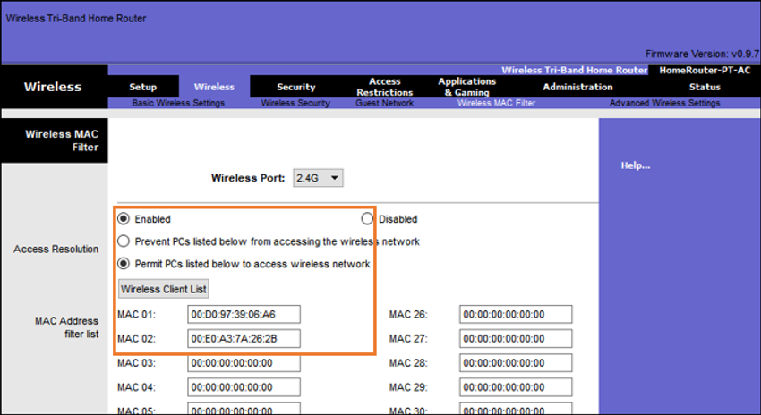

12.7.3

**802.11 Original Authentication Methods**

Although these two features would deter most users, the reality is that neither SSID cloaking nor MAC address filtering would deter a crafty intruder. SSIDs are easily discovered even if APs do not broadcast them and MAC addresses can be spoofed. The best way to secure a wireless network is to use authentication and encryption systems.

Two types of authentication were introduced with the original 802.11 standard:

* **Open system authentication**- Any wireless client should easily be able to connect and should only be used in situations where security is of no concern, such as those providing free internet access like cafes, hotels, and in remote areas. The wireless client is responsible for providing security such as using a virtual private network (VPN) to connect securely. VPNs provide authentication and encryption services. VPNs are beyond the scope of this topic.
* **Shared key authentication**- Provides mechanisms, such as WEP, WPA, WPA2, and WPA3 to authenticate and encrypt data between a wireless client and AP. However, the password must be pre-shared between both parties to connect.

The following chart summarizes these authentication methods.

AuthenticationOpenShared KeyWEPWPAWPA2WPA3

* No password required.
* Any client can associate.
* Typically used to provide free internet access in public areas.
* Client has full responsibility for security.

12.7.4

**Shared Key Authentication Methods**

There are four shared key authentication techniques available, as described in the table. Until the availability of WPA3 devices becomes ubiquitous, wireless networks should use the WPA2 standard.

| Table caption | |
| --- | --- |
| **Authentication Method** | **Description** |
| **Wired Equivalent Privacy (WEP)** | The original 802.11 specification designed to secure the data using the Rivest Cipher 4 (RC4) encryption method with a static key. However, the key never changes when exchanging packets. This makes it easy to hack. WEP is no longer recommended and should never be used. |
| **Wi-Fi Protected Access (WPA)** | A Wi-Fi Alliance standard that uses WEP, but secures the data with the much stronger Temporal Key Integrity Protocol (TKIP) encryption algorithm. TKIP changes the key for each packet, making it much more difficult to hack. |
| **WPA2** | WPA2 is the current industry standard for securing wireless networks. It uses the Advanced Encryption Standard (AES) for encryption. AES is currently considered the strongest encryption protocol. |
| **WPA3** | The next generation of Wi-Fi security. All WPA3-enabled devices use the latest security methods, disallow outdated legacy protocols, and require the use of Protected Management Frames (PMF). However, devices with WPA3 are not yet readily available. |

12.7.5

**Authenticating a Home User**

Home routers typically have two choices for authentication: WPA and WPA2. WPA2 is the stronger of the two. The figure shows the option to select one of two WPA2 authentication methods:

* **Personal** - Intended for home or small office networks, users authenticate using a pre-shared key (PSK). Wireless clients authenticate with the wireless router using a pre-shared password. No special authentication server is required.
* **Enterprise** - Intended for enterprise networks but requires a Remote Authentication Dial-In User Service (RADIUS) authentication server. Although more complicated to set up, it provides additional security. The device must be authenticated by the RADIUS server and then users must authenticate using 802.1X standard, which uses the Extensible Authentication Protocol (EAP) for authentication.

In the figure, the administrator is configuring the wireless router with WPA2 Personal authentication on the 2.4 GHz band.

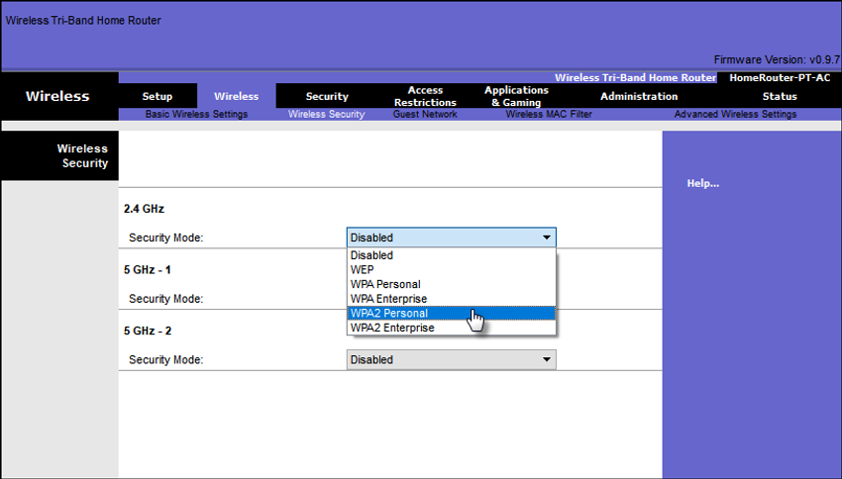

12.7.6

**Encryption Methods**

Encryption is used to protect data. If an intruder has captured encrypted data, they would not be able to decipher it in any reasonable amount of time.

The WPA and WPA2 standards use the following encryption protocols:

* **Temporal Key Integrity Protocol (TKIP)** - TKIP is the encryption method used by WPA. It provides support for legacy WLAN equipment by addressing the original flaws associated with the 802.11 WEP encryption method. It makes use of WEP, but encrypts the Layer 2 payload using TKIP, and carries out a Message Integrity Check (MIC) in the encrypted packet to ensure the message has not been altered.
* **Advanced Encryption Standard (AES)** - AES is the encryption method used by WPA2. It is the preferred method because it is a far stronger method of encryption. It uses the Counter Cipher Mode with Block Chaining Message Authentication Code Protocol (CCMP) that allows destination hosts to recognize if the encrypted and non-encrypted bits have been altered.

In the figure, the administrator is configuring the wireless router to use WPA2 with AES encryption on the 2.4 GHz band.

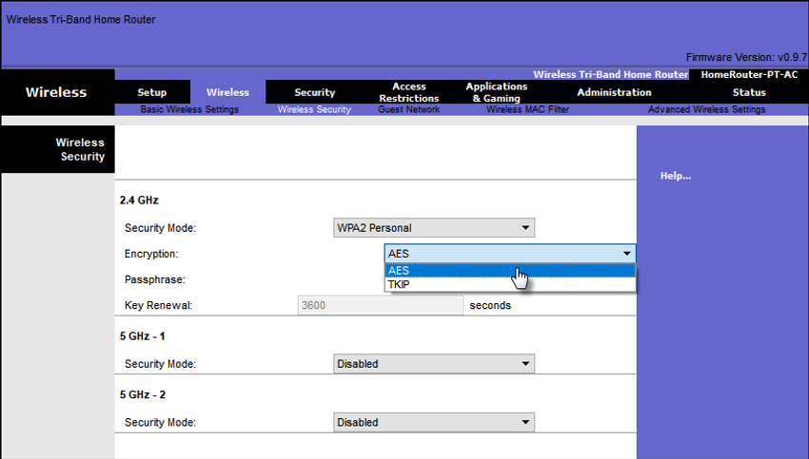

12.7.7

**Authentication in the Enterprise**

In networks that have stricter security requirements, an additional authentication or login is required to grant wireless clients such access. The Enterprise security mode choice requires an Authentication, Authorization, and Accounting (AAA) RADIUS server.

* **RADIUS Server IP address** - This is the reachable address of the RADIUS server.
* **UDP port numbers** - Officially assigned UDP ports 1812 for RADIUS Authentication, and 1813 for RADIUS Accounting, but can also operate using UDP ports 1645 and 1646, as shown in the figure.
* **Shared key** - Used to authenticate the AP with the RADIUS server.

In the figure, the administrator is configuring the wireless router with WPA2 Enterprise authentication using AES encryption. The RADIUS server IPv4 address is configured as well with a strong password to be used between the wireless router and the RADIUS server.

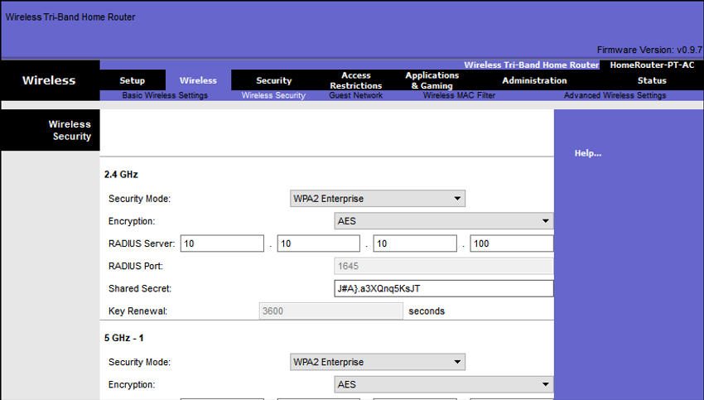

The shared key is not a parameter that must be configured on a wireless client. It is only required on the AP to authenticate with the RADIUS server. User authentication and authorization is handled by the 802.1X standard, which provides a centralized, server-based authentication of end users.

The 802.1X login process uses EAP to communicate with the AP and RADIUS server. EAP is a framework for authenticating network access. It can provide a secure authentication mechanism and negotiate a secure private key which can then be used for a wireless encryption session using TKIP or AES encryption.

12.7.8

**WPA3**

At the time of this writing, devices that support WPA3 authentication were not readily available. However, WPA2 is no longer considered secure. WPA3, if available, is the recommended 802.11 authentication method. WPA3 includes four features:

* WPA3-Personal
* WPA3-Enterprise
* Open Networks
* Internet of Things (IoT) Onboarding

**WPA3-Personal**

In WPA2-Personal, threat actors can listen in on the “handshake” between a wireless client and the AP and use a brute force attack to try and guess the PSK. WPA3-Personal thwarts this attack by using Simultaneous Authentication of Equals (SAE), a feature specified in the IEEE 802.11-2016. The PSK is never exposed, making it impossible for the threat actor to guess.

**WPA3-Enterprise**

WPA3-Enterprise still uses 802.1X/EAP authentication. However, it requires the use of a 192-bit cryptographic suite and eliminates the mixing of security protocols for previous 802.11 standards. WPA3-Enterprise adheres to the Commercial National Security Algorithm (CNSA) Suite which is commonly used in high security Wi-Fi networks.

**Open Networks**

Open networks in WPA2 send user traffic in unauthenticated, clear text. In WPA3, open or public Wi-Fi networks still do not use any authentication. However, they do use Opportunistic Wireless Encryption (OWE) to encrypt all wireless traffic.

**IoT Onboarding**

Although WPA2 included Wi-Fi Protected Setup (WPS) to quickly onboard devices without configuring them first, WPS is vulnerable to a variety of attacks and is not recommended. Furthermore, IoT devices are typically headless, meaning they have no built-in GUI for configuration, and needed any easy way to get connected to the wireless network. The Device Provisioning Protocol (DPP) was designed to address this need. Each headless device has a hardcoded public key. The key is typically stamped on the outside of the device or its packaging as a Quick Response (QR) code. The network administrator can scan the QR code and quickly onboard the device. Although not strictly part of the WPA3 standard, DPP will replace WPS over time.

## What did I learn in this module?

A Wireless LAN (WLAN) is a type of wireless network that is commonly used in homes, offices, and campus environments. Wireless networks are based on IEEE standards and can be classified into four main types: WPAN, WLAN, WMAN, and WWAN. Wireless LAN technologies uses the unlicensed radio spectrum to send and receive data. Examples of this technology are Bluetooth, WiMAX, Cellular Broadband, and Satellite Broadband. The IEEE 802.11 WLAN standards define how radio frequencies are used for wireless links. WLAN networks operate in the 2.4 GHz frequency band and the 5 GHz band. Standards ensure interoperability between devices that are made by different manufacturers. Internationally, the three organizations influencing WLAN standards are the ITU-R, the IEEE, and the Wi-Fi Alliance.

To communicate wirelessly, most devices include integrated wireless NICs that incorporate a radio transmitter/receiver. The wireless router serves as an access point, a switch, and a router. Wireless clients use their wireless NIC to discover nearby APs advertising their SSID. Clients then attempt to associate and authenticate with an AP. After being authenticated, wireless users have access to network resources. APs can be categorized as either autonomous APs or controller-based APs. There are three types of antennas for business class APs: omnidirectional, directional, and MIMO.

The 802.11 standard identifies two main wireless topology modes: Ad hoc mode and Infrastructure mode. Tethering is used to provide quick wireless access. Infrastructure mode defines two topology building blocks: A Basic Service Set (BSS) and an Extended Service Set (ESS). All 802.11 wireless frames contain the following fields: frame control, duration, address 1, address 2, address 3, sequence control, address 4, payload, and FCS. WLANs use CSMA/CA as the method to determine how and when to send data on the network. Part of the 802.11 process is discovering a WLAN and subsequently connecting to it. Wireless devices discover a wireless AP, authenticate with it, and then associate with it. Wireless clients connect to the AP using a scanning process which may be passive or active.

CAPWAP is an IEEE standard protocol that enables a WLC to manage multiple APs and WLANs. The CAPWAP split MAC concept does all of the functions normally performed by individual APs and distributes them between two functional components: AP MAC functions and WLC MAC functions. DTLS is a protocol which provides security between the AP and the WLC. FlexConnect is a wireless solution for branch office and remote office deployments. You configure and control access points in a branch office from the corporate office through a WAN link, without deploying a controller in each office. There are two modes of operation for the FlexConnect AP: connected and standalone.

Wireless LAN devices have transmitters and receivers tuned to specific frequencies of radio waves to communicate. Frequencies are allocated as ranges. Ranges are then split into smaller ranges called channels: DSSS, FHSS, and OFDM. The 802.11b/g/n standards operate in the 2.4 GHz to 2.5GHz spectrum. The 2.4 GHz band is subdivided into multiple channels. Each channel is allotted 22 MHz bandwidth and is separated from the next channel by 5 MHz. When planning the location of APs, the approximate circular coverage area is important.

Wireless networks are susceptible to threats, including: data interception, wireless intruders, DoS attacks, and rogue APs. Wireless DoS attacks can be the result of: improperly configured devices, a malicious user intentionally interfering with the wireless communication, and accidental interference. A rogue AP is an AP or wireless router that has been connected to a corporate network without explicit authorization. When connected, a threat actor can use the rogue AP to capture MAC addresses, capture data packets, gain access to network resources, or launch a MITM attack. In a MITM attack, the threat actor is positioned in between two legitimate entities to read or modify the data that passes between the two parties. A popular wireless MITM attack is called the “evil twin AP” attack, where a threat actor introduces a rogue AP and configures it with the same SSID as a legitimate AP. To prevent the installation of rogue APs, organizations must configure WLCs with rogue AP policies.

To keep wireless intruders out and protect data, two early security features are still available on most routers and APs: SSID cloaking and MAC address filtering. There are four shared key authentication techniques available: WEP, WPA, WPA2, and WPA3 (Devices with WPA3 are not yet readily available). Home routers typically have two choices for authentication: WPA and WPA2. WPA2 is the stronger of the two. Encryption is used to protect data. The WPA and WPA2 standards use the following encryption protocols: TKIP and AES. In networks that have stricter security requirements, an additional authentication or login is required to grant wireless clients access. The Enterprise security mode choice requires an Authentication, Authorization, and Accounting (AAA) RADIUS server.

## Video - Configure a Wireless Network

Click Play in the figure to view a demonstration of how to configure a wireless network.

13.1.2

## The Wireless Router

Remote workers, small branch offices, and home networks often use a small office and home router. These routers are sometimes called an integrated router because they typically include a switch for wired clients, a port for an internet connection (sometimes labeled “WAN”), and wireless components for wireless client access, as shown for the Cisco Meraki MX64W in the figure. For the rest of this module, small office and home routers are referred to as wireless routers.

The figure shows the back of a small office or home router. The router has two antennas, one on each side. On the left, there is a reset button. Next to the reset button there are four ports for LAN devices to connect. Then theres a port for the WAN connection and finally the the power button and the port for the power cord.

### Cisco Meraki MX64W

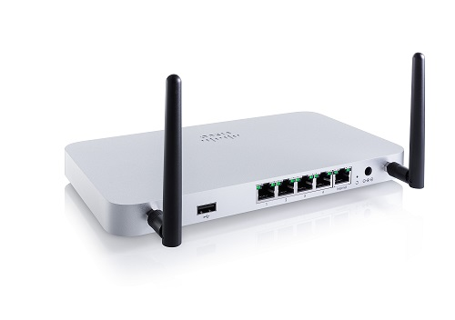

The next figure shows a topology depicting the physical connection of a wired laptop to the wireless router, which is then connected to a cable or DSL modem for internet connectivity.

The figure depicts the physical connection of a wired laptop to the wireless router, which is then connected to a cable or DSL modem for internet connectivity. It shows a person sitting at a computer desk. Connected to the back of the desktop computer is a link going to a wireless router and from the wireless router theres a link going to the broadband modem. The broadband modem has a serial connection to the Internet depicted by a cloud.

Wireless routerBroadband ModemInternet

These wireless routers typically provide WLAN security, DHCP services, integrated Name Address Translation (NAT), quality of service (QoS), as well as a variety of other features. The feature set will vary based on the router model.

**Note**: Cable or DSL modem configuration is usually done by the service provider’s representative either on-site or remotely through a walkthrough with you on the phone. If you buy the modem, it will come with documentation for how to connect it to your service provider which will most likely include contacting your service provider for more information.

13.1.3

## Log in to the Wireless Router

Most wireless routers are ready for service out of the box. They are preconfigured to be connected to the network and provide services. For example, the wireless router uses DHCP to automatically provide addressing information to connected devices. However, wireless router default IP addresses, usernames, and passwords can easily be found on the internet. Just enter the search phrase “default wireless router IP address” or “default wireless router passwords” to see a listing of many websites that provide this information. For example, username and password for the wireless router in the figure is “admin”. Therefore, your first priority should be to change these defaults for security reasons.

To gain access to the wireless router’s configuration GUI, open a web browser. In the address field, enter the default IP address for your wireless router. The default IP address can be found in the documentation that came with the wireless router or you can search the internet. The figure shows the IPv4 address 192.168.0.1, which is a common default for many manufacturers. A security window prompts for authorization to access the router GUI. The word admin is commonly used as the default username and password. Again, check your wireless router’s documentation or search the internet.

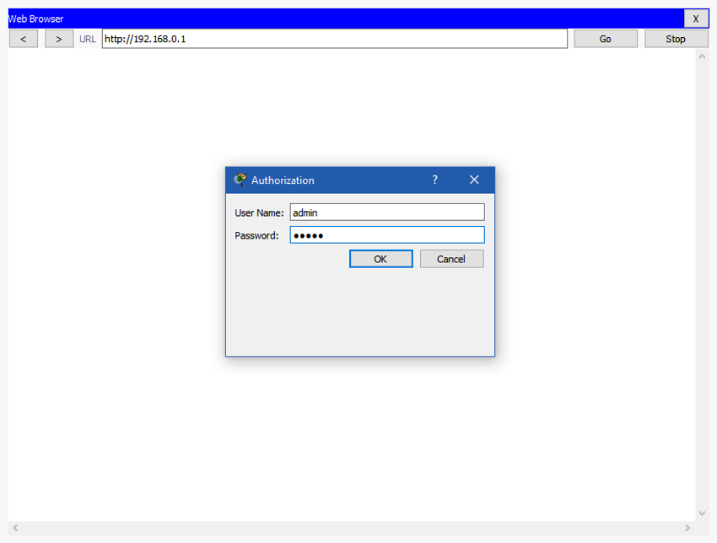

13.1.4

## Basic Network Setup

Basic network setup includes the following steps:

1. Log in to the router from a web browser.
2. Change the default administrative password.
3. Log in with the new administrative password.
4. Change the default DHCP IPv4 addresses.
5. Renew the IP address.
6. Log in to the router with the new IP address.

Click each step for more information and an example GUI.

**1. Log in to the router from a web browser.**

After logging in, a GUI opens. The GUI will have tabs or menus to help you navigate to various router configuration tasks. It is often necessary to save the settings changed in one window before proceeding to another window. At this point, it is a best practice to make changes to the default settings.

Click the next step.

**2. Change the default administrative password.**

To change the default login password, find the administration portion of the router’s GUI. In this example, the Administration tab was selected. This is where the router password can be changed. On some devices, such as the one in the example, you can only change the password. The username remains admin or whatever the default username is for the router you are configuring.

Click the next step

**3. Log in with the new administrative password.**

After you save the new password, the wireless router will request authorization again. Enter the username and new password, as shown in the example.

Click the next step.

**4. Change the default DHCP IPv4 addresses.**

Change the default router IPv4 address. It is a best practice to use private IPv4 addressing inside your network. The IPv4 address 10.10.10.1 is used in the example but it could be any private IPv4 address you choose.

Click the next step.

**5. Renew the IP address.**

When you click save, you will temporarily lose access to the wireless router. Open a command window and renew your IP address with the ipconfig /renew command, as shown in the example.

Click the next step.

**6. Log in to the router with the new IP address.**

Enter the router’s new IP address to regain access to the router configuration GUI, as shown in the example. You are now ready to continue configuring the router for wireless access.

**Basic Wireless Setup**

Basic wireless setup includes the following steps:

1. View the WLAN defaults.
2. Change the network mode.
3. Configure the SSID.
4. Configure the channel.
5. Configure the security mode.
6. Configure the passphrase.
7. **1. View the WLAN defaults.**
8. Out of the box, a wireless router provides wireless access to devices using a default wireless network name and password. The network name is called the Service Set Identified (SSID). Locate the basic wireless settings for your router to change these defaults, as shown in the example.
9. Click the next step.
10. **2. Change the network mode.**
11. Some wireless routers allow you to select which 802.11 standard to implement. The example shows that “Legacy” has been selected. This means wireless devices connecting to the wireless router can have a variety of wireless NICs installed. Today’s wireless routers configured for legacy or mixed mode most likely support 802.11a, 802.11n, and 802.11ac NICs.
12. Click the next step.

**3. Configure the SSID.**

Assign an SSID to the WLANs. OfficeNet is used in the example for all three WLANs (the third WLAN is not shown). The wireless router announces its presence by sending broadcasts advertising its SSID. This allows wireless hosts to automatically discover the name of the wireless network. If the SSID broadcast is disabled, you must manually enter the SSID on each wireless device that connects to the WLAN.

Click the next step.

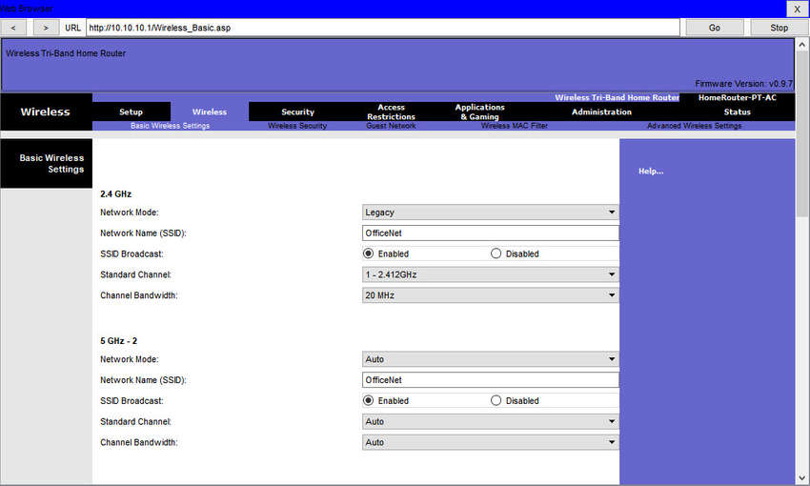

**4. Configure the channel.**

Devices configured with the same channel within the 2.4GHz band may overlap and cause distortion, slowing down the wireless performance and potentially break network connections. The solution to avoid interference is to configure non-overlapping channels on the wireless routers and access points that are near to each other. Specifically, channels 1, 6, and 11 are non-overlapping. In the example, the wireless router is configured to use channel 6.

Click the next step.

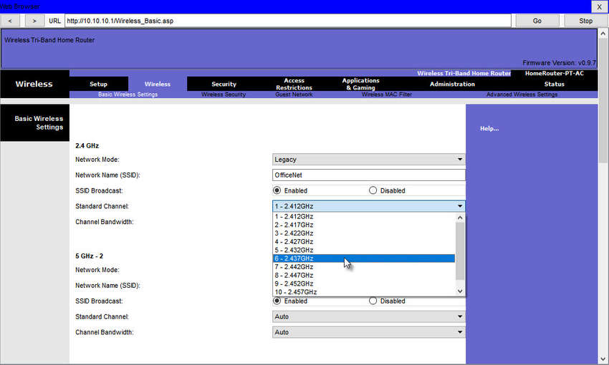

**5. Configure the security mode.**

Out of the box, a wireless router may have no WLAN security configured. In the example, the personal version of Wi-Fi Protected Access version 2 (WPA2 Personal) is selected for all three WLANs. WPA2 with Advanced Encryption Standard (AES) encryption is currently the strongest security mode.

Click the next step.

**6. Configure the passphrase.**

WPA2 personal uses a passphrase to authenticate wireless clients. WPA2 personal is easier to use in a small office or home environment because it does not require an authentication server. Larger organizations implement WPA2 enterprise and require wireless clients to authenticate with a username and password.

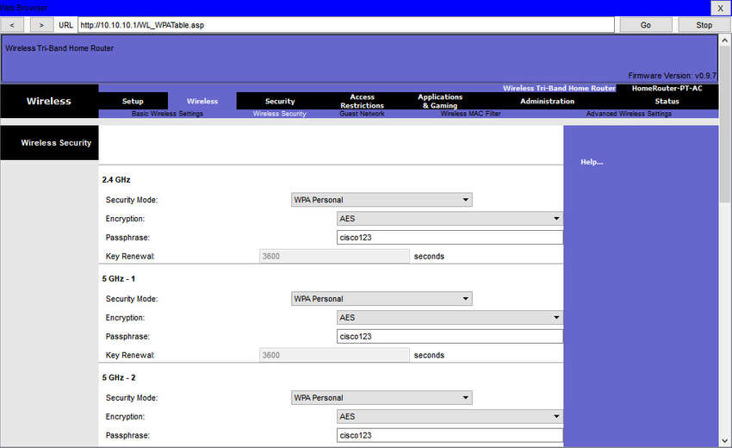

## Configure a Wireless Mesh Network

In a small office or home network, one wireless router may suffice to provide wireless access to all the clients. However, if you want to extend the range beyond approximately 45 meters indoors and 90 meters outdoors, you can add wireless access points. As shown in the wireless mesh network in the figure, two access points are configured with the same WLAN settings from our previous example. Notice that the channels selected are 1 and 11 so that the access points do not interfere with channel 6 configured previously on the wireless router.

The figure depicts two wireless access points in a small office or home network. The wireless access points connect wirelessly to a router. The router is connected to a broadband modem. The broadband modem is connected to a cloud depicting the Internet. There are arrows pointing from the wireless access points showing the configuration settings. One wireless access point is on channel 1 on 2.4GHz and the other is on channel 11 on 2.4GHz.

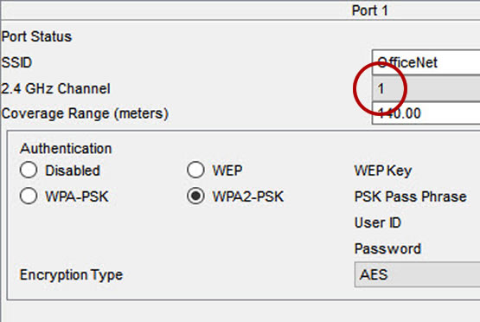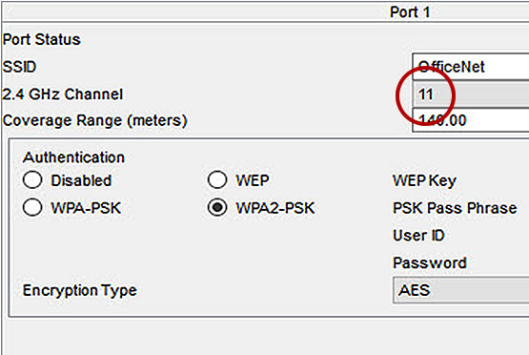

Internet

Extending a WLAN in a small office or home has become increasingly easier. Manufacturers have made creating a wireless mesh network (WMN) simple through smartphone apps. You buy the system, disperse the access points, plug them in, download the app, and configure your WMN in a few steps. Search the internet for “best wi-fi mesh network system” to find reviews of current offerings.

13.1.7

## NAT for IPv4

On a wireless router, if you look for a page like the Status page shown in the figure, you will find the IPv4 addressing information that the router uses to send data to the internet. Notice that the IPv4 address is 209.165.201.11 is a different network than the 10.10.10.1 address assigned to the router’s LAN interface. All the devices on the router’s LAN will get assigned addresses with the 10.10.10 prefix.

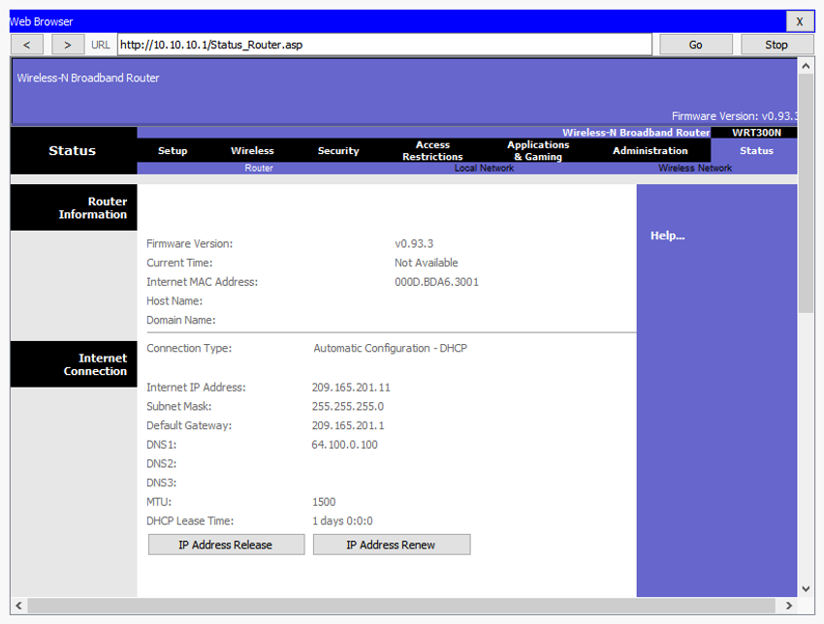

The 209.165.201.11 IPv4 address is publicly routable on the internet. Any address with the 10 in the first octet is a private IPv4 address and cannot be routed on the internet. Therefore, the router will use a process called Network Address Translation (NAT) to convert private IPv4 addresses to internet-routable IPv4 addresses. With NAT, a private (local) source IPv4 address is translated to a public (global) address. The process is reversed for incoming packets. The router is able to translate many internal IPv4 addresses into public addresses, by using NAT.

Some ISPs use private addressing to connect to customer devices. However, eventually, your traffic will leave the provider’s network and be routed on the internet. To see the IP addresses for your devices, search the internet for “what is my IP address.” Do this for other devices on the same network and you will see that they all share the same public IPv4 address. NAT makes this possible by tracking the source port numbers for every session established by a device. If your ISP has IPv6 enabled, you will see a unique IPv6 address for each device.

13.1.8

## Quality of Service

Many wireless routers have an option for configuring Quality of Service (QoS). By configuring QoS, you can guarantee that certain traffic types, such as voice and video, are prioritized over traffic that is not as time-sensitive, such as email and web browsing. On some wireless routers, traffic can also be prioritized on specific ports.

The figure is a simplified mockup of a QoS interface based on a Netgear GUI. You will usually find the QoS settings in the advanced menus. If you have a wireless router available, investigate the QoS settings. Sometimes, these might be listed under “bandwidth control” or something similar. Consult the wireless router’s documentation or search the internet for “qos settings” for your router’s make and model.

| **#** | **Qos Policy** | **Priority** | **Description** |
| --- | --- | --- | --- |
| 1 | IP Phone | High | IP Phone applications |
| 2 | Counter Strike | High | Online Gaming Counter Strike |
| 3 | Netflix | High | Online Video Streaming Netflix |
| 4 | FTP | Medium | FTP Applications |
| 5 | WWW | Medium | WWW Applications |
| 6 | Gnutella | Low | Gnutella Applications |
| 7 | SMTP | Medium | SMTP Applications |

Add Priority RoleAdvanced SetupAdministrationSecurityStorageSetupAdvanced HomeBasicAdvancedDelete AllEditDeleteCancelApplyQoS SetupInternet SetupWireless SetupLAN SetupQoS Setup

13.1.9

## Port Forwarding

Wireless routers typically block TCP and UDP ports to prevent unauthorized access in and out of a LAN. However, there are situations when specific ports must be opened so that certain programs and applications can communicate with devices on different networks. Port forwarding is a rule-based method of directing traffic between devices on separate networks.

When traffic reaches the router, the router determines if the traffic should be forwarded to a certain device based on the port number found with the traffic. For example, a router might be configured to forward port 80, which is associated with HTTP. When the router receives a packet with the destination port of 80, the router forwards the traffic to the server inside the network that serves web pages. In the figure, port forwarding is enabled for port 80 and is associated with the web server at IPv4 address 10.10.10.50.

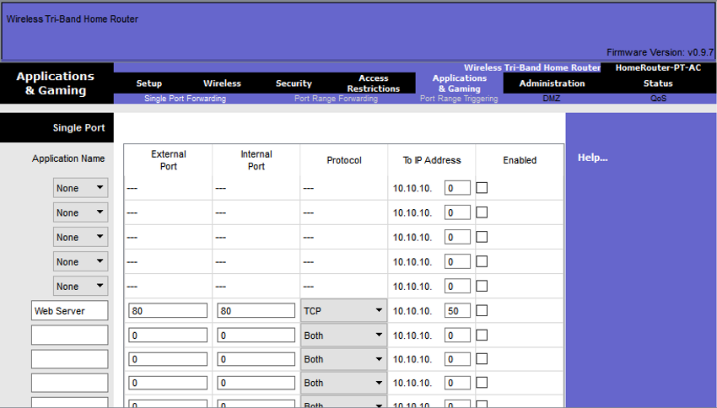

Port triggering allows the router to temporarily forward data through inbound ports to a specific device. You can use port triggering to forward data to a computer only when a designated port range is used to make an outbound request. For example, a video game might use ports 27000 to 27100 for connecting with other players. These are the trigger ports. A chat client might use port 56 for connecting the same players so that they can interact with each other. In this instance, if there is gaming traffic on an outbound port within the triggered port range, inbound chat traffic on port 56 is forwarded to the computer that is being used to play the video game and chat with friends. When the game is over and the triggered ports are no longer in use, port 56 is no longer allowed to send traffic of any type to this computer.

13.1.10

## Packet Tracer - Configure a Wireless Network

In this activity, you will configure a wireless router and an access point to accept wireless clients and route IP packets.

[Configure a Wireless Network](https://contenthub.netacad.com/courses/srwe/_common/13.1.10-packet-tracer---configure-a-wireless-network.pka)

13.1.11

## Lab - Configure a Wireless Network

In this lab, you will configure basic settings on a wireless router and connect a PC to router wirelessly.

**Video - Configure a Basic WLAN on the WLC**

In the previous topic you learned about remote site WLAN configuration. This topic is about configuring a basic WLAN on the WLC.

Click Play in the figure to view a demonstration of configuring a Cisco 3504 WLC with basic WLAN connectivity.

13.2.2

**WLC Topology**

The topology and addressing scheme used for the videos and this topic are shown in the figure and the table. The access point (AP) is a controller-based AP as opposed to an autonomous AP. Recall that controller-based APs require no initial configuration and are often called lightweight APs (LAPs). LAPs use the Lightweight Access Point Protocol (LWAPP) to communicate with a WLAN controller (WLC). Controller-based APs are useful in situations where many APs are required in the network. As more APs are added, each AP is automatically configured and managed by the WLC.

The figure shows a wireless LAN controller (WLC) topology. PC-A is a RADIUS/SNMP Server connected to R1 on R1s F0/0 interface. PC-B is connected to S1 on S1s F0/6 port. R1 and S1 are connected together on R1s F0/1 interface and on S1s F0/5 interface. S1 is connected to a WLC on its F0/18 port. On S1s F0/1 port its connected to an access point, AP1. A laptop is wirelessly connected to AP1.

**Topology**

PC-A PC-B R1 S1 AP1 WLC F0/0 F0/1 F0/5 F0/18 G1 F0/6

F0/1

RADIUS/SNMP ServerAdminPoE802.1q trunk802.1q trunk802.1q trunk

The AP is PoE, which means it is powered over the Ethernet cable that is attached to the switch.

**Addressing Table**

| DeviceInterfaceIP AddressSubnet MaskR1F0/0172.16.1.1255.255.255.0R1F0/1.1192.168.200.1255.255.255.0S1VLAN 1DHCPWLCManagement192.168.200.254255.255.255.0AP1Wired 0192.168.200.3255.255.255.0PC-ANIC172.16.1.254255.255.255.0PC-BNICDHCPWireless LaptopNICDHCP | | | |
| --- | --- | --- | --- |
| **Device** | **Interface** | **IP Address** | **Subnet Mask** |
| R1 | F0/0 | 172.16.1.1 | 255.255.255.0 |
| R1 | F0/1.1 | 192.168.200.1 | 255.255.255.0 |
| S1 | VLAN 1 | DHCP | |
| WLC | Management | 192.168.200.254 | 255.255.255.0 |
| AP1 | Wired 0 | 192.168.200.3 | 255.255.255.0 |
| PC-A | NIC | 172.16.1.254 | 255.255.255.0 |
| PC-B | NIC | DHCP | |
| Wireless Laptop | NIC | DHCP | |

13.2.3

**Log in to the WLC**

Configuring a wireless LAN controller (WLC) is not that much different from configuring a wireless router. The big difference is that a WLC controls APs and provides more services and management capabilities, many of which are beyond the scope of this module.

**Note**: The figures in this topic that show the graphical user interface (GUI) and menus are from a Cisco 3504 Wireless Controller. However, other WLC models will have similar menus and features.

The figure shows the user logging into the WLC with credentials that were configured during initial setup.

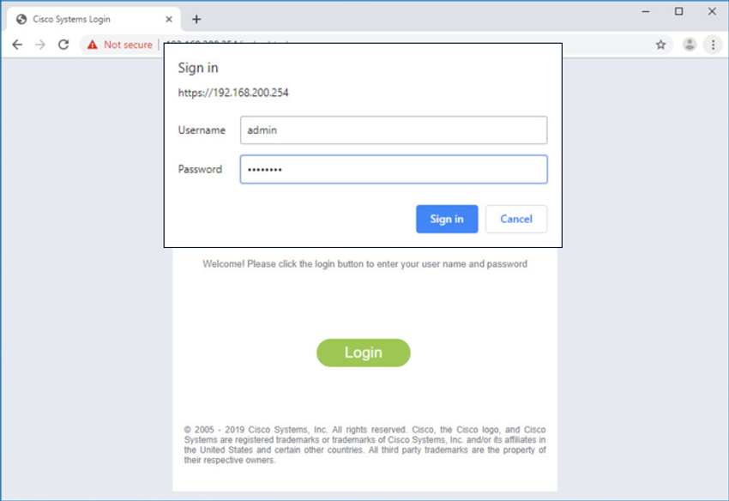

The **Network Summary** page is a dashboard that provides a quick overview of the number of configured wireless networks, associated access points (APs), and active clients. You can also see the number of rogue access points and clients, as shown in the figure.

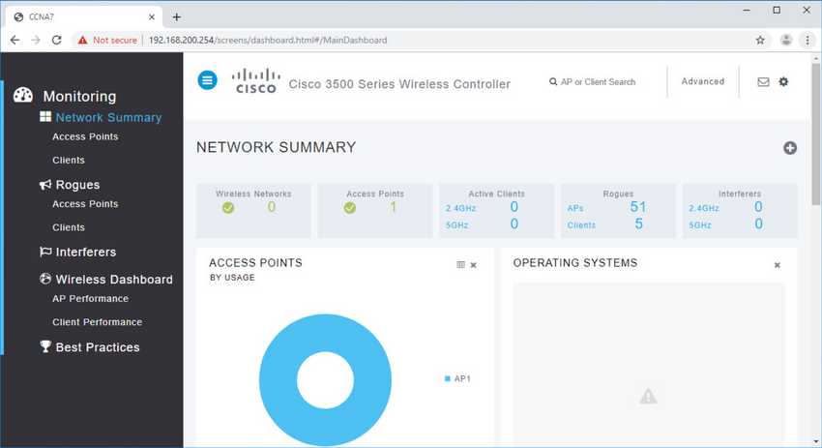

**View AP Information**

Click **Access Points** from the left menu to view an overall picture of the AP’s system information and performance, as shown in the next figure. The AP is using IP address 192.168.200.3. Because Cisco Discovery Protocol (CDP) is active on this network, the WLC knows that the AP is connected to the FastEthernet 0/1 port on the switch.

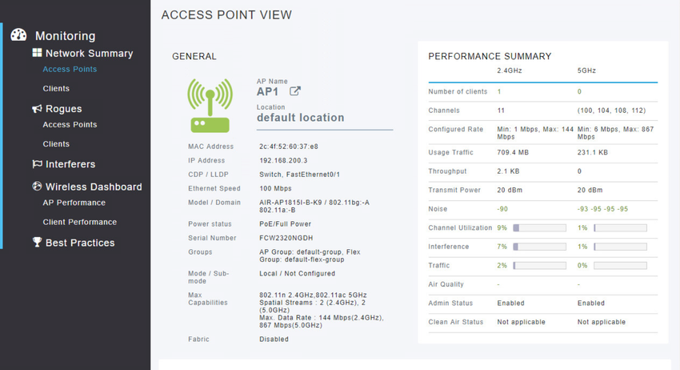

This AP in the topology is a Cisco Aironet 1815i which means you can use the command-line and a limited set of familiar IOS commands. In the example, the network administrator pinged the default gateway, pinged the WLC, and verified the wired interface.

AP1# **ping 192.168.200.1**

Sending 5, 100-byte ICMP Echos to 192.168.200.1, timeout is 2 seconds

!!!!!

Success rate is 100 percent (5/5), round-trip min/avg/max = 1069812.242/1071814.785/1073817.215 ms

AP1# **ping 192.168.200.254**

Sending 5, 100-byte ICMP Echos to 192.168.200.254, timeout is 2 seconds

!!!!!

Success rate is 100 percent (5/5), round-trip min/avg/max = 1055820.953/1057820.738/1059819.928 ms

AP1# **show interface wired 0**

wired0 Link encap:Ethernet HWaddr 2C:4F:52:60:37:E8

inet addr:192.168.200.3 Bcast:192.168.200.255 Mask:255.255.255.255

UP BROADCAST RUNNING PROMISC MULTICAST MTU:1500 Metric:1

RX packets:2478 errors:0 dropped:3 overruns:0 frame:0

TX packets:1494 errors:0 dropped:0 overruns:0 carrier:0

collisions:0 txqueuelen:80

RX bytes:207632 (202.7 KiB) TX bytes:300872 (293.8 KiB)

AP1#

13.2.5

**Advanced Settings**

Most WLC will come with some basic settings and menus that users can quickly access to implement a variety of common configurations. However, as a network administrator, you will typically access the advanced settings. For the Cisco 3504 Wireless Controller, click **Advanced** in the upper right-hand corner to access the advanced **Summary** page, as shown in the figure. From here, you can access all the features of the WLC.

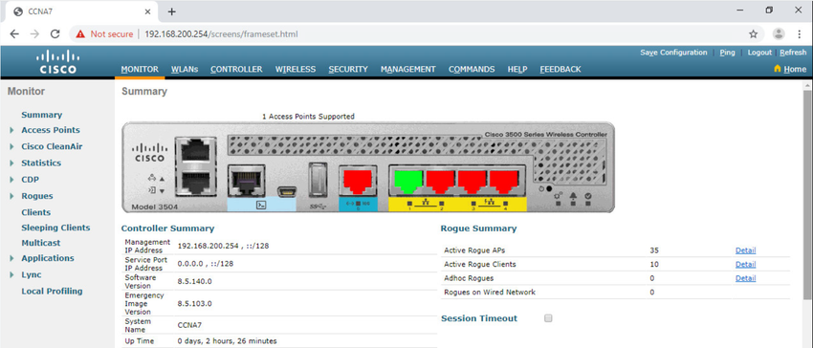

13.2.6

**Configure a WLAN**

Wireless LAN Controllers have ports and interfaces. Ports are the sockets for the physical connections to the wired network. They resemble switch ports. Interfaces are virtual. They are created in software and are very similar to VLAN interfaces. In fact, each interface that will carry traffic from a WLAN is configured on the WLC as a different VLAN. The Cisco 3504 WLC can support 150 access points and 4096 VLANs, however it only has five physical ports, as shown in the figure. This means that each physical port can support many APs and WLANs. The ports on the WLC are essentially trunk ports that can carry traffic from multiple VLANs to a switch for distribution to multiple APs. Each AP can support multiple WLANs.

The figure shows the front of a Cisco 3504 Wireless Controller. It has 2 service ports for out-of-band management, a console port, a mini-usb console port, 3.0 USB port, a 5G port, and four gigabit ports.

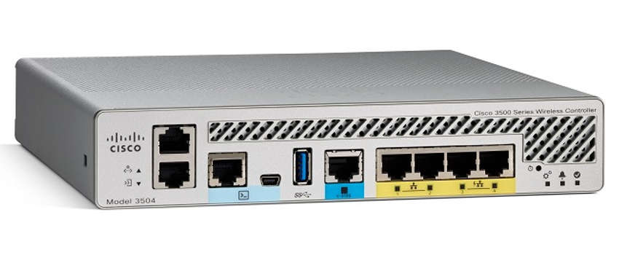

Basic WLAN configuration on the WLC includes the following steps:

1. Create the WLAN
2. Apply and Enable the WLAN
3. Select the Interface
4. Secure the WLAN
5. Verify the WLAN is Operational
6. Monitor the WLAN
7. View Wireless Client Information

Click each step for more information and an example GUI.

1. Create the WLAN

In the figure, the administrator is creating a new WLAN that will use Wireless_LAN as the name and service set identifier (SSID). The ID is an arbitrary value that is used to identify the WLAN in display output on the WLC.

The figure depicts the creation of a new WLAN on a WLC GUI. The WLANs New tab is selected with options for the Type, Profile Name, SSID and ID. The type is WLAN, the profile name is Wireless_LAN, the SSID is Wireless_LAN and the ID is 1.

13.2.7

2. Apply and Enable the WLAN

After clicking Apply, the network administrator must enable the WLAN before it can be accessed by users, as shown in the figure. The Enable checkbox allows the network administrator to configure a variety of features for the WLAN, as well as additional WLANs, before enabling them for wireless client access. From here, the network administrator can configure a variety of settings for the WLAN including security, QoS, policies, and other advanced settings.

3. Select the Interface

When you create a WLAN, you must select the interface that will carry the WLAN traffic. The next figure shows the selection of an interface that has already been created on the WLC. We will learn how to create interfaces later in this module.

4. Secure the WLAN

Click the Security tab to access all the available options for securing the LAN. The network administrator wants to secure Layer 2 with WPA2-PSK. WPA2 and 802.1X are set by default. In the Layer 2 Security drop down box, verify that WPA+WPA2 is selected (not shown). Click PSK and enter the pre-shared key, as shown in the figure. Then click Apply. This will enable the WLAN with WPA2-PSK authentication. Wireless clients that know the pre-shared key can now associate and authenticate with the AP.

5. Verify the WLAN is Operational

Click WLANs in the menu on the left to view the newly configured WLAN. In the figure, you can verify that WLAN ID 1 is configured with Wireless_LAN as the name and SSID, it is enabled, and is using WPA2 PSK security.

6. Monitor the WLAN

Click the Monitor tab at the top to access the advanced Summary page again. Here you can see that the Wireless_LAN now has one client using its services, as shown in the figure.

7. View Wireless Client Details

Click Clients in the left menu to view more information about the clients connected to the WLAN, as shown in the figure. One client is attached to Wireless_LAN through AP1 and was given the IP address 192.168.5.2. DHCP services in this topology are provided by the router.

this is the image’s alt text

## Video - Define an SNMP and RADIUS Server on the WLC

The previous topic covered configuring a basic WLAN on the WLC. Now you will learn about configuring a WPA2 Enterprise WLAN.

Click Play in the figure to view a demonstration of configuring SNMP and RADIUS services on the WLC.

13.3.2

## SNMP and RADIUS

In the figure, PC-A is running Simple Network Management Protocol (SNMP) and Remote Authentication Dial-In User Service (RADIUS) server software. SNMP is used to monitor the network. The network administrator wants the WLC to forward all SNMP log messages, called traps, to the SNMP server.

In addition, for WLAN user authentication, the network administrator wants to use a RADIUS server for authentication, authorization, and accounting (AAA) services. Instead of entering a publicly known pre-shared key to authenticate, as they do with WPA2-PSK, users will enter their own username and password credentials. The credentials will be verified by the RADIUS server. This way, individual user access can be tracked and audited if necessary and user accounts can be added or modified from a central location. The RADIUS server is required for WLANs that are using WPA2 Enterprise authentication.

**Note**: SNMP server and RADIUS server configuration is beyond the scope of this module.

The figure depicts a network topology. PC-A is a RADIUS/SNMP Server connected to R1 on R1s F0/0 interface. PC-B is connected to S1 on S1s F0/6 port. R1 and S1 are connected together on R1s F0/1 interface and on S1s F0/5 interface. S1 is connected to a WLC on its F0/18 port. On S1s F0/1 port its connected to an access point, AP1. A laptop is wirelessly connected to AP1.

### Topology

PC-A PC-B R1 S1 AP1 WLC F0/0 F0/1 F0/5 F0/18 G1 F0/6

F0/1

RADIUS/SNMP ServerAdminPoE802.1q trunk802.1q trunk802.1q trunk

13.3.3

## Configure SNMP Server Information

Click the **MANAGEMENT** tab to access a variety of management features. SNMP is listed at the top of the menu on the left. Click **SNMP** to expand the sub-menus, and then click **Trap Receivers**. Click **New...** to configure a new SNMP trap receiver, as shown in the figure.

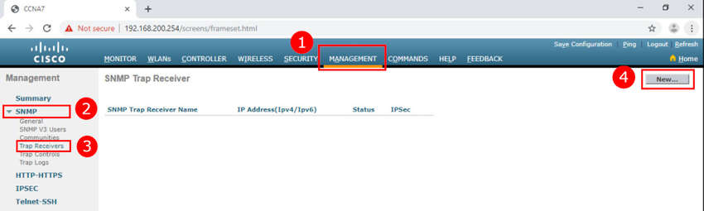

1. Click **MANAGEMENT**
2. Click **SNMP**
3. Click **Trap Receivers**
4. Click **New...**

Enter the SNMP Community name and the IP address (IPv4 or IPv6) for the SNMP server. Click **Apply**. The WLC will now forward SNMP log messages to the SNMP server.

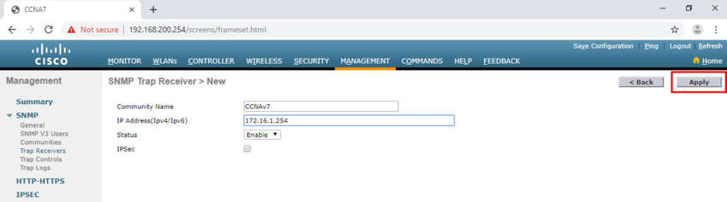

13.3.4

## Configure RADIUS Server Information

In our example configuration, the network administrator wants to configure a WLAN using WPA2 Enterprise, as opposed to WPA2 Personal or WPA2 PSK. Authentication will be handled by the RADIUS server running on PC-A.

To configure the WLC with the RADIUS server information, click the **SECURITY** tab > **RADIUS** > **Authentication**. No RADIUS servers are currently configured. Click **New...** to add PC-A as the RADIUS server.

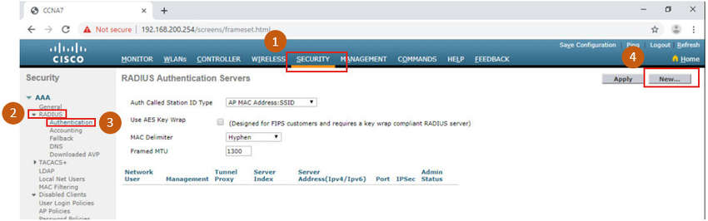

1. Click **SECURITY**
2. Click **RADIUS**
3. Click **Authentication**
4. Click **New...**

Enter the IPv4 address for PC-A and the shared secret. This is the password used between the WLC and the RADIUS server. It is not for users. Click **Apply**, as shown in the figure.

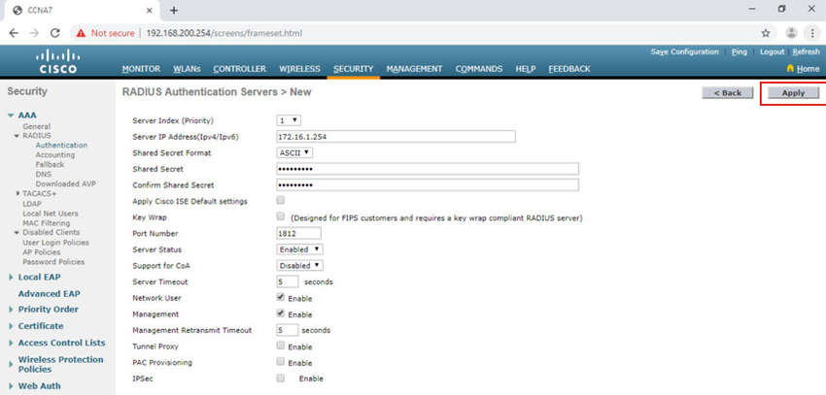

After clicking **Apply**, the list of configured **RADIUS Authentication Servers** refreshes with the new server listed, as shown in the figure.

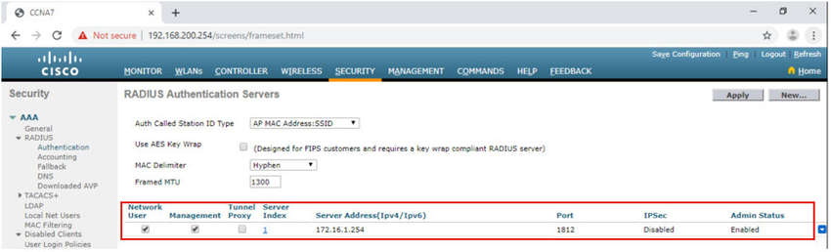

13.3.5

## Video - Configure a VLAN for a New WLAN

Click Play in the figure to view a demonstration of configuring a VLAN on the WLC.

13.3.6

## Topology with VLAN 5 Addressing

Each WLAN configured on the WLC needs its own virtual interface. The WLC has five physical ports for data traffic. Each physical port can be configured to support multiple WLANs, each on its own virtual interface. Physical ports can also be aggregated to create high-bandwidth links.

The network administrator has decided that the new WLAN will use interface VLAN 5 and network 192.168.5.0/24. R1 already has a subinterface configured and active for VLAN 5, as shown in the topology and **show ip interface brief** output.

The figure depicts a network topology. PC-A is a RADIUS/SNMP Server connected to R1 on R1s F0/0 interface. R1 has a sub-interface configured on VLAN 5 with the IP address 192.168.5.1. PC-B is connected to S1 on S1s F0/6 port. R1 and S1 are connected together on R1s F0/1 interface and on S1s F0/5 interface. S1 is connected to a WLC on its F0/18 port. The WLC has the management IP address of 192.168.200.254 and an interface on VLAN 5 with an IP address of 192.168.5.254. On S1s F0/1 port its connected to an access point, AP1. A laptop is wirelessly connected to AP1.

### Topology

PC-A PC-B R1 S1 AP1 F0/0 F0/18 F0/6 F0/5 F0/1 G1

F0/1

RADIUS/SNMP ServerPoEWLCManagement: 192.168.200.254  
Interface VLAN5: 192.168.5.254802.1q trunk802.1q trunk802.1q trunkVLAN5: 192.168.5.1

R1# **show ip interface brief**

Interface IP-Address OK? Method Status Protocol

FastEthernet0/0 172.16.1.1 YES manual up up

FastEthernet0/1 unassigned YES unset up up

FastEthernet0/1.1 192.168.200.1 YES manual up up

FastEthernet0/1.5 192.168.5.254 YES manual up up

(output omitted)

R1#

13.3.7

## Configure a New Interface

VLAN interface configuration on the WLC includes the following steps:

1. Create a new interface.
2. Configure the VLAN name and ID.
3. Configure the port and interface address.
4. Configure the DHCP server address.
5. Apply and Confirm.
6. Verify Interfaces.

Click each step for more information and an example GUI.

1. Create a new interface.

To add a new interface, click CONTROLLER > Interfaces > New..., as shown in the figure.

2. Configure the VLAN name and ID.

In the figure, the network administrator configures the interface name as vlan5 and the VLAN ID as 5. Clicking Apply will create the new interface.

3. Configure the port and interface address.

On the Edit page for the interface, configure the physical port number. G1 in the topology is Port Number 1 on the WLC. Then configure the VLAN 5 interface addressing. In the figure, VLAN 5 is assigned IPv4 address 192.168.5.254/24. R1 is the default gateway at IPv4 address 192.168.5.1.

4. Configure the DHCP server address.

In larger enterprises, WLCs will be configured to forward DHCP messages to a dedicated DHCP server. Scroll down the page to configure the primary DHCP server as IPv4 address 192.168.5.1, as shown in the figure. This is the default gateway router address. The router is configured with a DHCP pool for the WLAN network. As hosts join the WLAN that is associated with the VLAN 5 interface, they will receive addressing information from this pool.

5. Apply and Confirm.

Scroll to the top and click Apply, as shown in the figure. Click OK for the warning message.

6. Verify Interfaces.

Click Interfaces. The new vlan5 interface is now shown in the list of interfaces with its IPv4 address, as shown in the figure.

**d Wireless Essentials**

v7.0

[Skip to content](https://contenthub.netacad.com/srwe?lng=en#chunks-container)

* • • • • • • • • • • • • • • • • • • • • • • • • • • • • • • • • • • • • • • • • • • • • • • • • • • • • • • • • • • • • • • • • • • • • • • • • • • • • • • • • • • • • • • • • • • • • • • • • • • • • • • • • • • • • • •
* • • • • •

1. WLAN Configuration
2. Configure a WPA2 Enterprise WLAN on the WLC

**Configure a WPA2 Enterprise WLAN on the WLC**

13.3.1

**Video - Define an SNMP and RADIUS Server on the WLC**

The previous topic covered configuring a basic WLAN on the WLC. Now you will learn about configuring a WPA2 Enterprise WLAN.

Click Play in the figure to view a demonstration of configuring SNMP and RADIUS services on the WLC.

13.3.2

**SNMP and RADIUS**

In the figure, PC-A is running Simple Network Management Protocol (SNMP) and Remote Authentication Dial-In User Service (RADIUS) server software. SNMP is used to monitor the network. The network administrator wants the WLC to forward all SNMP log messages, called traps, to the SNMP server.

In addition, for WLAN user authentication, the network administrator wants to use a RADIUS server for authentication, authorization, and accounting (AAA) services. Instead of entering a publicly known pre-shared key to authenticate, as they do with WPA2-PSK, users will enter their own username and password credentials. The credentials will be verified by the RADIUS server. This way, individual user access can be tracked and audited if necessary and user accounts can be added or modified from a central location. The RADIUS server is required for WLANs that are using WPA2 Enterprise authentication.

**Note**: SNMP server and RADIUS server configuration is beyond the scope of this module.

The figure depicts a network topology. PC-A is a RADIUS/SNMP Server connected to R1 on R1s F0/0 interface. PC-B is connected to S1 on S1s F0/6 port. R1 and S1 are connected together on R1s F0/1 interface and on S1s F0/5 interface. S1 is connected to a WLC on its F0/18 port. On S1s F0/1 port its connected to an access point, AP1. A laptop is wirelessly connected to AP1.

**Topology**

PC-A PC-B R1 S1 AP1 WLC F0/0 F0/1 F0/5 F0/18 G1 F0/6

F0/1

RADIUS/SNMP ServerAdminPoE802.1q trunk802.1q trunk802.1q trunk

13.3.3

**Configure SNMP Server Information**

Click the **MANAGEMENT** tab to access a variety of management features. SNMP is listed at the top of the menu on the left. Click **SNMP** to expand the sub-menus, and then click **Trap Receivers**. Click **New...** to configure a new SNMP trap receiver, as shown in the figure.



1. Click **MANAGEMENT**
2. Click **SNMP**
3. Click **Trap Receivers**
4. Click **New...**

Enter the SNMP Community name and the IP address (IPv4 or IPv6) for the SNMP server. Click **Apply**. The WLC will now forward SNMP log messages to the SNMP server.



13.3.4

**Configure RADIUS Server Information**

In our example configuration, the network administrator wants to configure a WLAN using WPA2 Enterprise, as opposed to WPA2 Personal or WPA2 PSK. Authentication will be handled by the RADIUS server running on PC-A.

To configure the WLC with the RADIUS server information, click the **SECURITY** tab > **RADIUS** > **Authentication**. No RADIUS servers are currently configured. Click **New...** to add PC-A as the RADIUS server.



1. Click **SECURITY**
2. Click **RADIUS**
3. Click **Authentication**
4. Click **New...**

Enter the IPv4 address for PC-A and the shared secret. This is the password used between the WLC and the RADIUS server. It is not for users. Click **Apply**, as shown in the figure.



After clicking **Apply**, the list of configured **RADIUS Authentication Servers** refreshes with the new server listed, as shown in the figure.



13.3.5

**Video - Configure a VLAN for a New WLAN**

Click Play in the figure to view a demonstration of configuring a VLAN on the WLC.

13.3.6

**Topology with VLAN 5 Addressing**

Each WLAN configured on the WLC needs its own virtual interface. The WLC has five physical ports for data traffic. Each physical port can be configured to support multiple WLANs, each on its own virtual interface. Physical ports can also be aggregated to create high-bandwidth links.

The network administrator has decided that the new WLAN will use interface VLAN 5 and network 192.168.5.0/24. R1 already has a subinterface configured and active for VLAN 5, as shown in the topology and **show ip interface brief** output.

The figure depicts a network topology. PC-A is a RADIUS/SNMP Server connected to R1 on R1s F0/0 interface. R1 has a sub-interface configured on VLAN 5 with the IP address 192.168.5.1. PC-B is connected to S1 on S1s F0/6 port. R1 and S1 are connected together on R1s F0/1 interface and on S1s F0/5 interface. S1 is connected to a WLC on its F0/18 port. The WLC has the management IP address of 192.168.200.254 and an interface on VLAN 5 with an IP address of 192.168.5.254. On S1s F0/1 port its connected to an access point, AP1. A laptop is wirelessly connected to AP1.

**Topology**

PC-A PC-B R1 S1 AP1 F0/0 F0/18 F0/6 F0/5 F0/1 G1

F0/1

RADIUS/SNMP ServerPoEWLCManagement: 192.168.200.254  
Interface VLAN5: 192.168.5.254802.1q trunk802.1q trunk802.1q trunkVLAN5: 192.168.5.1

R1# **show ip interface brief**

Interface IP-Address OK? Method Status Protocol

FastEthernet0/0 172.16.1.1 YES manual up up

FastEthernet0/1 unassigned YES unset up up

FastEthernet0/1.1 192.168.200.1 YES manual up up

FastEthernet0/1.5 192.168.5.254 YES manual up up

(output omitted)

R1#

13.3.7

**Configure a New Interface**

VLAN interface configuration on the WLC includes the following steps:

1. Create a new interface.
2. Configure the VLAN name and ID.
3. Configure the port and interface address.
4. Configure the DHCP server address.
5. Apply and Confirm.
6. Verify Interfaces.

Click each step for more information and an example GUI.

**6. Verify Interfaces.**

Click **Interfaces.** The new **vlan5** interface is now shown in the list of interfaces with its IPv4 address, as shown in the figure.

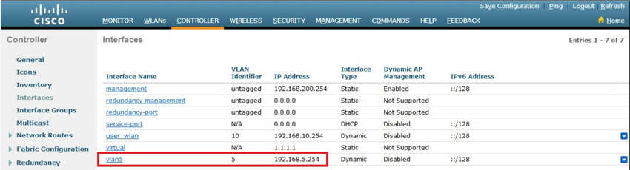

13.3.8

**Video - Configure a DHCP Scope**

Click Play in the figure to view a demonstration of configuring DHCP services.

13.3.9

**Configure a DHCP Scope**

DHCP scope configuration includes the following steps:

1. Create a new DHCP scope.
2. Name the DHCP scope.
3. Verify the new DHCP scope.
4. Configure and enable the new DHCP scope.
5. Verify the enable DHCP scope

Click each step for more information and an example GUI.

**1. Create a new DHCP scope.**

A DHCP scope is very similar to a DHCP pool on a router. It can include a variety of information including a pool of addresses to assign to DHCP clients, DNS server information, lease times, and more. To configure a new DHCP scope, click **Internal DHCP Server > DHCP Scope > New...**, as shown in the figure.

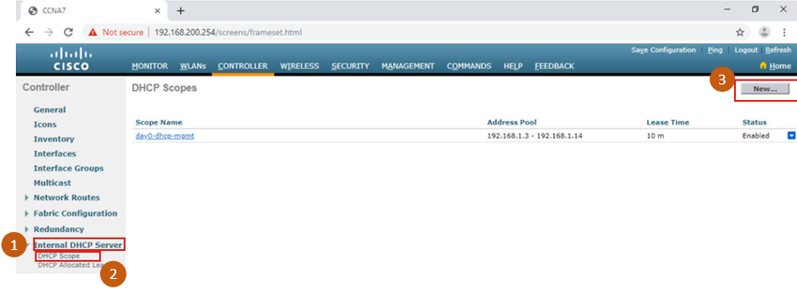

2. Name the DHCP scope.

On the next screen, name the scope. Because this scope will apply to the wireless management network, the network administrator uses Wireless_Management as the Scope Name and clicks Apply.

The figure depicts naming the DHCP Scope on a WLC GUI. The Controller tab on the main menu is selected and DHCP Scope > New is selected. The Scope name is Wireless_Management.

3. Verify the new DHCP scope.

You are returned to the DHCP Scopes page and can verify the scope is ready to be configured. Click the new Scope Name to configure the DHCP scope.

The figure depicts the verifying the new DHCP Scope on a WLC GUI. The Controller tab on the main menu is selected and the DHCP Scopes sub-menu is selected. The Wireless_Management is listed under Scope Name.

4. Configure and enable the new DHCP scope.

On the Edit screen for the Wireless_Management scope, configure a pool of addresses for the 192.168.200.0/24 network starting at .240 and ending at .249. The network address and subnet mask are configured. The default router IPv4 address is configured, which is the subinterface for R1 at 192.168.200.1. For this example, the rest of the scope is left unchanged. The network administrator selects Enabled from the Status drop down and clicks Apply.

The figure depicts the configuring and enabling the new DHCP Scope on a WLC GUI. The Controller tab on the main menu is selected and DHCP Scope > Edit is selected. The Pool Start IP address: 192.168.200.240, Pool End Address, 192.168.200.249, Network: 192.168.200.0, and Netmask: 255.255.255.0 are outlined in a square. The Default router: 192.168.200.1 and Status: enabled are outlined in rectangles.

5. Verify the enable DHCP scope

The network administrator is returned to the DHCP Scopes page and can verify the scope is ready to be allocated to a new WLAN.

The figure depicts verifying the enable DHCP Scope on a WLC GUI. The Controller tab on the main menu is selected and the DHCP Scopes sub-menu is selected. The Wireless_Management Address pool: 192.168.200.240 through 192.168.200.249 is outlined in a rectangle.

Configure a WPA2 Enterprise WLAN

By default, all newly created WLANs on the WLC will use WPA2 with Advanced Encryption System (AES). 802.1X is the default key management protocol used to communicate with the RADIUS server. Because the network administrator already configured the WLC with the IPv4 address of the RADIUS server running on PC-A, the only configuration left to do is to create a new WLAN to use interface vlan5.

Configuring a new WLAN on the WLC includes the following steps:

Create a new WLAN.

Configure the WLAN name and SSID.

Enable the WLAN for VLAN 5.

Verify AES and 802.1X defaults.

Configure WLAN security to use the RADIUS server.

Verify the new WLAN is available.

Click each step for more information and an example GUI.

1. Create a new WLAN.

Click the WLANs tab and then Go to create a new WLAN, as shown in the figure.

The figure depicts the creation of a new WLAN on a WLC GUI. The WLANs tab on the main menu is selected and the Go button on the Create New sub-menu is outlined with a rectangle.

2. Configure the WLAN name and SSID.

Fill in the profile name and SSID. In order to be consistent with the VLAN that was previously configured, choose an ID of 5. However, any available value can be used. Click Apply to create the new WLAN, as shown in the figure.

3. Enable the WLAN for VLAN 5.

The WLAN is created but it still needs to be enabled and associated with the correct VLAN interface. Change the status to Enabled and choose vlan5 from the Interface/Interface Group(G) dropdown list. Click Apply and click OK to accept the popup message, as shown in the figure.

The figure depicts enabling the WLAN for VLAN 5 on a WLC GUI. The WLANs tab on the main menu is selected. Under WLANs > Edit the General sub-menu is selected. The Status: enabled option is outlined with a rectangle and the number 1. Interface/Interface Group has vlan5 selected and outlined with a rectangle and the number 2. The Apply button is outlined with a rectangle and the number 3. A prompt with a warning that changing WLAN parameters while it is enabled will cause the WLAN to be momentarily disabled and radio reset thus may result in loss of connectivity for some clients. Press okay to continue. Next to the Okay button is the number 4.

4. Verify AES and 802.1X defaults.

Click the Security tab to view the default security configuration for the new WLAN. The WLAN will use WPA2 security with AES encryption. Authentication traffic is handled by 802.1X between the WLC and the RADIUS server.

5. Configure the RADIUS server.

We now need to select the RADIUS server that will be used to authenticate users for this WLAN. Click the AAA Servers tab. In the dropdown box select the RADIUS server that was configured on the WLC previously. Apply your changes.

6. Verify that the new WLAN is available.

To verify the new WLAN is listed and enabled, click Back or the WLANs submenu on the left. Both the Wireless_LAN WLAN and the CompanyName WLAN are listed. In the figure, notice that both are enabled. Wireless_LAN is using WPA2 with PSK authentication. CompanyName is using WPA2 security with 802.1X authentication.

**Troubleshoot WLAN Issues**

13.4.1

**Troubleshooting Approaches**

In the previous topics, you learned about WLAN configuration. Here we will discuss troubleshooting WLAN issues.

Network problems can be simple or complex, and can result from a combination of hardware, software, and connectivity issues. Technicians must be able to analyze the problem and determine the cause of the error before they can resolve the network issue. This process is called troubleshooting.

Troubleshooting any sort of network problem should follow a systematic approach. A common and efficient troubleshooting methodology is based on the scientific method and can be broken into the six main steps shown in the table.

| StepTitleDescription1Identify the ProblemThe first step in the troubleshooting process is to identify the problem. While tools can be used in this step, a conversation with the user is often very helpful.2Establish a Theory of Probable CausesAfter you have talked to the user and identified the problem, you can try and establish a theory of probable causes. This step often yields more than a few probable causes to the problem.3Test the Theory to Determine CauseBased on the probable causes, test your theories to determine which one is the cause of the problem. A technician will often apply a quick procedure to test and see if it solves the problem. If a quick procedure does not correct the problem, you might need to research the problem further to establish the exact cause.4Establish a Plan of Action to Resolve the Problem and Implement the SolutionAfter you have determined the exact cause of the problem, establish a plan of action to resolve the problem and implement the solution.5Verify Full System Functionality and Implement Preventive MeasuresAfter you have corrected the problem, verify full functionality and, if applicable, implement preventive measures.6Document Findings, Actions, and OutcomesIn the final step of the troubleshooting process, document your findings, actions, and outcomes. This is very important for future reference. | | |
| --- | --- | --- |
| **Step** | **Title** | **Description** |
| 1 | Identify the Problem | The first step in the troubleshooting process is to identify the problem. While tools can be used in this step, a conversation with the user is often very helpful. |
| 2 | Establish a Theory of Probable Causes | After you have talked to the user and identified the problem, you can try and establish a theory of probable causes. This step often yields more than a few probable causes to the problem. |
| 3 | Test the Theory to Determine Cause | Based on the probable causes, test your theories to determine which one is the cause of the problem. A technician will often apply a quick procedure to test and see if it solves the problem. If a quick procedure does not correct the problem, you might need to research the problem further to establish the exact cause. |
| 4 | Establish a Plan of Action to Resolve the Problem and Implement the Solution | After you have determined the exact cause of the problem, establish a plan of action to resolve the problem and implement the solution. |
| 5 | Verify Full System Functionality and Implement Preventive Measures | After you have corrected the problem, verify full functionality and, if applicable, implement preventive measures. |
| 6 | Document Findings, Actions, and Outcomes | In the final step of the troubleshooting process, document your findings, actions, and outcomes. This is very important for future reference. |

To assess the problem, determine how many devices on the network are experiencing the problem. If there is a problem with one device on the network, start the troubleshooting process at that device. If there is a problem with all devices on the network, start the troubleshooting process at the device where all other devices are connected. You should develop a logical and consistent method for diagnosing network problems by eliminating one problem at a time.

13.4.2

**Wireless Client Not Connecting**

When troubleshooting a WLAN, a process of elimination is recommended.

In the figure, a wireless client is not connecting to the WLAN.

The figure shows a network topology with a wireless client not able to connect to the AP. The figure has a router connected to a switch. The switch is connected to a second switch. The second switch is connected to a WLC, 2 PCs and the AP. The AP is wirelessly connected to a Cell phone, Tablet and Laptop. However the Laptop connection to the AP has an X indicating no connection has been formed.

AP

WLC

If there is no connectivity, check the following:

* Confirm the network configuration on the PC using the **ipconfig** command. Verify that the PC has received an IP address via DHCP or is configured with a static IP address.
* Confirm that the device can connect to the wired network. Connect the device to the wired LAN and ping a known IP address.
* If necessary, reload drivers as appropriate for the client. It may be necessary to try a different wireless NIC.
* If the wireless NIC of the client is working, check the security mode and encryption settings on the client. If the security settings do not match, the client cannot gain access to the WLAN.

If the PC is operational but the wireless connection is performing poorly, check the following:

* How far is the PC from an AP? Is the PC out of the planned coverage area (BSA)?
* Check the channel settings on the wireless client. The client software should detect the appropriate channel as long as the SSID is correct.
* Check for the presence of other devices in the area that may be interfering with the 2.4 GHz band. Examples of other devices are cordless phones, baby monitors, microwave ovens, wireless security systems, and potentially rogue APs. Data from these devices can cause interference in the WLAN and intermittent connection problems between a wireless client and AP.

Next, ensure that all the devices are actually in place. Consider a possible physical security issue. Is there power to all devices and are they powered on?

Finally, inspect links between cabled devices looking for bad connectors or damaged or missing cables. If the physical plant is in place, verify the wired LAN by pinging devices, including the AP. If connectivity still fails at this point, perhaps something is wrong with the AP or its configuration.

When the user PC is eliminated as the source of the problem, and the physical status of devices is confirmed, begin investigating the performance of the AP. Check the power status of the AP.

13.4.3

**Troubleshooting When the Network Is Slow**

To optimize and increase the bandwidth of 802.11 dual-band routers and APs, either:

* **Upgrade your wireless clients** - Older 802.11b, 802.11g, and even 802.11n devices can slow the entire WLAN. For the best performance, all wireless devices should support the same highest acceptable standard. Although 802.11ax was released in 2019, 802.11ac is most likely that highest standard that enterprises can currently enforce.
* **Split the traffic** - The easiest way to improve wireless performance is to split the wireless traffic between the 802.11n 2.4 GHz band and the 5 GHz band. Therefore, 802.11n (or better) can use the two bands as two separate wireless networks to help manage the traffic. For example, use the 2.4 GHz network for basic internet tasks, such as web browsing, email, and downloads, and use the 5 GHz band for streaming multimedia, as shown in the figure.

The figure depicts a home network splitting the traffic between 2.4GHz and 5GHz. The WLC is connected to a television, cell phone and tablet using 5GHz. It is also connected to two laptops using 2.4 GHz.

Home-Net5  
5 GHzHome-Net2.4  
2.4 GHz

There are several reasons for using a split-the-traffic approach:

* The 2.4 GHz band may be suitable for basic Internet traffic that is not time-sensitive.
* The bandwidth may still be shared with other nearby WLANs.
* The 5 GHz band is much less crowded than the 2.4 GHz band; ideal for streaming multimedia.
* The 5 GHz band has more channels; therefore, the channel chosen is likely interference-free.

By default, dual-band routers and APs use the same network name on both the 2.4 GHz band and the 5 GHz band. The simplest way to segment traffic is to rename one of the wireless networks. With a separate, descriptive name, it is easier to connect to the right network.

To improve the range of a wireless network, ensure the wireless router or AP location is free of obstructions, such as furniture, fixtures, and tall appliances. These block the signal, which shortens the range of the WLAN. If this still does not solve the problem, then a Wi-Fi Range Extender or deploying the Powerline wireless technology may be used.

13.4.4

**Updating Firmware**

Most wireless routers and APs offer upgradable firmware. Firmware releases may contain fixes for common problems reported by customers as well as security vulnerabilities. You should periodically check the router or AP for updated firmware. In the figure, the network administrator is verifying that the firmware is up to date on a Cisco Meraki AP.

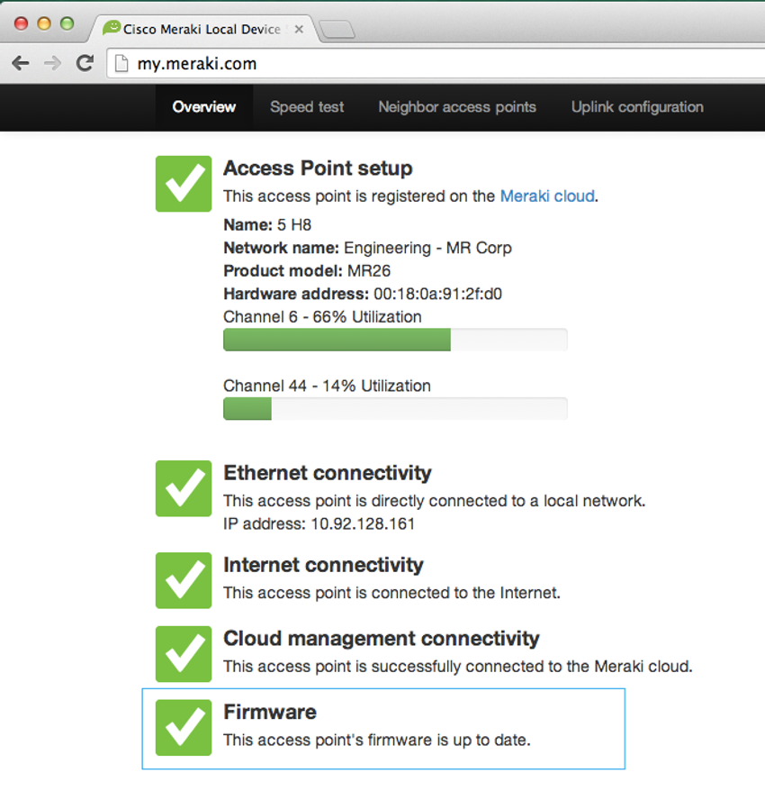

On a WLC, there will most likely be the ability to upgrade the firmware on all APs that the WLC controls. In the next figure, the network administrator is downloading the firmware image that will be used to upgrade all the APs.

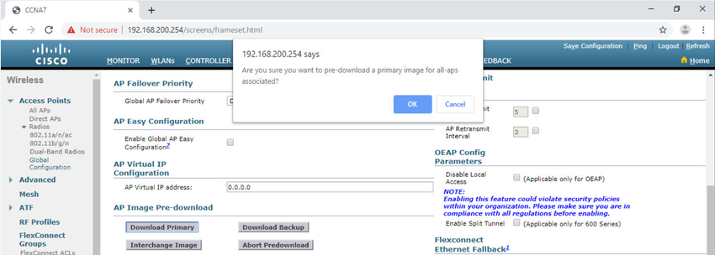

On a Cisco 3504 Wireless Controller, Click the **WIRELESS** tab > **Access Points** from the left menu > **Global Configuration** submenu. Then scroll to the bottom of the page for the AP Image Pre-download section.

Users will be disconnected from the WLAN and the internet until the upgrade finishes. The wireless router may need to reboot several times before normal network operations are restored.

**Packet Tracer - Troubleshoot WLAN Issues**

Now that you have learned how to configure wireless in home and enterprise networks, you need to learn how to troubleshoot in both wireless environments. Your goal is to enable connectivity between hosts on the networks to the Web Server by both IP address and URL. Connectivity between the home and enterprise networks is not required.

What did I learn in this module?

Remote workers, small branch offices, and home networks often use a wireless router, which typically include a switch for wired clients, a port for an internet connection (sometimes labeled “WAN”), and wireless components for wireless client access. Most wireless routers are preconfigured to be connected to the network and provide services. The wireless router uses DHCP to automatically provide addressing information to connected devices. Your first priority should be to change the username and password of your wireless router. Use your router’s interface to complete basic network and wireless setup. If you want to extend the range beyond approximately 45 meters indoors and 90 meters outdoors, you can add wireless access points. The router will use a process called Network Address Translation (NAT) to convert private IPv4 addresses to Internet-routable IPv4 addresses. By configuring QoS, you can guarantee that certain traffic types, such as voice and video, are prioritized over traffic that is not as time-sensitive, such as email and web browsing.

Lightweight APs (LAPs) use the Lightweight Access Point Protocol (LWAPP) to communicate with a WLAN controller (WLC). Configuring a wireless LAN controller (WLC) is similar to configuring a wireless router except that a WLC controls APs and provides more services and management capabilities. Use the WLC interface to view an overall picture of the AP’s system information and performance, to access advanced settings and to configure a WLAN.

SNMP is used monitor the network. The WLC is set to forward all SNMP log messages, called traps, to the SNMP server. For WLAN user authentication, a RADIUS server is used for authentication, accounting, and auditing (AAA) services. Individual user access can be tracked and audited. Use the WLC interface to configure SNMP server and RADIUS server information, VLAN interfaces, DHCP scope, and a WPA2 Enterprise WLAN.

There are six steps to the troubleshooting process. When troubleshooting a WLAN, a process of elimination is recommended. Common problems are: no connectivity and poorly performing wireless connection when the PC is operational. To optimize and increase the bandwidth of 802.11 dual-band routers and APs, either: upgrade your wireless clients or split the traffic. Most wireless routers and APs offer upgradable firmware. Firmware releases may contain fixes for common problems reported by customers as well as security vulnerabilities. You should periodically check the router or AP for updated firmware.

Why should I take this module?

Welcome to Routing Concepts!

No matter how effectively you set up your network, something will always stop working correctly, or even stop working completely. This is a simple truth about networking. So, even though you already know quite a bit about routing, you still need to know *how* your routers actually work. This knowledge is critical if you want to be able to troubleshoot your network. This module goes into detail about the workings of a router. Jump in!

14.0.2

What will I learn to do in this module?

**Module Title**: Routing Concepts

**Module Objective**: Explain how routers use information in packets to make forwarding decisions.

| Table caption | |
| --- | --- |
| **Topic Title** | **Topic Objective** |
| **Path Determination** | Explain how routers determine the best path. |
| **Packet Forwarding** | Explain how routers forward packets to the destination. |
| **Basic Router Configuration Review** | Configure basic settings on a router. |
| **IP Routing Table** | Describe the structure of a routing table. |
| **Static and Dynamic Routing** | Compare static and dynamic routing concepts. |

## Two Functions of Router

Before a router forwards a packet anywhere, it has to determine the best path for the packet to take. This topic explains how routers make this determination.

Ethernet switches are used to connect end devices and other intermediary devices, such as other Ethernet switches, to the same network. A router connects multiple networks, which means that it has multiple interfaces that each belong to a different IP network.

When a router receives an IP packet on one interface, it determines which interface to use to forward the packet to the destination. This is known as routing. The interface that the router uses to forward the packet may be the final destination, or it may be a network connected to another router that is used to reach the destination network. Each network that a router connects to typically requires a separate interface, but this may not always be the case.

The primary functions of a router are to determine the best path to forward packets based on the information in its routing table, and to forward packets toward their destination.

14.1.2

## Router Functions Example

The router uses its IP routing table to determine which path (route) to use to forward a packet. Click Play in the figure to follow a packet from the source PC to the destination PC. Watch how both R1 and R2 use their respective IP routing tables to first determine the best path, and then forward the packet.

The animation depicts two LAN networks with hosts connected by two routers R1 and R2. A packet is animated traversing the connection from one LAN to the other LAN. The router screens appear FOR R! and R2 showing the matching IP v.4 addresses in the router passing from one network to another.

192.168.3.0/24

LAN

LAN

192.168.1.0/24

R2 follows the same process.

Routers use the routing table like a map to discover the best path for a given network.

14.1.3

## Best Path Equals Longest Match

What is meant by the router must determine the best path in the routing table? The best path in the routing table is also known as the longest match. The longest match is a process the router uses to find a match between the destination IP address of the packet and a routing entry in the routing table.

The routing table contains route entries consisting of a prefix (network address) and prefix length. For there to be a match between the destination IP address of a packet and a route in the routing table, a minimum number of far-left bits must match between the IP address of the packet and the route in the routing table. The prefix length of the route in the routing table is used to determine the minimum number of far-left bits that must match. Remember that an IP packet only contains the destination IP address and not the prefix length.

The longest match is the route in the routing table that has the greatest number of far-left matching bits with the destination IP address of the packet. The route with the greatest number of equivalent far-left bits, or the longest match, is always the preferred route.

**Note**: The term prefix length will be used to refer to the network portion of both IPv4 and IPv6 addresses.

14.1.4

## IPv4 Address Longest Match Example

In the table, an IPv4 packet has the destination IPv4 address 172.16.0.10. The router has three route entries in its IPv4 routing table that match this packet: 172.16.0.0/12, 172.16.0.0/18, and 172.16.0.0/26. Of the three routes, 172.16.0.0/26 has the longest match and would be chosen to forward the packet. Remember, for any of these routes to be considered a match there must be at least the number of matching bits indicated by the subnet mask of the route.

| Destination IPv4 AddressAddress in Binary172.16.0.1010101100.00010000.00000000.00001010 | | | |
| --- | --- | --- | --- |
| **Destination IPv4 Address** | | | **Address in Binary** |
| 172.16.0.10 | | | **10101100.00010000.00000000.00**001010 |
| Route EntryPrefix/Prefix LengthAddress in Binary1172.16.0.0/1210101100.00010000.00000000.000010102172.16.0.0/1810101100.00010000.00000000.000010103172.16.0.0/2610101100.00010000.00000000.00001010 | | | | |
| **Route Entry** | **Prefix/Prefix Length** | **Address in Binary** | | |
| 1 | 172.16.0.0**/12** | **10101100.0001**0000.00000000.00001010 | | |
| 2 | 172.16.0.0**/18** | **10101100.00010000.00**000000.00001010 | | |
| 3 | 172.16.0.0**/26** | **10101100.00010000.00000000.00**001010 | | |

14.1.5

## IPv6 Address Longest Match Example

In the table, an IPv6 packet has the destination IPv6 address 2001:db8:c000::99. This example shows three route entries, but only two of them are a valid match, with one of those being the longest match. The first two route entries have prefix lengths that have the required number of matching bits as indicated by the prefix length. The first route entry with a prefix length of /40 matches the 40 far-left bits in the IPv6 address. The second route entry has a prefix length of /48 and with all 48 bits matching the destination IPv6 address, and is the longest match. The third route entry is not a match because its /64 prefix requires 64 matching bits. For the prefix 2001:db8:c000:5555::/64 to be a match, the first 64 bits must the destination IPv6 address of the packet. Only the first 48 bits match, so this route entry is not considered a match.

For the destination IPv6 packet with the address **2001:db8:c000**::99, consider the following three route entries:

| Route EntryPrefix/Prefix LengthDoes it match?12001:db8:c000::/40Match of 40 bits22001:db8:c000::/48Match of 48 bits (longest match)32001:db8:c000:5555::/64Does not match 64 bits | | |
| --- | --- | --- |
| **Route Entry** | **Prefix/Prefix Length** | **Does it match?** |
| 1 | **2001:db8:c0**00::**/40** | Match of 40 bits |
| 2 | **2001:db8:c000**::**/48** | Match of 48 bits (longest match) |
| 3 | **2001:db8:c000**:5555::**/64** | Does not match 64 bits |

14.1.6

## Build the Routing Table

A routing table consists of prefixes and their prefix lengths. But how does the router learn about these networks? How does R1 in the figure populate its routing table?

The figure depicts three types of networks Directed Connected Network, Remote Network, and Default Route. Router1 (R1) is the directly connected network with two switches S1 and S2 connected to two PCs PC1 and PC2. Each switch is connected to router R1. R1 and Router2(R2) are connected directly via point to point connection. R2 is connected two two switches S# and S4 with each switch having a PC PC3 and P4 connected to them. R2 forms the remoted network. R2 has an additional remote connection to the ISP by a point to point connection which is the Internet connection. The number scheme for each device is dual stack IPv4 and IPv6 addressees.

### **Networks from the Perspective of R1**

PC1PC2PC3PC4S1S2S4R1R2.10.10.10.10::10::10::10::1010.0.1.0/2410.0.2.0/2410.0.4.0/2410.0.5.0/242001:db8:acad:1::/642001:db8:acad:2::/642001:db8:acad:4::/642001:db8:acad:5::/64G0/0/0G0/0/1209.165.200.224/302001:db8:feed:224::/64.1::1.1::1.225::1.1::1S0/1/1S0/1/1S3::210.0.3.0/24S0/1/0.2G0/0/0G0/0/1.1::1.1::1ISP2001:db8:acad:3::/64.226::2S0/1/1

Internet**Directly Connected NetworkDirectly Connected NetworkRemote NetworksRemote NetworkRemote NetworkRemote NetworkDirectly Connected Network**

The networks in the topology are highlighted and labelled from the perspective of R1. All the IPv4 and IPv6 networks highlighted in yellow are directly connected networks. All the IPv4 and IPv6 networks highlighted in blue are remote networks.

Click each button for more information about the different ways a router learns routes.

Directly Connected Networks

Remote Networks

Default Route

**Directly Connected Networks**

Directly connected networks are networks that are configured on the active interfaces of a router. A directly connected network is added to the routing table when an interface is configured with an IP address and subnet mask (prefix length) and is active (up and up).

14.1.7

## Check Your Understanding - Path Determination

Начало формы

Check your understanding of routers by choosing the BEST answer to the following questions.

1. What table does a router use to determine how to forward an IP packet? routing table
2. What action will a router take on a packet with a destination IP address that is on a remote network? It will forward the packet to a next-hop router.
3. Which of the following routes may be found in a routing table? (Choose all that apply.)



directly connected networks



static routes



dynamic routing protocol routes



default route

1. What is used to determine the minimum number of far-left bits that must match between the prefix in the route entry and the destination IP address. prefix length of the destination IP address

Packet Forwarding Decision Process

Now that the router has determined the best path for a packet based on the longest match, it must determine how to encapsulate the packet and forward it out the correct egress interface.

The figure demonstrates how a router first determines the best path, and then forwards the packet.

The figure depicts how a router first determines the best path, and then forwards the packet. There are 5 steps depicted with these steps:

1. The data link frame with an encapsulated IP packet arrives on the ingress interface.

2. The router examines the destination IP address in the packet header and consults its IP routing table.

3. The router finds the longest matching prefix in the routing table.

4. The router encapsulates the packet in a data link frame and forwards it out the egress interface. The destination could be a device connected to the network or a next-hop router.

5. However, if there is no matching route entry the packet is dropped.

1123345

Data Link HeaderDestination IP AddressRest of IP PacketData Link TrailerFind the longest match between destination IP address and the entries in the routing tableNo matching route entry in the routing table, including no default routeRoute entry shows destination IP address is on a directly connected networkData Link HeaderDestination IP AddressRest of IP PacketData Link TrailerForward packet directly to destination deviceRoute entry shows destination IP address is on a remote networkData Link HeaderDestination IP AddressRest of IP PacketData Link TrailerForward packet to next-hop routerIP Routing TableRoute entries:  
Prefix/Prefix Length  
Prefix/Prefix Length  
Prefix/Prefix Length  
Prefix/Prefix Length  
...

The following steps describe the packet forwarding process shown in the figure:

1. The data link frame with an encapsulated IP packet arrives on the ingress interface.
2. The router examines the destination IP address in the packet header and consults its IP routing table.
3. The router finds the longest matching prefix in the routing table.
4. The router encapsulates the packet in a data link frame and forwards it out the egress interface. The destination could be a device connected to the network or a next-hop router.
5. However, if there is no matching route entry the packet is dropped.

Click each button for a description of the three things a router can do with a packet after it has determined the best path.

Forwards the Packet to a Device on a Directly Connected Network

Forwards the Packet to a Next-Hop Router

Drops the Packet - No Match in Routing Table

**Forwards the Packet to a Device on a Directly Connected Network**

If the route entry indicates that the egress interface is a directly connected network, this means that the destination IP address of the packet belongs to a device on the directly connected network. Therefore, the packet can be forwarded directly to the destination device. The destination device is typically an end device on an Ethernet LAN, which means the packet must be encapsulated in an Ethernet frame.

To encapsulate the packet in the Ethernet frame, the router needs to determine the destination MAC address associated with the destination IP address of the packet. The process varies based on whether the packet is an IPv4 or IPv6 packet:

* **IPv4 packet** - The router checks its ARP table for the destination IPv4 address and an associated Ethernet MAC address. If there is no match, the router sends an ARP Request. The destination device will return an ARP Reply with its MAC address. The router can now forward the IPv4 packet in an Ethernet frame with the proper destination MAC address.
* **IPv6 packet** - The router checks its neighbor cache for the destination IPv6 address and an associated Ethernet MAC address. If there is no match, the router sends an ICMPv6 Neighbor Solicitation (NS) message. The destination device will return an ICMPv6 Neighbor Advertisement (NA) message with its MAC address. The router can now forward the IPv6 packet in an Ethernet frame with the proper destination MAC address.

14.2.2

End-to-End Packet Forwarding

The primary responsibility of the packet forwarding function is to encapsulate packets in the appropriate data link frame type for the outgoing interface. For example, the data link frame format for a serial link could be Point-to-Point (PPP) protocol, High-Level Data Link Control (HDLC) protocol, or some other Layer 2 protocol.

Click each button and play the animations of PC1 sending a packet to PC2. Notice how the contents and format of the data link frame change at each hop.

PC1 Sends Packet to PC2

R1 Forwards the Packet to PC2

R2 Forwards the Packet to R3

R3 Forwards the Packet to PC2

**PC1 Sends Packet to PC2**

In the first animation, PC1 sends a packet to PC2. Since PC2 is on a different network, PC1 will forward the packet to its default gateway. PC1 will look in its ARP cache for the MAC address of the default gateway and add the indicated frame information.

**Note**: If an ARP entry does not exist in the ARP table for the default gateway of 192.168.1.1, PC1 sends an ARP request. Router R1 would then return an ARP reply with its MAC address.

The network diagram is PC1 connected to PC2 thru routers R1, R2, and R3. PC1 is 192.168.1.10 on network 192.168.1.0/24 connected to R1. R1 is connected to R2 on network 192.168.2.0/14 with Gigabit connections R1 G0/0/1 192.168.2.1 connected to R2 G/0/0 192.168.2.2. R2 connects to R3 on network 192.168.3.0/24. R2 S0/1/0 102.168.3.1 connects to R3 S0/1/0 192.168.3.2 on serial interfaces.. R3 connects to PC2 on network 192.168.4.0/24. The interface connection for R3 G0/0/0 192.168.4.1 connects directly to PC2 192.168.4.10. There are four different animations. The first animation depicts PC1s arp cache and decision to send the packet to R1 its gateway

What path does it need to take?

14.2.3

Packet Forwarding Mechanisms

As mentioned previously, the primary responsibility of the packet forwarding function is to encapsulate packets in the appropriate data link frame type for the outgoing interface. The more efficiently a router can perform this task, the faster packets can be forwarded by the router. Routers support the following three packet forwarding mechanisms:

* Process switching
* Fast switching
* Cisco Express Forwarding (CEF)

Assume that there is a traffic flow which consists of five packets. They are all going to the same destination. Click each button for more information about the packet forwarding mechanisms.

Process Switching

Fast Switching

CEF

**Process Switching**

An older packet forwarding mechanism still available for Cisco routers. When a packet arrives on an interface, it is forwarded to the control plane where the CPU matches the destination address with an entry in its routing table, and then determines the exit interface and forwards the packet. It is important to understand that the router does this for every packet, even if the destination is the same for a stream of packets. This process-switching mechanism is very slow and is rarely implemented in modern networks. Contrast this with fast switching.

The figure separates the control plane which is the CPU from the Data Plane. There are 5 packets labeled 1 thru 5 entering the Ingress Interface thru the data plane to the control plane. The control plane then forwards the packets thru the Data plane out the Egress Interface.

**Control PlaneIngress  
InterfaceData PlaneEgress  
Interface**1st Packet2nd Packet3rd Packet4th Packet5th PacketCPU

A common analogy used to describe these three different packet-forwarding mechanisms is as follows:

* Process switching solves a problem by doing math long hand, even if it is the identical problem that was just solved.
* Fast switching solves a problem by doing math long hand one time and remembering the answer for subsequent identical problems.
* CEF solves every possible problem ahead of time in a spreadsheet.

14.2.4

Check Your Understanding - Packet Forwarding

Начало формы

Check your understanding of forwarding packets from source to destination by choosing the BEST answer to the following questions.

1. If a router needs to send an ARP Request for the destination IPv4 address of the packet, this means the packet will be forwarded: To the device with the destination IPv4 address of the packet
2. If a router needs to send an ARP Request for the IPv4 address in one of its route entries, this means the packet will be forwarded: To a next-hop router
3. Which packet forwarding method is used by default on Cisco routers? Cisco Express Forwarding

Topology

A router creates a routing table to help it determine where to forward packets. But before diving into the details of the IP routing table, this topic reviews basic router configuration and verification tasks. You will also complete a Packet Tracer activity to refresh your skills.

The topology in the figure will be used for configuration and verification examples. It will also be used in the next topic to discuss the IP routing table.

The figure depicts a diagram of 3 routers R1,R2,and R3 connected to 4 switches S1,S2,S3 and S4. R1 connects to switches S1 and S2 using two gigabit connections G/0/0 and G0/0/1. PC1 is connected to switch 1 (S1)on network 10.0.1.0/24 and 2001:db8:acad:1::/64 with a dual stack ip address of .10 and ::10. PC2 is connected to switch 2 (S2) on network 10.0.2.0/24 and 2001:db8:acad:2::/64 with a dual stack ip address of .10 and ::10. R1 has a point to point network to R2 and the ISP networks. The serial connection to R2 is S0/1/01 and S0/1/0. The ISP connection is S0/1/1. The R1 to R2 network is network 10.0.3.0/22 and 2001:db8:acad:3::/64. The R2 network is 209.165.200.224/30 and 2001:db8:feed:224::/64 to the ISP. R2 has two gigabit connections to switches 3 (S3) and switch (S4) G0/0/0 and G/0/0/1. S3 is network 10.0.4.0/24 and 2001:db8:acad:4::/64 connected to the R2 interface G0/0/0. S4 is network 10.0.5.0/24 and 2001:db8:acad:5::/64 connected to R2 interface G0/0/1. PC3 connects to S3 with an address of .10 and ::10. PC4 connects to S4 with an address of .10 and ::10. R1 and R2 gateway addresses end with .1 and ::1. The serial interface between R1 and R2 have addresses of R1 .1 ans ::1 and R2 .2 and ::2. The R2 to ISP connection is .225 and .1 to ISP .226 and ::2.

PC1PC2PC3PC4S1S2S4R2.10.10.10.10::10::10::10::1010.0.1.0/2410.0.2.0/2410.0.4.0/2410.0.5.0/242001:db8:acad:1::/642001:db8:acad:2::/642001:db8:acad:4::/642001:db8:acad:5::/64G0/0/0G0/0/1209.165.200.224/302001:db8:feed:224::/64.1::1.1::1.225::1.1::1S0/1/1S0/1/1S3::210.0.3.0/24S0/1/0.2G0/0/0G0/0/1.1::1.1::1ISP2001:db8:acad:3::/64.226::2S0/1/1R1

Internet

14.3.2

Configuration Commands

The following examples show the full configuration for R1.

Router> **enable**

Router# **configure terminal**

Enter configuration commands, one per line. End with CNTL/Z.

Router(config)# **hostname R1**

R1(config)# **enable secret class**

R1(config)# **line console 0**

R1(config-line)# **logging synchronous**

R1(config-line)# **password cisco**

R1(config-line)# **login**

R1(config-line)# **exit**

R1(config)# **line vty 0 4**

R1(config-line)# **password cisco**

R1(config-line)# **login**

R1(config-line)# **transport input ssh telnet**

R1(config-line)# **exit**

R1(config)# **service password-encryption**

R1(config)# **banner motd #**

Enter TEXT message. End with a new line and the #

**\*\*\*\*\*\*\*\*\*\*\*\*\*\*\*\*\*\*\*\*\*\*\*\*\*\*\*\*\*\*\*\*\*\*\*\*\*\*\*\*\*\*\*\*\*\*\***

**WARNING: Unauthorized access is prohibited!**

**\*\*\*\*\*\*\*\*\*\*\*\*\*\*\*\*\*\*\*\*\*\*\*\*\*\*\*\*\*\*\*\*\*\*\*\*\*\*\*\*\*\*\*\*\*\*\***

**#**

R1(config)# **ipv6 unicast-routing**

R1(config)# **interface gigabitethernet 0/0/0**

R1(config-if)# **description Link to LAN 1**

R1(config-if)# **ip address 10.0.1.1 255.255.255.0**

R1(config-if)# **ipv6 address 2001:db8:acad:1::1/64**

R1(config-if)# **ipv6 address fe80::1:a link-local**

R1(config-if)# **no shutdown**

R1(config-if)# **exit**

R1(config)# **interface gigabitethernet 0/0/1**

R1(config-if)# **description Link to LAN 2**

R1(config-if)# **ip address 10.0.2.1 255.255.255.0**

R1(config-if)# **ipv6 address 2001:db8:acad:2::1/64**

R1(config-if)# **ipv6 address fe80::1:b link-local**

R1(config-if)# **no shutdown**

R1(config-if)# **exit**

R1(config)# **interface serial 0/1/1**

R1(config-if)# **description Link to R2**

R1(config-if)# **ip address 10.0.3.1 255.255.255.0**

R1(config-if)# **ipv6 address 2001:db8:acad:3::1/64**

R1(config-if)# **ipv6 address fe80::1:c link-local**

R1(config-if)# **no shutdown**

R1(config-if)# **exit**

R1# **copy running-config startup-config**

Destination filename [startup-config]?

Building configuration...

[OK]

R1#

14.3.3

Verification Commands

Common verification commands include the following:

* **show ip interface brief**
* **show running-config interface** *interface-type number*
* **show interfaces**
* **show ip interface**
* **show ip route**
* **ping**

In each case, replace **ip** with **ipv6** for the IPv6 version of the command. The figure shows the topology again for easy reference.

The figure depicts a diagram of 3 routers R1,R2,and R3 connected to 4 switches S1,S2,S3 and S4. R1 connects to switches S1 and S2 using two gigabit connections G/0/0 and G0/0/1. PC1 is connected to switch 1 (S1)on network 10.0.1.0/24 and 2001:db8:acad:1::/64 with a dual stack ip address of .10 and ::10. PC2 is connected to switch 2 (S2) on network 10.0.2.0/24 and 2001:db8:acad:2::/64 with a dual stack ip address of .10 and ::10. R1 has a point to point network to R2 and the ISP networks. The serial connection to R2 is S0/1/01 and S0/1/0. The ISP connection is S0/1/1. The R1 to R2 network is network 10.0.3.0/22 and 2001:db8:acad:3::/64. The R2 network is 209.165.200.224/30 and 2001:db8:feed:224::/64 to the ISP. R2 has two gigabit connections to switches 3 (S3) and switch (S4) G0/0/0 and G/0/0/1. S3 is network 10.0.4.0/24 and 2001:db8:acad:4::/64 connected to the R2 interface G0/0/0. S4 is network 10.0.5.0/24 and 2001:db8:acad:5::/64 connected to R2 interface G0/0/1. PC3 connects to S3 with an address of .10 and ::10. PC4 connects to S4 with an address of .10 and ::10. R1 and R2 gateway addresses end with .1 and ::1. The serial interface between R1 and R2 have addresses of R1 .1 ans ::1 and R2 .2 and ::2. The R2 to ISP connection is .225 and .1 to ISP .226 and ::2.

PC1PC2PC3PC4S1S2S4R2.10.10.10.10::10::10::10::1010.0.1.0/2410.0.2.0/2410.0.4.0/2410.0.5.0/242001:db8:acad:1::/642001:db8:acad:2::/642001:db8:acad:4::/642001:db8:acad:5::/64G0/0/0G0/0/1209.165.200.224/302001:db8:feed:224::/64.1::1.1::1.225::1.1::1S0/1/1S0/1/1S3::210.0.3.0/24S0/1/0.2G0/0/0G0/0/1.1::1.1::1ISP2001:db8:acad:3::/64.226::2S0/1/1R1

Internet

Click each button for the command output for R1.

show ip interface brief

show ipv6 interface brief

show running-config interface

show interfaces

show ip interface

show ipv6 interface

show ip route

show ipv6 route

ping

R1# **show ip interface brief**

Interface IP-Address OK? Method Status Protocol

GigabitEthernet0/0/0 10.0.1.1 YES manual up up

GigabitEthernet0/0/1 10.0.2.1 YES manual up up

Serial0/1/0 unassigned YES unset administratively down down

Serial0/1/1 10.0.3.1 YES manual up up

GigabitEthernet0 unassigned YES unset down down

R1#

14.3.4

Filter Command Output

Another useful feature that improves user experience in the command-line interface (CLI) is filtering **show** output. Filtering commands can be used to display specific sections of output. To enable the filtering command, enter a pipe (**|**) character after the **show** command and then enter a filtering parameter and a filtering expression.

The filtering parameters that can be configured after the pipe include:

* **section** - This displays the entire section that starts with the filtering expression.
* **include** - This includes all output lines that match the filtering expression.
* **exclude** - This excludes all output lines that match the filtering expression.
* **begin** - This displays all the output lines from a certain point, starting with the line that matches the filtering expression.

**Note**: Output filters can be used in combination with any **show** command.

The figure again shows the topology for your convenience

The figure depicts a diagram of 3 routers R1,R2,and R3 connected to 4 switches S1,S2,S3 and S4. R1 connects to switches S1 and S2 using two gigabit connections G/0/0 and G0/0/1. PC1 is connected to switch 1 (S1)on network 10.0.1.0/24 and 2001:db8:acad:1::/64 with a dual stack ip address of .10 and ::10. PC2 is connected to switch 2 (S2) on network 10.0.2.0/24 and 2001:db8:acad:2::/64 with a dual stack ip address of .10 and ::10. R1 has a point to point network to R2 and the ISP networks. The serial connection to R2 is S0/1/01 and S0/1/0. The ISP connection is S0/1/1. The R1 to R2 network is network 10.0.3.0/22 and 2001:db8:acad:3::/64. The R2 network is 209.165.200.224/30 and 2001:db8:feed:224::/64 to the ISP. R2 has two gigabit connections to switches 3 (S3) and switch (S4) G0/0/0 and G/0/0/1. S3 is network 10.0.4.0/24 and 2001:db8:acad:4::/64 connected to the R2 interface G0/0/0. S4 is network 10.0.5.0/24 and 2001:db8:acad:5::/64 connected to R2 interface G0/0/1. PC3 connects to S3 with an address of .10 and ::10. PC4 connects to S4 with an address of .10 and ::10. R1 and R2 gateway addresses end with .1 and ::1. The serial interface between R1 and R2 have addresses of R1 .1 ans ::1 and R2 .2 and ::2. The R2 to ISP connection is .225 and .1 to ISP .226 and ::2.

PC1PC2PC3PC4S1S2S4R2.10.10.10.10::10::10::10::1010.0.1.0/2410.0.2.0/2410.0.4.0/2410.0.5.0/242001:db8:acad:1::/642001:db8:acad:2::/642001:db8:acad:4::/642001:db8:acad:5::/64G0/0/0G0/0/1209.165.200.224/302001:db8:feed:224::/64.1::1.1::1.225::1.1::1S0/1/1S0/1/1S3::210.0.3.0/24S0/1/0.2G0/0/0G0/0/1.1::1.1::1ISP2001:db8:acad:3::/64.226::2S0/1/1R1

Internet

These examples demonstrate some of the more common uses of filtering parameters.

R1# **show running-config | section line vty**

line vty 0 4

password 7 121A0C0411044C

login

transport input telnet ssh

R1#

R1# **show ipv6 interface brief | include up**

GigabitEthernet0/0/0 [up/up]

GigabitEthernet0/0/1 [up/up]

Serial0/1/1 [up/up]

R1#

R1# **show ip interface brief | exclude unassigned**

Interface IP-Address OK? Method Status Protocol

GigabitEthernet0/0/0 192.168.10.1 YES manual up up

GigabitEthernet0/0/1 192.168.11.1 YES manual up up

Serial0/1/1 209.165.200.225 YES manual up up

R1#

R1# **show ip route | begin Gateway**

Gateway of last resort is not set

192.168.10.0/24 is variably subnetted, 2 subnets, 2 masks

C 192.168.10.0/24 is directly connected, GigabitEthernet0/0/0

L 192.168.10.1/32 is directly connected, GigabitEthernet0/0/0

192.168.11.0/24 is variably subnetted, 2 subnets, 2 masks

C 192.168.11.0/24 is directly connected, GigabitEthernet0/0/1

L 192.168.11.1/32 is directly connected, GigabitEthernet0/0/1

209.165.200.0/24 is variably subnetted, 2 subnets, 2 masks

C 209.165.200.224/30 is directly connected, Serial0/1/1

L 209.165.200.225/32 is directly connected, Serial0/1/1

R1#

14.3.5

Packet Tracer - Basic Router Configuration Review

Routers R1 and R2 each have two LANs. R1 is already configured. Your task is to configure the appropriate addressing for R2 and verify connectivity between the LANs.

Route Sources

How does a router know where it can send packets? It creates a routing table that is based on the network in which it is located.

A routing table contains a list of routes to known networks (prefixes and prefix lengths). The source of this information is derived from the following:

* Directly connected networks
* Static routes
* Dynamic routing protocols

In the figure, R1 and R2 are using the dynamic routing protocol OSPF to share routing information. In addition, R2 is configured with a default static route to ISP.

The figure depicts a diagram of 3 routers R1,R2,and R3 connected to 4 switches S1,S2,S3 and S4. R1 connects to switches S1 and S2 using two gigabit connections G/0/0 and G0/0/1. PC1 is connected to switch 1 (S1)on network 10.0.1.0/24 and 2001:db8:acad:1::/64 with a dual stack ip address of .10 and ::10. PC2 is connected to switch 2 (S2) on network 10.0.2.0/24 and 2001:db8:acad:2::/64 with a dual stack ip address of .10 and ::10. R1 has a point to point network to R2 and the ISP networks. The serial connection to R2 is S0/1/01 and S0/1/0. The ISP connection is S0/1/1. The R1 to R2 network is network 10.0.3.0/22 and 2001:db8:acad:3::/64. The R2 network is 209.165.200.224/30 and 2001:db8:feed:224::/64 to the ISP. R2 has two gigabit connections to switches 3 (S3) and switch (S4) G0/0/0 and G/0/0/1. S3 is network 10.0.4.0/24 and 2001:db8:acad:4::/64 connected to the R2 interface G0/0/0. S4 is network 10.0.5.0/24 and 2001:db8:acad:5::/64 connected to R2 interface G0/0/1. PC3 connects to S3 with an address of .10 and ::10. PC4 connects to S4 with an address of .10 and ::10. R1 and R2 gateway addresses end with .1 and ::1. The serial interface between R1 and R2 have addresses of R1 .1 ans ::1 and R2 .2 and ::2. The R2 to ISP connection is .225 and .1 to ISP .226 and ::2. The R1 router is highlighted in the diagram

PC1PC2PC3PC4S1S2S4R1R2.10.10.10.10::10::10::10::1010.0.1.0/2410.0.2.0/2410.0.4.0/2410.0.5.0/242001:db8:acad:1::/642001:db8:acad:2::/642001:db8:acad:4::/642001:db8:acad:5::/64G0/0/0G0/0/1209.165.200.224/302001:db8:feed:224::/64.1::1.1::1.225::1.1::1S0/1/1S0/1/1S3::210.0.3.0/24S0/1/0.2G0/0/0G0/0/1.1::1.1::1ISP2001:db8:acad:3::/64.226::2S0/1/1

**Internet**

Click each button to see the full routing table for each router after directly connected networks, static routing, and dynamic routing is configured. The rest of this topic will demonstrate how these tables are populated.

R1 Routing Table

R2 Routing Table

R1# **show ip route**

Codes: L - local, C - connected, S - static, R - RIP, M - mobile, B - BGP

D - EIGRP, EX - EIGRP external, O - OSPF, IA - OSPF inter area

N1 - OSPF NSSA external type 1, N2 - OSPF NSSA external type 2

E1 - OSPF external type 1, E2 - OSPF external type 2

i - IS-IS, su - IS-IS summary, L1 - IS-IS level-1, L2 - IS-IS level-2

ia - IS-IS inter area, * - candidate default, U - per-user static route

o - ODR, P - periodic downloaded static route, H - NHRP, l - LISP

a - application route

+ - replicated route, % - next hop override, p - overrides from PfR

Gateway of last resort is 10.0.3.2 to network 0.0.0.0

O*E2 0.0.0.0/0 [110/1] via 10.0.3.2, 00:51:34, Serial0/1/1

10.0.0.0/8 is variably subnetted, 8 subnets, 2 masks

C 10.0.1.0/24 is directly connected, GigabitEthernet0/0/0

L 10.0.1.1/32 is directly connected, GigabitEthernet0/0/0

C 10.0.2.0/24 is directly connected, GigabitEthernet0/0/1

L 10.0.2.1/32 is directly connected, GigabitEthernet0/0/1

C 10.0.3.0/24 is directly connected, Serial0/1/1

L 10.0.3.1/32 is directly connected, Serial0/1/1

O 10.0.4.0/24 [110/50] via 10.0.3.2, 00:24:22, Serial0/1/1

O 10.0.5.0/24 [110/50] via 10.0.3.2, 00:24:15, Serial0/1/1

R1#

In the routing tables for R1 and R2, notice that the sources for each route are identified by a code. The code identifies how the route was learned. For instance, common codes include the following:

* **L** - Identifies the address assigned to a router interface. This allows the router to efficiently determine when it receives a packet for the interface instead of being forwarded.
* **C** - Identifies a directly connected network.
* **S** - Identifies a static route created to reach a specific network.
* **O** - Identifies a dynamically learned network from another router using the OSPF routing protocol.
* **\*** - This route is a candidate for a default route.

14.4.2

Routing Table Principles

There are three routing table principles as described in the table. These are issues that are addressed by the proper configuration of dynamic routing protocols or static routes on all the routers between the source and destination devices.

| Routing Table PrincipleExampleEvery router makes its decision alone, based on the information it has in its own routing table.R1 can only forward packets using its own routing table. R1 does not know what routes are in the routing tables of other routers (e.g., R2).What a router has in its routing table does not mean that other routers have the same information.Just because router R1 has route in its routing table to a network in the internet via router R2, doesn’t mean R2 knows about that same network.Routing information about a path does not provide return routing information.R1 receives a packet with the destination IP address of PC1 and the source IP address of PC3. Just because R1 knows to forward the packet out its G0/0/0 interface, doesn’t necessarily mean that it knows how to forward packets originating from PC1 back to the remote network of PC3. | |
| --- | --- |
| **Routing Table Principle** | **Example** |
| Every router makes its decision alone, based on the information it has in its own routing table. | * R1 can only forward packets using its own routing table. * R1 does not know what routes are in the routing tables of other routers (e.g., R2). |
| The information in a routing table of one router does not necessarily match the routing table of another router. | Just because R1 has route in its routing table to a network in the internet via R2, that does not mean that R2 knows about that same network. |
| Routing information about a path does not provide return routing information. | R1 receives a packet with the destination IP address of PC1 and the source IP address of PC3. Just because R1 knows to forward the packet out its G0/0/0 interface, doesn’t necessarily mean that it knows how to forward packets originating from PC1 back to the remote network of PC3. |

14.4.3

Routing Table Entries

As a network administrator, it is imperative to know how to interpret the content of IPv4 and IPv6 routing tables. The figure displays IPv4 and IPv6 routing table entries on R1 for the route to remote network 10.0.4.0/24 and 2001:db8:acad:4::/64. Both these routes were learned dynamically from the OSPF routing protocol.

The figure depicts how to read an IPv4 routing entry and how to read a IPV6 routing entry. The routing table entry for IPv4 starts with the routing source 0 then the Destination network (prefix and prefix length) 10.0.4.0/24 next the Administrative distance of 110 and Metric of 50 next the Next-hop via 10.0.3.2 and Route timestamp of 00:13;29 ending with an Exit interface of Serial 0/1/1. Put together the entry is: 0 10.0.0.0/24 110/50 via 10.0.3.2 00:13:29 Serial 0/1/1. The ipv6 entry starts the same with the routing source 0 then the Destination network of 2001:DB8:ACAD:4::/64 the Administrative distance of 110 and Metric of 50 next the Next-hop via FE80::2:C there is no Route timestamp and ends with the Exit interface of Serial 0/1/1

O10.0.4.0/24O2001:DB8:ACAD:4::/64via FE80::2:C,[110/50]via 10.0.3.2,Serial0/1/1Serial0/1/100:13:29,[110/50]1234567123457

**IPv4 Routing TableIPv6 Routing Table**

In the figure, the numbers identify the following information:

1. **Route source** - This identifies how the route was learned.
2. **Destination network (prefix and prefix length)** - This identifies the address of the remote network.
3. **Administrative distance** - This identifies the trustworthiness of the route source. Lower values indicate preferred route source.
4. **Metric** - This identifies the value assigned to reach the remote network. Lower values indicate preferred routes.
5. **Next-hop** - This identifies the IP address of the next router to which the packet would be forwarded.
6. **Route timestamp** - This identifies how much time has passed since the route was learned.
7. **Exit interface** - This identifies the egress interface to use for outgoing packets to reach their final destination.

**Note**: The prefix length of the destination network specifies the minimum number of far-left bits that must match between the IP address of the packet and the destination network (prefix) for this route to be used.

14.4.4

Directly Connected Networks

Before a router can learn about any remote networks, it must have at least one active interface configured with an IP address and subnet mask (prefix length). This is known as a directly connected network or a directly connected route. Routers add a directly connected route to its routing table when an interface is configured with an IP address and is activated.

A directly connected network is denoted by a status code of **C** in the routing table. The route contains a network prefix and prefix length.

The routing table also contains a local route for each of its directly connected networks, indicated by the status code of **L**. This is the IP address that is assigned to the interface on that directly connected network. For IPv4 local routes the prefix length is /32 and for IPv6 local routes the prefix length is /128. This means the destination IP address of the packet must match all the bits in the local route for this route to be a match. The purpose of the local route is to efficiently determine when it receives a packet for the interface instead of a packet that needs to be forwarded.

Directly connected networks and local routes are shown in the following output.

R1# **show ip route**

Codes: L - local, C - connected, S - static, R - RIP, M - mobile, B - BGP

(Output omitted)

C 10.0.1.0/24 is directly connected, GigabitEthernet0/0/0

L 10.0.1.1/32 is directly connected, GigabitEthernet0/0/0

R1#

R1# **show ipv6 route**

IPv6 Routing Table - default - 10 entries

Codes: C - Connected, L - Local, S - Static, U - Per-user Static route

(Output omitted)

C 2001:DB8:ACAD:1::/64 [0/0]

via GigabitEthernet0/0/0, directly connected

L 2001:DB8:ACAD:1::1/128 [0/0]

via GigabitEthernet0/0/0, receive

R1#

14.4.5

Static Routes

After directly connected interfaces are configured and added to the routing table, static or dynamic routing can be implemented for accessing remote networks.

Static routes are manually configured. They define an explicit path between two networking devices. Unlike a dynamic routing protocol, static routes are not automatically updated and must be manually reconfigured if the network topology changes. The benefits of using static routes include improved security and resource efficiency. Static routes use less bandwidth than dynamic routing protocols, and no CPU cycles are used to calculate and communicate routes. The main disadvantage to using static routes is the lack of automatic reconfiguration if the network topology changes.

Static routing has three primary uses:

* It provides ease of routing table maintenance in smaller networks that are not expected to grow significantly.
* It uses a single default route to represent a path to any network that does not have a more specific match with another route in the routing table. Default routes are used to send traffic to any destination beyond the next upstream router.
* It routes to and from stub networks. A stub network is a network accessed by a single route, and the router has only one neighbor.

The figure shows an example of stub networks. Notice that any network attached to R1 would only have one way to reach other destinations, whether to networks attached to R2, or to destinations beyond R2. This means that networks 10.0.1.0/24 and 10.0.2.0/24 are stub networks and R1 is a stub router.

The figure depicts two stub networks consisting of a PC1 on network 10.0.1.0/24 and 2001:db8:acad:1::/64 connected to S1 switch which has a gigabit G0/0/0 connected to R1 router. PC2 is on network 10.0.2.4 and 2001:db8:acad:2::/64 connected to S2 switch which is connected to gigabit interface G0/0/1 on R1. R1 router is called a stub router. R1 is connected to the R2 router by a serial connection R1 S0/1/1 to S0/1/0 on R2 with a network address of 10.0.3.0/24. R2 connects to other networks. The PCs are dual stacked with addresses .10 and ::10. R1 interfaces are .1 and ::1. R2 has the serial connect address of .2 and ::2

.10::1010.0.2.0/242001:db8:acad:2::/64.1::1::2.2S0/1/1S0/1/010.0.3.0/24.10::1010.0.1.0/242001:db8:acad:1::/64G0/0/0G0/0/1.1::1.1::1PC1PC2S1S2R1R2

Internet and Other Networks**Stub NetworkStub NetworkStub Router**

In this example, a static route can be configured on R2 to reach the R1 networks. Additionally, because R1 has only one way to send out non-local traffic, a default static route can be configured on R1 to point to R2 as the next hop for all other networks.

14.4.6

Static Routes in the IP Routing Table

For demonstrating static routing, the topology in the figure is simplified to show only one LAN attached to each router. The figure shows IPv4 and IPv6 static routes configured on R1 to reach the 10.0.4.0/24 and 2001:db8:acad:4::/64 networks on R2. The configuration commands are for demonstration only and are discussed in another module.

The diagram depicts the configuration commands for R1 to set the static routes for IPv4 and IPv6 to reach PC3 from the topology described in figure 14.3.1. The IPv4 command is written as R1 (config)#ip route 10.0.4.0 255.255.255.0 10.0.3.2. The Remote IPv4 network address is 10.0.4.0 255.255.255.0. The IPv4 address of next hop router is 10.0.3.2. The IPv6 command is written as R1 (config)# ipv6 route 2001.db8.acad.4::/64 2001.db8.acad3::2. The remote IPv6 network address is 2001.db8.acad.4::/64and the IPv6 of next hop router is 2001.db8.acad3::2.

ip route 10.0.4.0 255.255.255.0 10.0.3.2 ipv6 route 2001.db8.acad.4::/64 2001.db8.acad.3::2 .10.1.1::1.2.1010.0.3.0/2410.0.1.0/24.1G0/0/0R2R1PC1S1S3::22001:db8:acad:1::/6410.0.4.0/24::1S0/1/1::10::10PC3::12001:db8:acad:3::/642001:db8:acad:4::/64S0/1/0G0/0/0R1 (config)#R1 (config)#

Remote IPv6 network addressIPv6 address of next hop routerRemote IPv4 network addressIPv4 address of next hop router

The output shows the IPv4 and IPv6 static routing entries on R1 that can reach the 10.0.4.0/24 and 2001:db8:acad:4::/64 networks on R2. Notice that both routing entries use the status code of **S** indicating that the route was learned by a static route. Both entries also include the IP address of the next hop router, via *ip-address*. The **static** parameter at the end of the command displays only static routes.

R1# **show ip route static**

Codes: L - local, C - connected, S - static, R - RIP, M - mobile, B - BGP

(output omitted)

10.0.0.0/8 is variably subnetted, 8 subnets, 2 masks

S 10.0.4.0/24 [1/0] via 10.0.3.2

R1# **show ipv6 route static**

IPv6 Routing Table - default - 8 entries

Codes: C - Connected, L - Local, S - Static, U - Per-user Static route

(output omitted)

S 2001:DB8:ACAD:4::/64 [1/0]

via 2001:DB8:ACAD:3::2

14.4.7

Dynamic Routing Protocols

Dynamic routing protocols are used by routers to automatically share information about the reachability and status of remote networks. Dynamic routing protocols perform several activities, including network discovery and maintaining routing tables.

Important advantages of dynamic routing protocols are the ability to select a best path, and the ability to automatically discover a new best path when there is a change in the topology.

Network discovery is the ability of a routing protocol to share information about the networks that it knows about with other routers that are also using the same routing protocol. Instead of depending on manually configured static routes to remote networks on every router, a dynamic routing protocol allows the routers to automatically learn about these networks from other routers. These networks, and the best path to each, are added to the routing table of the router, and identified as a network learned by a specific dynamic routing protocol.

The figure shows routers R1 and R2 using a common routing protocol to share network information.

The figure depicts a diagram of 3 routers R 1,R 2,and R3 connected to 4 switches S 1,S 2,S 3 and S4. R 1 connects to switches S 1 and S 2 using two gigabit connections G/0/0 and G0/0/1. P C1 is connected to switch 1 (S 1)on network 10.0.1.0/24 and 2001:db8:acad:1::/64 with a dual stack ip address of .10 and ::10. P C2 is connected to switch 2 (S 2) on network 10.0.2.0/24 and 2001:db8:acad:2::/64 with a dual stack ip address of .10 and ::10. R 1 has a point to point network to R 2 and the ISP networks. The serial connection to R 2 is S0/1/01 and S0/1/0. The ISP connection is S0/1/1. The R 1 to R 2 network is network 10.0.3.0/22 and 2001:db8:acad:3::/64. The R 2 network is 209.165.200.224/30 and 2001:db8:feed:224::/64 to the ISP. R 2 has two gigabit connections to switches 3 (S 3) and switch (S4) G0/0/0 and G/0/0/1. S 3 is network 10.0.4.0/24 and 2001:db8:acad:4::/64 connected to the R 2 interface G0/0/0. S4 is network 10.0.5.0/24 and 2001:db8:acad:5::/64 connected to R 2 interface G0/0/1. P C3 connects to S 3 with an address of .10 and ::10. P C4 connects to S4 with an address of .10 and ::10. R 1 and R 2 gateway addresses end with .1 and ::1. The serial interface between R 1 and R 2 have addresses of R 1 .1 ans ::1 and R 2 .2 and ::2. The R 2 to ISP connection is .225 and .1 to ISP .226 and ::2. The routers R 1 and R 2 are sharing any changes to the network by dynamic routing protocol with highlighted boxes from R 1 stating I will share with R 2 all the networks I know about and tell R 2 when there are any changes. The same applies for R 2 informing R 1.

PC1PC2PC3PC4S1S2S4R1R2.10.10.10.10::10::10::10::1010.0.1.0/2410.0.2.0/2410.0.4.0/2410.0.5.0/242001:db8:acad:1::/642001:db8:acad:2::/642001:db8:acad:4::/642001:db8:acad:5::/64G0/0/0G0/0/1209.165.200.224/302001:db8:feed:224::/64.1::1.1::1.225::1.1::1S0/1/1S0/1/1S3::210.0.3.0/24S0/1/0.2G0/0/0G0/0/1.1::1.1::1ISP2001:db8:acad:3::/64.226::2S0/1/1

I will share with R2 all the networks I know about and tell R2 when there are any changes.I will share with R1 all the networks I know about and tell R1 when there are any changes.**Internet**

14.4.8

Dynamic Routes in the IP Routing Table

A previous example used static routes to the 10.0.4.0/24 and 2001:db8:acad:4::/64 networks. These static routes are no longer configured and OSPF is now being used to dynamically learn all the networks connected to R1 and R2. The following examples show the IPv4 and IPv6 OSPF routing entries on R1 that can reach these networks on R2. Notice that both routing entries use the status code of **O** to indicate the route was learned by the OSPF routing protocol. Both entries also include the IP address of the next-hop router, via *ip-address*.

**Note**: IPv6 routing protocols use the link-local address of the next-hop router.

**Note**: OSPF routing configuration for IPv4 and IPv6 is beyond the scope of this course.

R1# **show ip route**

Codes: L - local, C - connected, S - static, R - RIP, M - mobile, B - BGP

D - EIGRP, EX - EIGRP external, O - OSPF, IA - OSPF inter area

(output omitted for brevity)

O 10.0.4.0/24 [110/50] via 10.0.3.2, 00:24:22, Serial0/1/1

O 10.0.5.0/24 [110/50] via 10.0.3.2, 00:24:15, Serial0/1/1

R1# **show ipv6 route**

IPv6 Routing Table - default - 10 entries

(Output omitted)

NDr - Redirect, RL - RPL, O - OSPF Intra, OI - OSPF Inter

O 2001:DB8:ACAD:4::/64 [110/50]

via FE80::2:C, Serial0/1/1

O 2001:DB8:ACAD:5::/64 [110/50]

via FE80::2:C, Serial0/1/1

14.4.9

Default Route

A default route is similar to a default gateway on a host. The default route specifies a next-hop router to use when the routing table does not contain a specific route that matches the destination IP address.

A default route can be either a static route or learned automatically from a dynamic routing protocol. A default route has an IPv4 route entry of 0.0.0.0/0 or an IPv6 route entry of ::/0. This means that zero or no bits need to match between the destination IP address and the default route.

Most enterprise routers have a default route in their routing table. This is to reduce the number of routes in a routing table.

A router, such as a home or small office router that only has one LAN, may reach all its remote networks through a default route. This is useful when the router has only directly connected networks and one exit point to a service provider router.

In the figure, routers R1 and R2 are using OSPF to share routing information about their own networks (10.0.x.x/24 and 2001:db8:acad:x::/64 networks). R2 has a static default route to the ISP router. R2 will forward any packets with a destination IP address that does not specifically match one of the networks in its routing table to the ISP router. This would include all packets destined for the internet.

The figure depicts a diagram of 3 routers R1,R2,and R3 connected to 4 switches S1,S2,S3 and S4. R1 connects to switches S1 and S2 using two gigabit connections G/0/0 and G0/0/1. PC1 is connected to switch 1 (S1)on network 10.0.1.0/24 and 2001:db8:acad:1::/64 with a dual stack ip address of .10 and ::10. PC2 is connected to switch 2 (S2) on network 10.0.2.0/24 and 2001:db8:acad:2::/64 with a dual stack ip address of .10 and ::10. R1 has a point to point network to R2 and the ISP networks. The serial connection to R2 is S0/1/01 and S0/1/0. The ISP connection is S0/1/1. The R1 to R2 network is network 10.0.3.0/22 and 2001:db8:acad:3::/64. The R2 network is 209.165.200.224/30 and 2001:db8:feed:224::/64 to the ISP. R2 has two gigabit connections to switches 3 (S3) and switch (S4) G0/0/0 and G/0/0/1. S3 is network 10.0.4.0/24 and 2001:db8:acad:4::/64 connected to the R2 interface G0/0/0. S4 is network 10.0.5.0/24 and 2001:db8:acad:5::/64 connected to R2 interface G0/0/1. PC3 connects to S3 with an address of .10 and ::10. PC4 connects to S4 with an address of .10 and ::10. R1 and R2 gateway addresses end with .1 and ::1. The serial interface between R1 and R2 have addresses of R1 .1 ans ::1 and R2 .2 and ::2. The R2 to ISP connection is .225 and .1 to ISP .226 and ::2. The diagram shows R2 has a static default route to the ISP router. The default route is advertised by R2 to R1 using the dynamic routing protocol OSPF. There is an arrow showing the route to the ISP.

PC1PC2PC3PC4S1S2S4R2.10.10.10.10::10::10::10::1010.0.1.0/2410.0.2.0/2410.0.4.0/2410.0.5.0/242001:db8:acad:1::/642001:db8:acad:2::/642001:db8:acad:4::/642001:db8:acad:5::/64G0/0/0G0/0/1209.165.200.224/302001:db8:feed:224::/64.1::1.1::1.225::1.1::1S0/1/1S0/1/1S3::210.0.3.0/24S0/1/0.2G0/0/0G0/0/1.1::1.1::1ISP2001:db8:acad:3::/64.226::2S0/1/1R112

**Internet**

1. R2 has a static default route to the ISP router.
2. The default route is advertised by R2 to R1 using the dynamic routing protocol OSPF.

R2 has shared its default route with R1 using OSPF. R1 will now have a default route in its routing table that it learned dynamically from OSPF. R1 will also forward any packets with a destination IP address that does not specifically match one of the networks in its routing table to R2.

The following examples show the IPv4 and IPv6 routing table entries for the static default routes configured on R2.

R2# **show ip route**

(Output omitted)

S* 0.0.0.0/0 [1/0] via 209.165.200.226

R2#

R2# **show ipv6 route**

(Output omitted)

S ::/0 [1/0]

via 2001:DB8:FEED:224::2

R2#

14.4.10

Structure of an IPv4 Routing Table

IPv4 was standardized in the early 1980s using the now obsolete classful addressing architecture. The IPv4 routing table is organized using this same classful structure. In the **show ip route** output, notice that some route entries are left justified while others are indented. This is based on how the routing process searches the IPv4 routing table for the longest match. This was all because of classful addressing. Although the lookup process no longer uses classes, the structure of the IPv4 routing table still retains in this format.

Router# **show ip route**

(Output omitted)

192.168.1.0/24 is variably subnetted, 2 subnets, 2 masks

C 192.168.1.0/24 is directly connected, GigabitEthernet0/0

L 192.168.1.1/32 is directly connected, GigabitEthernet0/0

O 192.168.2.0/24 [110/65] via 192.168.12.2, 00:32:33, Serial0/0/0

O 192.168.3.0/24 [110/65] via 192.168.13.2, 00:31:48, Serial0/0/1

192.168.12.0/24 is variably subnetted, 2 subnets, 2 masks

C 192.168.12.0/30 is directly connected, Serial0/0/0

L 192.168.12.1/32 is directly connected, Serial0/0/0

192.168.13.0/24 is variably subnetted, 2 subnets, 2 masks

C 192.168.13.0/30 is directly connected, Serial0/0/1

L 192.168.13.1/32 is directly connected, Serial0/0/1

192.168.23.0/30 is subnetted, 1 subnets

O 192.168.23.0/30 [110/128] via 192.168.12.2, 00:31:38, Serial0/0/0

Router#

**Note**: The IPv4 routing table in the example is not from any router in the topology used in this module.

Although the details of the structure are beyond the scope of this module, it is helpful to recognize the structure of the table. An indented entry is known as a child route. A route entry is indented if it is the subnet of a classful address (class A, B or C network). Directly connected networks will always be indented (child routes) because the local address of the interface is always entered in the routing table as a /32. The child route will include the route source and all the forwarding information such as the next-hop address. The classful network address of this subnet will be shown above the route entry, less indented, and without a source code. That route is known as a parent route.

**Note**: This is just a brief introduction to the structure of an IPv4 routing table and does not cover details or specifics of this architecture.

The next example shows the IPv4 routing table of R1 in the topology. Notice that all of the networks in the topology are subnets, which are child routes, of the class A network and parent route10.0.0.0/8.

R1# **show ip route**

(output omitted for brevity)

O*E2 0.0.0.0/0 [110/1] via 10.0.3.2, 00:51:34, Serial0/1/1

10.0.0.0/8 is variably subnetted, 8 subnets, 2 masks

C 10.0.1.0/24 is directly connected, GigabitEthernet0/0/0

L 10.0.1.1/32 is directly connected, GigabitEthernet0/0/0

C 10.0.2.0/24 is directly connected, GigabitEthernet0/0/1

L 10.0.2.1/32 is directly connected, GigabitEthernet0/0/1

C 10.0.3.0/24 is directly connected, Serial0/1/1

L 10.0.3.1/32 is directly connected, Serial0/1/1

O 10.0.4.0/24 [110/50] via 10.0.3.2, 00:24:22, Serial0/1/1

O 10.0.5.0/24 [110/50] via 10.0.3.2, 00:24:15, Serial0/1/1

R1#

14.4.11

Structure of an IPv6 Routing Table

The concept of classful addressing was never part of IPv6, so the structure of an IPv6 routing table is very straight forward. Every IPv6 route entry is formatted and aligned the same way.

R1# **show ipv6 route**

(output omitted for brevity)

OE2 ::/0 [110/1], tag 2

via FE80::2:C, Serial0/0/1

C 2001:DB8:ACAD:1::/64 [0/0]

via GigabitEthernet0/0/0, directly connected

L 2001:DB8:ACAD:1::1/128 [0/0]

via GigabitEthernet0/0/0, receive

C 2001:DB8:ACAD:2::/64 [0/0]

via GigabitEthernet0/0/1, directly connected

L 2001:DB8:ACAD:2::1/128 [0/0]

via GigabitEthernet0/0/1, receive

C 2001:DB8:ACAD:3::/64 [0/0]

via Serial0/1/1, directly connected

L 2001:DB8:ACAD:3::1/128 [0/0]

via Serial0/1/1, receive

O 2001:DB8:ACAD:4::/64 [110/50]

via FE80::2:C, Serial0/1/1

O 2001:DB8:ACAD:5::/64 [110/50]

via FE80::2:C, Serial0/1/1

L FF00::/8 [0/0]

via Null0, receive

R1#

14.4.12

Administrative Distance

A route entry for a specific network address (prefix and prefix length) can only appear once in the routing table. However, it is possible that the routing table learns about the same network address from more than one routing source.

Except for very specific circumstances, only one dynamic routing protocol should be implemented on a router. However, it is possible to configure both OSPF and EIGRP on a router, and both routing protocols may learn of the same destination network. Each routing protocol may decide on a different path to reach the destination based on the metric of that routing protocol.

This raises a few questions, such as the following:

* How does the router know which source to use?
* Which route should it install in the routing table? The route learned from OSPF, or the route learned from EIGRP?

Cisco IOS uses what is known as the administrative distance (AD) to determine the route to install into the IP routing table. The AD represents the "trustworthiness" of the route. The lower the AD, the more trustworthy the route source. Because EIGRP has an AD of 90 and OSPF has an AD of 110, the EIGRP route entry would be installed in the routing table.

**Note**: The AD does not necessarily represent which dynamic routing protocol is best.

A more common example is a router learning the same network address from a static route and a dynamic routing protocol, such as OSPF. A static route has an AD of 1, whereas an OSPF-discovered route has an AD of 110. Given two separate route sources to the same destination, the router chooses to install the route with the lowest AD. When a router has the choice of a static route and an OSPF route, the static route takes precedence.

**Note**: Directly connected networks have the lowest AD of 0. Only a directly connected network can have an AD of 0.

The table lists various routing protocols and their associated ADs.

| Route SourceAdministrative DistanceDirectly connected0Static route1EIGRP summary route5External BGP20Internal EIGRP90OSPF 110IS-IS115RIP120External EIGRP170Internal BGP200 | |
| --- | --- |
| **Route Source** | **Administrative Distance** |
| Directly connected | 0 |
| Static route | 1 |
| EIGRP summary route | 5 |
| External BGP | 20 |
| Internal EIGRP | 90 |
| OSPF | 110 |
| IS-IS | 115 |
| RIP | 120 |
| External EIGRP | 170 |
| Internal BGP | 200 |

14.4.13

Check Your Understanding - IP Routing Table

Начало формы

Check your understanding of the IP routing table by choosing the BEST answer to the following questions.

1. Which routing table principle is not correct? Routing information about a path from one network to another also provides routing information about the reverse, or return, path.
2. Which route entry would be used for a packet with a destination IP address that matches an IP address of one of the router interfaces? L for Local
3. What type of network is accessed by a single route and the router has only one neighbor? Stub network
4. Which two route sources have the ability to automatically discover a new best path when there is a change in the topology? (Choose two.) OSPF EIGRP
5. True or False? A default route can only be a static route. False
6. A network administrator configures a static route for the same destination network that was learned automatically by the router using OSPF. Which route will be installed and why? Static route because it has a lower administrative distance

Static or Dynamic?

The previous topic discussed the ways that a router creates its routing table. So, you now know that routing, like IP addressing, can be either static or dynamic. Should you use static or dynamic routing? The answer is both! Static and dynamic routing are not mutually exclusive. Rather, most networks use a combination of dynamic routing protocols and static routes.

**Static Routes**

Static routes are commonly used in the following scenarios:

* As a default route forwarding packets to a service provider
* For routes outside the routing domain and not learned by the dynamic routing protocol
* When the network administrator wants to explicitly define the path for a specific network
* For routing between stub networks

Static routes are useful for smaller networks with only one path to an outside network. They also provide security in a larger network for certain types of traffic, or links to other networks that need more control.

**Dynamic Routing Protocols**

Dynamic routing protocols help the network administrator manage the time-consuming and exacting process of configuring and maintaining static routes. Dynamic routing protocols are implemented in any type of network consisting of more than just a few routers. Dynamic routing protocols are scalable and automatically determine better routes if there is a change in the topology.

Dynamic routing protocols are commonly used in the following scenarios:

* In networks consisting of more than just a few routers
* When a change in the network topology requires the network to automatically determine another path
* For scalability. As the network grows, the dynamic routing protocol automatically learns about any new networks.

The table shows a comparison of some the differences between dynamic and static routing.

| Dynamic RoutingStatic RoutingConfiguration complexityIndependent of network sizeIncreases with network sizeTopology changesAutomatically adapts to topology changesAdministrator intervention requiredScalabilitySuitable for simple to complex network topologiesSuitable for simple topologiesSecuritySecurity must be configuredSecurity is inherentResource UsageUses CPU, memory, and link bandwidthNo additional resources neededPath PredictabilityRoute depends on topology and routing protocol usedExplicitly defined by the administrator | | |
| --- | --- | --- |
| **Feature** | **Dynamic Routing** | **Static Routing** |
| Configuration complexity | Independent of network size | Increases with network size |
| Topology changes | Automatically adapts to topology changes | Administrator intervention required |
| Scalability | Suitable for simple to complex network topologies | Suitable for simple topologies |
| Security | Security must be configured | Security is inherent |
| Resource Usage | Uses CPU, memory, and link bandwidth | No additional resources needed |
| Path Predictability | Route depends on topology and routing protocol used | Explicitly defined by the administrator |

14.5.2

Dynamic Routing Evolution

Dynamic routing protocols have been used in networks since the late 1980s. One of the first routing protocols was RIP. RIPv1 was released in 1988, but some of the basic algorithms within the protocol were used on the Advanced Research Projects Agency Network (ARPANET) as early as 1969.

As networks evolved and became more complex, new routing protocols emerged. The RIP protocol was updated to RIPv2 to accommodate growth in the network environment. However, RIPv2 still does not scale to the larger network implementations of today. To address the needs of larger networks, two advanced routing protocols were developed: OSPF and Intermediate System-to-Intermediate System (IS-IS). Cisco developed the Interior Gateway Routing Protocol (IGRP), which was later replaced by Enhanced IGRP (EIGRP), which also scales well in larger network implementations.

Additionally, there was the need to connect the different routing domains of different organizations and provide routing between them. The Border Gateway Protocol (BGP), the successor of Exterior Gateway Protocol (EGP) is used between Internet Service Providers (ISPs). BGP is also used between ISPs and some private organizations to exchange routing information.

The figure displays the timeline of when the various protocols were introduced.

The figure displays the timeline of when the various protocols were introduced. Starting with 1982 EGP, 1985 IGRP, 1988 RIPv1, 1990 IS-IS, 1991 OSPFv2, 1992 EIGRP, 1994 RIPv2, 1995 BGP, 1997 RIPng, 1998 BGP-MP, 1999 OSPFv3, 2000 IS-ISv6.

IS-ISv62008EGPIGRP19821985RIPv11988IS-ISOSPFv2EIGRP1990s199019911992BGPRIPv219941995RIPngBGP-MP19971998OSPFv319992000s

To support IPv6 communication, newer versions of the IP routing protocols have been developed, as shown in the IPv6 row in the table.

The table classifies the current routing protocols. Interior Gateway Protocols (IGPs) are routing protocols used to exchange routing information within a routing domain administered by a single organization. There is only one EGP and it is BGP. BGP is used to exchange routing information between different organizations, known as autonomous systems (AS). BGP is used by ISPs to route packets over the internet. Distance vector, link-state, and path vector routing protocols refer to the type of routing algorithm used to determine best path.

| Interior Gateway ProtocolsExterior Gateway ProtocolsDistance VectorLink-StatePath VectorIPv4RIPv2EIGRPOSPFv2IS-ISBGP-4IPv6RIPngEIGRP for IPv6OSPFv3IS-IS for IPv6BGP-MP | | | | | |
| --- | --- | --- | --- | --- | --- |
|  | **Interior Gateway Protocols** | | | | **Exterior Gateway Protocols** |
|  | **Distance Vector** | | **Link-State** | | **Path Vector** |
| **IPv4** | RIPv2 | EIGRP | OSPFv2 | IS-IS | BGP-4 |
| **IPv6** | RIPng | EIGRP for IPv6 | OSPFv3 | IS-IS for IPv6 | BGP-MP |

14.5.3

Dynamic Routing Protocol Concepts

A routing protocol is a set of processes, algorithms, and messages that are used to exchange routing information and populate the routing table with the choice of best paths. The purpose of dynamic routing protocols includes the following:

* Discovery of remote networks
* Maintaining up-to-date routing information
* Choosing the best path to destination networks
* Ability to find a new best path if the current path is no longer available

The main components of dynamic routing protocols include the following:

* **Data structures -** Routing protocols typically use tables or databases for their operations. This information is kept in RAM.
* **Routing protocol messages -** Routing protocols use various types of messages to discover neighboring routers, exchange routing information, and other tasks to learn and maintain accurate information about the network.
* **Algorithm -** An algorithm is a finite list of steps used to accomplish a task. Routing protocols use algorithms for facilitating routing information and for the best path determination.

Routing protocols allow routers to dynamically share information about remote networks and automatically offer this information to their own routing tables. Click Play to see an animation of this process.

The figure is an animation with three routers R1,R2 and R3 connected in a triangle pattern. The animation illustrates that when an update occurs on any router it is pushed out to the others.

Update

Update

Routing protocols determine the best path, or route, to each network. That route is then offered to the routing table. The route will be installed in the routing table if there is not another routing source with a lower AD. A primary benefit of dynamic routing protocols is that routers exchange routing information when there is a topology change. This exchange allows routers to automatically learn about new networks and to find alternate paths when there is a link failure to a current network.

14.5.4

Best Path

Before a path to a remote network is offered to the routing table, the dynamic routing protocol must determine the best path to that network. Determining the best path may involve the evaluation of multiple paths to the same destination network and selecting the optimum or shortest path to reach that network. Whenever multiple paths to the same network exist, each path uses a different exit interface on the router to reach that network.

The best path is selected by a routing protocol based on the value or metric it uses to determine the distance to reach a network. A metric is the quantitative value used to measure the distance to a given network. The best path to a network is the path with the lowest metric.

Dynamic routing protocols typically use their own rules and metrics to build and update routing tables. The routing algorithm generates a value, or a metric, for each path through the network. Metrics can be based on either a single characteristic or several characteristics of a path. Some routing protocols can base route selection on multiple metrics, combining them into a single metric.

The following table lists common dynamic protocols and their metrics.

| Routing ProtocolMetricRouting Information Protocol (RIP)The metric is “hop count”.Each router along a path adds a hop to the hop count.A maximum of 15 hops allowed.Open Shortest Path First (OSPF) The metric is “cost” which is the based on the cumulative bandwidth from source to destination.Faster links are assigned lower costs compared to slower (higher cost) links.Enhanced Interior Gateway Routing Protocol (EIGRP)It calculates a metric based on the slowest bandwidth and delay values.It could also include load and reliability into the metric calculation. | |
| --- | --- |
| **Routing Protocol** | **Metric** |
| **Routing Information Protocol (RIP)** | * The metric is “hop count”. * Each router along a path adds a hop to the hop count. * A maximum of 15 hops allowed. |
| **Open Shortest Path First (OSPF)** | * The metric is “cost” which is the based on the cumulative bandwidth from source to destination. * Faster links are assigned lower costs compared to slower (higher cost) links. |
| **Enhanced Interior Gateway Routing Protocol (EIGRP)** | * It calculates a metric based on the slowest bandwidth and delay values. * It could also include load and reliability into the metric calculation. |

The animation in the figure highlights how the path may be different depending on the metric being used. If the best path fails, the dynamic routing protocol will automatically select a new best path if one exists.

The figure is an animation with a PC labeled PC1 connected to a router R1. R1 is connected to R2 with a 1Gbps connection and R2 connects to R3 with a 1Gbps connection. R3 is connected to R1 with a 100Mbps connection. The routers are depicted similar to a right triangle. Another PC labeled PC2 is connected to R3. The animation runs depicting routing decisions based on hop count or bandwidth.

14.5.5

Load Balancing

What happens if a routing table has two or more paths with identical metrics to the same destination network?

When a router has two or more paths to a destination with equal cost metrics, then the router forwards the packets using both paths equally. This is called equal cost load balancing. The routing table contains the single destination network, but has multiple exit interfaces, one for each equal cost path. The router forwards packets using the multiple exit interfaces listed in the routing table.

If configured correctly, load balancing can increase the effectiveness and performance of the network.

Equal cost load balancing is implemented automatically by dynamic routing protocols. It is enabled with static routes when there are multiple static routes to the same destination network using different next-hop routers.

**Note**: Only EIGRP supports unequal cost load balancing.

The animation in the figure provides an example of equal cost load balancing.

The figure is an animation with four routers R1,R2,R3, and R4 interconnected to each other with 52Mbps connections. A PC labeled PC1 is connected to R1 and a second PC labeled to PC2 is connected to R3. When the animation runs packets from PC1 takes various paths thru the routers to PC2 which illustrate equal cost load balancing since all routers have equal connection speeds.

14.5.6

Check Your Understanding - Dynamic and Static Routing

Начало формы

Check your understanding of dynamic and static routing by choosing the BEST answer to the following questions.

1. Which type of routing automatically adapts to topology changes? dynamic routing protocols
2. What type of routing is typically used with a stub network? static routes
3. What metric is used by OSPF to determine the best path? cost
4. What term is used to describe routing over two or more paths to a destination with equal cost metrics? equal cost load balancing

What did I learn in this module?

**Path Determination**

The primary functions of a router are to determine the best path to forward packets based on the information in its routing table, and to forward packets toward their destination. The best path in the routing table is also known as the longest match. The longest match is the route in the routing table that has the greatest number of far-left matching bits with the destination IP address of the packet. Directly connected networks are networks that are configured on the active interfaces of a router. A directly connected network is added to the routing table when an interface is configured with an IP address and subnet mask (prefix length) and is active (up and up). Routers learn about remote networks in two ways: static routes are added to the routing table when a route is manually configured, and with dynamic routing protocols. Using dynamic routing protocols such as EIGRP and OSPF, routes are added to the routing table when routing protocols dynamically learn about the remote network.

**Packet Forwarding**

After a router determines the correct path, it can forward the packet on a directly connected network, it can forward the packet to a next-hop router, or it can drop the packet. The primary responsibility of the packet forwarding function is to encapsulate packets in the appropriate data link frame type for the outgoing interface. Routers support three packet forwarding mechanisms: process switching, fast switching, and CEF. The following steps describe the packet forwarding process:

1. The data link frame with an encapsulated IP packet arrives on the ingress interface.
2. The router examines the destination IP address in the packet header and consults its IP routing table.
3. The router finds the longest matching prefix in the routing table.
4. The router encapsulates the packet in a data link frame and forwards it out the egress interface. The destination could be a device connected to the network or a next-hop router.
5. However, if there is no matching route entry the packet is dropped.

**Basic Router Configuration Review**

There are several configuration and verification commands for routers, including **show ip route**, **show ip interface**, **show ip interface brief** and **show running-config**. To reduce the amount of command output, use a filter. Filtering commands can be used to display specific sections of output. To enable the filtering command, enter a pipe (|) character after the **show** command and then enter a filtering parameter and a filtering expression. The filtering parameters that can be configured after the pipe include the following:

* **section** - Shows entire section that starts with the filtering expression
* **include** - Includes all output lines that match the filtering expression
* **exclude** - Excludes all output lines that match the filtering expression
* **begin** - Shows all the output lines from a certain point, starting with the line that matches the filtering expression

**IP Routing Table**

A routing table contains a list of routes known networks (prefixes and prefix lengths). The source of this information is derived from directly connected networks, static routes, and dynamic routing protocols. Common routing table codes include:

* **L** - Identifies the address assigned to a router interface. This allows the router to efficiently determine when it receives a packet for the interface instead of being forwarded.
* **C** - Identifies a directly connected network.
* **S** - Identifies a static route created to reach a specific network.
* **O** - Identifies a dynamically learned network from another router using the OSPF routing protocol.
* **\*** - This route is a candidate for a default route.

Every router makes its decision alone, based on the information it has in its own routing table. The information in a routing table of one router does not necessarily match the routing table of another router. Routing information about a path does not provide return routing information. Routing table entries include the route source, destination network, AD, metric, next-hop, route timestamp, and exit interface. To learn about remote networks, a router must have at least one active interface configured with an IP address and subnet mask (prefix length), called a directly connected network. Static routes are manually configured and define an explicit path between two networking devices. Dynamic routing protocols can discover a network, maintain routing tables, select a best path, and automatically discover a new best path if the topology changes. The default route specifies a next-hop router to use when the routing table does not contain a specific route that matches the destination IP address. A default route can be either a static route or learned automatically from a dynamic routing protocol. A default route has an IPv4 route entry of 0.0.0.0/0 or an IPv6 route entry of ::/0. IPv4 routing tables still have a structure based on classful addressing represented by levels of indentation. IPv6 routing tables do not use the IPv4 routing table structure. Cisco IOS uses what is known as the administrative distance (AD) to determine the route to install into the IP routing table. The AD represents the "trustworthiness" of the route. The lower the AD, the more trustworthy the route source.

**Static and Dynamic Routing**

Static routes are commonly used:

* As a default route forwarding packets to a service provider.
* For routes outside the routing domain and not learned by the dynamic routing protocol.
* When the network administrator wants to explicitly define the path for a specific network.
* For routing between stub networks.

Dynamic routing protocol are commonly used:

* In networks consisting of more than just a few routers
* When a change in the network topology requires the network to automatically determine another path
* For scalability. As the network grows, the dynamic routing protocol automatically learns about any new networks.

Current routing protocols include IGPs and EGPs. IGPs exchange routing information within a routing domain administered by a single organization. The only EGP is BGP. BGP exchanges routing information between different organizations. BGP is used by ISPs to route packets over the internet. Distance vector, link-state, and path vector routing protocols refer to the type of routing algorithm used to determine best path. The main components of dynamic routing protocols are data structures, routing protocol messages, and algorithms. The best path is selected by a routing protocol based on the value or metric it uses to determine the distance to reach a network. A metric is the quantitative value used to measure the distance to a given network. The best path to a network is the path with the lowest metric. When a router has two or more paths to a destination with equal cost metrics, then the router forwards the packets using both paths equally. This is called equal cost load balancing.

14.6.2

Module Quiz - Routing Concepts

Начало формы

1. Which feature on a Cisco router permits the forwarding of traffic for which there is no specific route? gateway of last resort
2. Which three advantages are provided by static routing? (Choose three.)

* The path a static route uses to send data is known.
* Static routing does not advertise over the network, thus providing better security.
* Static routing typically uses less network bandwidth and fewer CPU operations than dynamic routing does.

1. What are two functions of dynamic routing protocols? (Choose two.)

* to discover the network
* to maintain routing tables

1. What is an advantage of using dynamic routing protocols instead of static routing? ability to actively search for new routes if the current path becomes unavailable​
2. Which value represents the "trustworthiness" of a route and is used to determine which route to install into the routing table when there are multiple routes toward the same destination? administrative distance
3. Which packet-forwarding method does a router use to make switching decisions when it is using a forwarding information base and an adjacency table? Cisco Express Forwarding
4. Which type of route would typically be used on a border router so that devices inside the company could access the Internet? default
5. What are two functions of a router? (Choose two.)

* A router connects multiple IP networks.
* It determines the best path to send packets.

.

1. When a router learns that multiple paths are available to a destination network from the same routing protocol, which factor is considered by a router to choose the best path to forward a packet? the lowest metric
2. Which two route source codes are automatically created within a routing table whenever a router interface is configured with an IP address and activated? (Choose two.) C L
3. The output of the **show ip route** command contains the following entry:

S  10.2.0.0 [1/0] via 172.16.2.2.

What value is indicated by the 1 in the [1/0] portion of the output?

administrative distance

Which type of static route creates a gateway of last resort? default static route

1. What are two common types of static routes in routing tables? (Choose two) a default static route a static route to a specific network
2. What are two reasons why an administrator might choose to use static routing rather than dynamic routing? (Choose two.) Static routing is more secure. Static routing uses less router processing and bandwidth.
3. What address and prefix length is used when configuring an IPv6 default static route?::/0

**Why should I take this module?**

Welcome to IP Static Routing!

There are so many different ways to dynamically route a packet that you might wonder why anybody would take the time to manually configure a static route. It is kind of like handwashing all of your clothes when you have a perfectly good washing machine. But you know that some clothing items cannot go in the washing machine. Some items benefit from being washed by hand. There is a similarity in networking. As it turns out, there are many situations where a manually configured a static route is your best option.

There are different kinds of static routes, and each is perfect for solving (or avoiding) a specific type of network problem. Many networks use both dynamic and static routing, so network administrators need to know how to configure, verify, and troubleshoot static routes. You are taking this course because you want to become a network administrator, or you want to improve your existing network administrator skills. You will be glad you took this module, because you will use these skills frequently! And because this module is about configuring static routes, there are several Syntax Checker activities, followed by a Packet Tracer and a Lab where you can hone your skills!

15.0.2

## What will I learn to do in this module?

**Module Title**: IP Static Routing

**Module Objective**: Configure IPv4 and IPv6 static routes.

| Table caption | |
| --- | --- |
| **Topic Title** | **Topic Objective** |
| **Static Routes** | Describe the command syntax for static routes. |
| **Configure IP Static Routes** | Configure IPv4 and IPv6 static routes. |
| **Configure IP Default Static Routes** | Configure IPv4 and IPv6 default static routes. |
| **Configure Floating Static Routes** | Configure a floating static route to provide a backup connection. |
| **Configure Static Host Routes** | Configure IPv4 and IPv6 static host routes that direct traffic to a specific host. |

Конец формы

Types of Static Routes

Static routes are commonly implemented on a network. This is true even when there is a dynamic routing protocol configured. For instance, an organization could configure a default static route to the service provider and advertise this route to other corporate routers using the dynamic routing protocol.

Static routes can be configured for IPv4 and IPv6. Both protocols support the following types of static routes:

* Standard static route
* Default static route
* Floating static route
* Summary static route

Static routes are configured using the **ip route** and **ipv6 route** global configuration commands.

15.1.2

Next-Hop Options

When configuring a static route, the next hop can be identified by an IP address, exit interface, or both. How the destination is specified creates one of the three following types of static route:

* **Next-hop route** - Only the next-hop IP address is specified
* **Directly connected static route** - Only the router exit interface is specified
* **Fully specified static route** - The next-hop IP address and exit interface are specified

15.1.3

IPv4 Static Route Command

IPv4 static routes are configured using the following global configuration command:

Router(config)# **ip route** *network-address subnet-mask* { *ip-address* | *exit-intf* [*ip-address*]} [*distance*]

**Note:** Either the *ip-address*, *exit-intf,* or the *ip-address* and *exit-intf* parameters must be configured.

The table describes the **ip route** command parameters.

| ParameterDescriptionnetwork-addressIdentifies the destination IPv4 network address of the remote network to add to the routing table.subnet-maskIdentifies the subnet mask of the remote network.The subnet mask can be modified to summarize a group of networks and create a summary static route.ip-addressIdentifies the next-hop router IPv4 address.Typically used with broadcast networks (i.e., Ethernet).Could create a recursive static route where the router performs an additional lookup to find the exit interface.exit-intfIdentifies the exit interface to forward packets.Creates a directly connected static route.Typically used in a point-to-point configuration.exit-intf ip-addressCreates a fully specified static route because it specifies the exit interface and next-hop IPv4 address.distanceOptional command that can be used to assign an administrative distance value between 1 and 255.Typically used to configure a floating static route by setting an administrative distance that is higher than a dynamically learned route. | |
| --- | --- |
| **Parameter** | **Description** |
| *network-address* | Identifies the destination IPv4 network address of the remote network to add to the routing table. |
| *subnet-mask* | * Identifies the subnet mask of the remote network. * The subnet mask can be modified to summarize a group of networks and create a summary static route. |
| *ip-address* | * Identifies the next-hop router IPv4 address. * Typically used with broadcast networks (i.e., Ethernet). * Could create a recursive static route where the router performs an additional lookup to find the exit interface. |
| *exit-intf* | * Identifies the exit interface to forward packets. * Creates a directly connected static route. * Typically used in a point-to-point configuration. |
| *exit-intf ip-address* | Creates a fully specified static route because it specifies the exit interface and next-hop IPv4 address. |
| *distance* | * Optional command that can be used to assign an administrative distance value between 1 and 255. * Typically used to configure a floating static route by setting an administrative distance that is higher than a dynamically learned route. |

15.1.4

IPv6 Static Route Command

IPv6 static routes are configured using the following global configuration command:

Router(config)# **ipv6 route** *ipv6-prefix*/*prefix-length* {*ipv6-address* | *exit-intf* [*ipv6-address*]} [*distance*]

Most of parameters are identical to the IPv4 version of the command.

The table shows the various **ipv6 route** command parameters and their descriptions.

| ParameterDescriptionipv6-prefixIdentifies the destination IPv6 network address of the remote network to add to the routing table./prefix-lengthIdentifies the prefix length of the remote network.ipv6-addressIdentifies the next-hop router IPv6 address.Typically used with broadcast networks (i.e., Ethernet)Could create a recursive static route where the router performs an additional lookup to find the exit interface.exit-intfIdentifies the exit interface to forward packets.Creates a directly connected static route.Typically used in a point-to-point configuration.exit-intf ipv6-addressCreates a fully specified static route because it specifies the exit interface and next-hop IPv6 address.distanceOptional command that can be sued to assign an administrative distance value between 1 and 255.Typically used to configure a floating static route by setting an administrative distance that is higher than a dynamically learned route. | |
| --- | --- |
| **Parameter** | **Description** |
| *ipv6-prefix* | Identifies the destination IPv6 network address of the remote network to add to the routing table. |
| */prefix-length* | Identifies the prefix length of the remote network. |
| *ipv6-address* | * Identifies the next-hop router IPv6 address. * Typically used with broadcast networks (i.e., Ethernet) * Could create a recursive static route where the router performs an additional lookup to find the exit interface. |
| *exit-intf* | * Identifies the exit interface to forward packets. * Creates a directly connected static route. * Typically used in a point-to-point configuration. |
| *exit-intf ipv6-address* | Creates a fully specified static route because it specifies the exit interface and next-hop IPv6 address. |
| *distance* | * Optional command that can be used to assign an administrative distance value between 1 and 255. * Typically used to configure a floating static route by setting an administrative distance that is higher than a dynamically learned route. |

**Note**: The **ipv6 unicast-routing** global configuration command must be configured to enable the router to forward IPv6 packets.

15.1.5

Dual-Stack Topology

The figure shows a dual-stack network topology. Currently, no static routes are configured for either IPv4 or IPv6.

The graphic shows a network of three routers. The topology has R1 is at the bottom left, R2 is at the middle top, and R3 is at the bottom right. There is a serial cable from R1s S0/1/0 interface to R2s S0/1/0 interface and another serial cable from R2s S0/1/1 interface to R3s S0/1/1 interface. All three LANs are using the G0/0/0 interface of their router. There is a switch connected to the router and a PC connected to the switch. PC1 is on the LAN for R1, PC2 is on the LAN for R2, and PC3 is on the LAN for R3. Router interfaces will be given .1 address for all LAN and WAN interfaces, except for both serial (WAN) interfaces on R2. These interfaces on R2 are given .2 since .1 is taken the WAN link. None the switches or the PCs were assigned IP addresses. The addressing on the LAN on R1 has the IPv4 address of 172.16.3.0/24 and the IPv6 addressing of 2001:db8:acad:3::/64. The WAN between R1 and R2 has the IPv4 address of 172.16.2.0/24 and the IPv6 addressing of 2001:db8:acad:2::/64. The addressing on the LAN on R2 has the IPv4 address of 172.16.1.0/24 and the IPv6 addressing of 2001:db8:acad:1::/64. The WAN between R2 and R3 has the IPv4 address of 192.168.1.0/24 and the IPv6 addressing of 2001:db8:cafe:1::/64. The addressing on the LAN on R3 has the IPv4 address of 192.168.2.0/24 and the IPv6 addressing of 2001:db8:cafe:2::/64.

R3172.16.1.0/242001:db8:acad:1::/64172.16.2.0/242001:db8:acad:2::/64192.168.1.0/242001:db8:cafe:1::/64172.16.3.0/242001:db8:acad:3::/64192.168.2.0/242001:db8:cafe:2::/64G0/0/0S0/1/1S0/1/0S0/1/1G0/0/0G0/0/0PC2PC1PC3R1R2S0/1/0.1.1.2.2.1.1.1

15.1.6

IPv4 Starting Routing Tables

Click each button to see the IPv4 routing table of each router and ping results. Notice that each router has entries only for directly connected networks and associated local addresses.

R1 IPv4 Routing Table

R2 IPv4 Routing Table

R3 IPv4 Routing Table

R1 Can Ping R2

R1 Cannot Ping R3 LAN

**R1 IPv4 Routing Table**

R1# **show ip route | begin Gateway**

Gateway of last resort is not set

172.16.0.0/16 is variably subnetted, 4 subnets, 2 masks

C 172.16.2.0/24 is directly connected, Serial0/1/0

L 172.16.2.1/32 is directly connected, Serial0/1/0

C 172.16.3.0/24 is directly connected, GigabitEthernet0/0/0

L 172.16.3.1/32 is directly connected, GigabitEthernet0/0/0

R1#

15.1.7

IPv6 Starting Routing Tables

Click each button to see the IPv6 routing table of each router and ping results. Notice that each router has entries only for directly connected networks and associated local addresses.

R1 IPv6 Routing Table

R2 IPv6 Routing Table

R3 IPv6 Routing Table

R1 Can Ping R2

R1 Cannot Ping R3 LAN

**R1 IPv6 Routing Table**

R1# **show ipv6 route | begin C**

C 2001:DB8:ACAD:2::/64 [0/0]

via Serial0/1/0, directly connected

L 2001:DB8:ACAD:2::1/128 [0/0]

via Serial0/1/0, receive

C 2001:DB8:ACAD:3::/64 [0/0]

via GigabitEthernet0/0/0, directly connected

L 2001:DB8:ACAD:3::1/128 [0/0]

via GigabitEthernet0/0/0, receive

L FF00::/8 [0/0]

via Null0, receive

R1#

15.1.8

Check Your Understanding - Static Routes

Начало формы

Check your understanding of static routes by choosing the BEST answer to the following questions.

1. Which two methods can be used to identify the next hop in a static route? (Choose two.) destination IP address exit interface
2. Which IPv4 static route statement is true? Using the exit interface only is common in a point-to-point configuration.
3. How is the destination network in an IPv6 static route identified? using an IPv6 prefix and prefix length

IPv4 Next-Hop Static Route

The commands to configure standard static routes varies slightly between IPv4 and IPv6. This topic shows you how to configure standard next-hop, directly connected, and full specified static routes for both IPv4 and Ipv6.

In a next-hop static route, only the next-hop IP address is specified. The exit interface is derived from the next hop. For example, three next-hop IPv4 static routes are configured on R1 using the IP address of the next hop, R2.

The graphic shows a network of three routers. The topology has R1 is at the bottom left, R2 is at the middle top, and R3 is at the bottom right. There is a serial cable from R1s S0/1/0 interface to R2s S0/1/0 interface and another serial cable from R2s S0/1/1 interface to R3s S0/1/1 interface. All three LANs are using the G0/0/0 interface of their router. There is a switch connected to the router and a PC connected to the switch. PC1 is on the LAN for R1, PC2 is on the LAN for R2, and PC3 is on the LAN for R3. Router interfaces will be given .1 address for all LAN and WAN interfaces, except for both serial (WAN) interfaces on R2. These interfaces on R2 are given .2 since .1 is taken the WAN link. None the switches or the PCs were assigned IP addresses. The addressing on the LAN on R1 has the IPv4 address of 172.16.3.0/24 and the IPv6 addressing of 2001:db8:acad:3::/64. The WAN between R1 and R2 has the IPv4 address of 172.16.2.0/24 and the IPv6 addressing of 2001:db8:acad:2::/64. The addressing on the LAN on R2 has the IPv4 address of 172.16.1.0/24 and the IPv6 addressing of 2001:db8:acad:1::/64. The WAN between R2 and R3 has the IPv4 address of 192.168.1.0/24 and the IPv6 addressing of 2001:db8:cafe:1::/64. The addressing on the LAN on R3 has the IPv4 address of 192.168.2.0/24 and the IPv6 addressing of 2001:db8:cafe:2::/64.

R3172.16.1.0/24172.16.2.0/24192.168.1.0/24172.16.3.0/24192.168.2.0/24G0/0/0S0/1/1S0/1/0S0/1/1G0/0/0G0/0/0PC2PC1PC3R1R2S0/1/0.1.1.2.2.1.1.12001:db8:acad:1::/642001:db8:cafe:1::/642001:db8:acad:2::/642001:db8:cafe:2::/642001:db8:acad:3::/64

The commands to configure R1 with the IPv4 static routes to the three remote networks are as follows:

R1(config)# **ip route 172.16.1.0 255.255.255.0 172.16.2.2**

R1(config)# **ip route 192.168.1.0 255.255.255.0 172.16.2.2**

R1(config)# **ip route 192.168.2.0 255.255.255.0 172.16.2.2**

The routing table for R1 now has routes to the three remote IPv4 networks.

R1# **show ip route | begin Gateway**

Gateway of last resort is not set

172.16.0.0/16 is variably subnetted, 5 subnets, 2 masks

S 172.16.1.0/24 [1/0] via 172.16.2.2

C 172.16.2.0/24 is directly connected, Serial0/1/0

L 172.16.2.1/32 is directly connected, Serial0/1/0

C 172.16.3.0/24 is directly connected, GigabitEthernet0/0/0

L 172.16.3.1/32 is directly connected, GigabitEthernet0/0/0

S 192.168.1.0/24 [1/0] via 172.16.2.2

S 192.168.2.0/24 [1/0] via 172.16.2.2

R1#

15.2.2

IPv6 Next-Hop Static Route

The commands to configure R1 with the IPv6 static routes to the three remote networks are as follows:

R1(config)# **ipv6 unicast-routing**

R1(config)# **ipv6 route 2001:db8:acad:1::/64 2001:db8:acad:2::2**

R1(config)# **ipv6 route 2001:db8:cafe:1::/64 2001:db8:acad:2::2**

R1(config)# **ipv6 route 2001:db8:cafe:2::/64 2001:db8:acad:2::2**

The routing table for R1 now has routes to the three remote IPv6 networks.

R1# **show ipv6 route**

IPv6 Routing Table - default - 8 entries

Codes: C - Connected, L - Local, S - Static, U - Per-user Static route

B - BGP, R - RIP, H - NHRP, I1 - ISIS L1

I2 - ISIS L2, IA - ISIS interarea, IS - ISIS summary, D - EIGRP

EX - EIGRP external, ND - ND Default, NDp - ND Prefix, DCE - Destination

NDr - Redirect, RL - RPL, O - OSPF Intra, OI - OSPF Inter

OE1 - OSPF ext 1, OE2 - OSPF ext 2, ON1 - OSPF NSSA ext 1

ON2 - OSPF NSSA ext 2, la - LISP alt, lr - LISP site-registrations

ld - LISP dyn-eid, lA - LISP away, le - LISP extranet-policy

a - Application

S 2001:DB8:ACAD:1::/64 [1/0]

via 2001:DB8:ACAD:2::2

C 2001:DB8:ACAD:2::/64 [0/0]

via Serial0/1/0, directly connected

L 2001:DB8:ACAD:2::1/128 [0/0]

via Serial0/1/0, receive

C 2001:DB8:ACAD:3::/64 [0/0]

via GigabitEthernet0/0/0, directly connected

L 2001:DB8:ACAD:3::1/128 [0/0]

via GigabitEthernet0/0/0, receive

S 2001:DB8:CAFE:1::/64 [1/0]

via 2001:DB8:ACAD:2::2

S 2001:DB8:CAFE:2::/64 [1/0]

via 2001:DB8:ACAD:2::2

L FF00::/8 [0/0]

via Null0, receive

15.2.3

IPv4 Directly Connected Static Route

When configuring a static route, another option is to use the exit interface to specify the next-hop address. The figure shows the topology again.

The graphic shows a network of three routers. The topology has R1 is at the bottom left, R2 is at the middle top, and R3 is at the bottom right. There is a serial cable from R1s S0/1/0 interface to R2s S0/1/0 interface and another serial cable from R2s S0/1/1 interface to R3s S0/1/1 interface. All three LANs are using the G0/0/0 interface of their router. There is a switch connected to the router and a PC connected to the switch. PC1 is on the LAN for R1, PC2 is on the LAN for R2, and PC3 is on the LAN for R3. Router interfaces will be given .1 address for all LAN and WAN interfaces, except for both serial (WAN) interfaces on R2. These interfaces on R2 are given .2 since .1 is taken the WAN link. None the switches or the PCs were assigned IP addresses. The addressing on the LAN on R1 has the IPv4 address of 172.16.3.0/24 and the IPv6 addressing of 2001:db8:acad:3::/64. The WAN between R1 and R2 has the IPv4 address of 172.16.2.0/24 and the IPv6 addressing of 2001:db8:acad:2::/64. The addressing on the LAN on R2 has the IPv4 address of 172.16.1.0/24 and the IPv6 addressing of 2001:db8:acad:1::/64. The WAN between R2 and R3 has the IPv4 address of 192.168.1.0/24 and the IPv6 addressing of 2001:db8:cafe:1::/64. The addressing on the LAN on R3 has the IPv4 address of 192.168.2.0/24 and the IPv6 addressing of 2001:db8:cafe:2::/64.

R3172.16.1.0/24172.16.2.0/24192.168.1.0/24172.16.3.0/24192.168.2.0/24G0/0/0S0/1/1S0/1/0S0/1/1G0/0/0G0/0/0PC2PC1PC3R1R2S0/1/0.1.1.2.2.1.1.12001:db8:acad:1::/642001:db8:cafe:1::/642001:db8:acad:2::/642001:db8:cafe:2::/642001:db8:acad:3::/64

Three directly connected IPv4 static routes are configured on R1 using the exit interface.

R1(config)# **ip route 172.16.1.0 255.255.255.0 s0/1/0**

R1(config)# **ip route 192.168.1.0 255.255.255.0 s0/1/0**

R1(config)# **ip route 192.168.2.0 255.255.255.0 s0/1/0**

The IPv4 routing table for R1 shows that when a packet is destined for the 192.168.2.0/24 network, R1 looks for a match in the routing table, and finds that it can forward the packet out of its Serial 0/1/0 interface.

**Note**: Using a next-hop address is generally recommended. Directly connected static routes should only be used with point-to-point serial interfaces, as in this example.

R1# **show ip route | begin Gateway**

Gateway of last resort is not set

172.16.0.0/16 is variably subnetted, 5 subnets, 2 masks

S 172.16.1.0/24 is directly connected, Serial0/1/0

C 172.16.2.0/24 is directly connected, Serial0/1/0

L 172.16.2.1/32 is directly connected, Serial0/1/0

C 172.16.3.0/24 is directly connected, GigabitEthernet0/0/0

L 172.16.3.1/32 is directly connected, GigabitEthernet0/0/0

S 192.168.1.0/24 is directly connected, Serial0/1/0

S 192.168.2.0/24 is directly connected, Serial0/1/0

15.2.4

IPv6 Directly Connected Static Route

In the example, three directly connected IPv6 static routes are configured on R1 using the exit interface.

R1(config)# **ipv6 route 2001:db8:acad:1::/64 s0/1/0**

R1(config)# **ipv6 route 2001:db8:cafe:1::/64 s0/1/0**

R1(config)# **ipv6 route 2001:db8:cafe:2::/64 s0/1/0**

The IPv6 routing table for R1 in the example output shows that when a packet is destined for the 2001:db8:cafe:2::/64 network, R1 looks for a match in the routing table and finds that it can forward the packet out of its Serial 0/1/0 interface.

**Note**: Using a next-hop address is generally recommended. Directly connected static routes should only be used with point-to-point serial interfaces, as in this example.

R1# **show ipv6 route**

IPv6 Routing Table - default - 8 entries

Codes: C - Connected, L - Local, S - Static, U - Per-user Static route

B - BGP, R - RIP, H - NHRP, I1 - ISIS L1

I2 - ISIS L2, IA - ISIS interarea, IS - ISIS summary, D - EIGRP

EX - EIGRP external, ND - ND Default, NDp - ND Prefix, DCE - Destination

NDr - Redirect, RL - RPL, O - OSPF Intra, OI - OSPF Inter

OE1 - OSPF ext 1, OE2 - OSPF ext 2, ON1 - OSPF NSSA ext 1

ON2 - OSPF NSSA ext 2, la - LISP alt, lr - LISP site-registrations

ld - LISP dyn-eid, lA - LISP away, le - LISP extranet-policy

a - Application

S 2001:DB8:ACAD:1::/64 [1/0]

via Serial0/1/0, directly connected

C 2001:DB8:ACAD:2::/64 [0/0]

via Serial0/1/0, directly connected

L 2001:DB8:ACAD:2::1/128 [0/0]

via Serial0/1/0, receive

C 2001:DB8:ACAD:3::/64 [0/0]

via GigabitEthernet0/0/0, directly connected

L 2001:DB8:ACAD:3::1/128 [0/0]

via GigabitEthernet0/0/0, receive

S 2001:DB8:CAFE:1::/64 [1/0]

via Serial0/1/0, directly connected

S 2001:DB8:CAFE:2::/64 [1/0]

via Serial0/1/0, directly connected

L FF00::/8 [0/0]

via Null0, receiveIPv6 Routing Table - default - 8 entries

R1#

15.2.5

IPv4 Fully Specified Static Route

In a fully specified static route, both the exit interface and the next-hop IP address are specified. This form of static route is used when the exit interface is a multi-access interface and it is necessary to explicitly identify the next hop. The next hop must be directly connected to the specified exit interface. Using an exit interface is optional, however it is necessary to use a next-hop address.

Suppose that the network link between R1 and R2 is an Ethernet link and that the GigabitEthernet 0/0/1 interface of R1 is connected to that network, as shown in the figure.

The graphic shows a network of three routers. The topology has R1 is at the bottom left, R2 is at the middle top, and R3 is at the bottom right. There is a crossover Ethernet cable from R1s G0/0/1 interface to R2s G0/0/1 interface and a serial cable from R2s S0/1/1 interface to R3s S0/1/1 interface. All three LANs are using the G0/0/0 interface of their router. There is a switch connected to the router and a PC connected to the switch. PC1 is on the LAN for R1, PC2 is on the LAN for R2, and PC3 is on the LAN for R3. Router interfaces will be given .1 address for all LAN and WAN interfaces, except for both connections on R2s interfaces that connect to the other routers. These interfaces on R2 are given .2 since .1 is taken the link. None the switches or the PCs were assigned IP addresses. R1 has a link-local address of FE80::1 on the interfaces and R2 has FE80::2 on the interfaces. The addressing on the LAN on R1 has the IPv4 address of 172.16.3.0/24 and the IPv6 addressing of 2001:db8:acad:3::/64. The Ethernet between R1 and R2 has the IPv4 address of 172.16.2.0/24 and the IPv6 addressing of 2001:db8:acad:2::/64. The addressing on the LAN on R2 has the IPv4 address of 172.16.1.0/24 and the IPv6 addressing of 2001:db8:acad:1::/64. The WAN between R2 and R3 has the IPv4 address of 192.168.1.0/24 and the IPv6 addressing of 2001:db8:cafe:1::/64. The addressing on the LAN on R3 has the IPv4 address of 192.168.2.0/24 and the IPv6 addressing of 2001:db8:cafe:2::/64.

R3172.16.1.0/24172.16.2.0/24192.168.1.0/24172.16.3.0/24192.168.2.0/24G0/0/0S0/1/1G0/0/1S0/1/1G0/0/0G0/0/0PC2PC1PC3R1R2G0/0/1.1.1.2.2.1.1.12001:db8:acad:1::/642001:db8:cafe:1::/642001:db8:acad:2::/642001:db8:cafe:2::/642001:db8:acad:3::/64fe80::2fe80::1

The difference between an Ethernet multi-access network and a point-to-point serial network is that a point-to-point serial network has only one other device on that network, the router at the other end of the link. With Ethernet networks, there may be many different devices sharing the same multi-access network, including hosts and even multiple routers.

It is recommended that when the exit interface is an Ethernet network, that the static route includes a next-hop address. You can also use a fully specified static route that includes both the exit interface and the next-hop address.

R1(config)# **ip route 172.16.1.0 255.255.255.0 GigabitEthernet 0/0/1 172.16.2.2**

R1(config)# **ip route 192.168.1.0 255.255.255.0 GigabitEthernet 0/0/1 172.16.2.2**

R1(config)# **ip route 192.168.2.0 255.255.255.0 GigabitEthernet 0/0/1 172.16.2.2**

When forwarding packets to R2, the exit interface is GigabitEthernet 0/0/1 and the next-hop IPv4 address is 172.16.2.2 as shown in the **show ip route** output from R1.

R1# **show ip route | begin Gateway**

Gateway of last resort is not set

172.16.0.0/16 is variably subnetted, 5 subnets, 2 masks

S 172.16.1.0/24 [1/0] via 172.16.2.2, GigabitEthernet0/0/1

C 172.16.2.0/24 is directly connected, GigabitEthernet0/0/1

L 172.16.2.1/32 is directly connected, GigabitEthernet0/0/1

C 172.16.3.0/24 is directly connected, GigabitEthernet0/0/0

L 172.16.3.1/32 is directly connected, GigabitEthernet0/0/0

S 192.168.1.0/24 [1/0] via 172.16.2.2, GigabitEthernet0/0/1

S 192.168.2.0/24 [1/0] via 172.16.2.2, GigabitEthernet0/0/1

15.2.6

IPv6 Fully Specified Static Route

In a fully specified IPv6 static route, both the exit interface and the next-hop IPv6 address are specified. There is a situation in IPv6 when a fully specified static route must be used. If the IPv6 static route uses an IPv6 link-local address as the next-hop address, use a fully specified static route. The figure shows an example of a fully specified IPv6 static route using an IPv6 link-local address as the next-hop address.

The graphic displays a simple network with two routers, R1 on the left and R2 on the right.  
The routers are connected together with a serial cable; both are using the S0/1/0 interface. Each router has a LAN that does not show specific equipment on it. The LAN on R1 has the IPv6 address of 2001:db8:acad:3::/64 and the LAN on R2 has the IPv6 address 2001:db8:acad:1::/64. The serial link has the address of 2001:db8:acad:2::/64, with R1 using ::1 and FE80::1 and R2 is using ::2 and FE80::2. Below the serial link is an orange field with the statement IPv6 Link-Local Addresses inside it. There are two orange arrows at each end of the field pointing up to the link-local addressing on the serial interface on both routers.

fe80::1fe80::2:1S0/1/02001:db8:acad:3::/642001:db8:acad:1::/642001:db8:acad:2::/64S0/1/0:2R1R2

IPv6 Link-local Addresses

R1(config)# **ipv6 route 2001:db8:acad:1::/64 fe80::2**

%Interface has to be specified for a link-local nexthop

R1(config)# **ipv6 route 2001:db8:acad:1::/64 s0/1/0 fe80::2**

In the example, a fully specified static route is configured using the link-local address of R2 as the next-hop address. Notice that IOS requires that an exit interface be specified.

The reason a fully specified static route must be used is because IPv6 link-local addresses are not contained in the IPv6 routing table. Link-local addresses are only unique on a given link or network. The next-hop link-local address may be a valid address on multiple networks connected to the router. Therefore, it is necessary that the exit interface be included.

The following example shows the IPv6 routing table entry for this route. Notice that both the next-hop link-local address and the exit interface are included.

R1# **show ipv6 route static | begin 2001:db8:acad:1::/64**

S 2001:DB8:ACAD:1::/64 [1/0]

via FE80::2, Seria0/1/0

15.2.7

Verify a Static Route

Along with **show ip route**, **show ipv6 route**, **ping** and **traceroute**, other useful commands to verify static routes include the following:

* **show ip route static**
* **show ip route** *network*
* **show running-config | section ip route**

Replace **ip** with **ipv6** for the IPv6 versions of the command.

Reference the figure when reviewing the command examples.

The graphic shows a network of three routers. The topology has R1 is at the bottom left, R2 is at the middle top, and R3 is at the bottom right. There is a serial cable from R1s S0/1/0 interface to R2s S0/1/0 interface and another serial cable from R2s S0/1/1 interface to R3s S0/1/1 interface. All three LANs are using the G0/0/0 interface of their router. There is a switch connected to the router and a PC connected to the switch. PC1 is on the LAN for R1, PC2 is on the LAN for R2, and PC3 is on the LAN for R3. Router interfaces will be given .1 address for all LAN and WAN interfaces, except for both serial (WAN) interfaces on R2. These interfaces on R2 are given .2 since .1 is taken the WAN link. None the switches or the PCs were assigned IP addresses. The addressing on the LAN on R1 has the IPv4 address of 172.16.3.0/24 and the IPv6 addressing of 2001:db8:acad:3::/64. The WAN between R1 and R2 has the IPv4 address of 172.16.2.0/24 and the IPv6 addressing of 2001:db8:acad:2::/64. The addressing on the LAN on R2 has the IPv4 address of 172.16.1.0/24 and the IPv6 addressing of 2001:db8:acad:1::/64. The WAN between R2 and R3 has the IPv4 address of 192.168.1.0/24 and the IPv6 addressing of 2001:db8:cafe:1::/64. The addressing on the LAN on R3 has the IPv4 address of 192.168.2.0/24 and the IPv6 addressing of 2001:db8:cafe:2::/64.

R3172.16.1.0/24172.16.2.0/24192.168.1.0/24172.16.3.0/24192.168.2.0/24G0/0/0S0/1/1S0/1/0S0/1/1G0/0/0G0/0/0PC2PC1PC3R1R2S0/1/0.1.1.2.2.1.1.12001:db8:acad:1::/642001:db8:cafe:1::/642001:db8:acad:2::/642001:db8:cafe:2::/642001:db8:acad:3::/64

Click each button for example output for IPv4 and IPv6 static routes.

Display Only IPv4 Static Routes

Display a Specific IPv4 Network

Display the IPv4 Static Route Configuration

Display Only IPv6 Static Routes

Display a Specific IPv6 Network

Display the IPv6 Static Route Configuration

This output shows only the IPv4 static routes in the routing table. Also note where the filter begins the output, excluding all the codes.

R1# **show ip route static | begin Gateway**

Gateway of last resort is not set

172.16.0.0/16 is variably subnetted, 5 subnets, 2 masks

S 172.16.1.0/24 [1/0] via 172.16.2.2

S 192.168.1.0/24 [1/0] via 172.16.2.2

S 192.168.2.0/24 [1/0] via 172.16.2.2

R1#

15.2.8

Syntax Checker - Configure Static Routes

Configure static routes based on the specified requirements

The graphic shows a network of three routers. The topology has R1 is at the bottom left, R2 is at the middle top, and R3 is at the bottom right. There is a crossover Ethernet cable from R1s G0/0/1 interface to R2s G0/0/1 interface and a serial cable from R2s S0/1/1 interface to R3s S0/1/1 interface. All three LANs are using the G0/0/0 interface of their router. There is a switch connected to the router and a PC connected to the switch. PC1 is on the LAN for R1, PC2 is on the LAN for R2, and PC3 is on the LAN for R3. Router interfaces will be given .1 address for all LAN and WAN interfaces, except for both connections on R2s interfaces that connect to the other routers. These interfaces on R2 are given .2 since .1 is taken the link. None the switches or the PCs were assigned IP addresses. R1 has a link-local address of FE80::1 on the interfaces and R2 has FE80::2 on the interfaces. The addressing on the LAN on R1 has the IPv4 address of 172.16.3.0/24 and the IPv6 addressing of 2001:db8:acad:3::/64. The Ethernet between R1 and R2 has the IPv4 address of 172.16.2.0/24 and the IPv6 addressing of 2001:db8:acad:2::/64. The addressing on the LAN on R2 has the IPv4 address of 172.16.1.0/24 and the IPv6 addressing of 2001:db8:acad:1::/64. The WAN between R2 and R3 has the IPv4 address of 192.168.1.0/24 and the IPv6 addressing of 2001:db8:cafe:1::/64. The addressing on the LAN on R3 has the IPv4 address of 192.168.2.0/24 and the IPv6 addressing of 2001:db8:cafe:2::/64.

R3172.16.1.0/24172.16.2.0/24192.168.1.0/24172.16.3.0/24192.168.2.0/24G0/0/0S0/1/1G0/0/1S0/1/1G0/0/0G0/0/0PC2PC1PC3R1R2G0/0/1.1.1.2.2.1.1.12001:db8:acad:1::/642001:db8:cafe:1::/642001:db8:acad:2::/642001:db8:cafe:2::/642001:db8:acad:3::/64fe80::2fe80::1

Configure an IPv4 next-hop static route on R2 to the 192.168.2.0/24 network using the next-hop address 192.168.1.1.

R2(config)#ip route 192.168.2.0 255.255.255.0 192.168.1.1

Configure a fully specified IPv4 static route on R2 to the 172.16.3.0/24 network using the exit interface/next-hop pair: **g0/0/1 172.16.2.1**

R2(config)#ip route 172.16.3.0 255.255.255.0 g0/0/1 172.16.2.1

Configure an IPv6 next-hop static route on R2 to the 2001:db8:cafe:2::/64 network using the next-hop address 2001:db8:cafe:1::1.

R2(config)#ipv6 route 2001:db8:cafe:2::/64 2001:db8:cafe:1::1

Configure a fully specified IPv6 static route on R2 to the 2001:db8:acad:3::/64 network using the exit interface/next-hop pair: **g0/0/1 / fe80::1**

R2(config)#ipv6 route 2001:db8:acad:3::/64 g0/0/1 fe80::1

Exit configuration mode and issue the command to display only the IPv4 static routes in the routing table of R2.

R2(config)#exit

*Sep 18 21:44:32.910: %SYS-5-CONFIG_I: Configured from console by console

R2#show ip route static

Codes: L - local, C - connected, S - static, R - RIP, M - mobile, B - BGP

D - EIGRP, EX - EIGRP external, O - OSPF, IA - OSPF inter area

N1 - OSPF NSSA external type 1, N2 - OSPF NSSA external type 2

E1 - OSPF external type 1, E2 - OSPF external type 2

i - IS-IS, su - IS-IS summary, L1 - IS-IS level-1, L2 - IS-IS level-2

ia - IS-IS inter area, * - candidate default, U - per-user static route

o - ODR, P - periodic downloaded static route, H - NHRP, l - LISP

a - application route

+ - replicated route, % - next hop override, p - overrides from PfR

Gateway of last resort is not set

172.16.0.0/16 is variably subnetted, 5 subnets, 2 masks

S 172.16.3.0/24 [1/0] via 172.16.2.1, GigabitEthernet0/0/1

S 192.168.2.0/24 [1/0] via 192.168.1.1

Issue the command to display only the IPv6 static routes in the routing table of R2.

R2#show ipv6 route static

IPv6 Routing Table - default - 9 entries

Codes: C - Connected, L - Local, S - Static, U - Per-user Static route

B - BGP, R - RIP, H - NHRP, I1 - ISIS L1

I2 - ISIS L2, IA - ISIS interarea, IS - ISIS summary, D - EIGRP

EX - EIGRP external, ND - ND Default, NDp - ND Prefix, DCE - Destination

NDr - Redirect, RL - RPL, O - OSPF Intra, OI - OSPF Inter

OE1 - OSPF ext 1, OE2 - OSPF ext 2, ON1 - OSPF NSSA ext 1

ON2 - OSPF NSSA ext 2, a - Application

S 2001:DB8:ACAD:3::/64 [1/0]

via FE80::1, GigabitEthernet0/0/1

S 2001:DB8:CAFE:2::/64 [1/0]

via 2001:DB8:CAFE:1::1

==============================================================

**You are now logged into R3:**

Configure a directly connected IPv4 static route on R3 to the 172.16.3.0/24 network using exit interface S0/1/1.

R3(config)#ip route 172.16.3.0 255.255.255.0 s0/1/1

Configure a directly connected IPv4 static route on R3 to the 172.16.1.0/24 network using exit interface S0/1/1.

R3(config)#ip route 172.16.1.0 255.255.255.0 s0/1/1

Configure a directly connected IPv4 static route on R3 to the 172.16.2.0/24 network using exit interface S0/1/1.

R3(config)#ip route 172.16.2.0 255.255.255.0 s0/1/1

Configure a directly connected IPv6 static route on R3 to the 2001:db8:acad:1::/64 network using exit interface S0/1/1.

R3(config)#ipv6 route 2001:db8:acad:1::/64 s0/1/1

Configure a directly connected IPv6 static route on R3 to the 2001:db8:acad:3::/64 network using exit interface S0/1/1.

R3(config)#ipv6 route 2001:db8:acad:3::/64 s0/1/1

Configure a directly connected IPv6 static route on R3 to the 2001:db8:acad:2::/64 network using exit interface S0/1/1.

R3(config)#ipv6 route 2001:db8:acad:2::/64 s0/1/1

Exit configuration mode and issue the command to display only the IPv4 static routes in the routing table of R3.

R3(config)#exit

Sep 18 21:47:57.894: %SYS-5-CONFIG_I: Configured from console by console

R3#show ip route static

Codes: L - local, C - connected, S - static, R - RIP, M - mobile, B - BGP

D - EIGRP, EX - EIGRP external, O - OSPF, IA - OSPF inter area

N1 - OSPF NSSA external type 1, N2 - OSPF NSSA external type 2

E1 - OSPF external type 1, E2 - OSPF external type 2

i - IS-IS, su - IS-IS summary, L1 - IS-IS level-1, L2 - IS-IS level-2

ia - IS-IS inter area, * - candidate default, U - per-user static route

o - ODR, P - periodic downloaded static route, H - NHRP, l - LISP

a - application route

+ - replicated route, % - next hop override, p - overrides from PfR

Gateway of last resort is not set

172.16.0.0/24 is subnetted, 3 subnets

S 172.16.1.0 is directly connected, Serial0/1/1

S 172.16.2.0 is directly connected, Serial0/1/1

S 172.16.3.0 is directly connected, Serial0/1/1

Issue the command to display only the IPv6 static routes in the routing table of R3.

R3#show ipv6 route static

IPv6 Routing Table - default - 8 entries

Codes: C - Connected, L - Local, S - Static, U - Per-user Static route

B - BGP, R - RIP, H - NHRP, I1 - ISIS L1

I2 - ISIS L2, IA - ISIS interarea, IS - ISIS summary, D - EIGRP

EX - EIGRP external, ND - ND Default, NDp - ND Prefix, DCE - Destination

NDr - Redirect, RL - RPL, O - OSPF Intra, OI - OSPF Inter

OE1 - OSPF ext 1, OE2 - OSPF ext 2, ON1 - OSPF NSSA ext 1

ON2 - OSPF NSSA ext 2, a - Application

S 2001:DB8:ACAD:1::/64 [1/0]

via Serial0/1/1, directly connected

S 2001:DB8:ACAD:2::/64 [1/0]

via Serial0/1/1, directly connected

S 2001:DB8:ACAD:3::/64 [1/0]

via Serial0/1/1, directly connected

You have successfully configured and verified IPv4 and IPv6 static routes.

## Default Static Route

This topic shows you how to configure a default route for IPv4 and IPv6. It also explains the situations in which a default route is a good choice. A default route is a static route that matches all packets. Instead of routers storing routes for all of the networks in the internet, they can store a single default route to represent any network that is not in the routing table.

Routers commonly use default routes that are either configured locally or learned from another router, using a dynamic routing protocol. A default route does not require any far-left bits to match between the default route and the destination IP address. A default route is used when no other routes in the routing table match the destination IP address of the packet. In other words, if a more specific match does not exist, then the default route is used as the Gateway of Last Resort.

Default static routes are commonly used when connecting an edge router to a service provider network, or a stub router (a router with only one upstream neighbor router).

The figure shows a typical default static route scenario.

The graphic shows two routers, R1 is on the bottom left and there is a serial connection to R2 on the upper right. Both routers are using S0/1/0 interface. R2 is connected to a cloud that says Network in the center of it. R1 is connected to a LAN that has a switch, S1, and PC labeled PC1 connected to S1. R1 is using G0/0/0 for the LAN; which has an IPv4 address of 172.16.3.0/24. The serial link has the IPv4 address of 172.16.2.0/24 on it. There is a yellow field around the LAN. Above the LAN field are the words: Stub Network in orange field and it is pointing with an arrow to the LAN. Below the LAN are the words: Stub Router in another orange field and it is pointing at R1. Below the diagram there is the statement: R1 only needs to know about directly connected networks. For all other networks it can use a default static route pointing to R2.

PC1S1R1R2G0/0/0S0/1/0172.16.2.0/24172.16.3.0/24S0/1/0

Stub NetworkStub RouterNetwork

R1 only needs to know about directly connected networks. For all other networks it can use a default static route pointing to R2.

**IPv4 Default Static Route**

The command syntax for an IPv4 default static route is similar to any other IPv4 static route, except that the network address is **0.0.0.0** and the subnet mask is **0.0.0.0**. The 0.0.0.0 0.0.0.0 in the route will match any network address.

**Note**: An IPv4 default static route is commonly referred to as a quad-zero route.

The basic command syntax for an IPv4 default static route is as follows:

Router(config)# **ip route 0.0.0.0 0.0.0.0** {ip-address | exit-intf}

**IPv6 Default Static Route**

The command syntax for an IPv6 default static route is similar to any other IPv6 static route, except that the ipv6-prefix/prefix-length is **::/0**, which matches all routes.

The basic command syntax for an IPv6 default static route is as follows:

Router(config)# **ipv6 route ::/0** {ipv6-address | exit-intf}

15.3.2

## Configure a Default Static Route

In the figure, R1 could be configured with three static routes, one to reach each of the remote networks in the example topology. However, R1 is a stub router because it is only connected to R2. Therefore, it would be more efficient to configure a single default static route.

The graphic shows a network of three routers. The topology has R1 is at the bottom left, R2 is at the middle top, and R3 is at the bottom right. There is a serial cable from R1s S0/1/0 interface to R2s S0/1/0 interface and another serial cable from R2s S0/1/1 interface to R3s S0/1/1 interface. All three LANs are using the G0/0/0 interface of their router. There is a switch connected to the router and a PC connected to the switch. PC1 is on the LAN for R1, PC2 is on the LAN for R2, and PC3 is on the LAN for R3. Router interfaces will be given .1 address for all LAN and WAN interfaces, except for both serial (WAN) interfaces on R2. These interfaces on R2 are given .2 since .1 is taken the WAN link. None the switches or the PCs were assigned IP addresses. The addressing on the LAN on R1 has the IPv4 address of 172.16.3.0/24 and the IPv6 addressing of 2001:db8:acad:3::/64. The WAN between R1 and R2 has the IPv4 address of 172.16.2.0/24 and the IPv6 addressing of 2001:db8:acad:2::/64. The addressing on the LAN on R2 has the IPv4 address of 172.16.1.0/24 and the IPv6 addressing of 2001:db8:acad:1::/64. The WAN between R2 and R3 has the IPv4 address of 192.168.1.0/24 and the IPv6 addressing of 2001:db8:cafe:1::/64. The addressing on the LAN on R3 has the IPv4 address of 192.168.2.0/24 and the IPv6 addressing of 2001:db8:cafe:2::/64.

R3172.16.1.0/24172.16.2.0/24192.168.1.0/24172.16.3.0/24192.168.2.0/24G0/0/0S0/1/1DCES0/1/0S0/1/1G0/0/0G0/0/0PC2PC1PC3R1R2S0/1/0 DCE.1.1.2.2.1.1.12001:db8:cafe:1::/642001:db8:cafe:2::/642001:db8:acad:3::/642001:db8:acad:1::/642001:db8:acad:2::/64

The example shows an IPv4 default static route configured on R1. With the configuration shown in the example, any packets not matching more specific route entries are forwarded to R2 at 172.16.2.2.

R1(config)# **ip route 0.0.0.0 0.0.0.0 172.16.2.2**

An IPv6 default static route is configured in similar fashion. With this configuration any packets not matching more specific IPv6 route entries are forwarded to R2 at 2001:db8:acad:2::2

R1(config)# **ipv6 route ::/0 2001:db8:acad:2::2**

15.3.3

## Verify a Default Static Route

The graphic shows a network of three routers. The topology has R1 is at the bottom left, R2 is at the middle top, and R3 is at the bottom right. There is a serial cable from R1s S0/1/0 interface to R2s S0/1/0 interface and another serial cable from R2s S0/1/1 interface to R3s S0/1/1 interface. All three LANs are using the G0/0/0 interface of their router. There is a switch connected to the router and a PC connected to the switch. PC1 is on the LAN for R1, PC2 is on the LAN for R2, and PC3 is on the LAN for R3. Router interfaces will be given .1 address for all LAN and WAN interfaces, except for both serial (WAN) interfaces on R2. These interfaces on R2 are given .2 since .1 is taken the WAN link. None the switches or the PCs were assigned IP addresses. The addressing on the LAN on R1 has the IPv4 address of 172.16.3.0/24 and the IPv6 addressing of 2001:db8:acad:3::/64. The WAN between R1 and R2 has the IPv4 address of 172.16.2.0/24 and the IPv6 addressing of 2001:db8:acad:2::/64. The addressing on the LAN on R2 has the IPv4 address of 172.16.1.0/24 and the IPv6 addressing of 2001:db8:acad:1::/64. The WAN between R2 and R3 has the IPv4 address of 192.168.1.0/24 and the IPv6 addressing of 2001:db8:cafe:1::/64. The addressing on the LAN on R3 has the IPv4 address of 192.168.2.0/24 and the IPv6 addressing of 2001:db8:cafe:2::/64.

R3172.16.1.0/24172.16.2.0/24192.168.1.0/24172.16.3.0/24192.168.2.0/24G0/0/0S0/1/1S0/1/0S0/0/1G0/0/0G0/0/0PC2PC1PC3R1R2S0/0/0.1.1.2.2.1.1.12001:db8:acad:1::/642001:db8:acad:2::/642001:db8:acad:3::/642001:db8:cafe:2::/642001:db8:cafe:1::/64

**Verify IPv4 Default Static Route**

The **show ip route static** command output from R1 displays the contents of the static routes in the routing table. Note the asterisk (*) next to the route with code ‘S’. As displayed in the codes table in the **show ip route** output, the asterisk indicates that this static route is a candidate default route, which is why it is selected as the Gateway of Last Resort.

R1# **show ip route static**

Codes: L - local, C - connected, S - static, R - RIP, M - mobile, B - BGP   
D - EIGRP, EX - EIGRP external, O - OSPF, IA - OSPF inter area   
N1 - OSPF NSSA external type 1, N2 - OSPF NSSA external type 2   
E1 - OSPF external type 1, E2 - OSPF external type 2   
i - IS-IS, su - IS-IS summary, L1 - IS-IS level-1, L2 - IS-IS level-2   
ia - IS-IS inter area, * - candidate default, U - per-user static route   
o - ODR, P - periodic downloaded static route, H - NHRP, l - LISP   
+ - replicated route, % - next hop override   
  
Gateway of last resort is 172.16.2.2 to network 0.0.0.0

S* 0.0.0.0/0 [1/0] via 172.16.2.2

R1#

**Verify IPv6 Default Static Route**

This example shows the **show ipv6 route static** command output to display the contents of the routing table.

R1# **show ipv6 route static**

IPv6 Routing Table - default - 8 entries

Codes: C - Connected, L - Local, S - Static, U - Per-user Static route

B - BGP, R - RIP, H - NHRP, I1 - ISIS L1

I2 - ISIS L2, IA - ISIS interarea, IS - ISIS summary, D - EIGRP

EX - EIGRP external, ND - ND Default, NDp - ND Prefix, DCE - Destination

NDr - Redirect, RL - RPL, O - OSPF Intra, OI - OSPF Inter

OE1 - OSPF ext 1, OE2 - OSPF ext 2, ON1 - OSPF NSSA ext 1

ON2 - OSPF NSSA ext 2, la - LISP alt, lr - LISP site-registrations

ld - LISP dyn-eid, lA - LISP away, le - LISP extranet-policy

a - Application

S ::/0 [1/0]

via 2001:DB8:ACAD:2::2

R1#

Notice that the static default route configuration uses the /0 mask for IPv4 default routes and the ::/0 prefix for IPv6 default routes. Remember that the IPv4 subnet mask and IPv6 prefix-length in a routing table determines how many bits must match between the destination IP address of the packet and the route in the routing table. A /0 mask or ::/0 prefix indicates that none of the bits are required to match. As long as a more specific match does not exist, the default static route matches all packets.

15.3.4

## Syntax Checker - Configure Default Static Routes

Configure and verify default static routes based on the specified requirements.

The graphic shows a network of three routers. The topology has R1 is at the bottom left, R2 is at the middle top, and R3 is at the bottom right. There is a serial cable from R1s S0/1/0 interface to R2s S0/1/0 interface and another serial cable from R2s S0/1/1 interface to R3s S0/1/1 interface. All three LANs are using the G0/0/0 interface of their router. There is a switch connected to the router and a PC connected to the switch. PC1 is on the LAN for R1, PC2 is on the LAN for R2, and PC3 is on the LAN for R3. Router interfaces will be given .1 address for all LAN and WAN interfaces, except for both serial (WAN) interfaces on R2. These interfaces on R2 are given .2 since .1 is taken the WAN link. None the switches or the PCs were assigned IP addresses. The addressing on the LAN on R1 has the IPv4 address of 172.16.3.0/24 and the IPv6 addressing of 2001:db8:acad:3::/64. The WAN between R1 and R2 has the IPv4 address of 172.16.2.0/24 and the IPv6 addressing of 2001:db8:acad:2::/64. The addressing on the LAN on R2 has the IPv4 address of 172.16.1.0/24 and the IPv6 addressing of 2001:db8:acad:1::/64. The WAN between R2 and R3 has the IPv4 address of 192.168.1.0/24 and the IPv6 addressing of 2001:db8:cafe:1::/64. The addressing on the LAN on R3 has the IPv4 address of 192.168.2.0/24 and the IPv6 addressing of 2001:db8:cafe:2::/64.

R3172.16.1.0/24172.16.2.0/24192.168.1.0/24172.16.3.0/24192.168.2.0/24G0/0/0S0/1/1S0/1/0S0/1/1G0/0/0G0/0/0PC2PC1PC3R1R2S0/1/0.1.1.2.2.1.1.12001:db8:acad:3::/642001:db8:acad:2::/642001:db8:acad:1::/642001:db8:cafe:1::/642001:db8:cafe:2::/64

Configure an IPv4 default static route on R3 to reach all remote networks. Use the next-hop IPv4 address argument.

R3(config)#ip route 0.0.0.0 0.0.0.0 192.168.1.2

Configure an IPv6 default static route on R3 to reach all remote networks. Use the next-hop IPv6 address argument.

R3(config)#ipv6 route ::/0 2001:db8:cafe:1::2

Exit configuration mode and display only the static routes in the IPv4 routing table.

R3(config)#exit

*Sep 16 10:11:43.767: %SYS-5-CONFIG\_I: Configured from console by console

R3#show ip route static

Codes: L - local, C - connected, S - static, R - RIP, M - mobile, B - BGP

D - EIGRP, EX - EIGRP external, O - OSPF, IA - OSPF inter area

N1 - OSPF NSSA external type 1, N2 - OSPF NSSA external type 2

E1 - OSPF external type 1, E2 - OSPF external type 2

i - IS-IS, su - IS-IS summary, L1 - IS-IS level-1, L2 - IS-IS level-2

ia - IS-IS inter area, * - candidate default, U - per-user static route

o - ODR, P - periodic downloaded static route, H - NHRP, l - LISP

a - application route

+ - replicated route, % - next hop override

Gateway of last resort is not set

Display only the static routes in the IPv6 routing table.

R3#show ipv6 route static

IPv6 Routing Table - default - 1 entries

Codes: C - Connected, L - Local, S - Static, U - Per-user Static route

B - BGP, R - RIP, H - NHRP, I1 - ISIS L1

I2 - ISIS L2, IA - ISIS interarea, IS - ISIS summary, D - EIGRP

EX - EIGRP external, RL - RPL, O - OSPF Intra, OI - OSPF Inter

OE1 - OSPF ext 1, OE2 - OSPF ext 2, ON1 - OSPF NSSA ext 1

ON2 - OSPF NSSA ext 2, a - Application

You have successfully configured and verified default static routes.

Floating Static Routes

As with the other topics in this module, you will learn how to configure IPv4 and IPv6 floating static routes and when to use them.

Another type of static route is a floating static route. Floating static routes are static routes that are used to provide a backup path to a primary static or dynamic route, in the event of a link failure. The floating static route is only used when the primary route is not available.

To accomplish this, the floating static route is configured with a higher administrative distance than the primary route. The administrative distance represents the trustworthiness of a route. If multiple paths to the destination exist, the router will choose the path with the lowest administrative distance.

For example, assume that an administrator wants to create a floating static route as a backup to an EIGRP-learned route. The floating static route must be configured with a higher administrative distance than EIGRP. EIGRP has an administrative distance of 90. If the floating static route is configured with an administrative distance of 95, the dynamic route learned through EIGRP is preferred to the floating static route. If the EIGRP-learned route is lost, the floating static route is used in its place.

In the figure, the branch router typically forwards all traffic to the HQ router over the private WAN link. In this example, the routers exchange route information using EIGRP. A floating static route, with an administrative distance of 91 or higher, could be configured to serve as a backup route. If the private WAN link fails and the EIGRP route disappears from the routing table, the router selects the floating static route as the best path to reach the HQ LAN.

The graphic shows two routers that have two serial connections each to two different clouds that will allow communication between the routers. On the left, the first router is called Branch and the second router is called HQ and is on the right. Both routers are using S0/1/0 to connect to the cloud at the top of topology. This cloud has the words Private WAN in the center of it with the address 172.16.1.0/30. Both routers are using S0/1/1 to connect to the bottom cloud. This cloud has a router called ISP. The cloud has the word Internet in it. The Branch router connection to the ISP is 209.165.200.240/29 with .242 on the Branch side and .241 on the ISP side. The HQ router connection to the ISP is 209.165.200.224/29 with .226 on the HQ side and .225 on the ISP side. There is a purple curved line that extends from the Branch router over the Private WAN cloud and points to the HQ router. There is number 1 in a circle on the Branch side. In a Purple box by the Branch router states: I prefer to reach the HQ router using the private WAN link. At the bottom is another curved line that is gray and goes from the Branch router under the Internet cloud and points at the HQ router. There is number 2 in a circle on the Branch side. In a Gray box by the Branch router states: However, if that link ever fails, I can use a floating static route connecting to the internet as a backup. At the bottom of the topology diagram are two numbered statements: 1. A route learned through dynamic routing is preferred. and 2. If a dynamic route is lost, the floating static route will be used.

172.16.1.0/30209.165.200.224/29209.165.200.240/29.225.241S0/1/1.242S0/1/0.2.1S0/1/1.226S0/1/012

I prefer to reach the HQ router using the private WAN link.However, if that link ever fails, I can use a floating static route connecting to the internet as a backup.BranchPrivate WANInternetISPHQ

1. A route learned through dynamic routing is preferred.
2. If a dynamic route is lost, the floating static route will be used.

By default, static routes have an administrative distance of 1, making them preferable to routes learned from dynamic routing protocols. For example, the administrative distances of some common interior gateway dynamic routing protocols are:

* EIGRP = 90
* OSPF = 110
* IS-IS = 115

The administrative distance of a static route can be increased to make the route less desirable than that of another static route or a route learned through a dynamic routing protocol. In this way, the static route “floats” and is not used when the route with the better administrative distance is active. However, if the preferred route is lost, the floating static route can take over, and traffic can be sent through this alternate route.

15.4.2

Configure IPv4 and IPv6 Floating Static Routes

IP floating static routes are configured by using the **distance** argument to specify an administrative distance. If no administrative distance is configured, the default value (1) is used.

Refer to the topology in the figure and the **ip route** and **ipv6 route** commands issued on R1. In this scenario, the preferred default route from R1 is to R2. The connection to R3 should be used for backup only.

The graphic shows a network of three routers. The topology has R1 is at the bottom left, R2 is at the middle top, and R3 is at the bottom right. There is a serial cable from R1s S0/1/0 interface to R2s S0/1/0 interface and another serial cable from R2s S0/1/1 interface to R3s S0/1/1 interface. The is now a third serial link between R1s S0/1/1 interface with an address of .1 and R3s S0/1/0 interface with an address of .2. This link has the IPv4 address of 10.10.10.0/24 and the IPv6 address of 2001:db8:feed:10::/64. All three LANs are using the G0/0/0 interface of their router. There is a switch connected to the router and a PC connected to the switch. PC1 is on the LAN for R1, PC2 is on the LAN for R2, and PC3 is on the LAN for R3. Router interfaces will be given .1 address for all LAN and WAN interfaces, except for both serial (WAN) interfaces on R2. These interfaces on R2 are given .2 since .1 is taken the WAN link. None the switches or the PCs were assigned IP addresses. The addressing on the LAN on R1 has the IPv4 address of 172.16.3.0/24 and the IPv6 addressing of 2001:db8:acad:3::/64. The WAN between R1 and R2 has the IPv4 address of 172.16.2.0/24 and the IPv6 addressing of 2001:db8:acad:2::/64. The addressing on the LAN on R2 has the IPv4 address of 172.16.1.0/24 and the IPv6 addressing of 2001:db8:acad:1::/64. The WAN between R2 and R3 has the IPv4 address of 192.168.1.0/24 and the IPv6 addressing of 2001:db8:cafe:1::/64. The addressing on the LAN on R3 has the IPv4 address of 192.168.2.0/24 and the IPv6 addressing of 2001:db8:cafe:2::/64.

R3.1PC2PC1PC3R2.1172.16.1.0/24172.16.2.0/24192.168.1.0/24172.16.3.0/24192.168.2.0/24G0/0/0S0/1/1S0/1/0G0/0/0G0/0/0.2.2.1.1.1S0/1/0S0/1/110.10.10.0/24.1.2R1S0/1/0S0/1/12001:db8:acad:1::/642001:db8:feed:10::/642001:db8:acad:2::/642001:db8:cafe:2::/642001:db8:cafe:1::/642001:db8:acad:3::/64

R1(config)# **ip route 0.0.0.0 0.0.0.0 172.16.2.2**

R1(config)# **ip route 0.0.0.0 0.0.0.0 10.10.10.2 5**

R1(config)# **ipv6 route ::/0 2001:db8:acad:2::2**

R1(config)# **ipv6 route ::/0 2001:db8:feed:10::2 5**

R1 is configured with IPv4 and IPv6 default static routes pointing to R2. Because no administrative distance is configured, the default value (1) is used for these static routes. R1 is also configured with IPv4 and IPv6 floating static default routes pointing to R3 with an administrative distance of 5. This value is greater than the default value of 1 and therefore; this route floats and is not present in the routing table unless the preferred route fails.

The **show ip route** and **show ipv6 route** output verifies that the default routes to R2 are installed in the routing table. Note that the IPv4 floating static route to R3 is not present in the routing table.

R1# **show ip route static | begin Gateway**

Gateway of last resort is 172.16.2.2 to network 0.0.0.0

S* 0.0.0.0/0 [1/0] via 172.16.2.2

R1# **show ipv6 route static | begin S :**

S ::/0 [1/0]

via 2001:DB8:ACAD:2::2

R1#

Use the **show run** command to verify that floating static routes are in the configuration. For example, the following command output verifies that both IPv6 static default routes are in the running configuration.

R1# **show run | include ipv6 route**

ipv6 route ::/0 2001:db8:feed:10::2 5

ipv6 route ::/0 2001:db8:acad:2::2

R1#

15.4.3

Test the Floating Static Route

In the figure, what would happen if R2 failed?

The graphic shows a network of three routers. The topology has R1 is at the bottom left, R2 is at the middle top, and R3 is at the bottom right. There is a serial cable from R1s S0/1/0 interface to R2s S0/1/0 interface and another serial cable from R2s S0/1/1 interface to R3s S0/1/1 interface. The is now a third serial link between R1s S0/1/1 interface with an address of .1 and R3s S0/1/0 interface with an address of .2. This link has the IPv4 address of 10.10.10.0/24 and the IPv6 address of 2001:db8:feed:10::/64. All three LANs are using the G0/0/0 interface of their router. There is a switch connected to the router and a PC connected to the switch. PC1 is on the LAN for R1, PC2 is on the LAN for R2, and PC3 is on the LAN for R3. Router interfaces will be given .1 address for all LAN and WAN interfaces, except for both serial (WAN) interfaces on R2. These interfaces on R2 are given .2 since .1 is taken the WAN link. None the switches or the PCs were assigned IP addresses. The addressing on the LAN on R1 has the IPv4 address of 172.16.3.0/24 and the IPv6 addressing of 2001:db8:acad:3::/64. The WAN between R1 and R2 has the IPv4 address of 172.16.2.0/24 and the IPv6 addressing of 2001:db8:acad:2::/64. The addressing on the LAN on R2 has the IPv4 address of 172.16.1.0/24 and the IPv6 addressing of 2001:db8:acad:1::/64. The WAN between R2 and R3 has the IPv4 address of 192.168.1.0/24 and the IPv6 addressing of 2001:db8:cafe:1::/64. The addressing on the LAN on R3 has the IPv4 address of 192.168.2.0/24 and the IPv6 addressing of 2001:db8:cafe:2::/64.

R3.1PC2PC1PC3R2.1172.16.1.0/24172.16.2.0/24192.168.1.0/24172.16.3.0/24192.168.2.0/24G0/0/0S0/1/1S0/1/0G0/0/0G0/0/0.2.2.1.1.1S0/1/1S0/1/0S0/1/110.10.10.0/24.1.2R1S0/1/02001:db8:acad:1::/642001:db8:feed:10::/642001:db8:acad:2::/642001:db8:cafe:2::/642001:db8:cafe:1::/642001:db8:acad:3::/64

To simulate this failure, both serial interfaces of R2 are shut down, as shown in the configuration.

R2(config)# **interface s0/1/0**

R2(config-if)# **shut**

*Sep 18 23:36:27.000: %LINK-5-CHANGED: Interface Serial0/1/0, changed state to administratively down

*Sep 18 23:36:28.000: %LINEPROTO-5-UPDOWN: Line protocol on Interface Serial0/1/0, changed state to down

R2(config-if)# **interface s0/1/1**

R2(config-if)# **shut**

*Sep 18 23:36:41.598: %LINK-5-CHANGED: Interface Serial0/1/1, changed state to administratively down

*Sep 18 23:36:42.598: %LINEPROTO-5-UPDOWN: Line protocol on Interface Serial0/1/1, changed state to down

Notice that R1 automatically generates messages indicating that the serial interface to R2 is down.

R1#

*Sep 18 23:35:48.810: %LINK-3-UPDOWN: Interface Serial0/1/0, changed state to down

R1#

*Sep 18 23:35:49.811: %LINEPROTO-5-UPDOWN: Line protocol on Interface Serial0/1/0, changed state to down

R1#

A look at the IP routing tables of R1 verifies that the floating static default routes are now installed as the default routes and are pointing to R3 as the next-hop router.

R1# **show ip route static | begin Gateway**

Gateway of last resort is 10.10.10.2 to network 0.0.0.0

S* 0.0.0.0/0 [5/0] via 10.10.10.2

R1# **show ipv6 route static | begin ::**

S ::/0 [5/0]

via 2001:DB8:FEED:10::2

R1#

15.4.4

Syntax Checker - Configure Floating Static Route

Configure and verify floating static routes based on the specified requirements.

The graphic shows a network of three routers. The topology has R1 is at the bottom left, R2 is at the middle top, and R3 is at the bottom right. There is a serial cable from R1s S0/1/0 interface to R2s S0/1/0 interface and another serial cable from R2s S0/1/1 interface to R3s S0/1/1 interface. The is now a third serial link between R1s S0/1/1 interface with an address of .1 and R3s S0/1/0 interface with an address of .2. This link has the IPv4 address of 10.10.10.0/24 and the IPv6 address of 2001:db8:feed:10::/64. All three LANs are using the G0/0/0 interface of their router. There is a switch connected to the router and a PC connected to the switch. PC1 is on the LAN for R1, PC2 is on the LAN for R2, and PC3 is on the LAN for R3. Router interfaces will be given .1 address for all LAN and WAN interfaces, except for both serial (WAN) interfaces on R2. These interfaces on R2 are given .2 since .1 is taken the WAN link. None the switches or the PCs were assigned IP addresses. The addressing on the LAN on R1 has the IPv4 address of 172.16.3.0/24 and the IPv6 addressing of 2001:db8:acad:3::/64. The WAN between R1 and R2 has the IPv4 address of 172.16.2.0/24 and the IPv6 addressing of 2001:db8:acad:2::/64. The addressing on the LAN on R2 has the IPv4 address of 172.16.1.0/24 and the IPv6 addressing of 2001:db8:acad:1::/64. The WAN between R2 and R3 has the IPv4 address of 192.168.1.0/24 and the IPv6 addressing of 2001:db8:cafe:1::/64. The addressing on the LAN on R3 has the IPv4 address of 192.168.2.0/24 and the IPv6 addressing of 2001:db8:cafe:2::/64.

R3.1PC2PC1PC3R2.1172.16.1.0/24172.16.2.0/24192.168.1.0/24172.16.3.0/24192.168.2.0/24G0/0/0S0/1/1S0/1/0G0/0/0G0/0/0.2.2.1.1.1S0/1/1S0/1/0S0/1/110.10.10.0/24.1.2R1S0/1/02001:db8:acad:1::/642001:db8:feed:10::/642001:db8:acad:2::/642001:db8:cafe:2::/642001:db8:cafe:1::/642001:db8:acad:3::/64

Configure an IPv4 default static route on R3 using the next-hop address 192.168.1.2.

R3(config)#ip route 0.0.0.0 0.0.0.0 192.168.1.2

Configure an IPv4 default static route on R3 using the next-hop address 10.10.10.1 with an administrative distance of 5.

R3(config)#ip route 0.0.0.0 0.0.0.0 10.10.10.1 5

Configure an IPv6 default static route on R3 using the next-hop address 2001:db8:cafe:1::2

R3(config)#ipv6 route ::/0 2001:db8:cafe:1::2

Configure an IPv6 default route on R3 using the next-hop address 2001:db8:feed:10::1 with an administrative distance of 5.

R3(config)#ipv6 route ::/0 2001:db8:feed:10::1 5

Exit configuration mode and display the IPv4 routing table.

R3(config)#exit

*Sep 20 02:55:53.327: %SYS-5-CONFIG_I: Configured from console by console

R3#show ip route

Codes: L - local, C - connected, S - static, R - RIP, M - mobile, B - BGP

D - EIGRP, EX - EIGRP external, O - OSPF, IA - OSPF inter area

N1 - OSPF NSSA external type 1, N2 - OSPF NSSA external type 2

E1 - OSPF external type 1, E2 - OSPF external type 2

i - IS-IS, su - IS-IS summary, L1 - IS-IS level-1, L2 - IS-IS level-2

ia - IS-IS inter area, * - candidate default, U - per-user static route

o - ODR, P - periodic downloaded static route, H - NHRP, l - LISP

+ - replicated route, % - next hop override

Gateway of last resort is 192.168.1.2 to network 0.0.0.0

S* 0.0.0.0/0 [1/0] via 192.168.1.2

10.0.0.0/8 is variably subnetted, 2 subnets, 2 masks

C 10.10.10.0/24 is directly connected, Serial0/1/0

L 10.10.10.2/32 is directly connected, Serial0/1/0

192.168.1.0/24 is variably subnetted, 2 subnets, 2 masks

C 192.168.1.0/24 is directly connected, Serial0/1/1

L 192.168.1.1/32 is directly connected, Serial0/1/1

192.168.2.0/24 is variably subnetted, 2 subnets, 2 masks

C 192.168.2.0/24 is directly connected, GigabitEthernet0/0/0

L 192.168.2.1/32 is directly connected, GigabitEthernet0/0/0

Display the IPv6 routing table.

R3#show ipv6 route

IPv6 Routing Table - default - 8 entries

Codes: C - Connected, L - Local, S - Static, U - Per-user Static route

B - BGP, R - RIP, H - NHRP, I1 - ISIS L1

I2 - ISIS L2, IA - ISIS interarea, IS - ISIS summary, D - EIGRP

EX - EIGRP external, ND - ND Default, NDp - ND Prefix, DCE - Destination

NDr - Redirect, RL - RPL, O - OSPF Intra, OI - OSPF Inter

OE1 - OSPF ext 1, OE2 - OSPF ext 2, ON1 - OSPF NSSA ext 1

ON2 - OSPF NSSA ext 2, a - Application

S ::/0 [1/0]

via 2001:DB8:CAFE:1::2

C 2001:DB8:CAFE:1::/64 [0/0]

via Serial0/1/1, directly connected

L 2001:DB8:CAFE:1::1/128 [0/0]

via Serial0/1/1, receive

C 2001:DB8:CAFE:2::/64 [0/0]

via GigabitEthernet0/0/0, directly connected

L 2001:DB8:CAFE:2::1/128 [0/0]

via GigabitEthernet0/0/0, receive

C 2001:DB8:FEED:10::/64 [0/0]

via Serial0/1/0, directly connected

L 2001:DB8:FEED:10::2/128 [0/0]

via Serial0/1/0, receive

L FF00::/8 [0/0]

via Null0, receive

You have successfully configured and verified floating static routes.

Reset

Host Routes

This topic shows you how to configure an IPv4 and IPv6 static host route and when to use them.

A host route is an IPv4 address with a 32-bit mask, or an IPv6 address with a 128-bit mask. The following shows the three ways a host route can be added to the routing table:

* Automatically installed when an IP address is configured on the router (as shown in the figures)
* Configured as a static host route
* Host route automatically obtained through other methods (discussed in later courses)

15.5.2

Automatically Installed Host Routes

Cisco IOS automatically installs a host route, also known as a local host route, when an interface address is configured on the router. A host route allows for a more efficient process for packets that are directed to the router itself, rather than for packet forwarding. This is in addition to the connected route, designated with a **C** in the routing table for the network address of the interface.

When an active interface on a router is configured with an IP address, a local host route is automatically added to the routing table. The local routes are marked with **L** in the output of the routing table.

For example, refer to the topology in the figure.

The graphic shows a topology of two routers. On the left is the ISP router connected by a serial cable to the Branch router on the right. The ISP has a connection to a device called Server on the left side. The server has an IPv4 address of 209.165.200.238/27 and an IPv6 address of 2001:db8:acad:2::238/64. The serial link between the two routers has an IPv6 address of 2001:db8:acad:1::/64 and an IPv4 address of 198.51.100.0/30. The ISP router has the IP addresses of .2, ::2, and fe80::2 assigned to its interface. The Branch router has the IP addresses of .1, ::1, and fe80::1 assigned to it.

209.165.200.238/272001:db8:acad:2::238/64S0/1/0fe80::22001:db8:acad:1:/64198.51.100.0/30.2::2.1::1BranchISP

**Server**

The IP addresses assigned to the Branch Serial0/1/0 interface are 198.51.100.1/30 and 2001:db8:acad:1::1/64. The local routes for the interface are installed by the IOS in the IPv4 and IPv6 routing tables, as shown in the example.

Branch# **show ip route | begin Gateway**

Gateway of last resort is not set

198.51.100.0/24 is variably subnetted, 2 subnets, 2 masks

C 198.51.100.0/30 is directly connected, Serial0/1/0

L 198.51.100.1/32 is directly connected, Serial0/1/0

Branch# **show ipv6 route | begin ::**

C 2001:DB8:ACAD:1::/64 [0/0]

via Serial0/1/0, directly connected

L 2001:DB8:ACAD:1::1/128 [0/0]

via Serial0/1/0, receive

L FF00::/8 [0/0]

via Null0, receive

15.5.3

Static Host Routes

A host route can be a manually configured static route to direct traffic to a specific destination device, such as the server shown in the figure. The static route uses a destination IP address and a 255.255.255.255 (/32) mask for IPv4 host routes, and a /128 prefix length for IPv6 host routes.

The graphic shows a topology of two routers. On the left is the ISP router connected by a serial cable to the Branch router on the right. The ISP has a connection to a device called Server on the left side. The server has an IPv4 address of 209.165.200.238/27 and an IPv6 address of 2001:db8:acad:2::238/64. The serial link between the two routers has an IPv6 address of 2001:db8:acad:1::/64 and an IPv4 address of 198.51.100.0/30. The ISP router has the IP addresses of .2, ::2, and fe80::2 assigned to its interface. The Branch router has the IP addresses of .1, ::1, and fe80::1 assigned to it.

209.165.200.238/272001:db8:acad:2::238/64.2::2S0/1/0fe80::22001:db8:acad:1::/64198.51.100.0/30.1::1BranchISP

**Server**

15.5.4

Configure Static Host Routes

The example shows the IPv4 and IPv6 static host route configuration on the Branch router to access the server.

Branch(config)# **ip route 209.165.200.238 255.255.255.255 198.51.100.2**

Branch(config)# **ipv6 route 2001:db8:acad:2::238/128 2001:db8:acad:1::2**

Branch(config)# **exit**

Branch#

15.5.5

Verify Static Host Routes

A review of both the IPv4 and IPv6 route tables verifies that the routes are active.

Branch# **show ip route | begin Gateway**

Gateway of last resort is not set

198.51.100.0/24 is variably subnetted, 2 subnets, 2 masks

C 198.51.100.0/30 is directly connected, Serial0/1/0

L 198.51.100.1/32 is directly connected, Serial0/1/0

209.165.200.0/32 is subnetted, 1 subnets

S 209.165.200.238 [1/0] via 198.51.100.2

Branch# **show ipv6 route**

(Output omitted)

C 2001:DB8:ACAD:1::/64 [0/0]

via Serial0/1/0, directly connected

L 2001:DB8:ACAD:1::1/128 [0/0]

via Serial0/1/0, receive

S 2001:DB8:ACAD:2::238/128 [1/0]

via 2001:DB8:ACAD:1::2

Branch#

15.5.6

Configure IPv6 Static Host Route with Link-Local Next-Hop

For IPv6 static routes, the next-hop address can be the link-local address of the adjacent router. However, you must specify an interface type and an interface number when using a link-local address as the next hop, as shown in the example. First, the original IPv6 static host route is removed, then a fully specified route configured with the IPv6 address of the server and the IPv6 link-local address of the ISP router.

Branch(config)# **no ipv6 route 2001:db8:acad:2::238/128 2001:db8:acad:1::2**

Branch(config)# **ipv6 route 2001:db8:acad:2::238/128 serial 0/1/0 fe80::2**

Branch# show ipv6 route | begin ::

C 2001:DB8:ACAD:1::/64 [0/0]

via Serial0/1/0, directly connected

L 2001:DB8:ACAD:1::1/128 [0/0]

via Serial0/1/0, receive

S 2001:DB8:ACAD:2::238/128 [1/0]

via FE80::2, Serial0/1/0

Branch#

15.5.7

Syntax Checker - Configure Static Host Routes

Configure and verify static host routes based on the specified requirements

The graphic shows a topology of two routers. On the left is the ISP router connected by a serial cable to the Branch router on the right. The ISP has a connection to a device called Server on the left side. The server has an IPv4 address of 209.165.200.238/27 and an IPv6 address of 2001:db8:acad:2::238/64. The serial link between the two routers has an IPv6 address of 2001:db8:acad:1::/64 and an IPv4 address of 198.51.100.0/30. The ISP router has the IP addresses of .2, ::2, and fe80::2 assigned to its interface. The Branch router has the IP addresses of .1, ::1, and fe80::1 assigned to it.

209.165.200.238/272001:db8:acad:2::238/64S0/1/0fe80::22001:db8:acad:1::/64198.51.100.0/30.2::2.1::1BranchISP

**Server**

Display the routing tables on the Branch router.

* Issue the command to view the IPv4 routing table.
* Issue the command to view the IPv6 routing table.

Branch#show ip route

Codes: L - local, C - connected, S - static, R - RIP, M - mobile, B - BGP

D - EIGRP, EX - EIGRP external, O - OSPF, IA - OSPF inter area

N1 - OSPF NSSA external type 1, N2 - OSPF NSSA external type 2

E1 - OSPF external type 1, E2 - OSPF external type 2

i - IS-IS, su - IS-IS summary, L1 - IS-IS level-1, L2 - IS-IS level-2

ia - IS-IS inter area, * - candidate default, U - per-user static route

o - ODR, P - periodic downloaded static route, H - NHRP, l - LISP

a - application route

+ - replicated route, % - next hop override, p - overrides from PfR

Gateway of last resort is not set

198.51.100.0/24 is variably subnetted, 2 subnets, 2 masks

C 198.51.100.0/30 is directly connected, Serial0/1/0

L 198.51.100.1/32 is directly connected, Serial0/1/0

Branch#show ipv6 route

IPv6 Routing Table - default - 3 entries

Codes: C - Connected, L - Local, S - Static, U - Per-user Static route

B - BGP, R - RIP, H - NHRP, I1 - ISIS L1

I2 - ISIS L2, IA - ISIS interarea, IS - ISIS summary, D - EIGRP

EX - EIGRP external, ND - ND Default, NDp - ND Prefix, DCE - Destination

NDr - Redirect, RL - RPL, O - OSPF Intra, OI - OSPF Inter

OE1 - OSPF ext 1, OE2 - OSPF ext 2, ON1 - OSPF NSSA ext 1

ON2 - OSPF NSSA ext 2, a - Application

C 2001:DB8:ACAD:1::/64 [0/0]

via Serial0/1/0, directly connected

L 2001:DB8:ACAD:1::1/128 [0/0]

via Serial0/1/0, receive

L FF00::/8 [0/0]

via Null0, receive

Enter Global Configuration mode to configure the following:

* A static IPv4 route to a host at address 209.165.200.238 and an exit interface of **s0/1/0**.
* A static IPv6 route to a host at address 2001:db8:acad::2/128 and an exit interface of **s0/1/0**.

**Note**: Be sure to use **s0/1/0** as the interface designation.

Branch#configure terminal

Branch(config)#ip route 209.165.200.238 255.255.255.255 s0/1/0

Branch(config)#ipv6 route 2001:db8:acad:2::238/128 s0/1/0

Exit configuration mode and display the IPv4 and IPv6 routing tables.

Branch(config)#exit

*Sep 19 19:06:47.301: %SYS-5-CONFIG_I: Configured from console by console

Branch#show ip route

Codes: L - local, C - connected, S - static, R - RIP, M - mobile, B - BGP

D - EIGRP, EX - EIGRP external, O - OSPF, IA - OSPF inter area

N1 - OSPF NSSA external type 1, N2 - OSPF NSSA external type 2

E1 - OSPF external type 1, E2 - OSPF external type 2

i - IS-IS, su - IS-IS summary, L1 - IS-IS level-1, L2 - IS-IS level-2

ia - IS-IS inter area, * - candidate default, U - per-user static route

o - ODR, P - periodic downloaded static route, H - NHRP, l - LISP

a - application route

+ - replicated route, % - next hop override, p - overrides from PfR

Gateway of last resort is not set

198.51.100.0/24 is variably subnetted, 2 subnets, 2 masks

C 198.51.100.0/30 is directly connected, Serial0/1/0

L 198.51.100.1/32 is directly connected, Serial0/1/0

209.165.200.0/32 is subnetted, 1 subnets

S 209.165.200.238 is directly connected, Serial0/1/0

Branch#show ipv6 route

IPv6 Routing Table - default - 4 entries

Codes: C - Connected, L - Local, S - Static, U - Per-user Static route

B - BGP, R - RIP, H - NHRP, I1 - ISIS L1

I2 - ISIS L2, IA - ISIS interarea, IS - ISIS summary, D - EIGRP

EX - EIGRP external, ND - ND Default, NDp - ND Prefix, DCE - Destination

NDr - Redirect, RL - RPL, O - OSPF Intra, OI - OSPF Inter

OE1 - OSPF ext 1, OE2 - OSPF ext 2, ON1 - OSPF NSSA ext 1

ON2 - OSPF NSSA ext 2, a - Application

C 2001:DB8:ACAD:1::/64 [0/0]

via Serial0/1/0, directly connected

L 2001:DB8:ACAD:1::1/128 [0/0]

via Serial0/1/0, receive

S 2001:DB8:ACAD:2::238/128 [1/0]

via Serial0/1/0, directly connected

L FF00::/8 [0/0]

via Null0, receive

You have successfully configured static host routes.

Packet Tracer - Configure IPv4 and IPv6 Static and Default Routes

In this Packet Tracer summary activity, you will configure static, default, and floating static routes for both the IPv4 and IPv6 protocols.

 Configure IPv4 and IPv6 Static and Default Routes

[Configure IPv4 and IPv6 Static and Default Routes](https://contenthub.netacad.com/courses/srwe/_common/15.6.1-packet-tracer---configure-ipv4-and-ipv6-static-and-default-routes.pka)

15.6.2

Lab - Configure IPv4 and IPv6 Static and Default Routes

In this lab, you will complete the following objectives:

* Part 1: Build the Network and Configure Basic Device Settings
* Part 2: Configure and Verify IP and IPv6 Addressing on R1 and R2
* Part 3: Configure and Verify Static and Default Routing for IPv4 on R1 and R2
* Part 4: Configure and Verify Static and Default Routing for IPv6 on R1 and R2

 Configure IPv4 and IPv6 Static and Default Routes

15.6.3

What did I learn in this module?

**Static Routes**

Static routes can be configured for IPv4 and IPv6. Both protocols support the following types of static routes: standard static route, default static route, floating static route, and summary static route. Static routes are configured using the ip route and ipv6 route global configuration commands. When configuring a static route, the next hop can be identified by an IP address, exit interface, or both. How the destination is specified creates one of the three following types of static route: next-hop, directly connected, and fully specified. IPv4 static routes are configured using the following global configuration command: **ip route** *network-address subnet-mask* { *ip-address* | *exit-intf* [*ip=address*] } [**distance**]. IPv6 static routes are configured using the following global configuration command: **ipv6 route** *ipv6-prefix/prefix-length* { *ipv6-address* | *exit-intf* [*ipv6-address*]} [**distance**]. The command to start an IPv4 routing table is **show ip route** | **begin Gateway**. The command to start an IPv6 routing table is **show ipv6 route** | **begin C.**

**Configure IP Static Routes**

In a next-hop static route, only the next-hop IP address is specified. The exit interface is derived from the next hop. When configuring a static route, another option is to use the exit interface to specify the next-hop address. Directly connected static routes should only be used with point-to-point serial interfaces. In a fully specified static route, both the exit interface and the next-hop IP address are specified. This form of static route is used when the exit interface is a multi-access interface and it is necessary to explicitly identify the next hop. The next hop must be directly connected to the specified exit interface. In a fully specified IPv6 static route, both the exit interface and the next-hop IPv6 address are specified. Along with **show ip route**, **show ipv6 route**, **ping** and **traceroute**, other useful commands to verify static routes include: **show ip route static**, **show ip route** *network*, and **show running-config | section ip route**. Replace ip with ipv6 for the IPv6 versions of the command.

**Configure IP Default Static Routes**

A default route is a static route that matches all packets. A default route does not require any far-left bits to match between the default route and the destination IP address. Default static routes are commonly used when connecting an edge router to a service provider network, and a stub router. The command syntax for an IPv4 default static route is similar to any other IPv4 static route, except that the network address is 0.0.0.0 and the subnet mask is 0.0.0.0. The 0.0.0.0 0.0.0.0 in the route will match any network address. The command syntax for an IPv6 default static route is similar to any other IPv6 static route, except that the ipv6-prefix/prefix-length is ::/0, which matches all routes. To verify an IPv4 default static route, use the **show ip route static** command. For IPV6 use the **show ipv6 route static** command.

**Configure Floating Static Routes**

Floating static routes are static routes that are used to provide a backup path to a primary static or dynamic route in the event of a link failure. The floating static route is configured with a higher administrative distance than the primary route. By default, static routes have an administrative distance of 1, making them preferable to routes learned from dynamic routing protocols. The administrative distances of some common interior gateway dynamic routing protocols are EIGRP = 90, OSPF = 110, and IS-IS = 115. IP floating static routes are configured by using the **distance** argument to specify an administrative distance. If no administrative distance is configured, the default value (1) is used. The **show ip route** and **show ipv6 route** output verifies that the default routes to a router are installed in the routing table.

**Configure Static Host Routes**

A host route is an IPv4 address with a 32-bit mask or an IPv6 address with a 128-bit mask. There are three ways a host route can be added to the routing table: automatically installed when an IP address is configured on the router, configured as a static host route, or automatically obtained through other methods not covered in this module. Cisco IOS automatically installs a host route, also known as a local host route, when an interface address is configured on the router. A host route can be a manually configured static route to direct traffic to a specific destination device. For IPv6 static routes, the next-hop address can be the link-local address of the adjacent router; however, you must specify an interface type and an interface number when using a link-local address as the next hop. To do this, the original IPv6 static host route is removed, then a fully specified route is configured with the IPv6 address of the server and the IPv6 link-local address of the ISP router.

15.6.4

Module Quiz - IP Static Routing

Начало формы

1. A network administrator configures a router by the command **ip route 0.0.0.0 0.0.0.0 209.165.200.226**. What is the purpose of this command? to provide a route to forward packets for which there is no route in the routing table
2. Which type of static route that is configured on a router uses only the exit interface? fully specified static route
3. A network administrator uses the command **ip route 172.18.0.0 255.255.0.0 S0/0/1** to configure a floating static route on a router. That route will function as a backup route to reach the EIGRP learned network 172.18.0.0/16. After this configuration, the EIGRP route is removed from the routing table even though EIGRP is still functioning properly. Why is the static route not functioning as intended? The administrative distance value is not high enough on the static route.
4. What type of static route is created when the next-hop IP address and exit interface are specified? fully specified static route
5. What is the correct syntax of a floating static route? **ip route 209.165.200.228 255.255.255.248 10.0.0.1 120**
6. Which static route statement shows a recursive IPv6 static route? ipv6 route 2001:db8:cafe:1::/56 2001:db8:1000:10::1
7. A network administrator is configuring a route to forward packets to a specific web server. What type of route should be configured by the administrator? a host route
8. Which command would create a valid IPv6 default route? **ipv6 route ::/0 2001:db8:acad:2::a**
9. What is a characteristic of a default static route? ​It identifies the gateway IP address to which the router sends all IP packets for which it does not have a learned or static route.
10. What is the purpose of a floating static route? It allows an alternate connection to be used when the preferred link fails.
11. Which IPv6 static route would serve as a backup route to a dynamic route learned through OSPF? Router1(config)# **ipv6 route 2001:db8:acad:1::/32  2001:db8:acad:6::2 200**
12. What command, or set of commands, would be used to determine if the following configuration on router HQ works as designed?

**ip route  0.0.0.0 0.0.0.0 serial 0/0/0 10  
ip route 0.0.0.0 0.0.0.0 serial 0/1/0**

HQ(config)# **interface serial 0/1/0**  
HQ(config-if)# **shutdown**  
HQ(config-if)# **end**  
HQ# **show ip route**

Which type of static route typically uses the *distance* parameter in the **ip route** global configuration command? floating static route

1. Why would a floating static route be configured with an administrative distance that is higher than the administrative distance of a dynamic routing protocol that is running on the same router? to be used as a backup route
2. What network address and subnet mask combination would be used to create a default static route that matches any IPv4 destinatio-n? 0.0.0.0 0.0.0.0

**Why should I take this module?**

Welcome to Troubleshoot Static and Default Routes!

Well done! You have come to the final module in the Switching, Routing, and Wireless Essentials v7.0 (SRWE) course. This course gave you the in-depth knowledge and skills you need to set up switches and routers (including wireless devices) on your growing network. You really are good at network administration!

But what makes a good network administrator into a great one? The ability to effectively troubleshoot. The best way to gain network troubleshooting skills is simple: always be troubleshooting. In this module, you will troubleshoot both static and default routes. There is a Syntax Checker, a Packet Tracer, and a hands-on Lab where you can hone your troubleshooting skills. Let’s get to it!

16.0.2

## What will I learn to do in this module?

**Module Title**: Troubleshoot Static and Default Routes

**Module Objective**: Troubleshoot static and default route configurations.

| Table caption | |
| --- | --- |
| **Topic Title** | **Topic Objective** |
| **Packet Processing with Static Routes** | Explain how a router processes packets when a static route is configured. |
| **Troubleshoot IPv4 Static and Default Route Configuration** | Troubleshoot common static and default route configuration issues. |

Static Routes and Packet Forwarding

Before diving into the troubleshooting portion of this module, this topic provides a brief review of how packets are forwarded in static routes. In the figure, click Play to see the animation where PC1 is sending a packet to PC3.

The figure is an animation depicting PC2 connected to a switch on network 172.16.1.0/24. The switch is then connected to router (R2) on Gigabit interface G0/0/0 with a Gateway address of .1. R2 has two serial connections S0/1/0 and S0/1/1 connected to router (R1) for S0/1/0 and router (R3) on connection S0/1/1. The network address from R1 to R2 is 172.16.2.0/14 and for R2 to R3 it is 192.181.1.0/24. The Serial connect addresses for R2 are .2 while R1 and R3 are .1. R1 is connected via Gigabit interface G0/0/0 to a switch on a network with address 172.16.3.0/24 with PC1 connected to the switch. R3 has a Gigabit connection to a switch on network 192.168.2.0/24 with PC3 connected to the switch.

The following describes the packet forwarding process with static routes, as demonstrated in the animation:

1. The packet arrives on the GigabitEthernet 0/0/0 interface of R1.
2. R1 does not have a specific route to the destination network, 192.168.2.0/24. Therefore, R1 uses the default static route.
3. R1 encapsulates the packet in a new frame. Because the link to R2 is a point-to-point link, R1 adds an "all 1s" address for the Layer 2 destination address.
4. The frame is forwarded out of the Serial 0/1/0 interface. The packet arrives on the Serial 0/1/0 interface on R2.
5. R2 de-encapsulates the frame and looks for a route to the destination. R2 has a static route to 192.168.2.0/24 out of the Serial 0/1/1 interface.
6. R2 encapsulates the packet in a new frame. Because the link to R3 is a point-to-point link, R2 adds an "all 1s" address for the Layer 2 destination address.
7. The frame is forwarded out of the Serial 0/1/1 interface. The packet arrives on the Serial 0/1/1 interface on R3.
8. R3 de-encapsulates the frame and looks for a route to the destination. R3 has a connected route to 192.168.2.0/24 out of the GigabitEthernet 0/0/0 interface.
9. R3 looks up the ARP table entry for 192.168.2.10 to find the Layer 2 Media Access Control (MAC) address for PC3. If no entry exists, R3 sends an Address Resolution Protocol (ARP) request out of the GigabitEthernet 0/0/0 interface, and PC3 responds with an ARP reply, which includes the PC3 MAC address.
10. R3 encapsulates the packet in a new frame with the MAC address of the GigabitEthernet 0/0/0 interface as the source Layer 2 address, and the MAC address of PC3 as the destination MAC address.
11. The frame is forwarded out of GigabitEthernet 0/0/0 interface. The packet arrives on the network interface card (NIC) interface of PC3.

16.1.2

Check Your Understanding - Packet Processing with Static Routes

The exhibit depicts PC2 connected to a switch on network 172.16.1.0/24. The switch is then connected to router (R2) on Gigabit interface G0/0/0 with a Gateway address of .1. R2 has two serial connections S0/1/0 and S0/1/1 connected to router (R1) for S0/1/0 and router (R3) on connection S0/1/1. The network address from R1 to R2 is 172.16.2.0/14 and for R2 to R3 it is 192.181.1.0/24. The Serial connect addresses for R2 are .2 while R1 and R3 are .1. R1 is connected via Gigabit interface G0/0/0 to a switch on a network with address 172.16.3.0/24 with PC1 connected to the switch. R3 has a Gigabit connection to a switch on network 192.168.2.0/24 with PC3 connected to the switch.

R3172.16.1.0/24172.16.2.0/24192.168.1.0/24172.16.3.0/24192.168.2.0/24G0/0/0S0/1/1S0/1/0S0/1/1G0/0/0G0/0/0PC2PC1PC3R1R2S0/1/0.1.1.2.2.1.1.1

Начало формы

Check your understanding of packet processing with static routes by choosing the BEST answer to the following questions.

1. **Refer to the exhibit.** True or False? R1 must encapsulate received packets into new frames before forwarding them to R2. **True**
2. **Refer to the exhibit.** True or False? R2 will forward frames to R3 with an all 1s Layer 2 address. **True**
3. **Refer to the exhibit.** What action will R3 take to forward a frame if it does not have an entry in the ARP table to resolve a destination MAC address? **sends an ARP request**

Static Routes and Packet Forwarding

Before diving into the troubleshooting portion of this module, this topic provides a brief review of how packets are forwarded in static routes. In the figure, click Play to see the animation where PC1 is sending a packet to PC3.

The figure is an animation depicting PC2 connected to a switch on network 172.16.1.0/24. The switch is then connected to router (R2) on Gigabit interface G0/0/0 with a Gateway address of .1. R2 has two serial connections S0/1/0 and S0/1/1 connected to router (R1) for S0/1/0 and router (R3) on connection S0/1/1. The network address from R1 to R2 is 172.16.2.0/14 and for R2 to R3 it is 192.181.1.0/24. The Serial connect addresses for R2 are .2 while R1 and R3 are .1. R1 is connected via Gigabit interface G0/0/0 to a switch on a network with address 172.16.3.0/24 with PC1 connected to the switch. R3 has a Gigabit connection to a switch on network 192.168.2.0/24 with PC3 connected to the switch.

The following describes the packet forwarding process with static routes, as demonstrated in the animation:

1. The packet arrives on the GigabitEthernet 0/0/0 interface of R1.
2. R1 does not have a specific route to the destination network, 192.168.2.0/24. Therefore, R1 uses the default static route.
3. R1 encapsulates the packet in a new frame. Because the link to R2 is a point-to-point link, R1 adds an "all 1s" address for the Layer 2 destination address.
4. The frame is forwarded out of the Serial 0/1/0 interface. The packet arrives on the Serial 0/1/0 interface on R2.
5. R2 de-encapsulates the frame and looks for a route to the destination. R2 has a static route to 192.168.2.0/24 out of the Serial 0/1/1 interface.
6. R2 encapsulates the packet in a new frame. Because the link to R3 is a point-to-point link, R2 adds an "all 1s" address for the Layer 2 destination address.
7. The frame is forwarded out of the Serial 0/1/1 interface. The packet arrives on the Serial 0/1/1 interface on R3.
8. R3 de-encapsulates the frame and looks for a route to the destination. R3 has a connected route to 192.168.2.0/24 out of the GigabitEthernet 0/0/0 interface.
9. R3 looks up the ARP table entry for 192.168.2.10 to find the Layer 2 Media Access Control (MAC) address for PC3. If no entry exists, R3 sends an Address Resolution Protocol (ARP) request out of the GigabitEthernet 0/0/0 interface, and PC3 responds with an ARP reply, which includes the PC3 MAC address.
10. R3 encapsulates the packet in a new frame with the MAC address of the GigabitEthernet 0/0/0 interface as the source Layer 2 address, and the MAC address of PC3 as the destination MAC address.
11. The frame is forwarded out of GigabitEthernet 0/0/0 interface. The packet arrives on the network interface card (NIC) interface of PC3.

16.1.2

Check Your Understanding - Packet Processing with Static Routes

The exhibit depicts PC2 connected to a switch on network 172.16.1.0/24. The switch is then connected to router (R2) on Gigabit interface G0/0/0 with a Gateway address of .1. R2 has two serial connections S0/1/0 and S0/1/1 connected to router (R1) for S0/1/0 and router (R3) on connection S0/1/1. The network address from R1 to R2 is 172.16.2.0/14 and for R2 to R3 it is 192.181.1.0/24. The Serial connect addresses for R2 are .2 while R1 and R3 are .1. R1 is connected via Gigabit interface G0/0/0 to a switch on a network with address 172.16.3.0/24 with PC1 connected to the switch. R3 has a Gigabit connection to a switch on network 192.168.2.0/24 with PC3 connected to the switch.

R3172.16.1.0/24172.16.2.0/24192.168.1.0/24172.16.3.0/24192.168.2.0/24G0/0/0S0/1/1S0/1/0S0/1/1G0/0/0G0/0/0PC2PC1PC3R1R2S0/1/0.1.1.2.2.1.1.1

Начало формы

Check your understanding of packet processing with static routes by choosing the BEST answer to the following questions.

1. **Refer to the exhibit.** True or False? R1 must encapsulate received packets into new frames before forwarding them to R2. True
2. **Refer to the exhibit.** True or False? R2 will forward frames to R3 with an all 1s Layer 2 address. True
3. **Refer to the exhibit.** What action will R3 take to forward a frame if it does not have an entry in the ARP table to resolve a destination MAC address? sends an ARP request

Network Changes

No matter how well you set up your network, you will have to be ready to troubleshoot some problem. Networks are frequently subject to events that can cause their status to change. For example, an interface can fail, or a service provider drops a connection. Links can become oversaturated, or an administrator may enter a wrong configuration.

When there is a change in the network, connectivity may be lost. Network administrators are responsible for pinpointing and solving the problem. To find and solve these issues, a network administrator must be familiar with tools to help isolate routing problems quickly.

16.2.2

Common Troubleshooting Commands

Common IOS troubleshooting commands include the following:

* **ping**
* **traceroute**
* **show ip route**
* **show ip interface brief**
* **show cdp neighbors detail**

The figure shows the topology used to demonstrate these commands.

The figure depicts PC2 connected to a switch on network 172.16.1.0/24. The switch is then connected to router (R2) on Gigabit interface G0/0/0 with a Gateway address of .1. R2 has two serial connections S0/1/0 and S0/1/1 connected to router (R1) for S0/1/0 and router (R3) on connection S0/1/1. The network address from R1 to R2 is 172.16.2.0/14 and for R2 to R3 it is 192.181.1.0/24. The Serial connect addresses for R2 are .2 while R1 and R3 are .1. R1 is connected via Gigabit interface G0/0/0 to a switch on a network with address 172.16.3.0/24 with PC1 connected to the switch. R3 has a Gigabit connection to a switch on network 192.168.2.0/24 with PC3 connected to the switch.

R3172.16.1.0/24172.16.2.0/24192.168.1.0/24172.16.3.0/24192.168.2.0/24G0/0/0S0/1/1S0/1/0S0/1/1G0/0/0G0/0/0PC2PC1PC3R1R2S0/1/0.1.1.2.2.1.1.1

Click each button for an example and explanation of these common troubleshooting commands.

ping

traceroute

show ip route

show ip interface brief

show cdp neighbors

**ping**

The example displays the result of an extended ping from the source interface of R1 to the LAN interface of R3. An extended ping is an enhanced version of the ping utility. Extended ping enables you to specify the source IP address for the ping packets.

R1# **ping 192.168.2.1 source 172.16.3.1**

Type escape sequence to abort.

Sending 5, 100-byte ICMP Echos to 192.168.2.1, timeout is 2 seconds:

Packet sent with a source address of 172.16.3.1

!!!!!

Success rate is 100 percent (5/5), round-trip min/avg/max = 3/3/5 ms

R1#

16.2.3

Solve a Connectivity Problem

Finding a missing (or misconfigured) route is a relatively straightforward process if the right tools are used in a methodical manner.

For instance, the user at PC1 reports that he cannot access resources on the R3 LAN. This can be confirmed by pinging the LAN interface of R3 using the LAN interface of R1 as the source. Again, we will use the topology in the figure to demonstrate how to troubleshoot this connectivity problem.

The figure depicts PC2 connected to a switch on network 172.16.1.0/24. The switch is then connected to router (R2) on Gigabit interface G0/0/0 with a Gateway address of .1. R2 has two serial connections S0/1/0 and S0/1/1 connected to router (R1) for S0/1/0 and router (R3) on connection S0/1/1. The network address from R1 to R2 is 172.16.2.0/14 and for R2 to R3 it is 192.181.1.0/24. The Serial connect addresses for R2 are .2 while R1 and R3 are .1. R1 is connected via Gigabit interface G0/0/0 to a switch on a network with address 172.16.3.0/24 with PC1 connected to the switch. R3 has a Gigabit connection to a switch on network 192.168.2.0/24 with PC3 connected to the switch.

R3172.16.1.0/24172.16.2.0/24192.168.1.0/24172.16.3.0/24192.168.2.0/24G0/0/0S0/1/1S0/1/0S0/1/1G0/0/0G0/0/0PC2PC1PC3R1R2S0/1/0.1.1.2.2.1.1.1

Click each button to see how troubleshooting commands are used to solve a connectivity problem.

Ping the Remote LAN

Ping the Next-Hop Router

Ping R3 LAN from S0/1/0

Verify the R2 Routing Table

Correct the R2 Static Route Configuration

Verify New Static Route is Installed

Ping the Remote LAN Again

**Ping the Remote LAN**

The network administrator can test connectivity between the two LANs from R1 instead of PC1. This can be done by sourcing the ping from the G0/0/0 interface on R1 to the G0/0/0 interface on R3, as shown in the example. The ping results show that there is no connectivity between these LANs.

R1# **ping 192.168.2.1 source g0/0/0**

Type escape sequence to abort.

Sending 5, 100-byte ICMP Echos to 192.168.2.1, timeout is 2 seconds:

Packet sent with a source address of 172.16.3.1

.....

Success rate is 0 percent (0/5)

16.2.4

Syntax Checker - Troubleshoot IPv4 Static and Default Routes

Troubleshoot IPv4 Static and Default Routes based on the specified requirements

The figure depicts PC2 connected to a switch on network 172.16.1.0/24. The switch is then connected to router (R2) on Gigabit interface G0/0/0 with a Gateway address of .1. R2 has two serial connections S0/1/0 and S0/1/1 connected to router (R1) for S0/1/0 and router (R3) on connection S0/1/1. The network address from R1 to R2 is 172.16.2.0/14 and for R2 to R3 it is 192.181.1.0/24. The Serial connect addresses for R2 are .2 while R1 and R3 are .1. R1 is connected via Gigabit interface G0/0/0 to a switch on a network with address 172.16.3.0/24 with PC1 connected to the switch. R3 has a Gigabit connection to a switch on network 192.168.2.0/24 with PC3 connected to the switch.

R3172.16.1.0/24172.16.2.0/24192.168.1.0/24172.16.3.0/24192.168.2.0/24G0/0/0S0/1/1S0/1/0S0/1/1G0/0/0G0/0/0PC2PC1PC3R1R2S0/1/0.1.1.2.2.1.1.1

Send a ping from R1 to the G0/0/0 interface on R3.

R1#ping 192.168.2.1

Type escape sequence to abort.

Sending 5, 100-byte ICMP Echos to 192.168.2.1, timeout is 2 seconds:

U.U.U

Success rate is 0 percent (0/5)

Test the next hop gateway by sending a ping from R1 to the S0/1/0 interface of R2.

R1#ping 172.16.2.2

Type escape sequence to abort.

Sending 5, 100-byte ICMP Echos to 172.16.2.2, timeout is 2 seconds:

!!!!!

Success rate is 100 percent (5/5), round-trip min/avg/max = 2/2/3 ms

Review the routing table on R1.

R1#show ip route

Codes: L - local, C - connected, S - static, R - RIP, M - mobile, B - BGP

D - EIGRP, EX - EIGRP external, O - OSPF, IA - OSPF inter area

N1 - OSPF NSSA external type 1, N2 - OSPF NSSA external type 2

E1 - OSPF external type 1, E2 - OSPF external type 2

i - IS-IS, su - IS-IS summary, L1 - IS-IS level-1, L2 - IS-IS level-2

ia - IS-IS inter area, * - candidate default, U - per-user static route

o - ODR, P - periodic downloaded static route, H - NHRP, l - LISP

a - application route

+ - replicated route, % - next hop override, p - overrides from PfR

Gateway of last resort is not set

172.16.0.0/16 is variably subnetted, 5 subnets, 2 masks

S 172.16.1.0/24 [1/0] via 172.16.2.2

C 172.16.2.0/24 is directly connected, Serial0/1/0

L 172.16.2.1/32 is directly connected, Serial0/1/0

C 172.16.3.0/24 is directly connected, GigabitEthernet0/0/0

L 172.16.3.1/32 is directly connected, GigabitEthernet0/0/0

S 192.168.1.0/24 [1/0] via 172.16.2.2

S 192.168.2.0/24 [1/0] via 172.16.2.2

Review the routing table on R2.

R2#show ip route

Codes: L - local, C - connected, S - static, R - RIP, M - mobile, B - BGP

D - EIGRP, EX - EIGRP external, O - OSPF, IA - OSPF inter area

N1 - OSPF NSSA external type 1, N2 - OSPF NSSA external type 2

E1 - OSPF external type 1, E2 - OSPF external type 2

i - IS-IS, su - IS-IS summary, L1 - IS-IS level-1, L2 - IS-IS level-2

ia - IS-IS inter area, * - candidate default, U - per-user static route

o - ODR, P - periodic downloaded static route, H - NHRP, l - LISP

a - application route

+ - replicated route, % - next hop override, p - overrides from PfR

Gateway of last resort is not set

172.16.0.0/16 is variably subnetted, 5 subnets, 2 masks

C 172.16.1.0/24 is directly connected, GigabitEthernet0/0/0

L 172.16.1.1/32 is directly connected, GigabitEthernet0/0/0

C 172.16.2.0/24 is directly connected, Serial0/1/0

L 172.16.2.2/32 is directly connected, Serial0/1/0

S 172.16.3.0/24 [1/0] via 172.16.2.1

192.168.1.0/24 is variably subnetted, 2 subnets, 2 masks

C 192.168.1.0/24 is directly connected, Serial0/1/1

L 192.168.1.2/32 is directly connected, Serial0/1/1

Enter configuration mode and configure a static route on R2 to reach the R3 LAN.

R2#configure terminal

R2(config)#ip route 192.168.2.0 255.255.255.0 192.168.1.1

Exit configuration mode and review the routing table on R2.

R2(config)#exit

*Sep 20 03:10:34.913: %SYS-5-CONFIG_I: Configured from console by console

R2#show ip route

Codes: L - local, C - connected, S - static, R - RIP, M - mobile, B - BGP

D - EIGRP, EX - EIGRP external, O - OSPF, IA - OSPF inter area

N1 - OSPF NSSA external type 1, N2 - OSPF NSSA external type 2

E1 - OSPF external type 1, E2 - OSPF external type 2

i - IS-IS, su - IS-IS summary, L1 - IS-IS level-1, L2 - IS-IS level-2

ia - IS-IS inter area, * - candidate default, U - per-user static route

o - ODR, P - periodic downloaded static route, H - NHRP, l - LISP

a - application route

+ - replicated route, % - next hop override, p - overrides from PfR

Gateway of last resort is not set

172.16.0.0/16 is variably subnetted, 5 subnets, 2 masks

C 172.16.1.0/24 is directly connected, GigabitEthernet0/0/0

L 172.16.1.1/32 is directly connected, GigabitEthernet0/0/0

C 172.16.2.0/24 is directly connected, Serial0/1/0

L 172.16.2.2/32 is directly connected, Serial0/1/0

S 172.16.3.0/24 [1/0] via 172.16.2.1

192.168.1.0/24 is variably subnetted, 2 subnets, 2 masks

C 192.168.1.0/24 is directly connected, Serial0/1/1

L 192.168.1.2/32 is directly connected, Serial0/1/1

S 192.168.2.0/24 [1/0] via 192.168.1.1

Send a ping from R1 to the G0/0/0 interface on R3.

R1#ping 192.168.2.1

Type escape sequence to abort.

Sending 5, 100-byte ICMP Echos to 192.168.2.1, timeout is 2 seconds:

!!!!!

Success rate is 100 percent (5/5), round-trip min/avg/max = 3/3/4 ms

You have successfully performed troubleshooting on IPv4 static and default routes.

Reset

Packet Tracer - Troubleshoot Static and Default Routes

In this activity you will troubleshoot and static and default routes and repair any errors that you find.

* Troubleshoot IPv4 static routes.
* Troubleshoot IPv6 static routes.
* Configure IPv4 static routes.
* Configure IPv4 default routes.
* Configure IPv6 static routes.

 Troubleshoot Static and Default Routes

[Troubleshoot Static and Default Routes](https://contenthub.netacad.com/courses/srwe/_common/16.3.1-packet-tracer---troubleshoot-static-and-default-routes.pka)

16.3.2

Lab - Troubleshoot Static and Default Routes

In this lab, you will complete the following objectives:

* Evaluate Network Operation
* Gather information, create an action plan, and implement corrections

 Troubleshoot IPv4 and IPv6 Static and Default Routes

16.3.3

What did I learn in this module?

**Packet Processing with Static Routes**

1. The packet arrives on the interface of R1.
2. R1 does not have a specific route to the destination network; therefore, R1 uses the default static route.
3. R1 encapsulates the packet in a new frame. Because the link to R2 is a point-to-point link, R1 adds an "all 1s" address for the Layer 2 destination address.
4. The frame is forwarded out of the appropriate interface. The packet arrives on the interface on R2.
5. R2 de-encapsulates the frame and looks for a route to the destination. R2 has a static route to the destination network out of one of its interfaces.
6. R2 encapsulates the packet in a new frame. Because the link to R3 is a point-to-point link, R2 adds an "all 1s" address for the Layer 2 destination address.
7. The frame is forwarded out of the appropriate interface. The packet arrives on the interface on R3.
8. R3 de-encapsulates the frame and looks for a route to the destination. R3 has a connected route to the destination network out of one of its interfaces.
9. R3 looks up the ARP table entry for the destination network to find the Layer 2 MAC address for PC3. If no entry exists, R3 sends an ARP request out of one of its interfaces, and PC3 responds with an ARP reply, which includes the PC3 MAC address.
10. R3 encapsulates the packet in a new frame with the MAC address of the appropriate interface as the source Layer 2 address and the MAC address of PC3 as the destination MAC address.
11. The frame is forwarded out of the appropriate interface. The packet arrives on the network interface card (NIC) interface of PC3.

**Troubleshoot IPv4 Static and Default Route Configuration**

Networks are frequently subject to events that can cause their status to change. An interface can fail, or a service provider drops a connection. Links can become oversaturated, or an administrator may enter a wrong configuration. Common IOS troubleshooting commands include the following:

* **ping**
* **traceroute**
* **show ip route**
* **show ip interface brief**
* **show cdp neighbors detail**

16.3.4

Module Quiz - Troubleshoot Static and Default Routes

Начало формы

1. Which sequence correctly identifies the order of the steps that a router will perform when it receives a packet on an Ethernet interface?
   1. The router examines the destination MAC address.
   2. The router identifies the Ethernet Type field.
   3. The router de-encapsulates the Ethernet frame.
   4. The router examines the destination IP address.
2. Which three IOS troubleshooting commands can help to isolate problems with a static route? (Choose three.) **show ip route** **show ip interface brief** **ping**
3. A network administrator has entered a static route to an Ethernet LAN that is connected to an adjacent router. However, the route is not shown in the routing table. Which command would the administrator use to verify that the exit interface is up?  **show ip interface brief**
4. A static route has been configured on a router. However, the destination network no longer exists. What should an administrator do to remove the static route from the routing table? Remove the route using the **no ip route** command.
5. Which statement describes the sequence of processes executed by a router when it receives a packet from a host to be delivered to a host on another network? It de-encapsulates the packet, selects the appropriate path, and encapsulates the packet to forward it toward the destination host.
6. A network engineer issues the **show cdp neighbor** command on several network devices during the process of network documentation. What is the purpose of performing this command? to obtain information about directly connected Cisco devices
7. A network administrator notices that a correctly entered static route is not in the routing table. What two router commands would an administrator use to determine if the exit interface was up and the next hop address is available? (Choose two.) **show ip interface brief** **ping**
8. A network administrator has entered the following command:

**ip route 192.168.10.64 255.255.255.192 serial0/0/1**

When the network administrator enters the command **show ip route**, the route is not in the routing table. What should the administrator do next?

Verify that the serial 0/0/1 interface is active and available.

.

1. What will a router do if it does not have a default route configured and a packet needs to be forwarded to a destination network that is not listed in the routing table? drop it
2. What does the letter C mean next to an entry in the output of the **show ip route** command? It identifies a network that is directly connected to the router.

Конец формы

An attacker sends a BPDU message with priority 0.What type of attack is this?

STP attack

Which statement describes the behavior of a switch when the MAC address table is full?

It treats frames as unknown unicast and floods all incoming frames to all ports within the local VLAN

What command should be implemented on unused switch ports in order to provide basic security?  
Shutdown

When a router learns that multiple paths are available to a destination network from the same routing protocol, which factor is considered by a router to the best path to forward a packet?

The lowest metric

What port security violation mode is enabled by default?

Shutdown

What is the effect of switchport port-security command entered in an interface configuration mode?

Enables port security function

Choose the correct full command to configure IPv6 Static Route Command?

Router(config)# ipv6 route ipv6-prefix/prefix-length {ipv6-address|exit-intf[ip-address]}[distance]

How is the destination network in an IPv6 static route identified?

Using an IPv6 prefix and prefix length

Choose correct example of configuration IPv4 Fully Specified Static Route?

R1(config)#ip route 172.16.1.0 255.255.255.0 GigabitEthernet 0/0/1 172.16.2.2

A network administrator is configuring a route to forward packets to a specific web server. What type of route should be configured by the administrator?

A host route

What network address and subnet mask combination would be used to create a default static route that matches any IPv4 destination?

0.0.0.0.0.0.0.0

Choose the correct example command of IPv4 Default Static Route

R1(config)# **ip route 0.0.0.0 0.0.0.0 172.16.2.2**

Fill the blank:

Route can be a manually configured static route to direct traffic to a specific destination device, such as the server shown in the figure. The static route uses a destination IP address and a 255.255.255.255(/32) mask for IPv4 routes, and a/128 prefix length for IPv6routes.

A host

What command, or set of commands, would be used determine if the following configuration on router HQ works as designed?

HQ(config)#interface serial 0/1/0

HQ(config-if)shutdown

HQ(config-if)end

HQ#show ip route

IP floating static routes are configured by using the distance argument to specify an administrative distance. If no administrative distance is configured, the default value(1) is used.?

True

When configuring a static route, one option is to use the exit interface to specify the next-hop address. The figure shows the topology again. Please choose correct configuration commands for “R1”

R1(config)# **ip route 172.16.1.0 255.255.255.0 s0/1/0** R1(config)# **ip route 192.168.1.0 255.255.255.0 s0/1/0** R1(config)# **ip route 192.168.2.0 255.255.255.0 s0/1/0**

Refer to the exhibit. True or False?R2 will forward frames to R3 with an all 1s Layer 2 address.

True

Which global configuration commands are used to configure static routes?  
ip route

Ipv6 route

What type of route is destination below:  
This type of routes are static routes that are used to provide a backup path to a primary static or dynamic route, in the event is only used when the primary route is not available.

To accomplish this, the static route is configured with a higher administrative distance than the primary route.

Floating static route

You are given the figure. Please choose correct version of configuration for IPv6 Next-Hop Static Route for “R1”

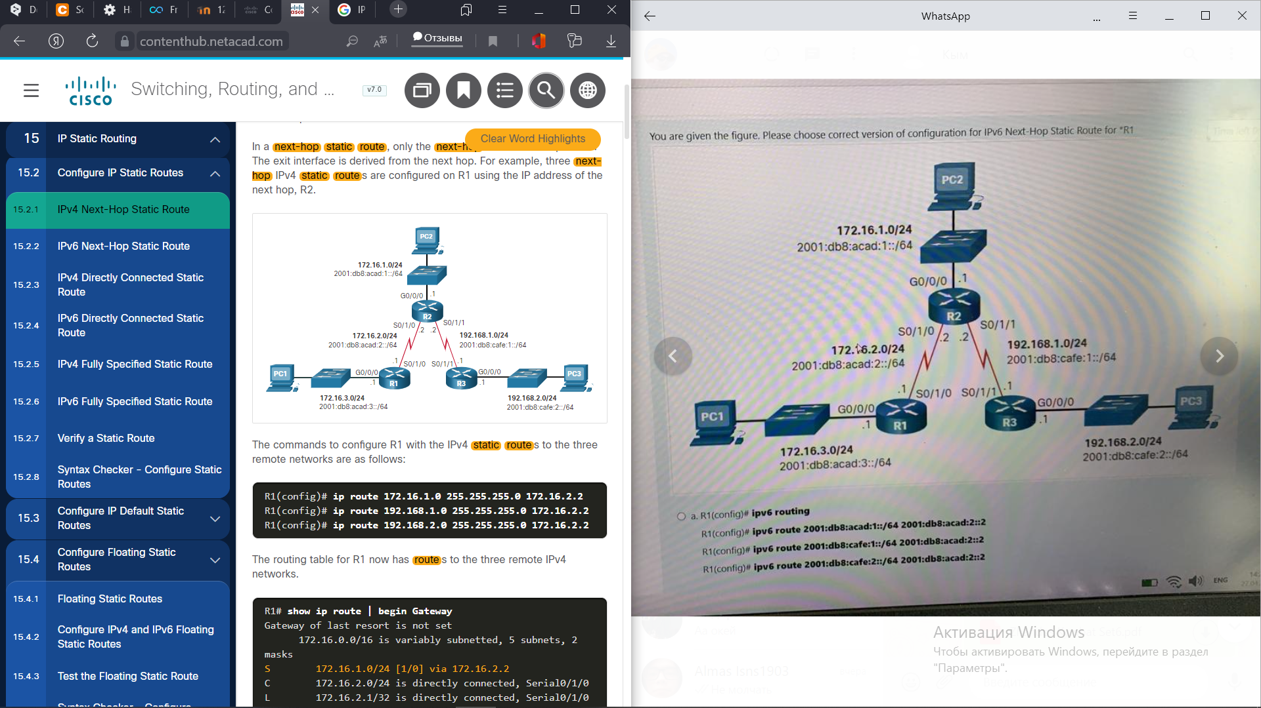

R1(config)# ipv6 route 2001:db8:acad:1::/64 s0/1/0

R1(config)# ipv6 route 2001:db8:cafe:1::/64 s0/1/0

R1(config)# ipv6 route 2001:db8:cafe:2::/64 s0/1/0

Next-hop route stands for the next-hop IP address and exit interface are specified

False

Choose the correct example of configuration IPv6 default route

R1(config)# **ipv6 route ::/0 2001:db8:acad:2::2**

What type of static route is used as the Gateway of Last Resort?  
default route

What command, or set of commands, would be used to determine if the following configuration on router HQ works as designed?  
ip route 0.0.0.0.0.0.0.0 serial 0/0/0 10

Ip route 0.0.0.0.0.0.0.0 serial 0/1/0

HQ(config)#interface serial 0/1/0

HQ(config-if)shutdown

HQ(config-if)end

HQ#show ip route

Which static route statement shows a recursive Ipv6 static route?

Ipv6 route 2001:db8:café:1::/56 2001:db8:1000:10::1

Choose all common IOS troubleshooting commands include the following:

* **ping**
* **traceroute**
* **show ip route**
* **show ip interface brief**
* **show cdp neighbors detail**

What command shows the following result(fill the white space)

**show ip route | begin Gateway**

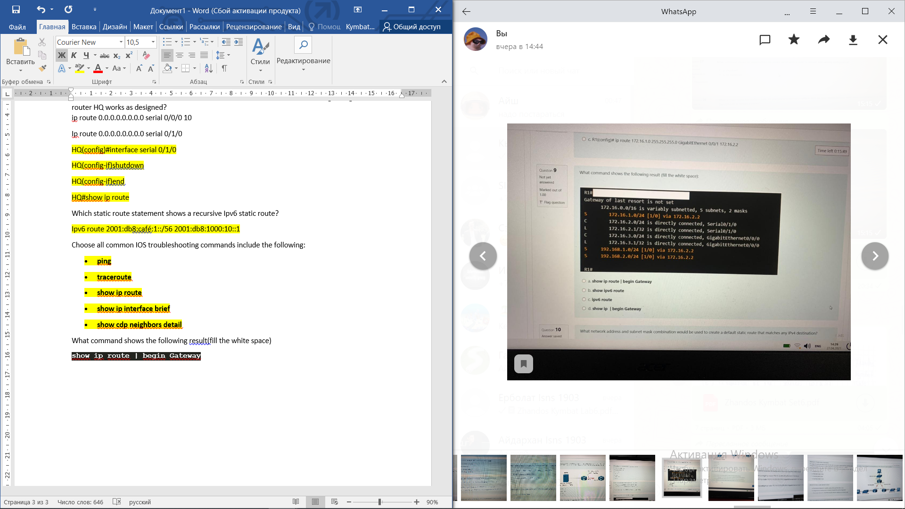

Which is correct IPv4 Static Route command?(be careful with parameters)

Router(config)# ip route network-address subnet-mask { ip-address | exit-intf [ip-address]} [distance]

Which IPv4 static route statement is true?

Using the exit interface only is common in a point to point configuration

Which protocols in AAA are responsible for authentication users against a central database of usernames and password?(Choose two)

RADIUS

TACACS+

What you need to check in case of a problem with connecting to the WLAN network of the wireless client in case the computer is working correctly?

Check the channel settings on the wireless client

Check for the presence of other devices in the area that may be interfering with the 2.4 GHz band

Check how far the PC is might be from an AP

What is one of the most effective methods to mitigate MAC address table overflow attacks?

Port security

What does FHRPs provide to the cliens?

Alternative default gateways

The IEEE 802.1X standards is responsible for…

restriction unauthorized workstations from connecting to a LAN through publicly accessible switch ports

In setting up a small office network, the network administrator decides to assign private IP address dynamically to workstations and mobile devices. Which feature must be enabled on the company router in order for office devices to access the intern

- NAT

What is the best way to prevent a VLAN hopping attack?

- Disable trunk negotiation for trunk ports and statically set nontrunk ports as access ports

Refer the exhibit. When action will R3 take forward a frame if it does not have an entry in the ARP table to resolve a destination MAC address?

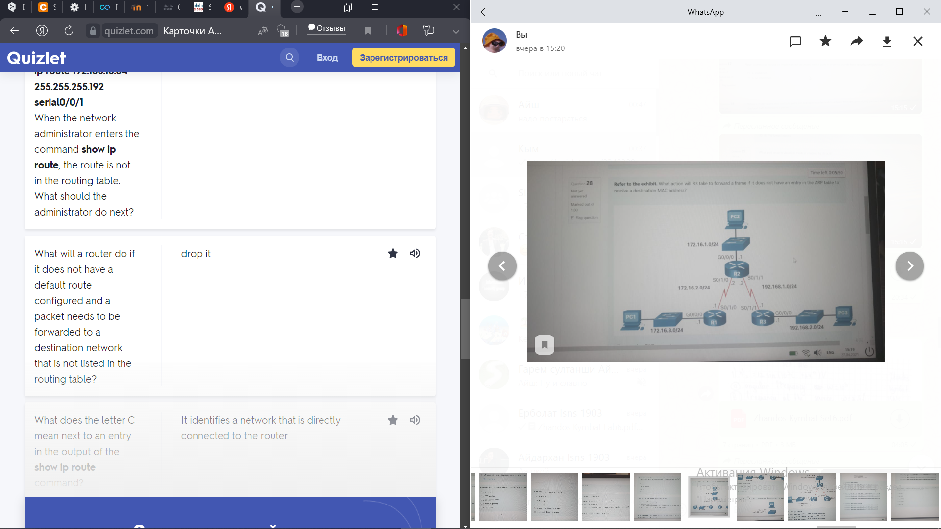

Sends an ARP request

Which service is enabled on a Cisco router by default that can reveal significant information about the router and potentially make in more vulnerable to attack?

CDP

Which two methods can be used to identify the next hop in a static route???

Exit interface

What troubleshooting command can be show the following result

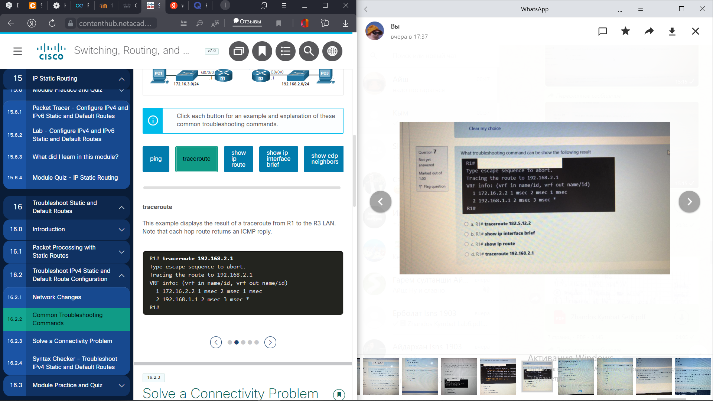

Traceroute 192.168.2.1

After entering command switchport port-security on interface configuration mode the following message appears:

Command rejected: fastEthernet0/1 is a dynamic port

What command must be entered to solve this problem?

Switchport mode access

How many default gateways can each host receive in a switched network?

1

Users on an IEEE 801.11n network are complaining of slow speeds. The network administrator checks the AP and verifies it is operating properly. What can be done to improve the wireless performance in the network?

Split the wireless traffic between the 802.11n 2.4 GHz band and the 5 GHz band.

Accounting is a component of AAA which is responsible for…

Collecting and reporting usage data for auditing and billing purposes

How is information added to the routing table for static routes?

The routing table is filled in manually

Where are dynamically learned MAC addresses stored when sticky learning is enabled with the switchport port-security mac-address sticky command?

- RAM

What device is assigned the role of alternative default gateway?

Standby router

R1#

Interface IP address OK

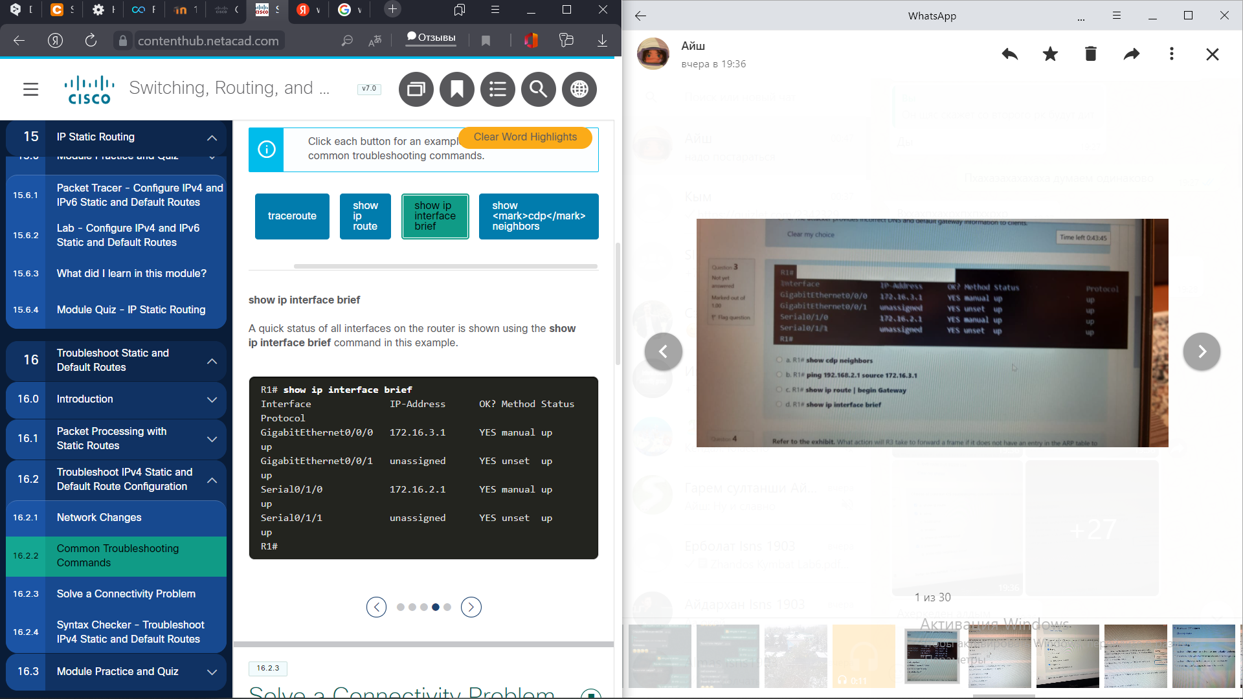

Show ip interface brief

Which two route sources have the ability to automatically discover a new best path there is a change in the topology?(Choose two)

OSPF  
EIGRP

A network administrator is configuring DHCP snooping on a switch.

Which configuration command should be used first?

**ip dhcp snooping**

Because of implemented security controls, a user can only access a server with FTP. Which AAA component accomplishes this?

- authorization

What address and prefix length is used when configuration an IPv6 default static route?

::/0.

What are two functions of a router? (Choose two.)

* A router connects multiple IP networks.
* It determines the best path to send packets.

Which command must be enabled to force a new HSRP election process?

**standby preempt**

**Which three channels are non-overlapping for 802.11b/g/n networks?**

**1,6,11**

**What two common types of static routes in routing tables?(Choose two)**

 a default static route

a static route to a specific network

Which two route sources codes are automatically creates within a routing table whenever a router interface is configured with an IP address and activated?(Choose two)

C

D

Which FHRP implementation is nonproprietary and support IPv4 and IPv6 election protocols?

VRRPv3

What is the newest packet forwarding method?

Cisco Express Forwarding

Which are dynamically learned MAC addresses stored when sticky learning is enabled with the switchport port-security mac-address sticky command?

NVRAM

What is a difference between autonomous APs that operate in a home environment and controller-based Aps that operate in a corporate environment?

Controller-based APs can be automatically configured and managed by a WLAN controller

What is the default for newly created WLANs on the WLC?

WPA2 with Advanced Encryption System (AES)

Users on an IEEE 801.11n network are complaining of slow speeds. The network administrator checks the AP and verifies it is operating properly. What can be done to improve the wireless performance in the network?

Split the wireless traffic between the 802.11n 2.4 GHz band and the 5 GHz band.

Which WLC tab would a network administrator typically use to see a summary view of the most heavily used WLANs including the number of clients using a particular WLAN?

Monitor

Which feature of 802.11n wireless access points allows them to transmit data at faster speeds than previous versions of 802.11 WI-FI standards did?

MIMO

Which one of these shared key authentication techniques is considered the most secured standard?

WPA2

A laptop cannot connect to a wireless access point. Which two troubleshooting steps should be taken first?

Ensure that the wireless NIC is enabled

Ensure that the wireless SSID is chosen

How to start setting up a new interface during configuring the VLAN interface on the WLC?

From creating a new interface

What IPv4 address is not routed on the Internet?

10.10.10.1

Match each technology to its most corresponding description.

Multi-access networks carrying both data and voice communications. Current standards are 4G and 5G.

Cellular

An IEEE 802.15 standards that uses a device-pairing process to communicate over distances up to 100m. It can be found in smart home devices, audio connections, automobiles, and other devices that require a short distance connection.

Bluetooth

An alternative to broadband wired internet connections. It is an IEEE 802.16 standard that provides high-speed wireless broadband access of up to 50.

WiMAX

Provides network access to remote sites through the use of a directional antenna in a form of a dish. It is usually more expensive and requires a clear line of sight. Typically. It is used by rural homeowners and businesses where cable and DSL are not available.

Satellite Breadboard

What does the stage of identifying the problem mean when troubleshooting WLAN issues?

conversation with the user

What method WLANs use to determine how and when to send data on the network?

CSMA/CA

What you need to check in case of a problem with connecting to the WLAN network of the wireless client in case the computer is working correctly?(Choose three)

Check the channel settings on the wireless client

Check for the presence of other devices in the area that may be interfering with the 2.4 GHz band

Check how far the PC is might be from an AP

Match standard names to its corresponding descriptions according to the Institute of Electrical and Electronics Engineers (IEEE) standards.

Uses transmitters to provide wireless service over a larger geographic area. Suitable for providing wireless access to a city or specific district. Use specific licensed frequencies.

WMAN

Uses transmitters to cover a medium-sized network, usually up to 100 meters. Suitable for use in a SOHO and a campus environment. Based on the 802.11 standard and a 2.4 GHz or 5GHz radio frequency.

WLAN

Uses transmitters to provide coverage over an extensive geographic area. Suitable for national and global communications. Use specific licensed frequencies.

WWAN

Uses low powered transmitters for a short-range network, usually 6 to 9 maters. Based on the 802.15 standard and a 2.4 GHz radio frequency

WPAN

What is the difference between Autonomous APs and Controller based APs

In the context of mobile devices, what does the term tethering involve?

Connecting a mobile device to another mobile device or computer to share a network connection

Match the descriptions of each wireless networks threat to its name.

Access to WLAN services can be compromised either accidently or maliciously. Various solutions exists depending on the source of the DoS attack.

Denial of Service (DoS) Attacks -

Unauthorized users attempting to access network resources can be deterred through effective authentications techniques

Wireless intruders

Wireless data should be encrypted to prevent it from being read by eavesdroppers

Interception of data

Unauthorized access points installed by a well-intentioned user or for malicious purposes can be detected using management software.

Rogue APs

Which characteristic describes a wireless client operating in active mode?

Must know the SSID to connect to an AP

Which procedure is recommended to mitigate the chances of ARP spoofing?

Enable DHCP snooping on selected VLANs

MIMO technology…

Uses multiple antennas to improve communication performance

Which protocol could be used by a company to implement authentication, authorization and collection of information about the resources used?

RADIUS

A customer installs a wireless access point at home in the closet next to the kitchen. The customer mentions that the wireless communication performance seems degraded when the cordless phone or the microwave oven is in use. What is the possible reason for this degradation?

The wireless signal is in the same radio frequency range as the household devices are in

AP stands for…

Access point

Which of the following wireless networks typically uses lower powered transmitters for short ranges?

- WPAN

Which of the following wireless networks are specified in the IEEE 802.11 standards for the 2.4 GHz and 5 GHz radio frequencies?

- WLAN

Which of the following is an IEEE 802.15 WPAN standard that uses a device-pairing process to communicate?

- Bluetooth

Which 802.11 standards exclusively use the 5 GHz radio frequency? (Choose 2)

- 802.11a

- 802.11ac

Which standards organization is responsible for allocating radio frequencies?

- ITU-R

True or False: Laptops that do not have an integrated wireless NIC can only be attached to the network through a wired connection.

- False

Which of the following components are integrated in a wireless home router? (Choose three.)

- Access point

- Switch

- Router

True or False: When you need to expand the coverage of a small network, the best solution is to use a range extender.

- False

Which of the following is a standalone device, like a home router, where the entire WLAN configuration resides on the device?

- Autonomous AP

Which of the following antennas provide 360 degrees of coverage?

- Omnidirectional

Which wireless topology mode is used by two devices to connect in a peer-to-peer network?

- Ad hoc

True or False: An ESS is created when two or more BSSs need to be joined to support roaming clients.

- True

How many address fields are in the 802.11 wireless frame?

- 4

What is the term for an AP that openly advertises its service periodically?

- Passive

What is the term for an AP that does not send a beacon, but waits for clients to send probes?

- Active

What IP versions does CAPWAP support?

- IPv4 by default, but can configure IPv6

What UDP ports and IP protocols are used by CAPWAP for IPv4? (Choose three.)

- 5246

- 17

- 5247

What UDP ports and IP protocols are used by CAPWAP for IPv6? (Choose three.)

- 136

- 5246

- 5247

In the split MAC architecture for CAPWAP, which of the following are the responsibility of the AP? (Choose four.)

- Packet acknowledgments and retransmissions

- Beacons and probe responses

- MAC layer data encryption and decryption

- Frame queueing and packet prioritization

In the split MAC architecture for CAPWAP, which of the following are the responsibility of the WLC? (Choose four.)

- Authentication

- Association and re-association of roaming clients

- Termination of 802.11 traffic on a wired interface

- Frame translation to other protocols

True or False: DTLS is enabled by default on the control and data CAPWAP tunnels.

- False

Which of the following statements are true about modes of operation for a FlexConnect AP? (Choose two.)

- In standalone mode, the WLC is unreachable and the AP switches local traffic and performs client authentication locally.

- In connect mode, the WLC is reachable and performs all its CAPWAP functions.

Which of the following modulation techniques rapidly switches a signal among frequency channels?

- FHSS

Which of the following modulation techniques spreads a signal over a larger frequency band?

- DSSS

Which of the following modulation techniques is used in the new 802.11ax standard?

- OFDMA

How many channels are available for the 2.4 GHz band in Europe?

- 13

How many channels are available for the 5 GHz band?

- 24

Which of the following is most likely NOT the source of a wireless DoS attack?

- Rougue AP

True or False: A rogue AP is a misconfigured AP connected to the network and a possible source of DoS attacks.

- False

What type of attack is an “evil twin AP” attack?

- MITM

What are the best ways to secure WLANs? (Choose two.)

- Authentication

- Encryption

Which of the following authentication methods does not use a password shared between the wireless client and the AP?

- Open

Which encryption method is used by the original 802.11 specification?

- RC4

Which of the following encryption methods uses CCMP to recognize if the encrypted and non-encrypted bits have been altered?

- AES

Which of the following authentication methods has the user enter a pre-shared password? (Choose two)

- WPA Personal

- WPA2 Personal

In the context of mobile devices, what does the term tethering involve?

- connecting a mobile device to another mobile device or computer to share a network connection

Which feature of 802.11n wireless access points allows them to transmit data at faster speeds than previous versions of 802.11 Wi-Fi standards did?

- MIMO

Which method of wireless authentication is currently considered to be the strongest?

- WPA2

Which parameter is commonly used to identify a wireless network name when a home wireless AP is being configured?

- SSID

Which characteristic describes a wireless client operating in active mode?

- must know the SSID to connect to an AP

Which IEEE standard operates at wireless frequencies in both the 5 GHz and 2.4 GHz ranges?

- 802.11n

Which statement describes an autonomous access point?

- It is a standalone access point

Which two roles are typically performed by a wireless router that is used in a home or small business? (Choose two.)

- access point

- Ethernet switch

Which protocol and port numbers are used by both IPv4 and IPv6 CAPWAP tunnels? (Choose two.)

- UPD

- 5246 and 5247

If three 802.11b access points need to be deployed in close proximity, which three frequency channels should be used? (Choose three.)

- 6

- 11

- 1

Which type of telecommunication technology is used to provide Internet access to vessels at sea?

- satellite

Which wireless network topology is being configured by a technician who is installing a keyboard, a mouse, and headphones, each of which uses Bluetooth?

- ad hoc mode

Which type of wireless topology is created when two or more Basic Service Sets are interconnected by Ethernet?

- ESS

What Wi-Fi management frame is regularly broadcast by APs to announce their presence?

- beacon

A user is configuring a wireless access point and wants to prevent any neighbors from discovering the network. What action does the user need to take?

- Disable SSID broadcast

When a wireless network in a small office is being set up, which type of IP addressing is typically used on the networked devices?

- private

A user has just purchased a generic home router and would like to secure it. What should be done to help secure the wireless home router?

- Change the default administrator password

Which protocol could be used by a company to monitor devices such as a wireless LAN controller (WLC)?

- SNMP

When configuring a Cisco 3500 series wireless LAN controller (WLC) for a WPA2 Enterprise WLAN, what has to be created on the WLC before creating the new WLAN?

- a VLAN for the wireless network

What is a DHCP scope as it relates to a WLAN configured on the WLC controller?

- a pool of IP addresses for WLAN clients

Why would a technician configure a passphrase for a WLAN on a wireless router?

- to configure wireless client authentication

A customer installs a wireless access point at home in the closet next to the kitchen. The customer mentions that the wireless communication performance seems degraded when the cordless phone or the microwave oven is in use. What is the possible reason for this degradation?

- The wireless signal is in the same radio frequency range as the household devices are in.

What functionality is required on routers to provide remote workers with VoIP and videoconferencing capabilities?

- QoS

A wireless router is displaying the IP address of 192.168.0.1. What could this mean?

- The wireless router still has the factory default IP address

A laptop cannot connect to a wireless access point. Which two troubleshooting steps should be taken first? (Choose two.)

- Ensure that the wireless SSID is chosen.

- Ensure that the wireless NIC is enabled.

In setting up a small office network, the network administrator decides to assign private IP addresses dynamically to workstations and mobile devices. Which feature must be enabled on the company router in order for office devices to access the internet?

- NAT

What is a difference between autonomous APs that operate in a home environment and controller-based APs that operate in a corporate environment?

- Controller-based APs can be automatically configured and managed by a WLAN controller

Which WLC tab would a network administrator typically use to see a summary view of the most heavily used WLANs including the number of clients using a particular WLAN?

- Monitor

Users on an IEEE 802.11n network are complaining of slow speeds. The network administrator checks the AP and verifies it is operating properly. What can be done to improve the wireless performance in the network?

- Split the wireless trafic between the 802.11n 2.4 GHz band and the 5 GHz band

Which device monitors SMTP traffic to block threats and encrypt outgoing messages to prevent data loss?

ESA

Which devices are specifically designed for network security?(Choose three)

NAC

NGFW

VPN-enabled router

What are two types of switch ports that are used on Cisco switches as part of the defense against DHCP spoofing attacks?

Untrusted port

Trusted DHCP port

After entering command switchport port-security on interface configuration mode the following message appears:

Command rejected: fastEthernet0/1 is a dynamic port

What command must be entered to solve this problem?

Switchport mode access

Accounting is a component of AAA which is responsible for…

Collecting and reporting usage data for auditing and billing purposes

Which of the following mitigation techniques prevents ARP spoofing and ARP poisoning attacks?

DAI

What command is used to set the number of allowed MAC addresses on a port ?

Switchport port-security maximum

Which service is enabled on a Cisco router by default that can reveal significant information about the router and potentially make it more vulnerable to attack?

CDP

Which procedure is recommended to mitigate the chances of ARP spoofing?

Enable DAI on the management

Which of the following mitigation techniques prevents many types of attacks including MAC address table overflow and DHCP starvation attacks?

Port security

What command should be implement on unused switch ports in order to provide basic security configuration?

Shutdown

What port security violation mode is enabled by default?

Shutdown

Which two features on a Cisco CataLyst switch can be used to mitigate DHCP starvation and DHCP spoofing attack?(Choose two)

Port security

DHCP snooping

Authentication is a component of AAA which is responsible for…

Controlling who is permitted to access the network?

What is the purpose of BPDU guard function?

To disable a port that receives a BPDU

A network administrator is configuring DHCP snooping on a switch. Which configuration command should be used first?

Ip dhcp snooping

Which two commands can be used to enable PortFast on a switch?(Choose two)

S1(config-if)# spanning-tree portfast

S1(config)#spanning-tree portfast default

An attacker configures a host with the 802.1Q protocol and forms a trunk with the connected switch. What type of attack is this?

VLAN hopping

What definition describes DDos attack?

This is a coordinated attack from many devices with the intention of degrading or halting public access to an organization’s website and resources.

What definition describes Data Breach attack?

This is an attack in which an organization’s data servers or hosts are compromised to steal confidential information

Which attack encrypts the data on hosts in an attempt to extract a monetary payment from the victim?

- Ransomware

Which devices are specifically designed for network security? (Choose three)

-VPN-enabled router

- NGFW

- NAC

Which device monitors SMTP traffic to block threats and encrypt outgoing messages to prevent data loss?

- ESA

Which device monitors HTTP traffic to block access to risky sites and encrypt outgoing messages?

- WSA

Which AAA component is responsible for collecting and reporting usage data for auditing and billing purposes?

- Accounting

Which AAA component is responsible for controlling who is permitted to access the network?

- Authentication

Which AAA component is responsible for determining what the user can access?

- Authorization

In an 802.1X implementation, which device is responsible for relaying responses?

- Authenticator

Which of the following mitigation techniques are used to protect Layer 3 through Layer 7 of the OSI Model? (Choose three.)

- VPN

- Firewalls

- IPS devices

Which of the following mitigation techniques prevents many types of attacks including MAC address table overflow and DHCP starvation attacks?

- Port security

Which of the following mitigation techniques prevents MAC and IP address spoofing?

- IPSG

Which of the following mitigation techniques prevents ARP spoofing and ARP poisoning attacks?

- DAI

Which of the following mitigation techniques prevents DHCP starvation and DHCP spoofing attacks?

- DHCP snooping

What is the behavior of a switch as a result of a successful MAC address table attack?

- The switch will forward all received frames to all other ports within the VLAN

What would be the primary reason a threat actor would launch a MAC address overflow attack?

- So that the threat actor can see frames that are destined for other devices

What mitigation technique must be implemented to prevent MAC address overflow attacks?

- Port security

A threat actor changes the MAC address of the threat actor's device to the MAC address of the default gateway. What type of attack is this?

- Address spoofing

A threat actor sends a BPDU message with priority 0. What type of attack is this?

- STP attack

A threat actor leases all the available IP addresses on a subnet. What type of attack is this?

- DHCP starvation

A threat actor sends a message that causes all other devices to believe the MAC address of the threat actor's device is the default gateway. What type of attack is this?

- ARP spoofing

A threat actor configures a host with the 802.1Q protocol and forms a trunk with the connected switch. What type of attack is this?

- VLAN hopping

A threat actor discovers the IOS version and IP addresses of the local switch. What type of attack is this?

- CDP reconnaissance

What two protocols are supported on Cisco devices for AAA communications? (Choose two.)

- TACACS+

- RADIUS

Which service is enabled on a Cisco router by default that can reveal significant information about the router and potentially make it more vulnerable to attack?

- CDP

When security is a concern, which OSI Layer is considered to be the weakest link in a network system?​

- Layer 2

Which Layer 2 attack will result in a switch flooding incoming frames to all ports?

- MAC address overflow

Why is authentication with AAA preferred over a local database method?

- it provides a fallback authentication method if the administrator forgets the username or password

In a server-based AAA implementation, which protocol will allow the router to successfully communicate with the AAA server?

- RADIUS

Which Cisco solution helps prevent MAC and IP address spoofing attacks?

- IP Source Guard

What is the purpose of AAA accounting?

- to collect and report application usage

Which Layer 2 attack will result in legitimate users not getting valid IP addresses?

- DHCP starvation

Which three Cisco products focus on endpoint security solutions? (Choose three.)

- Web Security Appliance

- Email Security Appliance

- NAC Appliance

True or False?

In the 802.1X standard, the client attempting to access the network is referred to as the supplicant.

- true

What is involved in an IP address spoofing attack?

- A legitimate network IP address is hijacked by a rogue node

What three services are provided by the AAA framework? (Choose three.)

- authentication

- accounting

- authorization

Because of implemented security controls, a user can only access a server with FTP. Which AAA component accomplishes this?

- authorization

What mitigation plan is best for thwarting a DoS attack that is creating a MAC address table overflow?

- enable port security

What is a recommended best practice when dealing with the native VLAN?

- Assign it to an unused VLAN

On what switch ports should PortFast be enabled to enhance STP stability?

- all end-user ports

Which command would be best to use on an unused switch port if a company adheres to the best practices as recommended by Cisco?

- shutdown

Which two features on a Cisco Catalyst switch can be used to mitigate DHCP starvation and DHCP spoofing attacks? (Choose two.)

- DHCP snooping

- port security

What is the best way to prevent a VLAN hopping attack?

- Disable trunk negotiation for trunk ports and statically set nontrunk ports as access ports

Which procedure is recommended to mitigate the chances of ARP spoofing?

- Enable DHCP snooping on selected VLANs

What are two types of switch ports that are used on Cisco switches as part of the defense against DHCP spoofing attacks? (Choose two.)

- untrusted port

- trusted DHCP port

Which two commands can be used to enable PortFast on a switch? (Choose two.)

- S1(config-if)#spanning-tree portfast

- S1(config)# spanning-tree portfast default

An administrator who is troubleshooting connectivity issues on a switch notices that a switch port configured for port security is in the err-disabled state. After verifying the cause of the violation, how should the administrator re-enable the port without disrupting network operation?

- Issue the shutdown command followed by the no shutdown command on the interface

A network administrator is configuring DHCP snooping on a switch. Which configuration command should be used first?

- ip dhcp snooping

A network administrator is configuring DAI on a switch with the command ip arp inspection validate dst-mac. What is the purpose of this configuration command?

- to check the destination MAC address in the Ethernet header against the target MAC address in the ARP body

Which security feature should be enabled in order to prevent an attacker from overflowing the MAC address table of a switch?

- port security

What Layer 2 attack is mitigated by disabling Dynamic Trunking Protocol?

- VLAN hopping

A network administrator is configuring DAI on a switch. Which command should be used on the uplink interface that connects to a router?

- ip arp inspection trust

Where are dynamically learned MAC addresses stored when sticky learning is enabled with the switchport port-security mac-address sticky command?

- RAM

What type of attack implies that the hacker is positioned in between two legitmate entities in order to read or modify the data that passes between the two parties.

MITM

How is called the network name in the WLAN default settings?

SSID

Match each antenna type its description

Provide 360 degree coverage and are ideal in houses, open office areas, conference, rooms, and outside areas

Omnidirectional antennas

Focus the radio signal in a given direction. Examples include Yagi and parabolic dish antennas.

Directional antennas

Uses multiple antennas to increase available bandwidth for IEEE 802.11n/ac/ax wireless networks. Up to eight transmit and receive antennas can be used to increase throughput.

Multiple Input Multiple Output (MIMO)

Which device monitors SMTP traffic to block threats and encrypt outgoing messages to prevent data loss?

ESA

Which devices are specifically designed for network security?(Choose three)

NAC

NGFW

VPN-enabled router

What are two types of switch ports that are used on Cisco switches as part of the defense against DHCP spoofing attacks?

Untrusted port

Trusted DHCP port

After entering command switchport port-security on interface configuration mode the following message appears:

Command rejected: fastEthernet0/1 is a dynamic port

What command must be entered to solve this problem?

Switchport mode access

Accounting is a component of AAA which is responsible for…

Collecting and reporting usage data for auditing and billing purposes

Which of the following mitigation techniques prevents ARP spoofing and ARP poisoning attacks?

DAI

What command is used to set the number of allowed MAC addresses on a port ?

Switchport port-security maximum

Which service is enabled on a Cisco router by default that can reveal significant information about the router and potentially make it more vulnerable to attack?

CDP

Which procedure is recommended to mitigate the chances of ARP spoofing?

Enable DAI on the management

Which of the following mitigation techniques prevents many types of attacks including MAC address table overflow and DHCP starvation attacks?

Port security

What command should be implement on unused switch ports in order to provide basic security configuration?

Shutdown

What port security violation mode is enabled by default?

Shutdown

Which two features on a Cisco CataLyst switch can be used to mitigate DHCP starvation and DHCP spoofing attack?(Choose two)

Port security

DHCP snooping

Authentication is a component of AAA which is responsible for…

Controlling who is permitted to access the network?

What is the purpose of BPDU guard function?

To disable a port that receives a BPDU

A network administrator is configuring DHCP snooping on a switch. Which configuration command should be used first?

Ip dhcp snooping

Which two commands can be used to enable PortFast on a switch?(Choose two)

S1(config-if)# spanning-tree portfast

S1(config)#spanning-tree portfast default

An attacker configures a host with the 802.1Q protocol and forms a trunk with the connected switch. What type of attack is this?

VLAN hopping

What definition describes DDos attack?

This is a coordinated attack from many devices with the intention of degrading or halting public access to an organization’s website and resources.

What definition describes Data Breach attack?

This is an attack in which an organization’s data servers or hosts are compromised to steal confidential information

Which attack encrypts the data on hosts in an attempt to extract a monetary payment from the victim?

- Ransomware

Which devices are specifically designed for network security? (Choose three)

-VPN-enabled router

- NGFW

- NAC

Which device monitors SMTP traffic to block threats and encrypt outgoing messages to prevent data loss?

- ESA

Which device monitors HTTP traffic to block access to risky sites and encrypt outgoing messages?

- WSA

Which AAA component is responsible for collecting and reporting usage data for auditing and billing purposes?

- Accounting

Which AAA component is responsible for controlling who is permitted to access the network?

- Authentication

Which AAA component is responsible for determining what the user can access?

- Authorization

In an 802.1X implementation, which device is responsible for relaying responses?

- Authenticator

Which of the following mitigation techniques are used to protect Layer 3 through Layer 7 of the OSI Model? (Choose three.)

- VPN

- Firewalls

- IPS devices

Which of the following mitigation techniques prevents many types of attacks including MAC address table overflow and DHCP starvation attacks?

- Port security

Which of the following mitigation techniques prevents MAC and IP address spoofing?

- IPSG

Which of the following mitigation techniques prevents ARP spoofing and ARP poisoning attacks?

- DAI

Which of the following mitigation techniques prevents DHCP starvation and DHCP spoofing attacks?

- DHCP snooping

What is the behavior of a switch as a result of a successful MAC address table attack?

- The switch will forward all received frames to all other ports within the VLAN

What would be the primary reason a threat actor would launch a MAC address overflow attack?

- So that the threat actor can see frames that are destined for other devices

What mitigation technique must be implemented to prevent MAC address overflow attacks?

- Port security

A threat actor changes the MAC address of the threat actor's device to the MAC address of the default gateway. What type of attack is this?

- Address spoofing

A threat actor sends a BPDU message with priority 0. What type of attack is this?

- STP attack

A threat actor leases all the available IP addresses on a subnet. What type of attack is this?

- DHCP starvation

A threat actor sends a message that causes all other devices to believe the MAC address of the threat actor's device is the default gateway. What type of attack is this?

- ARP spoofing

A threat actor configures a host with the 802.1Q protocol and forms a trunk with the connected switch. What type of attack is this?

- VLAN hopping

A threat actor discovers the IOS version and IP addresses of the local switch. What type of attack is this?

- CDP reconnaissance

What two protocols are supported on Cisco devices for AAA communications? (Choose two.)

- TACACS+

- RADIUS

Which service is enabled on a Cisco router by default that can reveal significant information about the router and potentially make it more vulnerable to attack?

- CDP

When security is a concern, which OSI Layer is considered to be the weakest link in a network system?​

- Layer 2

Which Layer 2 attack will result in a switch flooding incoming frames to all ports?

- MAC address overflow

Why is authentication with AAA preferred over a local database method?

- it provides a fallback authentication method if the administrator forgets the username or password

In a server-based AAA implementation, which protocol will allow the router to successfully communicate with the AAA server?

- RADIUS

Which Cisco solution helps prevent MAC and IP address spoofing attacks?

- IP Source Guard

What is the purpose of AAA accounting?

- to collect and report application usage

Which Layer 2 attack will result in legitimate users not getting valid IP addresses?

- DHCP starvation

Which three Cisco products focus on endpoint security solutions? (Choose three.)

- Web Security Appliance

- Email Security Appliance

- NAC Appliance

True or False?

In the 802.1X standard, the client attempting to access the network is referred to as the supplicant.

- true

What is involved in an IP address spoofing attack?

- A legitimate network IP address is hijacked by a rogue node

What three services are provided by the AAA framework? (Choose three.)

- authentication

- accounting

- authorization

Because of implemented security controls, a user can only access a server with FTP. Which AAA component accomplishes this?

- authorization

What mitigation plan is best for thwarting a DoS attack that is creating a MAC address table overflow?

- enable port security

What is a recommended best practice when dealing with the native VLAN?

- Assign it to an unused VLAN

On what switch ports should PortFast be enabled to enhance STP stability?

- all end-user ports

Which command would be best to use on an unused switch port if a company adheres to the best practices as recommended by Cisco?

- shutdown

Which two features on a Cisco Catalyst switch can be used to mitigate DHCP starvation and DHCP spoofing attacks? (Choose two.)

- DHCP snooping

- port security

What is the best way to prevent a VLAN hopping attack?

- Disable trunk negotiation for trunk ports and statically set nontrunk ports as access ports

Which procedure is recommended to mitigate the chances of ARP spoofing?

- Enable DHCP snooping on selected VLANs

What are two types of switch ports that are used on Cisco switches as part of the defense against DHCP spoofing attacks? (Choose two.)

- untrusted port

- trusted DHCP port

Which two commands can be used to enable PortFast on a switch? (Choose two.)

- S1(config-if)#spanning-tree portfast

- S1(config)# spanning-tree portfast default

An administrator who is troubleshooting connectivity issues on a switch notices that a switch port configured for port security is in the err-disabled state. After verifying the cause of the violation, how should the administrator re-enable the port without disrupting network operation?

- Issue the shutdown command followed by the no shutdown command on the interface

A network administrator is configuring DHCP snooping on a switch. Which configuration command should be used first?

- ip dhcp snooping

A network administrator is configuring DAI on a switch with the command ip arp inspection validate dst-mac. What is the purpose of this configuration command?

- to check the destination MAC address in the Ethernet header against the target MAC address in the ARP body

Which security feature should be enabled in order to prevent an attacker from overflowing the MAC address table of a switch?

- port security

What Layer 2 attack is mitigated by disabling Dynamic Trunking Protocol?

- VLAN hopping

A network administrator is configuring DAI on a switch. Which command should be used on the uplink interface that connects to a router?

- ip arp inspection trust

Where are dynamically learned MAC addresses stored when sticky learning is enabled with the switchport port-security mac-address sticky command?

- RAM

Which device monitors SMTP traffic to block threats and encrypt outgoing messages to prevent data loss?

ESA

Which devices are specifically designed for network security?(Choose three)

NAC

NGFW

VPN-enabled router

What are two types of switch ports that are used on Cisco switches as part of the defense against DHCP spoofing attacks?

Untrusted port

Trusted DHCP port

After entering command switchport port-security on interface configuration mode the following message appears:

Command rejected: fastEthernet0/1 is a dynamic port

What command must be entered to solve this problem?

Switchport mode access

Accounting is a component of AAA which is responsible for…

Collecting and reporting usage data for auditing and billing purposes

Which of the following mitigation techniques prevents ARP spoofing and ARP poisoning attacks?

DAI

What command is used to set the number of allowed MAC addresses on a port ?

Switchport port-security maximum

Which service is enabled on a Cisco router by default that can reveal significant information about the router and potentially make it more vulnerable to attack?

CDP

Which procedure is recommended to mitigate the chances of ARP spoofing?

Enable DAI on the management

Which of the following mitigation techniques prevents many types of attacks including MAC address table overflow and DHCP starvation attacks?

Port security

What command should be implement on unused switch ports in order to provide basic security configuration?

Shutdown

What port security violation mode is enabled by default?

Shutdown

Which two features on a Cisco CataLyst switch can be used to mitigate DHCP starvation and DHCP spoofing attack?(Choose two)

Port security

DHCP snooping

Authentication is a component of AAA which is responsible for…

Controlling who is permitted to access the network?

What is the purpose of BPDU guard function?

To disable a port that receives a BPDU

A network administrator is configuring DHCP snooping on a switch. Which configuration command should be used first?

Ip dhcp snooping

Which two commands can be used to enable PortFast on a switch?(Choose two)

S1(config-if)# spanning-tree portfast

S1(config)#spanning-tree portfast default

An attacker configures a host with the 802.1Q protocol and forms a trunk with the connected switch. What type of attack is this?

VLAN hopping

What definition describes DDos attack?

This is a coordinated attack from many devices with the intention of degrading or halting public access to an organization’s website and resources.

What definition describes Data Breach attack?

This is an attack in which an organization’s data servers or hosts are compromised to steal confidential information

Which attack encrypts the data on hosts in an attempt to extract a monetary payment from the victim?

- Ransomware

Which devices are specifically designed for network security? (Choose three)

-VPN-enabled router

- NGFW

- NAC

Which device monitors SMTP traffic to block threats and encrypt outgoing messages to prevent data loss?

- ESA

Which device monitors HTTP traffic to block access to risky sites and encrypt outgoing messages?

- WSA

Which AAA component is responsible for collecting and reporting usage data for auditing and billing purposes?

- Accounting

Which AAA component is responsible for controlling who is permitted to access the network?

- Authentication

Which AAA component is responsible for determining what the user can access?

- Authorization

In an 802.1X implementation, which device is responsible for relaying responses?

- Authenticator

Which of the following mitigation techniques are used to protect Layer 3 through Layer 7 of the OSI Model? (Choose three.)

- VPN

- Firewalls

- IPS devices

Which of the following mitigation techniques prevents many types of attacks including MAC address table overflow and DHCP starvation attacks?

- Port security

Which of the following mitigation techniques prevents MAC and IP address spoofing?

- IPSG

Which of the following mitigation techniques prevents ARP spoofing and ARP poisoning attacks?

- DAI

Which of the following mitigation techniques prevents DHCP starvation and DHCP spoofing attacks?

- DHCP snooping

What is the behavior of a switch as a result of a successful MAC address table attack?

- The switch will forward all received frames to all other ports within the VLAN

What would be the primary reason a threat actor would launch a MAC address overflow attack?

- So that the threat actor can see frames that are destined for other devices

What mitigation technique must be implemented to prevent MAC address overflow attacks?

- Port security

A threat actor changes the MAC address of the threat actor's device to the MAC address of the default gateway. What type of attack is this?

- Address spoofing

A threat actor sends a BPDU message with priority 0. What type of attack is this?

- STP attack

A threat actor leases all the available IP addresses on a subnet. What type of attack is this?

- DHCP starvation

A threat actor sends a message that causes all other devices to believe the MAC address of the threat actor's device is the default gateway. What type of attack is this?

- ARP spoofing

A threat actor configures a host with the 802.1Q protocol and forms a trunk with the connected switch. What type of attack is this?

- VLAN hopping

A threat actor discovers the IOS version and IP addresses of the local switch. What type of attack is this?

- CDP reconnaissance

What two protocols are supported on Cisco devices for AAA communications? (Choose two.)

- TACACS+

- RADIUS

Which service is enabled on a Cisco router by default that can reveal significant information about the router and potentially make it more vulnerable to attack?

- CDP

When security is a concern, which OSI Layer is considered to be the weakest link in a network system?​

- Layer 2

Which Layer 2 attack will result in a switch flooding incoming frames to all ports?

- MAC address overflow

Why is authentication with AAA preferred over a local database method?

- it provides a fallback authentication method if the administrator forgets the username or password

In a server-based AAA implementation, which protocol will allow the router to successfully communicate with the AAA server?

- RADIUS

Which Cisco solution helps prevent MAC and IP address spoofing attacks?

- IP Source Guard

What is the purpose of AAA accounting?

- to collect and report application usage

Which Layer 2 attack will result in legitimate users not getting valid IP addresses?

- DHCP starvation

Which three Cisco products focus on endpoint security solutions? (Choose three.)

- Web Security Appliance

- Email Security Appliance

- NAC Appliance

True or False?

In the 802.1X standard, the client attempting to access the network is referred to as the supplicant.

- true

What is involved in an IP address spoofing attack?

- A legitimate network IP address is hijacked by a rogue node

What three services are provided by the AAA framework? (Choose three.)

- authentication

- accounting

- authorization

Because of implemented security controls, a user can only access a server with FTP. Which AAA component accomplishes this?

- authorization

What mitigation plan is best for thwarting a DoS attack that is creating a MAC address table overflow?

- enable port security

What is a recommended best practice when dealing with the native VLAN?

- Assign it to an unused VLAN

On what switch ports should PortFast be enabled to enhance STP stability?

- all end-user ports

Which command would be best to use on an unused switch port if a company adheres to the best practices as recommended by Cisco?

- shutdown

Which two features on a Cisco Catalyst switch can be used to mitigate DHCP starvation and DHCP spoofing attacks? (Choose two.)

- DHCP snooping

- port security

What is the best way to prevent a VLAN hopping attack?

- Disable trunk negotiation for trunk ports and statically set nontrunk ports as access ports

Which procedure is recommended to mitigate the chances of ARP spoofing?

- Enable DHCP snooping on selected VLANs

What are two types of switch ports that are used on Cisco switches as part of the defense against DHCP spoofing attacks? (Choose two.)

- untrusted port

- trusted DHCP port

Which two commands can be used to enable PortFast on a switch? (Choose two.)

- S1(config-if)#spanning-tree portfast

- S1(config)# spanning-tree portfast default

An administrator who is troubleshooting connectivity issues on a switch notices that a switch port configured for port security is in the err-disabled state. After verifying the cause of the violation, how should the administrator re-enable the port without disrupting network operation?

- Issue the shutdown command followed by the no shutdown command on the interface

A network administrator is configuring DHCP snooping on a switch. Which configuration command should be used first?

- ip dhcp snooping

A network administrator is configuring DAI on a switch with the command ip arp inspection validate dst-mac. What is the purpose of this configuration command?

- to check the destination MAC address in the Ethernet header against the target MAC address in the ARP body

Which security feature should be enabled in order to prevent an attacker from overflowing the MAC address table of a switch?

- port security

What Layer 2 attack is mitigated by disabling Dynamic Trunking Protocol?

- VLAN hopping

A network administrator is configuring DAI on a switch. Which command should be used on the uplink interface that connects to a router?

- ip arp inspection trust

Where are dynamically learned MAC addresses stored when sticky learning is enabled with the switchport port-security mac-address sticky command?

- RAM

1. What table does a router use to determine how to forward an IP packet?

routing table

2. What action will a router take on a packet with a destination IP address that is on a remote network?

It will forward the packet to a next-hop router.

3. Which of the following routes may be found in a routing table? (Choose all that apply.)

directly connected networks

static routes

dynamic routing protocol routes

default route

4. What is used to determine the minimum number of far-left bits that must match between the prefix in the route entry and the destination IP address.

- Prefix length in the routing table entry

5. If a router needs to send an ARP Request for the destination IPv4 address of the packet, this means the packet will be forwarded:

To the device with the destination IPv4 address of the packet

6. If a router needs to send an ARP Request for the IPv4 address in one of its route entries, this means the packet will be forwarded:

To a next-hop router

7. Which packet forwarding method is used by default on Cisco routers?

Cisco Express Forwarding

1. Which routing table principle is not correct?

- Routing information about a path from one network to another also provides routing information about the reverse, or return, path.

2. Which route entry would be used for a packet with a destination IP address that matches an IP address of one of the router interfaces?

L for Local

3. What type of network is accessed by a single route and the router has only one neighbor?

Stub network

4. Which two route sources have the ability to automatically discover a new best path when there is a change in the topology? (Choose two.)

OSPF

EIGRP

5. True or False? A default route can only be a static route.

False

6. A network administrator configures a static route for the same destination network that was learned automatically by the router using OSPF. Which route will be installed and why?

Static route because it has a lower administrative distance

1. Which type of routing automatically adapts to topology changes?

dynamic routing protocols

2. What type of routing is typically used with a stub network?

static routes

3. What metric is used by OSPF to determine the best path?

Cost

4. What term is used to describe routing over two or more paths to a destination with equal cost metrics?

equal cost load balancing

1. Which feature on a Cisco router permits the forwarding of traffic for which there is no specific route?

gateway of last resort

2. Which three advantages are provided by static routing? (Choose three.)

The path a static route uses to send data is known.

Static routing does not advertise over the network, thus providing better security.

Static routing typically uses less network bandwidth and fewer CPU operations than dynamic routing does.

3. What are two functions of dynamic routing protocols? (Choose two.)

to maintain routing tables

to discover the network

4. What is an advantage of using dynamic routing protocols instead of static routing?

ability to actively search for new routes if the current path becomes unavailable

5. Which value represents the "trustworthiness" of a route and is used to determine which route to install into the routing table when there are multiple routes toward the same destination?

administrative distance

6. Which packet-forwarding method does a router use to make switching decisions when it is using a forwarding information base and an adjacency table?

Cisco Express Forwarding

7. Which type of route would typically be used on a border router so that devices inside the company could access the Internet?

Default

8. What are two functions of a router? (Choose two.)

It determines the best path to send packets.

A router connects multiple IP networks.

9. When a router learns that multiple paths are available to a destination network from the same routing protocol, which factor is considered by a router to choose the bestpath to forward a packet?

- the lowest metric

10. Which two route source codes are automatically created within a routing table whenever a router interface is configured with an IP address and activated? (Choose two.)

- L

- C

11. The output of the show ip route command contains the following entry:

S 10.2.0.0 [1/0] via 172.16.2.2.

What value is indicated by the 1 in the [1/0] portion of the output?

- administrative distance

12. Which type of static route creates a gateway of last resort?

- default static route

13. What are two common types of static routes in routing tables? (Choose two)

- a default static route

- a static route to a specific network

14. What are two reasons why an administrator might choose to use static routing rather than dynamic routing? (Choose two.)

- Static routing is more secure.

- Static routing uses less router processing and bandwidth.

15. What address and prefix length is used when configuring an IPv6 default static route?

- ::/0

1. Which two methods can be used to identify the next hop in a static route? (Choose two.)

destination IP address

exit interface

2. Which IPv4 static route statement is true?

Using the exit interface only is common in a point-to-point configuration.

3. How is the destination network in an IPv6 static route identified?

using an IPv6 prefix and prefix length

1. A network administrator configures a router by the command ip route 0.0.0.0 0.0.0.0 209.165.200.226. What is the purpose of this command?

to provide a route to forward packets for which there is no route in the routing table

2. Which type of static route that is configured on a router uses only the exit interface?

directly connected static route

3. A network administrator uses the command ip route 172.18.0.0 255.255.0.0 S0/0/1 to configure a floating static route on a router. That route will function as a backup route to reach the EIGRP learned network 172.18.0.0/16. After this configuration, the EIGRP route is removed from the routing table even though EIGRP is still functioning properly. Why is the static route not functioning as intended?

The administrative distance value is not high enough on the static route.

4. What type of static route is created when the next-hop IP address and exit interface are specified?

fully specified static route

5. What is the correct syntax of a floating static route?

ip route 209.165.200.228 255.255.255.248 10.0.0.1 120

6. Which static route statement shows a recursive IPv6 static route?

ipv6 route 2001:db8:cafe:1::/56 2001:db8:1000:10::1

7. A network administrator is configuring a route to forward packets to a specific web server. What type of route should be configured by the administrator?

a host route

8. Which command would create a valid IPv6 default route?

ipv6 route ::/0 2001:db8:acad:2::a

9. What is a characteristic of a default static route?

It identifies the gateway IP address to which the router sends all IP packets for which it does not have a learned or static route.

10. What is the purpose of a floating static route?

It allows an alternate connection to be used when the preferred link fails.

11. Which IPv6 static route would serve as a backup route to a dynamic route learned through OSPF?

Router1(config)# ipv6 route 2001:db8:acad:1::/32 2001:db8:acad:6::2 200

12. What command, or set of commands, would be used to determine if the following configuration on router HQ works as designed?

ip route 0.0.0.0 0.0.0.0 serial 0/0/0 10

ip route 0.0.0.0 0.0.0.0 serial 0/1/0

HQ(config)# interface serial 0/1/0

HQ(config-if)# shutdown

HQ(config-if)# end

HQ# show ip route

13. Which type of static route typically uses the distance parameter in the ip route global configuration command?

floating static route

14. Why would a floating static route be configured with an administrative distance that is higher than the administrative distance of a dynamic routing protocol that is running on the same router?

to be used as a backup route

15. What network address and subnet mask combination would be used to create a default static route that matches any IPv4 destination?

0.0.0.0 0.0.0.0

1. Refer to the exhibit. True or False? R1 must encapsulate received packets into new frames before forwarding them to R2.

True

2. Refer to the exhibit. True or False? R2 will forward frames to R3 with an all 1s Layer 2 address.

True

3. Refer to the exhibit. What action will R3 take to forward a frame if it does not have an entry in the ARP table to resolve a destination MAC address?

sends an ARP request

1. Which sequence correctly identifies the order of the steps that a router will perform when it receives a packet on an Ethernet interface?

1. The router examines the destination MAC address.

2. The router identifies the Ethernet Type field.

3. The router de-encapsulates the Ethernet frame.

4. The router examines the destination IP address.

2. Which three IOS troubleshooting commands can help to isolate problems with a static route? (Choose three.)

show ip interface brief

show ip route

Ping

3. A network administrator has entered a static route to an Ethernet LAN that is connected to an adjacent router. However, the route is not shown in the routing table. Which command would the administrator use to verify that the exit interface is up?

show ip interface brief

4. A static route has been configured on a router. However, the destination network no longer exists. What should an administrator do to remove the static route from the routing table?

Remove the route using the no ip route command.

5. Which statement describes the sequence of processes executed by a router when it receives a packet from a host to be delivered to a host on another network?

It de-encapsulates the packet, selects the appropriate path, and encapsulates the packet to forward it toward the destination host.

6. A network engineer issues the show cdp neighbor command on several network devices during the process of network documentation. What is the purpose of performing this command?

to obtain information about directly connected Cisco devices

7. A network administrator notices that a correctly entered static route is not in the routing table. What two router commands would an administrator use to determine if the exit interface was up and the next hop address is available? (Choose two.)

ping

show ip interface brief

8. A network administrator has entered the following command:

ip route 192.168.10.64 255.255.255.192 serial0/0/1

When the network administrator enters the command show ip route, the route is not in the routing table. What should the administrator do next?

Verify that the serial 0/0/1 interface is active and available.

9. What will a router do if it does not have a default route configured and a packet needs to be forwarded to a destination network that is not listed in the routing table?

drop it

10. What does the letter C mean next to an entry in the output of the show ip route command?

It identifies a network that is directly connected to the router.

Which protocols in AAA are responsible for authentication users against a central database of usernames and password? Choose two

RADIUS,TACACS+

What you need to check in case of a problem with connecting to the Wlan network of the wireless client in case the computer is working correctly? Choose three

An attacker sends a BPDU message with priority 0.What type of attack is this?

STP attack

What does FHRPs provide to the clients?

Hopping

The IEEE 802.1X standard is responsible for

restricts unauthorized workstations from connecting to a LAN through publicly accessible switch ports.

In setting up a small office network, the network administrator decides to assign private IP addresses dynamically to workstations and mobile devices. Which feature must be enabled on the company router in order for office devices to access the internet?

NAT

What is the best way to prevent a VLAN hopping attack?

Disable trunk negotiation for trunk ports and statically set nontrunk ports as access ports.

**Refer to the exhibit.** What action will R3 take to forward a frame if it does not have an entry in the ARP table to resolve a destination MAC address?

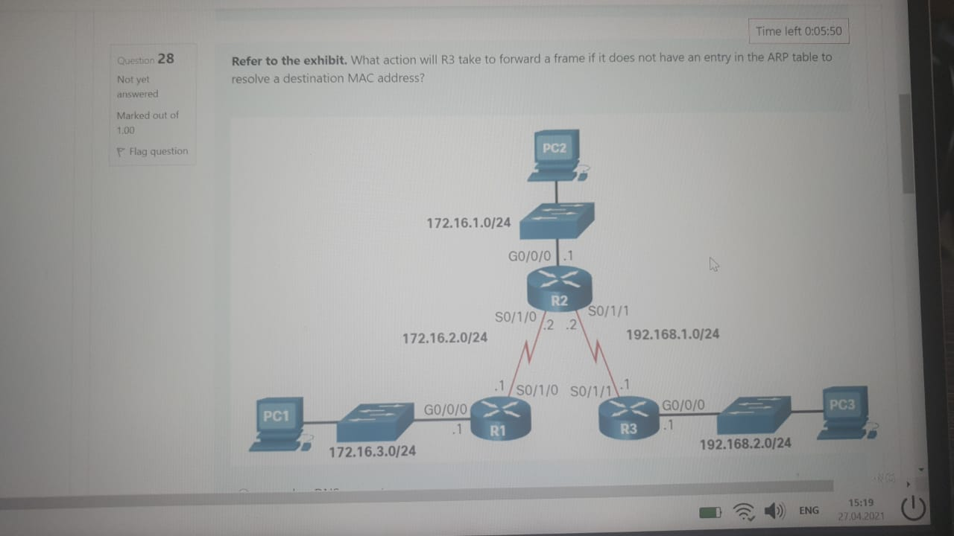

**sends an ARP request**

You are given the figure. Please choose correct version of configuration for IPv6 next-hop static route for r1

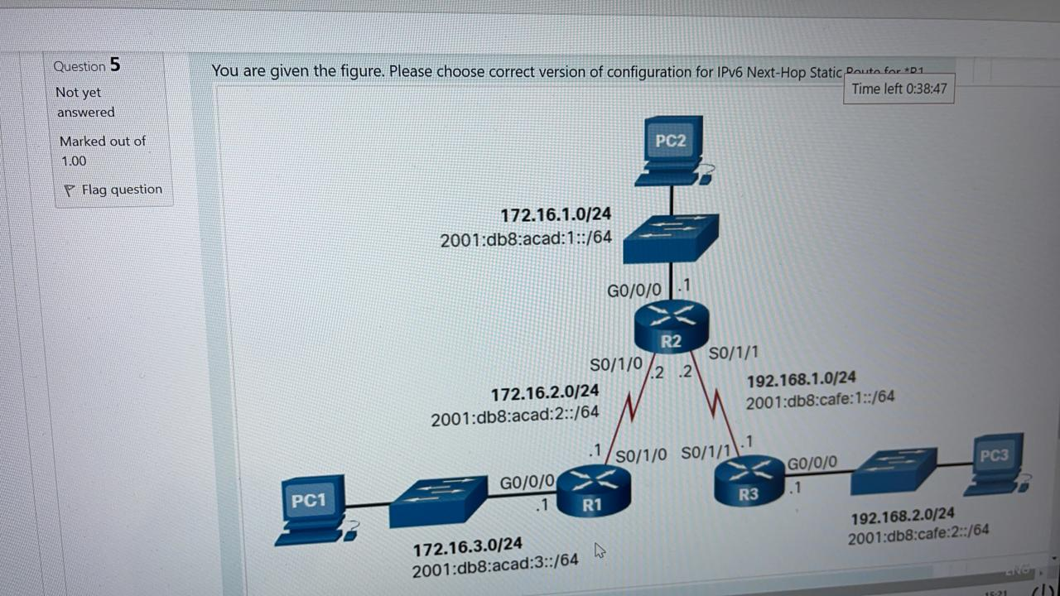

R1(config)# **ipv6 unicast-routing**

R1(config)# **ipv6 route 2001:db8:acad:1::/64 2001:db8:acad:2::2**

R1(config)# **ipv6 route 2001:db8:cafe:1::/64 2001:db8:acad:2::2**

R1(config)# **ipv6 route 2001:db8:cafe:2::/64 2001:db8:acad:2::2**

Which service is enabled on a Cisco router by default that can reveal significant information about the router and potentially make it more vulnerable to attack?

CDP

How to increase the bandwidth of dual band routers

Split the traffic

Upgrade your wireless clients

Choose the correct full command to configure IPv6 Static route command

Router(config)# **ipv6 route** *ipv6-prefix*/*prefix-length* {*ipv6-address* | *exit-intf* [*ipv6-address*]} [*distance*]

Which two methods can be used to identify the next hop in a static route? (Choose two.)

destination IP address exit interface

Fill the blank: __can be a manually configured static route to direct traffic to a specific destination device, such as the server shown in the figure. The static route uses a destination IP address and a 255.255.255.255 (/32) mask for IPv4 host routes, and a /128 prefix length for IPv6 host routes.

host route

What command, or set of commands, would be used to determine if the following configuration on router HQ works as designed?

**ip route  0.0.0.0 0.0.0.0 serial 0/0/0 10  
ip route 0.0.0.0 0.0.0.0 serial 0/1/0**

HQ(config)# **interface serial 0/1/0**  
HQ(config-if)# **shutdown**  
HQ(config-if)# **end**  
HQ# **show ip route**

Which IPv4 static route statement is true?

Using the exit interface only is common in a point-to-point configuration.

Choose correct example of configuration ipv4 fully specified static route

R1(config)# **ip route 172.16.1.0 255.255.255.0 GigabitEthernet 0/0/1 172.16.2.2**

Which global configuration commands are used to configure static routes?

Ipv6 route

Ip route

What type of route is described below: This type of routes are static routes that are used to provide a backup path to a primary static or dynamic route, in the event of a link failure. The floating static route is only used when the primary route is not available.

Floating static route

What troubleshooting command can be show the following result

R1# **traceroute 192.168.2.1** Type escape sequence to abort. Tracing the route to 192.168.2.1 VRF info: (vrf in name/id, vrf out name/id) 1 172.16.2.2 1 msec 2 msec 1 msec 2 192.168.1.1 2 msec 3 msec *

What command shows the following result (fill the white space)

R1# **show ip route | begin Gateway**

Gateway of last resort is not set 172.16.0.0/16 is variably subnetted, 5 subnets, 2 masks S 172.16.1.0/24 [1/0] via 172.16.2.2 C 172.16.2.0/24 is directly connected, Serial0/1/0 L 172.16.2.1/32 is directly connected, Serial0/1/0 C 172.16.3.0/24 is directly connected, GigabitEthernet0/0/0 L 172.16.3.1/32 is directly connected, GigabitEthernet0/0/0 S 192.168.1.0/24 [1/0] via 172.16.2.2 S 192.168.2.0/24 [1/0] via 172.16.2.2

show ip route | begin Gateway

After entering command switchport port-security on interface configuration mode the following message appears: Command rejected: FasrEthernet0/1 is a dynamic port.

………….

Switchport mode access

**Refer to the exhibit.** What action will R3 take to forward a frame if it does not have an entry in the ARP table to resolve a destination MAC address?

**sends an ARP request**

How many default gateways can each host receive in a switched network?

Accounting is a component of AAA which is responsible for

Collecting and reporting usage data for auditing and billing purposes

Where are dynamically learned MAC addresses stored when sticky learning is enabled with the **switchport port-security mac-address sticky** command?

RAM

What device is assigned the role of alternate default gateway?

standby router

Which statement describes the behavior of a switch when the mac address table is full?

It treats the frame as an unknown unicast and begins to flood all incoming traffic to all ports only within the local VLAN.

What port security violation mode is enabled by default?

Shutdown

How is the destination network in an IPV6 static route identified?

using an IPv6 prefix and prefix length

A network administrator is configuring a route to forward packets to a specific web server. What type of route should be configured by the administrator?

a host route

What network address and subnet mask combination would be used to create a default static route that matches any IPv4 destination?

0.0.0.0 0.0.0.0

Choose correct example command of ipv4 default static route.

R1(config)# **ip route 0.0.0.0 0.0.0.0 172.16.2.2**

IP floating static routes are configured by using the **distance** argument to specify an administrative distance. If no administrative distance is configured, the default value (1) is used.

True

What type of route is described below: __are static routes that are used to provide a backup path to a primary static or dynamic route, in the event of a link failure. The floating static route is only used when the primary route is not available. Floating static routes are static routes that are used to provide a backup path to a primary static or dynamic route, in the event of a link failure. The floating static route is only used when the primary route is not available.

Floating static routes

Next-hop route stand for the next-hop Ip address and exit interface are specified

False

Choose the correct example configuration IPv6 default route

R1(config)#ipv6 route ::/0 2001:db8:acad:2::2

What type of static route is used as the Gateway of last resort?

default route

Which static route statement shows a recursive IPv6 static route?

ipv6 route 2001:db8:cafe:1::/56 2001:db8:1000:10::1

Choose all common IOS troubleshooting commands include the following:

**Ping**

**Traceroute**

**show ip route**

**show ip interface brief**

**show cdp neighbors detail**

When configuring a static route, another option is to use the exit interface to specify the next-hop address. The figure shows the topology again.

Please choose correct configuration commands for “R1”

R1(config)# ip route 172.16.1.0 255.255.255.0 s0/1/0

R1(config)# ip route 192.168.1.0 255.255.255.0 s0/1/0

R1(config)# ip route 192.168.2.0 255.255.255.0 s0/1/0

Refer to the exhibit. True or False? R2 will forward frames to R3 with an all 1s Layer 2 address.

True

Which is correct IPV4 static route command? (be careful with parameters):

Router(config)# **ip route** *network-address subnet-mask* { *ip-address* | *exit-intf* [*ip-address*]} [*distance*]

The following configuration commands are entered on an Interface



A device with MAC address **A42E.5292.123F** connected to this interface sends a broadcast frame to the network. What will happen when the frame arrives to the Fa0/1 interface?

The frame will be discarded, and Syslog message will be sent

What is the effect of **switchport port-security** command entered in an interface configuration mode?

Enables port security function

Choose possible administrative distance that matches the following behavior:

For example, assume that an administrator wants to create a floating static route as a backup to an EIGRP-learned route. The floating static route must be configured with a higher administrative distance than EIGRP. EIGRP has an administrative distance of 90. If the floating static route is configured with an administrative distance of 95, the dynamic route learned through EIGRP is preferred to the floating static route. If the EIGRP-learned route is lost, the floating static route is used in its place.

* 95

What does mean << Directly Connected Netwoks >> mean?

* networks that are configured on the active interfaces of a router. A directly connected network is added to the routing table when an interface is configured with an IP address and subnet mask (prefix length) and is active (up and up).

What’s the newest packet forwarding method?

* Cisco Express Forwarding (CEF)

What filtering parameter display all the output lines from a certain point?

* begin

What is typical for the OSPF routing protocol?

* Faster links are assigned lower costs compared to slower (higher cost) links.

What is the most obsolete packet forwarding method?

* **Process Switching**

**An administrator who is troubleshooting connectivity issues on a switch notices that a switch port configured for port security is in the err-disabled state. After verifying the cause of the violation, how should the administrator re-enable the port without disrupting network operation?**

* **Issue the shutdown command followed by the no shutdown command on the interface.**

Which device monitors SMTP traffic to block threats and encrypt outgoing messages to prevent data loss?

* ESA

Which two statements are true about half-duplex and full-duplex communications?

* Full duplex allows both ends to transmit and receive simultaneously.  
  **Full duplex offers 100 percent potential use of the bandwidth.**

What is the significant difference between a hub and a Layer 2 LAN switch?

**A hub divides collision domains, and a switch divides broadcast domains.**

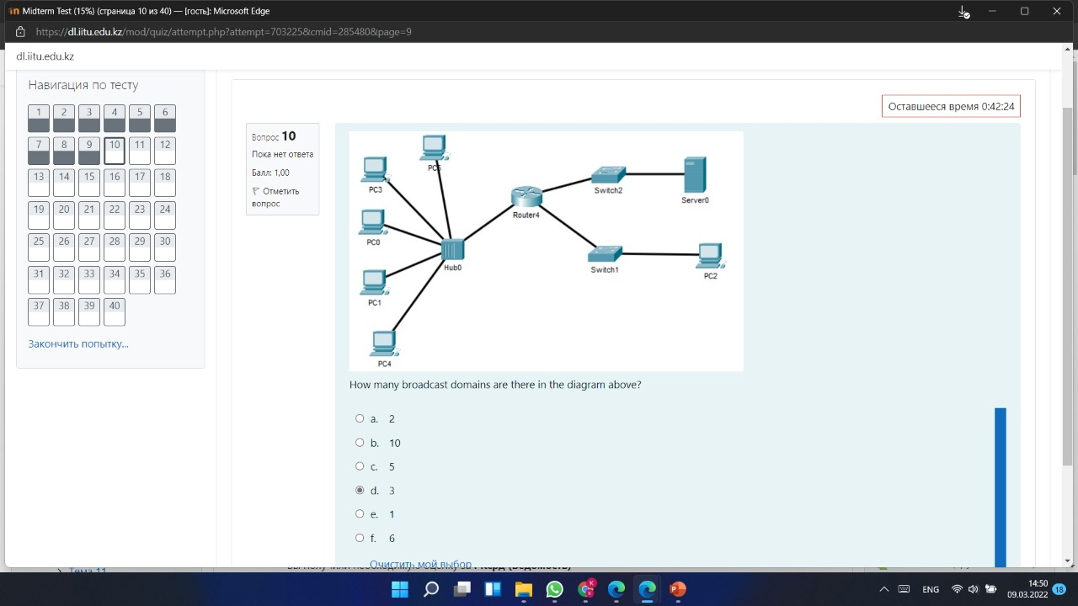

3

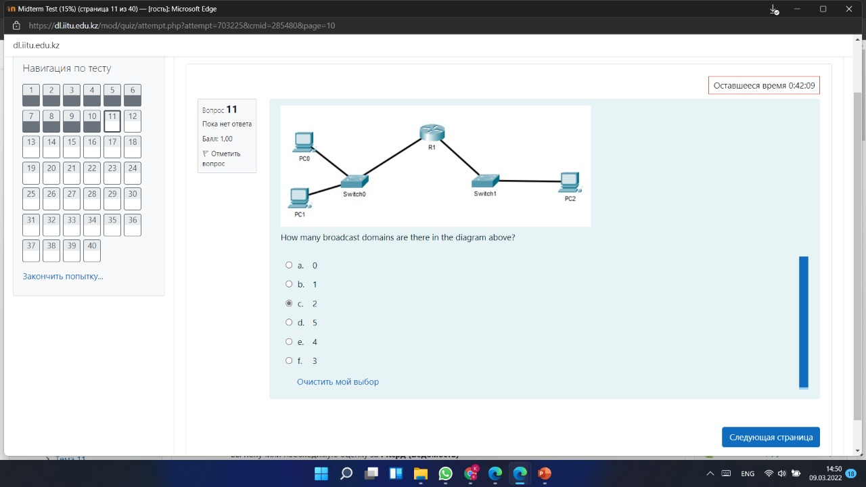

2

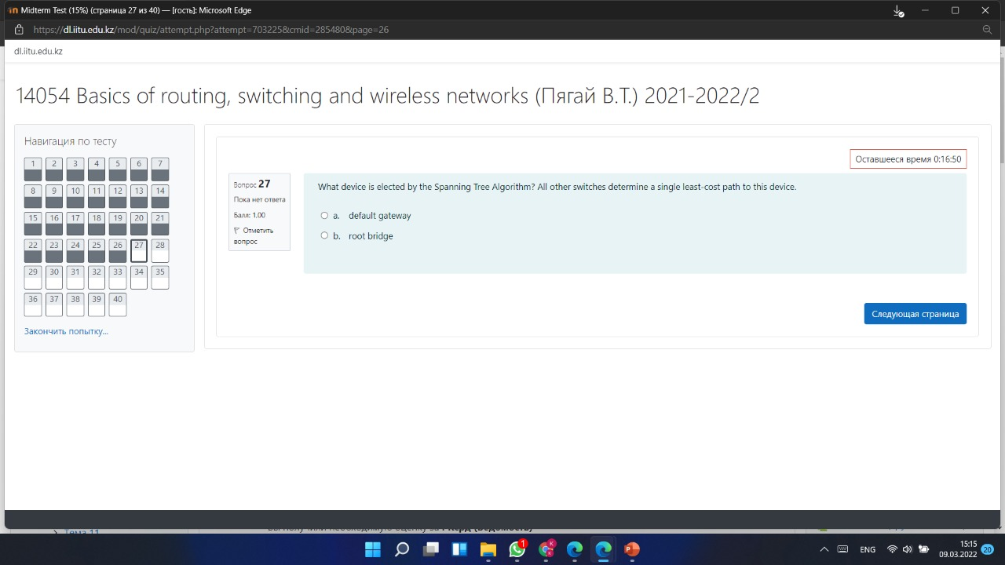

Root bridge

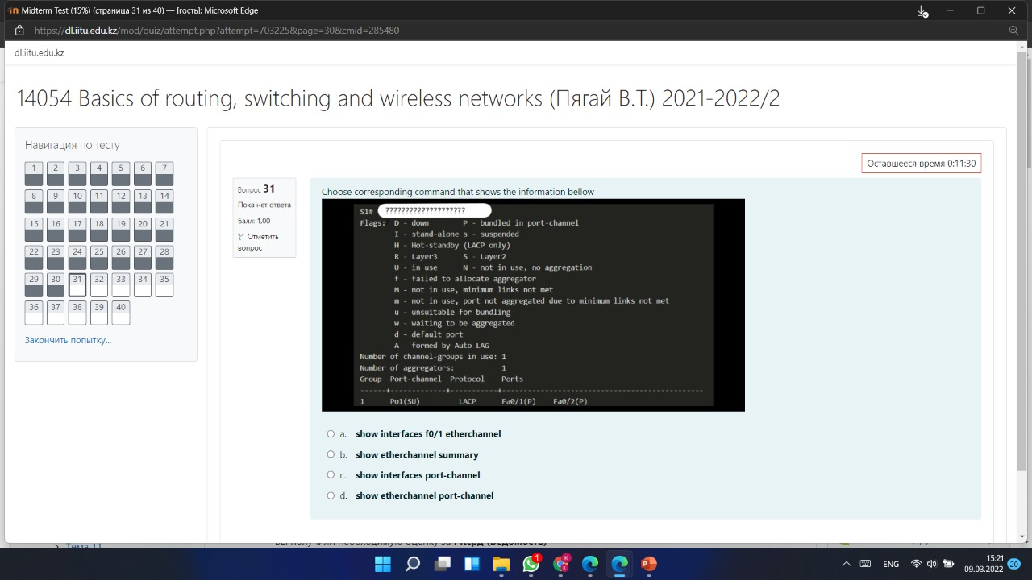

**show etherchannel summary.**